Permafrost Atmospheric Science in Cambridge Bay, Canada

License# 04 020 16R-M

Timeframe: May 01, 2016 – December 31, 2016 (Total research phase: 2016-2020)
Purpose: To understand the environment change of Arctic permafrost
Goals and objectives:
- Monitoring carbon dioxide and black carbon for atmospheric sciences
- Temperature and precipitation manipulation experiments
- Characterization of ecological components and their response to climate change

For long-term monitoring of CO₂ and energy exchange between the atmosphere and the ecosystem, an eddy covariance flux system together with a net radiometer was operated on an Environment Canada tower about 50 m away from the climate manipulation plots this year (69°7'47.7"N, 105°3'35.3"W). For quality control of flux data and diagnosis of the impact of a garbage incineration plat southeast away from the flux tower on atmosphere quality, an aethalometer was installed to measure black carbon concentration in a building of upper air station on July, 2013. Maintenance of and data retrieval from the flux system and the aethalometer were supported by Qillaq Innovations through regular visits to the site every two weeks. At the moment, fluxes of CO₂ and energy (since July, 2012) and CH₄ (since July, 2015, except in wintertime) are being measured at the site and the flux of N₂O, another major greenhouse gas, will also be measured in 2018. For this, KOPRI has discussed with Qillag Innovations to put a shelter near the flux tower, where electricity power is available for flux measurement, including the N₂O analyzer. Apart from this work, KOPRI has also been working on establishing internet connection to monitor the flux data online. It is planned to complete these tasks in the summer of 2017. Soil temperature and soil water content have been measured at depth of 0.1 m near the tower since July, 2014. On August, 2016 chamber measurements for CO₂ and CH₄ emission from the soil near the flux system were tested at some points with regular maintenance of the flux system. In 2017, ten collars with diameter of ~ 0.2 m will be put at some representative points within the site for short-term continuous chamber measurements. With complementary measurements and modeling studies, carbon and nitrogen cycle scale will be evaluated at the site.
To investigate the effects of increasing temperature and precipitation in Arctic tundra, we have continued the climate manipulation experiment since 2012. Installing open top chambers (OTCs) to experiment with increasing temperature and watering every week to increase precipitation were started on June 20 and ended in September 30, 2016. We are currently monitoring air temperature, relative humidity, soil temperature, soil moisture content, and NDVI from the climate manipulation plots. We are also planning to establish snow fences to observe the effects of snow depth (winter warming, higher soil moisture condition, and shorter growing season periods) in 2017.

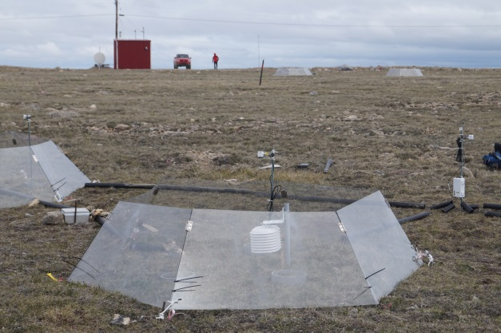
OTC installation in June, 2016

