Permafrost Atmospheric Science in Cambridge Bay, Canada

License# 04 020 16R-M

Timeframe: Jan 01, 2017 – December 31, 2017 (Total research phase: 2016-2020)
Purpose: To understand the environment change of Arctic permafrost
Goals and objectives:
- Monitoring carbon dioxide and black carbon in the atmosphere
- Investigating the effects of changing temperature and precipitation in Arctic tundra
- Examining the effect of snow depth on tundra ecosystem
- Characterizing the ecological components and their response to climate change

For long-term monitoring of CO₂ and energy exchange between the atmosphere and terrestrial biosphere, an eddy covariance flux system together with a net radiometer was operated on an Environment Canada tower about 50 m away from the climate manipulation plots (69°7'47.7"N, 105°3'35.3"W) since summer in 2012. Complimentary measurements for soil temperature and soil water content have been measured at a depth of 0.1 m near the tower since July 2014. For quality control of flux data and diagnosis of the impact of a garbage incineration plat southeast away from the flux tower on atmosphere quality, an aethalometer was installed to measure black carbon concentration in a building of upper air station on July, 2013. Maintenance of and data retrieval from both the flux system and aethalometer were supported by Qillaq Innovations through regular visits to the site every two weeks.
For the maintenance of the flux system and additional chamber measurements, two researchers visited the site from June 21 to July 9, 2017. The researchers calibrated the gas analyzers (EC150 & LI7700) with CO₂/CH₄ gas, and water vapor generated by the dew point generator (LI610). Chamber measurements for CO₂ and CH₄ emissions from the soil were conducted at 12 points near the tower and the nearest lake from the tower using LGR portable gas analyzer with Licor Chamber. For the measurements, twelve collars with a diameter of ~ 0.2 m were installed in the site. In addition, for continuous and automatic chamber measurement of CO₂/CH₄ emission during summer season, we made a small plot 300m away from the tower (Figure 1). Electricity power was provided to the plot from the tower. Continuous and automatic chamber measurement were conducted from July to September at 2017. Lastly, with the support of Qillaq Innovations, a hut (350Ⅹ220Ⅹ230cm) was put near the flux tower where electricity power is available, which will allow us to measure turbulent N₂O-CH₄ flux from 2018 summer (Figure 2).
To investigate the effects of increasing temperature and precipitation in Arctic tundra, we have been conducting the climate manipulation experiment since 2012. This year, from June 16 to September 21, we installed open top chambers (OTCs) to experiment with increasing temperature and watered every week to increase precipitation. We are currently monitoring air temperature, relative humidity, soil temperature, soil moisture content, and NDVI from the climate manipulation plots. We are planning to monitor CO₂ flux and to measure dissolved organic carbon, N mineralization rates, and microbial characteristics during growing seasons in 2018.
To investigate dry tundra ecosystem’s response to a changing amount of snowfall, we installed 6 snow fences in 2017. A snow fence creates a gradient of snow depth throughout the winter, and plots of control, shallower and deeper snow depths are set up at each fence. Soil samples were taken for analyzing soil and microbial characteristics, and we also measured CO2 flux rates (rates of photosynthetic uptake, respiration) in July. We plan to continue these observations and to conduct electronic and electromagnetic geophysical survey from the onset of snowmelt to the end of growing season in 2018.
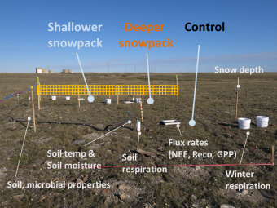
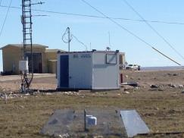
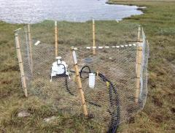
Fig. 3. A setup of snow manipulation experiment
Fig 2 Hut installed near the flux tower.
Fig 1 Automatic Chamber system near the lake.

