NRI Licence #: 04 019 14N-A
NIRB File No: 14YN034

First inventory of lakes and rivers on Victoria Island:
2014 field season trip report

18.3.2015

Milla Rautio, PhD & Canada Research Chair
Dept of fundamental sciences,
Université du Québec à Chicoutimi (UQAC),
Chicoutimi QC G7H 2B1,
Phone : (418)5455011 ext. 5084
milla.rautio@uqac.ca

Michael Power
Dept. of Biology,
Univ. of Waterloo,
200 University Avenue West,
Waterloo, ON, N2L 3G1.
Phone: 519-888-4567 ext. 32595.
m3power@sciborg.uwaterloo.ca

Joseph Culp
Environment Canada (EC) @ CRI/Univ New Brunswick (UNB),
10 Bailey Drive, PO Box 4400,
Fredericton NB E3B 5A3.
Phone: 506-458-7458.
joseph.culp@ec.gc.ca

The Canadian High Arctic Research Station (CHARS) at Cambridge Bay, Nunavut, will strengthen Canada’s role as a leader in Arctic science and will allow for research that until now has not been possible or has been difficult to carry out in the North due to logistic constraints. The lack of state-of-art research facilities and common methodology to measure and monitor many environmental processes has hampered the ability to develop conceptual frameworks that could integrate how changes to Arctic landscapes are likely to be linked to the biodiversity and productivity of these systems.

As an initial step in addressing the knowledge shortfall a sampling campaign of freshwater ecosystems the Greiner Lake watershed near Cambridge Bay was carried out in the summer of 2014. Sampling of 20 lakes, rivers and their immediate watersheds was carried out to provide a baseline description of the ecological variability of water quality, phyto- and zooplankton biodiversity and biomass, trophic structure and carbon fluxes.

The sampling contributes also to the Circumpolar Biodiversity Monitoring Program (CBMP) that has been created in collaboration with all the 8 circumpolar countries. Each country aims to follow the same sampling protocol with the aim to provide high quality and comparable information of different environments in the Arctic and their biodiversity.
The results described below are based on the analyses at the Laboratory of Aquatic Sciences (LASA) of UQAC. Additional analyses from the sampling campaign are being conducted at University of Waterloo (stable isotopes) and Environment Canada (macroinvertebrates).

Sampling

The sampling took place between August 30 and September 3, 2014. Twenty sites (Fig. 1) in the Greiner Lake watershed were visited with a helicopter. Sixteen of the sites (CBL 1-16) were connected to other lakes with streams or rivers and are considered lakes. Four sites (CBL 17-20) were shallow ponds without inlets or outlets. The lakes were sampled from the outlet that integrates the information from the lake water column; the ponds were sampled from several locations along the shore. Each site was visited for about an hour during which the site was sampled for about 8 L of water, small amounts of benthic material (< 5 cm²) and zooplankton. Zooplankton was sampled with plankton nets from a water volume of some hundreds of liters (Fig. 2). Terrestrial vegetation and soils around the sites were samples (about 50 g per site). The samples were brought to the Arctic College laboratory in Cambridge Bay where water was preserved for nutrient analyses and filtered for carbon characterization, fatty acids, stable isotopes and chlorophyll. A small aliquot (100 mL) was preserved with Lugol’s solution for phytoplankton identification and counts. Zooplankton were a) preserved with formaldehyde for taxonomy and counts and b) sorted alive for fatty acid and stable isotope analyses and frozen. Benthic organic material and terrestrial vegetation were frozen for chlorophyll, stable isotopes and fatty acids.

Fig. 1 Map showing the locations of the 16 lakes (CBL 1-16) and ponds (CBL 17-20) that were sampled between August 30 and September 3, 2014.
The samples and analyses were based on recommendations outlined in the Arctic Freshwater Biodiversity Monitoring Plan for circumpolar Arctic freshwater biodiversity assessment to be carried out for all Arctic countries in five year intervals. Each analysis has been pointed out as a key variable indicating the environmental status of a given water body.

Analysis | Justification as important Focal Ecosystem Component (FEC)
Phytoplankton | High importance because they are the base of the food web, sensitive to change, diagnostic of certain types of change, metrics have been developed to identify stressor effects, low variance within a system; some long term monitoring data available.
Benthic algae | High importance because they are the base of the food web, sensitive to change; data availability generally low, samples sporadic spatially, chl a used as a measure of periphyton production; high feasibility due to high ease of sampling and low cost, potential for archival analysis
Zooplankton | Food for higher trophic levels, important consumers and secondary producers in the food web; community structure reflects environmental changes; easy to sample and fairly easy to identify; some long term monitoring data available.
Lipids and their fatty acids/energy flow | Important for community function and biodiversity, useful to detect changes within and among systems, useful for assessment of targeted species to identify energy flow (benthic vs. pelagic); few data exist.
Seston dry weight,  DOC/CDOM* | High importance because indicators of overall productivity of the system, strong relationship with biodiversity; high feasibility of sampling due to ease of sample collection and low cost; data are spatially and temporally extensive
*DOC= Dissolved organic carbon, CDOM = Chromophoric dissolved organic matter

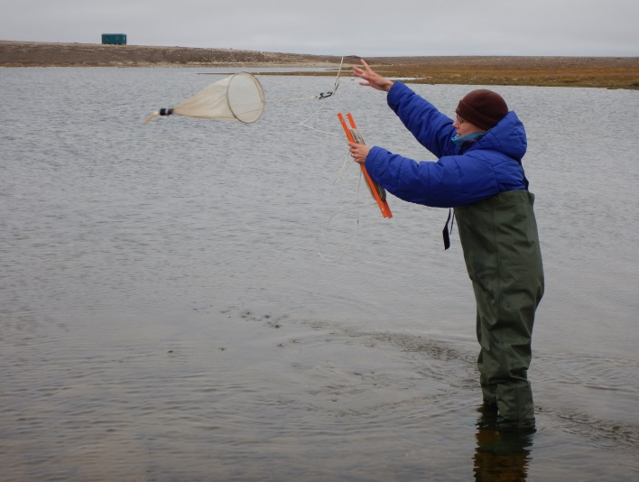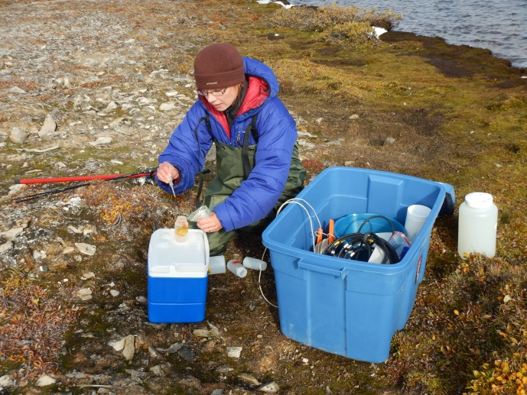

Fig.2. Sampling CBL lakes. Photo on left shows zooplankton sampling with a plankton net, in the photo on the right Lugol’s solution is added to a phytoplankton sample.

Preliminary results

Because of the limestone bedrock, the lakes on Victoria Island are highly alkaline with pH ranging from 8.0 to 8.6. They are also characterized with high conductivity (mean 390 µS cm⁻²) which partly results from relatively high nutrient conditions in these systems. Total phosphorus (TP) ranged from 8.1 to 18.7 mg L⁻¹. The lakes (CBL 1-16) were in general characterized with more diluted waters than the ponds (CBL 17-20) with a magnitude of order higher values in conductivity, total and dissolved nitrogen, and seston dry weight (Table 1). The higher amount of organic material in the water column of the ponds, as was indicated by the seston DW, was also reflected in the light attenuation (K_{d} PAR) of these waters. All lakes could be characterized as highly transparent with light penetrating to more than 20 m in the water column. Light in the ponds attenuated twice as fast as in the lakes. The shallow depth of the ponds compensated for this higher light attenuation.

The high transparency of the lakes and ponds meant that there was enough light for photosynthesis even in the bottom. The bottoms of these lakes were covered with benthic algae often forming a layer of organic material that is several mm thick (Fig. 3). Phytoplankton biomass was low and made of highly variable taxa (Fig. 4).

The number of species and the biomass of zooplankton were high especially in the ponds that are too shallow to harbor fish that are the main predators of zooplankton. The zooplankton were also highly pigmented, possibly as a response to ozone depletion and high solar ultraviolet exposure in these transparent waters (Fig. 5).

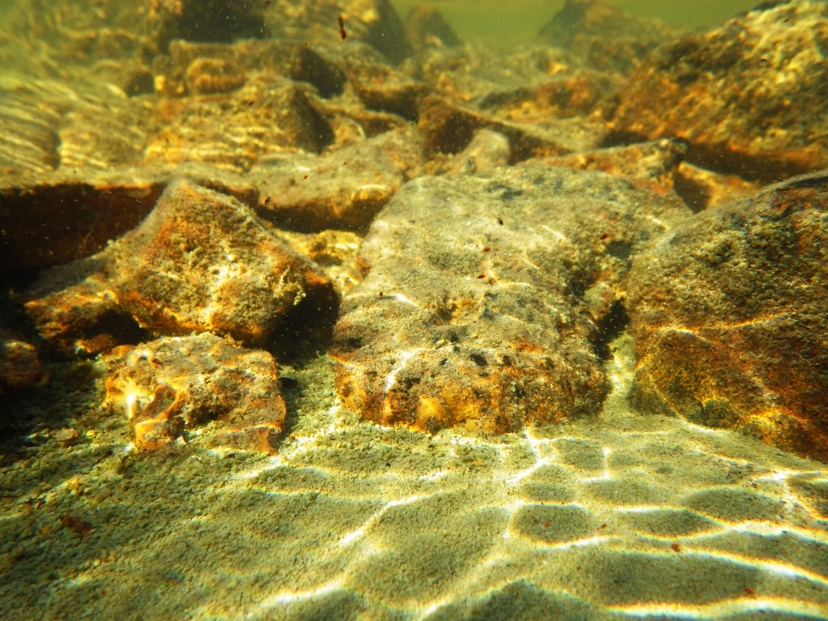

Fig. 3. Underwater photo of a bottom of ponds showing the thick layers of benthic algae growing on rocks and soft sediment. Notice also the red zooplankton.

Fig. 4. Examples of phytoplankton found in the sampled lakes on Victoria Island. From top left to bottom right: Chilomonas, Cyclotella, Oocystis, unknown flagellates, Sphaerocystis, Tabellaria.

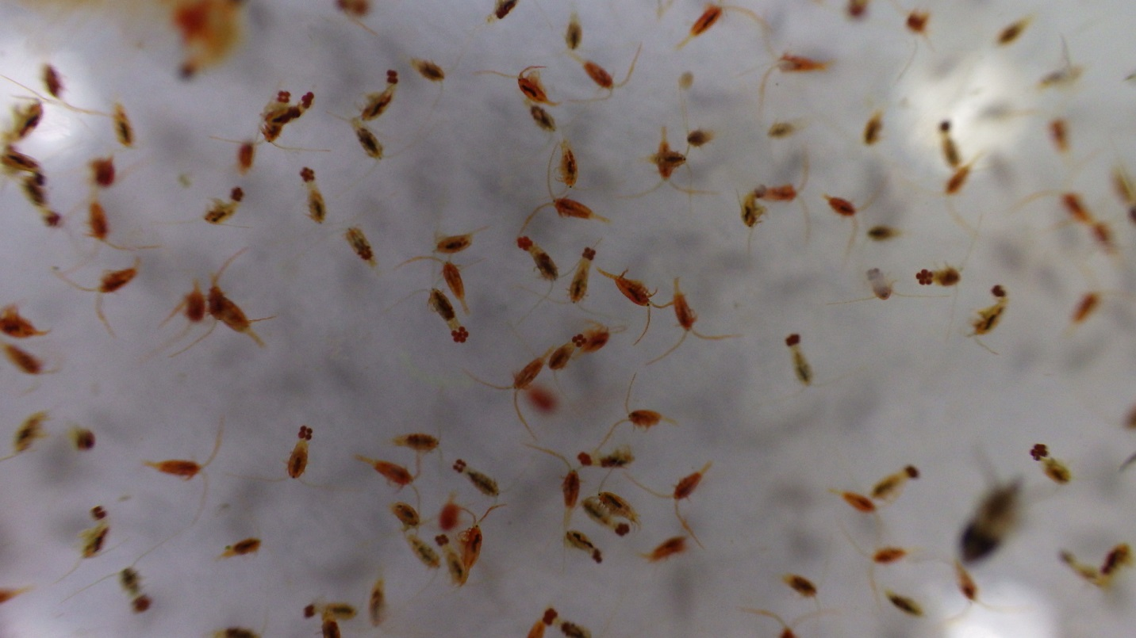

Fig. 5. Calanoid copepods carrying eggs. The red color comes from photoprotective astaxanthin pigment.
We also made estimations of the nutritional quality of aquatic foods based on their lipid and fatty acid composition which can be used as indicators of trophic relationships as well as of the quality of aquatic food sources for human use.

Lipids and their fatty acids were sampled from zooplankton, seston, benthos, terrestrial vegetation and soils. The results show that zooplankton has the highest percentage of lipids per unit mass, followed by seston, benthos, terrestrial vegetation and soils (Fig. 6a). The percentage of polyunsaturated fatty acids (PUFA) was, however, highest in the catchment vegetation and soils (Fig. 6b). These results will be combined with stable isotope signatures of the samples and carbon quality in each source habitat to estimate food web structure and diet sources of zooplankton and other aquatic organisms. The preliminary results of carbon quality (high values of SUVA and CDOM: indicators of the presence of terrestrial carbon in lakes) (Table 1) show that the land-lake coupling is stronger in ponds with terrestrial carbon sources likely playing an important role in aquatic food web ecology.

Aquatic animals, including different taxa of zooplankton, benthic invertebrates, mysids and stickle backs were also in more detailed compared in their lipid quantity and quality. Most of these organisms are putative diet sources for arctic charr, lake trout and other valuable fish. Our results show that copepods, mysids and benthic invertebrates contain the highest amount of lipids (Fig. 7a) but according to the PUFA content the mysids make the best fish food, followed by stickle backs and benthic invertebrates (Fig. 7b).

Fig. 6. Lipids in zooplankton, seston, benthos, terrestrial vegetation and soils. A) The ranking of percentage lipids per unit mass and b) percentage of PUFA in different sources of lipids.
Fig. 7. Amount of lipids in the putative diet sources of arctic charr and other fish. A) The ranking of percentage lipids per unit mass and b) percentage of PUFA in different sources of lipids.

Summary and sampling plan for 2015

The monitoring for 2015 will build on the work by our team in 2014 that addressed the knowledge shortfall of freshwater ecosystems on Victoria Island in the Greiner Lake watershed.
The work will be carried out between June 8 and September 5, 2015, by a total number of 3 personnel. The samples have been processed, and some of the results have been included in a research paper that will be submitted shortly. Two video podcasts were made of the sampling campaign to inform Northerners and the broader public of our work. The project will also be described in AANDC Publications by the writer Janet Hunter in 2015. A full use of this initial dataset will be implemented as part of the proposed monitoring for 2015 with a large number of additional samples and measurements.

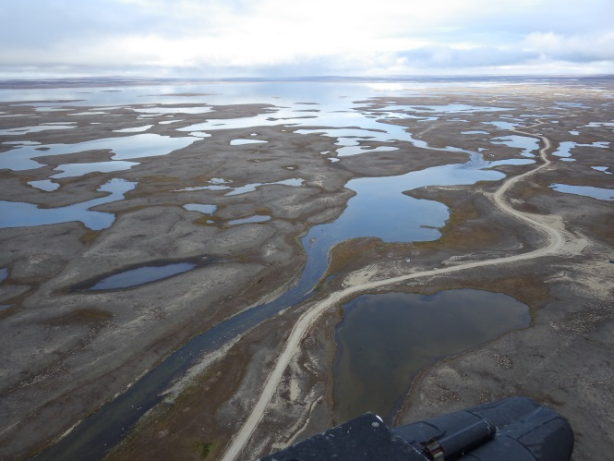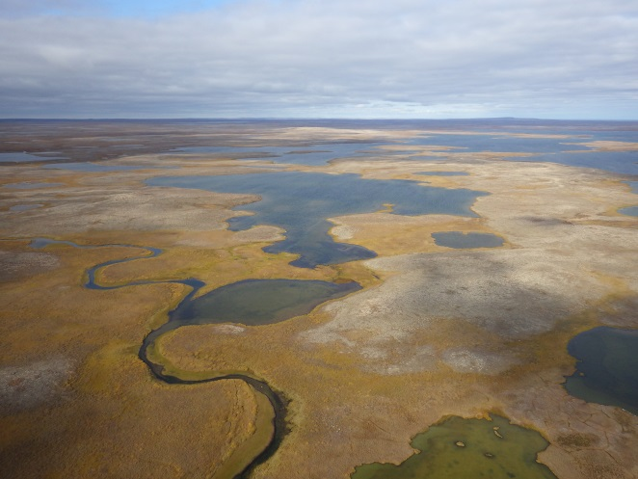

Table 1. Limnological characteristics of the sampled sites. The measured variables include temperature (Temp), conductivity (Cond), pH, lights attenuation coefficient for photosynthetically available radiation (Kd PAR), total nitrogen (TN), total dissolved nitrogen (TN diss), total phosphorus (TP), seston dry weight (DW), seston cholorophyll-a (Chl-water), benthic chlorophyll-a (Chl-benthic), dissolved organic carbon (DOC), specific UV absorbance (SUVA) and chromophoric dissolved organic carbon (CDOM).
Site | Date | Lat | Lon | Temp | Cond | pH | K_{d} PAR | TN | TN diss | TP | DW | Chl-water | Chl-benthos | DOC | SUVA | CDOM
 |  |  |  | Celcius | µScm |  | m⁻¹ | mg/L | mg/L | mg/L | µg/L | µg/L | mg/m⁻² | mg/L | A254 | a320
CBL1 | 30.8.2014 | 69.17674 | 104.1467 | 8.5 | 450 | 8.1 | 0.81 | 0.73 | 0.39 | 96.3 | 1.36 | 0.55 | 28.9 | 6.4 | 1.3 | 7.6
CBL2 | 30.8.2014 | 69.15665 | 104.1709 | 8.4 | 280 | 8.6 | 1.89 | 0.50 | 0.25 | 16.6 | 1.40 | 0.89 | 16.1 | 4.4 | 1.0 | 5.4
CBL3 | 30.8.2014 | 69.16155 | 104.5164 | 8.2 | 295 | 8.6 | 0.43 | 0.46 | 0.23 | 15.3 | 1.37 | 2.37 | 16.8 | 4.2 | 1.1 | 9.6
CBL4 | 31.8.2014 | 69.20183 | 104.7682 | 7.6 | 258 | 8 | 0.30 | 0.48 | 0.23 | 18.7 | 1.30 | 1.61 | 11.2 | 4.1 | 0.9 | 4.4
CBL5 | 31.8.2014 | 69.22874 | 104.7591 | 7.4 | 242 | 8 | 2.34 | 0.36 | 0.18 | 13.5 | 1.08 | 1.71 | 17.1 | 3.3 | 0.6 | 2.1
CBL6 | 31.8.2014 | 69.2416 | 104.7171 | 10 | 244 | 8.2 | 1.37 | 0.41 | 0.18 | 14.0 | 1.62 | 1.37 | 6.9 | 3.1 | 0.8 | 7.5
CBL7 | 31.8.2014 | 69.2729 | 104.7161 | 7.5 | 246 | 8.3 | 1.82 | 0.41 | 0.20 | 14.2 | 1.09 | 1.37 | 7.0 | 3.5 | 0.6 | 2.6
CBL8 | 1.9.2014 | 69.07447 | 104.3584 | 7.2 | 258 | 8.1 | 3.57 | 0.47 | 0.22 | 14.0 | 1.01 | 1.16 | 13.8 | 4.8 | 0.7 | 3.3
CBL9 | 1.9.2014 | 69.07729 | 104.4011 | 7.2 | 258 | 8.2 | 3.93 | 0.43 | 0.22 | 10.6 | 0.85 | 0.39 | 21.3 | 4.2 | 0.9 | 8.0
CBL10 | 1.9.2014 | 69.09504 | 104.4028 | 7.3 | 331 | 8.2 | 2.55 | 0.56 | 0.29 | 13.8 | 1.45 | 1.36 | 25.6 | 4.9 | 1.1 | 6.1
CBL11 | 1.9.2014 | 69.14977 | 104.6388 | 9 | 294 | 8 | 1.84 | 0.42 | 0.20 | 11.9 | 1.18 | 1.80 | 21.9 | 3.9 | 1.0 | 6.0
CBL12 | 1.9.2014 | 69.16284 | 104.6168 | 8.4 | 702 | 8.1 | 2.41 | 0.94 | 0.47 | 15.4 | 2.67 | 1.04 | 25.3 | 7.7 | 1.4 | 6.8
CBL13 | 1.9.2014 | 69.2203 | 105.0958 | 8 | 423 | 8.5 | 0.15 | 0.41 | 0.22 | 10.4 | 0.56 | 0.57 | 7.9 | 3.4 | 0.5 | 0.9
CBL14 | 2.9.2014 | 69.21848 | 105.1273 | 7.5 | 353 | 8.4 | 0.47 | 0.44 | 0.23 | 8.1 | 0.92 | 0.64 | 6.7 | 3.9 | 0.6 | 1.7
CBL15 | 2.9.2014 | 69.24606 | 105.111 | 8.2 | 214 | 8.4 | 0.78 | 0.45 | 0.23 | 15.3 | 4.47 | 1.05 | 28.7 | 4.1 | 0.9 | 3.9
CBL16 | 2.9.2014 | 69.24506 | 105.0667 | 8.5 | 292 | 8.6 | 0.31 | 0.58 | 0.31 | 12.1 | 0.82 | 0.67 | 19.3 | 5.5 | 1.0 | 4.7
CBL17 | 3.9.2014 | 69.22258 | 105.0772 | 9.9 | 774 | 8.4 | 3.66 | 1.44 | 0.74 | 9.7 | 1.67 | 0.42 | 22.2 | 14.6 | 3.2 | 21.3
CBL18 | 3.9.2014 | 69.28286 | 104.7585 | 10 | 694 | 8.5 | 2.36 | 1.34 | 0.72 | 11.4 | 1.88 | 0.82 | 13.8 | 12.8 | 2.0 | 12.2
CBL19 | 3.9.2014 | 69.16594 | 104.2891 | 10.5 | 596 | 8.6 | 1.77 | 1.24 | 0.68 | 11.6 | 4.66 | 0.34 | 16.6 | 13.7 | 3.5 | 24.7
CBL20 | 3.9.2014 | 69.16554 | 104.6296 | 10.2 | 594 | 8.5 | 1.54 | 1.46 | 0.77 | 21.0 | 1.59 | 0.10 | 10.5 | 14.2 | 2.8 | 13.2
Mean | Lakes (CBL 1-16) |  |  | 8.1 | 321 | 8.3 | 1.6 | 0.5 | 0.3 | 18.8 | 1.4 | 1.2 | 17.2 | 4.5 | 0.9 | 5.0
 | Ponds (CBL17-20) |  |  | 10.2 | 665 | 8.5 | 2.3 | 1.4 | 0.7 | 13.4 | 2.5 | 0.4 | 15.8 | 13.8 | 2.9 | 17.9

