NRI Laisiat #: 04 019 14N-A
NIRB Naunaiyarvia No: 14YN034

Hivulliqpaaq naunaiyaiyut tattinut kuukkanullu Kiillinnirmi:
2014 manirami ikaarniata havaatigut unipkaarutaa

18.3.2015

Milla Rautio, PhD & Kanatam Qauyiharnirnut Ikhivautalik
Dept of fundamental sciences,
Université du Québec à Chicoutimi (UQAC),
Chicoutimi QC G7H 2B1,
Hivayautit : (418)5455011 ext. 5084
milla.rautio@uqac.ca

Michael Power
Avatiliqinirnut Pilirivvik,
Univ. of Waterloo,
200 University Avenue West,
Waterloo, ON, N2L 3G1.
Hivayautit: 519-888-4567 ext. 32595.
m3power@sciborg.uwaterloo.ca

Joseph Culp
Avatilirinirnut Kanatami (EC) @ CRI/Univ New Brunswick (UNB),
10 Bailey Drive, PO Box 4400,
Fredericton NB E3B 5A3.
Hivayautit: 506-458-7458.
joseph.culp@ec.gc.ca

Hamna Kaniitian Ukiuqtaqtum Qauyiharvik (CHARS) Iqaluktuuttiaq, Nunavut hakugikhipkainiaqtangit Kanatam havaariyakhaat hivuliqtiulutik Ukiuqtaqtum qauyihaiyunit naunaiyaiyunut ayurnailiqhuni naunaiyainahuarnigut taimaa ayurnaraluarami qangaraalungmi naunaiyaiyut Ukiuqtaqtumi. Taimaa ihuaqutikhaqanngitkaluaramik qangaraaluk naunaiyainahuaraangat ihivriurnahuaqhugillu amihuuyut avatingnut piliriakhait hakuiqhimayayaat pinahuarutaanit pivalliagiami nalaumattiaqtumik havaariyakhait taimaa ilauvigilaaqtaat qanuq aallannguqpallianingit Ukiuqtatum nunaa maniraalu taimaa katilviuvlunilu aallatqiit uumayut nunami nutqahuilaittunilu haffuminngat aulaninganillu.

Iniliutuanganit kiugiangani qauyimaningit ikiklivluni ihivriurnikkut ingilrayunit imatqikpiaqtuni uumayut iluani Iqaluktuuttiam Tahiani qurluangan haniani Iqaluktuuttiam havaktauhimalraangat auyami 2014 mi. Ihivriuqhimayangit 20 nit tahiinit, kuukkait qurluangillu havaktauhimagaluaqtut ilaliutauvluni kigliat tukinga haffuminngat nunat avataillu aallatqiktaqtut imaitigut, nauttiangit- puptaumayut iiyingnut tautungnaittut uumayut kumait aallatqiit uumayut uumayuit aallatqiit niqinnariyangillu uumayulingnit aallatqiit.

Hamna ihivriuqtangit ikayuutauvluni uuminngat Ukuiqtaqtum tamainnut Uumayulingnit Amiqhainikkut Havauhiat (CBMP) tiliuqhimayaat ilaliutauvlunilu ukuninngat tamainnut 8 nit ukiuqtaqtum hinaa nunallaangit. Tamait nunallaangi hivunigiyangit malikhugit adjigiiktunit ihivriurningit maligautait hivunigivlugulu ilaliutigivlugu puqtuyumik ihuaqutait uuminngatut naunaitkutait aallatqiit avatingnit iluani Ukiuqtaqtumi uumayulingnillu iluaniittut.
Hamna kiuviniit tukiliutilik ataaniittut naunaiyaiqhimayut haffuminngat qauyihaqhimaningit Qauyiharvigyuanganit Imarmiuttanit Qauyihaiyut (LASA) of UQAC. Ilagiyangillu qauyiharniit haffuminngat qauyihaiyunit ihivriuqhiyunit ingilrayunit havaktauhimayut uvani Ilinniarvigyuangat Waterloo mi (hakugiktumik ilaliutait) unalu Avatilirinirnit Kanatami (macroinvertebrates).

Uukturautiyut

Hamna uukturautihimagaluaqtut uvani Aagasi 30 Saptaipa 3, 2014. Avatingnit inianit (Naun. 1) iluani Iqaluktuuttiap Tahia qurluangit nayuqtauhimagaluaqtut halikaaptakkut. Quliup arvinilik iniit (CBL 1-16) katilviuhimayut aahiit tahiinit qurlualingnit kuugalingnit taimaa ihumagiyauvluni tahiit. Hitamat iniit (CBL 17-20) ikkattut tahirait kangiqhuittumik angmaumayuittunillu ilagiyangit naunaitkutit tattiinit imaup mikhaagut; tahirait ihivriuqtauvlutik qaffiuyunit amihuvyaktumik inianit hinaangat. Tamait inia nayuqtauhimagaluaqtut ikaarnit atauhirmik inia ihivriuqtautillutik uuminngat 8 nit Liitastigut imarmit, mikiyumik benthic mik iluliqarniqhutik (< 5 cm²) unalu imarmiuyut uumayuit iiyingnut takunnaittut. Imarmiuttat uumayuit iiyingnut takunnaittut iiyingnut ihivriuqtauhimayut kumakhiunmut imarmit amihuuningit ilangillu hannanut liitastigut imarmit (Naun. 2). Manirarmit nauhimayut nunaillu hilataani inianit ihivriuqtauhimayullu (haffuminngat 50 g inianit). Hamna ihivriuqtangit agyaqtauhimayut Ilihariaqpaallirvingnut Iqaluktuuttiam qauyiharvingnut imaq tutquqhimavluni qauyihaqhutik tutquttiaqhimavlutik puuqhimavlutik naunaiqhiivlutik qanurilingaqarniqqat, uqhulingnit ilaqariakhaat, hunanigluunit ukuninngat isotopes unalu chlorophyll. Mikiyumik aliquot (100 mL) tutquqhimayauyuq ukuninngat Lugol’p ilaliutainit haffuminngat mikiyunnuit nauhimayut puptaumayut imarmi naunaiyaiyut kititiqtauvlunilu. Mikiyunnuit uumayuit iiyingnut takunnaittut imarmiuttat tutquqtauvlunilu ukuninngat katittugut kititiqtauvluniluunalu b) ihuaqhiriiqhugillu uumatillutik qiniqhiavlutik uqhulingnit ilulia uuminngat formaldehyde naunaiyainahuaqhutik isotope mik qauyaqhutik qiqivlugillu. Benthic uumayulingnit ilulilgit manirarmiuttat nauhimayut qiqittiqhugit qiniqhiavlutik chlorophyll, isotopes unalu uqhulingnit ilulilgit.

Naun. 1 Nunauyaq takunnaqtuq iniit haffuminngat 16 tahiit (CBL 1-16) tahiraillu (CBL 17-20) ihivriuqtauhimayut uvani Aagasi 30 mi unalu Saptaipa 3, 2014 mi.
Ihivriugait qauyihaiyullu malikhugit titiraqhimayumi kiuvikhangit tukhiutainillu tiliuqhimayuq iluan Ukiuqtaqtum Halumayut Imait Uumayulingnit Amiqhaiyut Parnautainit haffuminnat Ukiuqtaqtum hinaagut halumayut imait uumayulingnit qauyihaiyut turaaqhivlutik tamainnut Ukiuqtaqtum nunallaangit uvani tallimanut ukiungagut nutqaqattaqhutik. Tamaat qauyihaiviniit naunaiyaiyuq itquqhugit aallatqiit naunaiyarvianit avatait ilitquhiita ihuaqhiriiqhimayuq imaup timinganit.

Qauyiharniq | Kangiqhitaarniq piyumalluaqtut Hivunikhautikhaq Avatiqatigiingniq Ilangani (HAI)
Takunnaittut Nauhimayut Imarmi Phytoplankton | Ihumagilluangit taimaa niriqatautigamik, qayagiyauyullu aallannguqtaugumik, qauyiharnaqhutik aallatqiinut aallannguqpauhianut, uukturauhiniq pivalliavluni naunaiyaigiangani ayuqhautaugumik aktuqtaunirnut, ikittumik aallannguqtatut iluani ilulingmi; ilangit pikhaaqhimayut amiqharnaqtut naunaiyaivikhat aturnaqtut.
Benthic algae  Aallatqiit Imarmiuttat Nauttiat | Ihumagilluangit taimaa niriqatautigamik, qayagiyauyullu aallannguqtaugumik; naunaiyarvikhaat ikittuq, ihivriurningit aadjigiinngittut, chl a uuktuqtauvaktut haffuminngat periphyton hanaliuqpaktangit; kingiktumik aktuumilaaqhuni puqtuyumik qauyihaqtumik akikittuuvluni, taimaa tutquqtaulaaqhutik qauyihainirnit
Takunnaittut Qupilruit kinguillu imarmiittut  Zooplankton | Niqikhamut kingiktut uukturautainit, ihumagiyauvlunilu niuvirumayunut tuglianilu niriqattautiyunut; nunalingnit tiliugait takunnaqhuni avatingnut aallannguqtunut; ayurnaittullu qauyihariami nalunaittuuvlutiktauq, ilangit aturaarnaqtumik amiqhainirnut naunaiyaivikhamut piyumagumik.
Uqhuit unalu uqhulingnit iluaniittut /hakugingnia qurluanga | Ihumagiyauyuq nunalingnit hulidjutikhamut aallatqiit nauttiat huradjaillu, aturnaqhutik naunaiyaigiangat aallannguqtumik iluani avataanilu qauyihaqtunut, aturnaqhuni naunaiyaigiami hivunikhautikhamut uumayuit naunaiyaigiami hakugingnia qurluaqtut mportant (benthic vs. pelagic); ikittut naunaiyaiyut ittut.
Seston paniumayuq uqumainia,  DOC/CDOM* | Ihumagiyaulluaqtuq naunaiyaivingat tamainnut nutqayuittumik haffuminngat hakugingnianut, hakugiktuq ilagiiktunut ukuninngat aallatqiit nauttiat huradjaillu; kingiktumik aktuumilaaqtuq qauyihaqtuqtut taimaa ayurnaittumik kititiqhiyut akikittunilu; naunaiyaiyut inilgit hililaaqhutik
*DOC=Nunguttit uumayuit ilalgit carbon, CDOM = Chromophoric nunguhimayut nauhimayut ilulik

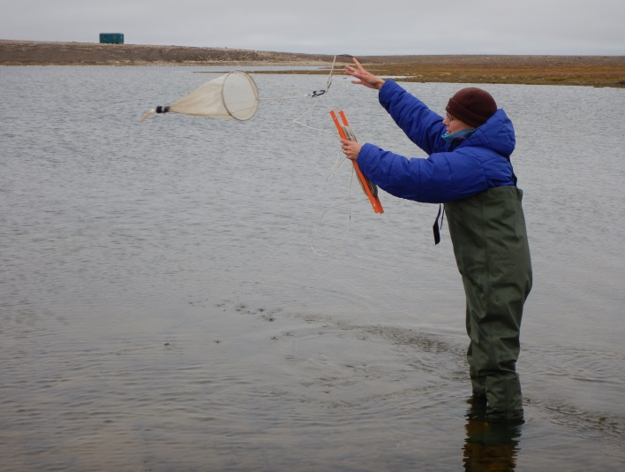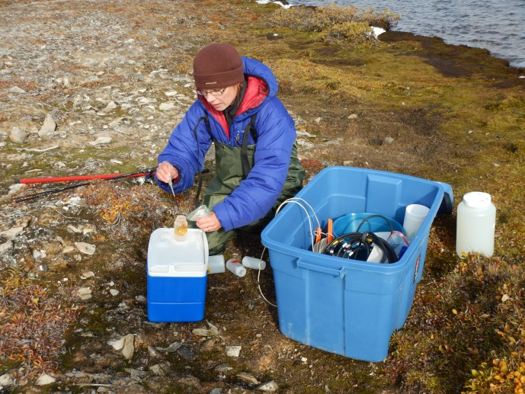

Naun.2. Ihivriuqhiyut CBL tahiit. Piksa haumingmi tautuktatit mikiyuinnuit uumayuit takunnaittut iiyingnit ihivriuqhivaktut uuminngat kumakhiuqtunit, uvani piksami taliqpingmi Lugol’p kangiqhidjutaa ilagiyauyuq uvani mikiyunnuit nauttiat takunnaittut ihivriuqhimayuq.

Hivulliqpaangat kiuviniit

Hamna hiuraqtut uyarat qaiqtuit, tahiit Kiillinirmi amihuuyut ukuninngat uutirnarninga piirumi ukunninga pH aktuumivluni haffuminngat 8.0 to 8.6. Ilitquhiqaqhunilu kingiktumik naunairahuaka quaqhalaania (tukinga 390 µS cm⁻²) ilanganit kiulingnit haffuminngat ilagiyangit amihunit niqinnaqtumik ilingayut iluani uumayuit auladjutait. Tamait havigaliqanngittut (TP) aktuumavlutik hamanngat 8.1 mit 18.7 mg L^{-1 mut}. Tahiit (CBL 1-16) ilitquhiqaqhutik hatpiaqtumik imait tahirarnit (CBL 17-20) uuminngat angiyaaqtumik kingiktumik anginiqhautait uuminngat naunairahyaqa quaqhalaarnia, tamaat nunguhimayut ilulilgit, unalu seston paniumayuq uqumailinga (Naunaitkut 1). Una kingitqiyami haffuminngat uumayuit ilulgit iluani imarmi ilait tahirarmit naunaiyauyauq haffuminngat seston DW, taimaa tautungnaqhunilu ikittumik hakuiqtut (K_{d} PAR) imarmit. Tamaat tahiit ilitquhiriyauyut kingiktumik tatungnaqpiaqtumik ikittumik hakugiktumik amihunit 20 m iluani imaup. Ikittumi iluani tahirat hakuiqhimaningit malruiqtaqhuni tahirmit. Una ikkattumi tahirarmi akiliqhugit kingitqiyaanit ikittumik hakugingnianit.

Una kingiktuq tautungnaqhuni tattiinnit tahirarnillu tukiqaqhuni amihunit qaumayuuvluni piksaliuriami imaup iluani ataanilu. Ataa tahirnit pulahimayut uuminngat aallatqiit imarmiuttat nauttiat taimaa angiklivalliavlutik uumayuit ilulit hilikhuni amihuyunit mm hilingnia (Naun. 3). Takunnaittut imarmi nauhimayut amihuryuat ikittuugaluit puqtuuvlunilu aallatqiit taxa nit (Naun. 4).

Amihut uumayuit unalu amihuryuangat takunnaittut qupilruit kinguillu imarmiittut
Amihuryuat tahirarmit ikkatpallaaqhuni Iqaluit niqikhaqhiuqtut taimaa niqikhaqhiuqtut uuminngat takunnaittut qupilruit kinguillu imarmiittut. Takunnaittut Qupilruit kinguillu imarmiittut aallatqiit ivitaalgit, taimaa hilaup uunnakpallianinga hiqinip qaumanianillu tautungnaqhuni imarmit (Naun. 5).

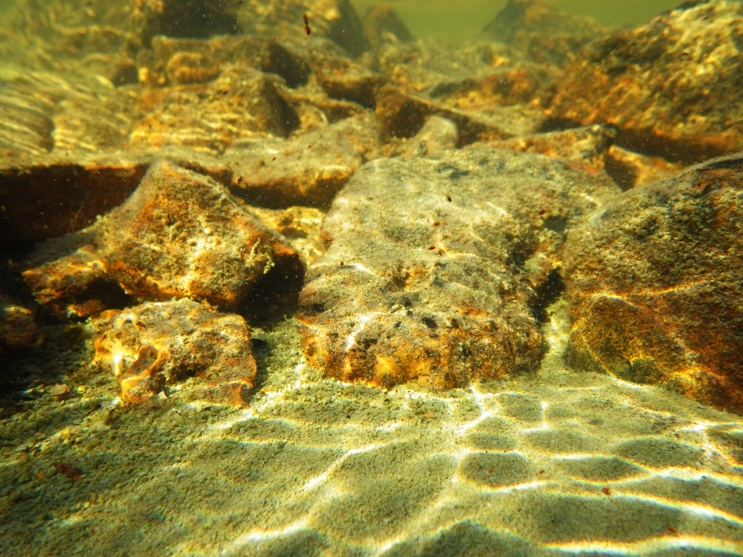

Naun. 3. Imaup ataani piksa ataangat tahirait takunnaqtuq hiliktumik qaliriiqtut haffuminngat aallatqiit imarmiuttat nauttiat angikliliqtut uyararnit aqittumilu hiurarnut. Naunaittuq hamna aupayaaqtuq takunnaittut qupilruit kinguillu imarmiittut.

Naun. 4. Ihivriugait ukuninngat takunnaittut qupilruit kinguillu imarmiittut nalvaaqtauyut tattiinit Kiillinirmi. Qulaanngat haumingmi ataanit taliqpiangmi: Chilomonas, Cyclotella, Oocystis, qauyimayaunngittut, Sphaerocystis, Tabellaria.

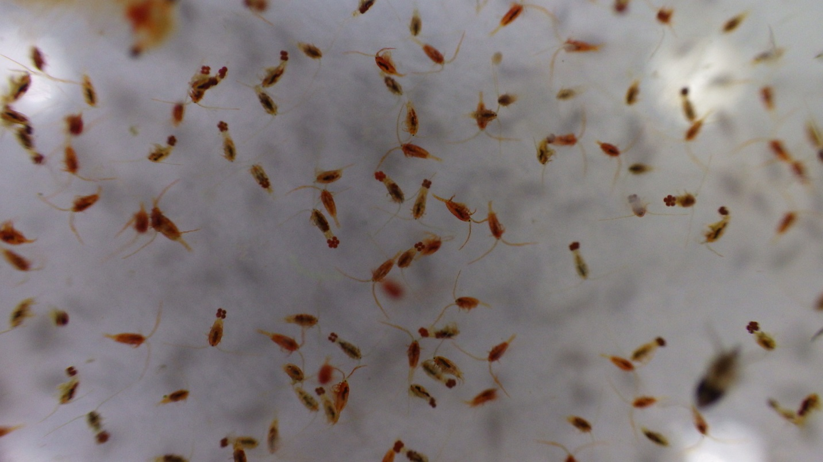

Naun 5. Calanoid copepods tigumiaqtangit manniit. Una aupayaaqtut ivitaangit haffuminngat piksaliuqhimayut qayagivlugit astaxanthin ivitaaq.
Kangiqhihimayavut haffuminngat nirinnaqtunit nakuuqpiangit imarmiuttanit niqikhait taimaa itquvlugit uqhuat uqhulingnillu ilanganit havaangit atuqtaulaaqtut naunaiyailutik ilagiiktunit uuminngalu nakuurutaat imarmiuttat niqikhautait inungnut atuqtakhaat.

Uqhut uqhulgit ihivriuqtauvlutik haffuminngat takunnaittut qupilruit kinguillu imarmiittut, seston, benthos, nunamiittut nauhimayut nunallu iluanit. Hamna kiuviniit takunnaqhunilu takunnaittut qupilruit kinguillu imarmiittut uqhuqaqhutik, uuminngattauq seston, benthos, nunamiuttat nauttiat nunallu (naun. 6a). Angiyaaqtut haffuminngat uqhulingnit ilulik polyusaturated fatty acids (PUFA), kihiani, amihuryuat ihivriuqtangit nauhimayut nunaillu (Naun.6b). Tahapkuat kiuviniit ilaginiaqtangit ukuninngat ihivriuqhimayangit unalu iluliutiqariakhait tamainnut nayuqpauhianit kangiqhiluni niriqattatautiyunut tiliugait iluaniittunit haffuminngat takunnaittut qupilruit kinguillu imarmiittut aahiillu imarmiuttat uumayuit. Hivulliqpaangit kiuviniit haffuminngat uumayuit nakuuqpiangit (amihuryuat nakuudjutait uuminngat SUVA unalu CDOM: naunaitkutauyut ublumimut nunamiuttat uumyuit tahirnit) (Tukiliut 1) takunnaqtuq taimaa nunamiut-tahirnut ilagiik hakugitqiyauvlutik tahirarnit ukuninngat nunamiuttat uumayuit ilanganit taimaa ihumagiyaulluaqtangit iluani imarmiuttat niriqattauyitunut avatait.

Imarmiuttat huradjat, ilagivluniuk aallatqiit taxa haffuminngat takunnaittut qupilruit kinguillu imarmiittut, benthic tunuani hauniqaanigttunit, uumayuit unalu mikiyuinnuit Iqaluit taimaa tukiqaqhutik ilagivlugillu uqhuqarniat amihuuningit nakuuhingillu. Amihuuyut uumayuit nirinnariyangit iqalukpiinut, ihuut unalu aallat iqalungnut.
Hamna naunaiyaqhimayavut takunnaqtuq tahapkuat benthic tunuani hauniqaanigttunit, uumayuit unalu mikiyuinnuit Iqaluit taimaa uqhuqaqhutik (naun.7a) kihimi ukuninngat PUFA ilalgit una mysids nakuuqpiaqtut iqalutqikpiaqhutik, uuminngalu mikiyunnuit iqalut unalu benthic tunuani hauniqaanigttunit (Naun. 7b).

Naun. 6. Uqhulgit uvani takunnaittut qupilruit kinguillu imarmiittut, seston, benthos, nunamit nauttia nunaillu. A) Puqtuuvluni amitqiyauvluni uqhulingnit angiyaarningnut unalu b) amihuuningat haffuminngat PUFA aallatqiit uqhulingnit.
Naun. 7. Amihuryuat uqhulingnit iluani ilitariyauyunut niqiit ukuninngat iqalukpik aallat iqalungnit. A) una puqtuuvlunilu amihuuning uqhulingnit angiyualingnit unalu b) amihuryuangit PUFA nit aallanut uqhulingnit.

Nailiyauhimayuq unipkaarut unalu ihivriuqtangit parnautingit 2015 nut

Una amiqhaiyut 2015 nut huli havaffaariniarmiyavut havaktivut 2014 mit kiuhimalugit ilitturiyavut ikivallialiqtumik halumayumik imait avatiqatigiiktunut Kiillinirmi iluani Iqalukttuutiak Tahianit imaita.
Havaaq havaktauniaqtuq uvani Juun 8 unalu Saptaipa 5, 2015 mi, havaktiqarlutik pingahunik. Ihivriuqtakhait pivalliahimayangit, ilangillu kiuviniit ilaliutauhimayuq qauyihaqhutik titiqqainit turaaqtitauhunnguyuq qakugunnuaq.
Malruk qunnialiuqtut takunnaqtut qunnialiuqhimayuq ihivriuqhilutik ingilraa naunaiyaivlutik Ukiuqtaqtumiuttat hivituyunullu kitunuliqaak havakhimayavut. Hamna havaariyauyukhaq tukimuarniaqtangillu uvani AANDC Makpiraaliuqtunut hamanngat titiraqti Janet Hunter uvani 2015 mi. Tamatkiumayunut aturnaqtut haffuminngat qaritauyanut iliurarnaqtuq pilimmakhautauniaqhuni ilaginiaqhuni tukhiutauhimayuq amiqhainirnut 2015 mi hivituyumik amihuuyut ilagiyauyunut ihivriuqtangit uuktuqhimayangillu.

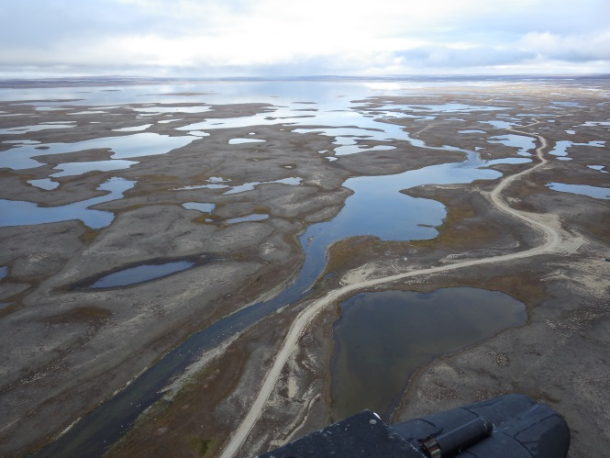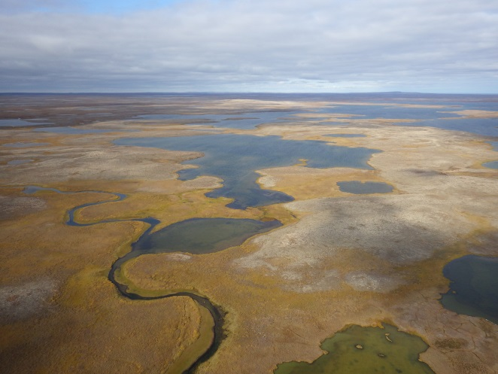

Tukiliut 1. Limnological ilitquhiita ihivriuqhiyut iniit. Uuktuqtauyut aallatqiit ilagiyaat uunnarninga (Temp), uunnautinga (Cond), pH, qaumania hakuiqtut uuktuutaat ukuninngat ilitquhiunngitaa tautungnaqtuq uunautaa (Kd PAR), tautungnaittut ilaliutilik anuritut (TN), tamatkiuyut nunguttut tautungnaittut anuritut (TN diss), tamatkiuyut havigaliunngittut ilaliutilik (TP), seston pamiumayut (DW), seston cholorophyll-a (Chl-imaq), benthic chlorophyll-a (Chl-benthic), nunguttut uumayulik havigaliunngittut ilaliutit (DOC), nanminiq UV (SUVA) unalu chromophoric nunguttut uumayulik ilulik (CDOM).
Ini | Ublua | Lat | Lon | Uunn | uunna | pH | K_{d} PAR | TN | TN diss | TP | DW | Chl-imaq | Chl-benthos | DOC | SUVA | CDOM
 |  |  |  | Niklaumania | µScm |  | m⁻¹ | mg/L | mg/L | mg/L | µg/L | µg/L | mg/m⁻² | mg/L | A254 | a320
CBL1 | 30.8.2014 | 69.17674 | 104.1467 | 8.5 | 450 | 8.1 | 0.81 | 0.73 | 0.39 | 96.3 | 1.36 | 0.55 | 28.9 | 6.4 | 1.3 | 7.6
CBL2 | 30.8.2014 | 69.15665 | 104.1709 | 8.4 | 280 | 8.6 | 1.89 | 0.50 | 0.25 | 16.6 | 1.40 | 0.89 | 16.1 | 4.4 | 1.0 | 5.4
CBL3 | 30.8.2014 | 69.16155 | 104.5164 | 8.2 | 295 | 8.6 | 0.43 | 0.46 | 0.23 | 15.3 | 1.37 | 2.37 | 16.8 | 4.2 | 1.1 | 9.6
CBL4 | 31.8.2014 | 69.20183 | 104.7682 | 7.6 | 258 | 8 | 0.30 | 0.48 | 0.23 | 18.7 | 1.30 | 1.61 | 11.2 | 4.1 | 0.9 | 4.4
CBL5 | 31.8.2014 | 69.22874 | 104.7591 | 7.4 | 242 | 8 | 2.34 | 0.36 | 0.18 | 13.5 | 1.08 | 1.71 | 17.1 | 3.3 | 0.6 | 2.1
CBL6 | 31.8.2014 | 69.2416 | 104.7171 | 10 | 244 | 8.2 | 1.37 | 0.41 | 0.18 | 14.0 | 1.62 | 1.37 | 6.9 | 3.1 | 0.8 | 7.5
CBL7 | 31.8.2014 | 69.2729 | 104.7161 | 7.5 | 246 | 8.3 | 1.82 | 0.41 | 0.20 | 14.2 | 1.09 | 1.37 | 7.0 | 3.5 | 0.6 | 2.6
CBL8 | 1.9.2014 | 69.07447 | 104.3584 | 7.2 | 258 | 8.1 | 3.57 | 0.47 | 0.22 | 14.0 | 1.01 | 1.16 | 13.8 | 4.8 | 0.7 | 3.3
CBL9 | 1.9.2014 | 69.07729 | 104.4011 | 7.2 | 258 | 8.2 | 3.93 | 0.43 | 0.22 | 10.6 | 0.85 | 0.39 | 21.3 | 4.2 | 0.9 | 8.0
CBL10 | 1.9.2014 | 69.09504 | 104.4028 | 7.3 | 331 | 8.2 | 2.55 | 0.56 | 0.29 | 13.8 | 1.45 | 1.36 | 25.6 | 4.9 | 1.1 | 6.1
CBL11 | 1.9.2014 | 69.14977 | 104.6388 | 9 | 294 | 8 | 1.84 | 0.42 | 0.20 | 11.9 | 1.18 | 1.80 | 21.9 | 3.9 | 1.0 | 6.0
CBL12 | 1.9.2014 | 69.16284 | 104.6168 | 8.4 | 702 | 8.1 | 2.41 | 0.94 | 0.47 | 15.4 | 2.67 | 1.04 | 25.3 | 7.7 | 1.4 | 6.8
CBL13 | 1.9.2014 | 69.2203 | 105.0958 | 8 | 423 | 8.5 | 0.15 | 0.41 | 0.22 | 10.4 | 0.56 | 0.57 | 7.9 | 3.4 | 0.5 | 0.9
CBL14 | 2.9.2014 | 69.21848 | 105.1273 | 7.5 | 353 | 8.4 | 0.47 | 0.44 | 0.23 | 8.1 | 0.92 | 0.64 | 6.7 | 3.9 | 0.6 | 1.7
CBL15 | 2.9.2014 | 69.24606 | 105.111 | 8.2 | 214 | 8.4 | 0.78 | 0.45 | 0.23 | 15.3 | 4.47 | 1.05 | 28.7 | 4.1 | 0.9 | 3.9
CBL16 | 2.9.2014 | 69.24506 | 105.0667 | 8.5 | 292 | 8.6 | 0.31 | 0.58 | 0.31 | 12.1 | 0.82 | 0.67 | 19.3 | 5.5 | 1.0 | 4.7
CBL17 | 3.9.2014 | 69.22258 | 105.0772 | 9.9 | 774 | 8.4 | 3.66 | 1.44 | 0.74 | 9.7 | 1.67 | 0.42 | 22.2 | 14.6 | 3.2 | 21.3
CBL18 | 3.9.2014 | 69.28286 | 104.7585 | 10 | 694 | 8.5 | 2.36 | 1.34 | 0.72 | 11.4 | 1.88 | 0.82 | 13.8 | 12.8 | 2.0 | 12.2
CBL19 | 3.9.2014 | 69.16594 | 104.2891 | 10.5 | 596 | 8.6 | 1.77 | 1.24 | 0.68 | 11.6 | 4.66 | 0.34 | 16.6 | 13.7 | 3.5 | 24.7
CBL20 | 3.9.2014 | 69.16554 | 104.6296 | 10.2 | 594 | 8.5 | 1.54 | 1.46 | 0.77 | 21.0 | 1.59 | 0.10 | 10.5 | 14.2 | 2.8 | 13.2
Tukingit | Tahiit (CBL 1-16) |  |  | 8.1 | 321 | 8.3 | 1.6 | 0.5 | 0.3 | 18.8 | 1.4 | 1.2 | 17.2 | 4.5 | 0.9 | 5.0
 | Tahirat (CBL17-20) |  |  | 10.2 | 665 | 8.5 | 2.3 | 1.4 | 0.7 | 13.4 | 2.5 | 0.4 | 15.8 | 13.8 | 2.9 | 17.9

