20 January 2020

Mosha Cote
Research Liaison
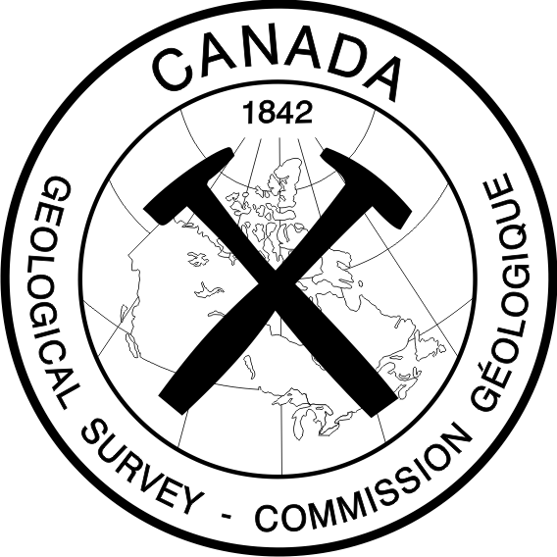
Nunavut Research Institute
Box 1720, Iqaluit, NU X0A 0H0
mosha.cote@arcticcollege.ca

RE: Scientific Research License # 03 010 16N-A, 03 003 17R-M, 03 005 18R-M,
03 011 19R-M

Dear Mr. Cote,

Please accept this application for renewal of scientific research license # 03 010 16N-A, 03 003 17R-M, 03 005 18R-M, 03 011 19R-M for the year 2020. I have attached our Annual Summary Report for 2019 that details our research activities and findings in English and Inuktitut.

As this is an ongoing project, there are no anticipated substantive changes to the objectives, study locations or research methods. Our tentative fieldwork plans for 2020 are as follows:

1) June/July 2020: 3 personnel for 20 days for data collection and observations of permafrost and ground ice in the region of Rankin Inlet. Methods and study locations are as described in the original research proposal.

2) September/October 2020: 2 personnel for 15 days for data collection and observation in the region of Rankin Inlet.

3) TBD: Community visits in the Kivalliq Region, NU.

Best Regards,
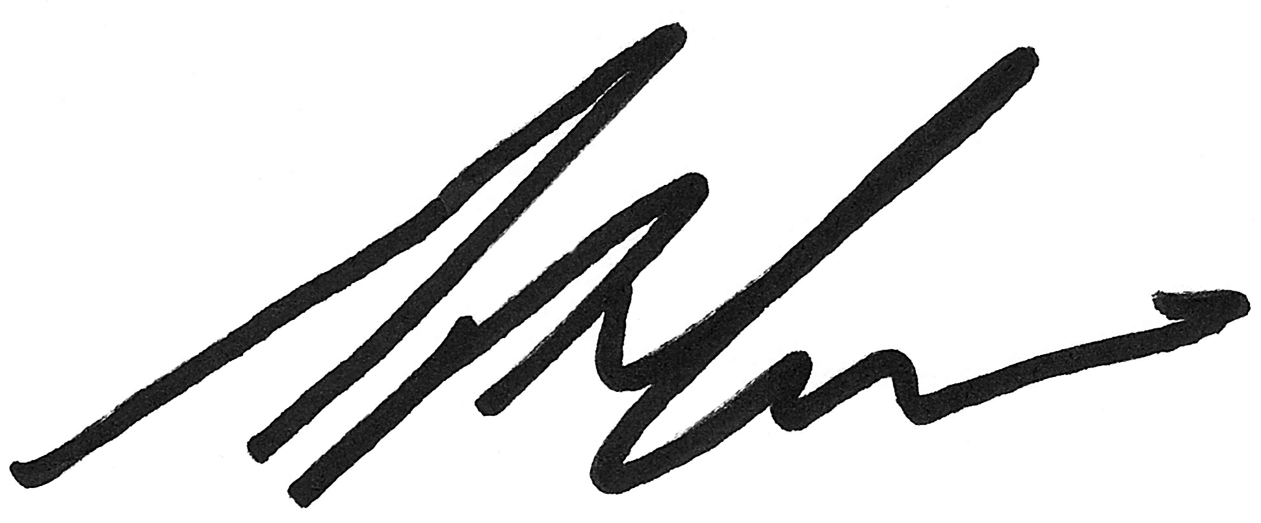

Greg Oldenborger
Geological Survey of Canada
Natural Resources Canada
183-601 Booth St., Ottawa, ON K1A 0E8
Phone: 613-868-2474
Email: greg.oldenborger@canada.ca

Nunavut Scientific Research License # 03 010 16N-A, 03 003 17R-M, 03 005 18R-M,
03 011 19R-M: 2019 Annual Summary

Permafrost and ground ice are important features of the Nunavut landscape. Information on ground temperature and ground ice conditions is important for modelling the response of permafrost to climate warming, understanding surface water-ground water interactions, and predicting the behaviour of permafrost as an engineering substrate. However, there is a scarcity of permafrost knowledge in the Kivalliq region of Nunavut.

In the summer of 2016, following a community workshop in Rankin Inlet, the Geological Survey of Canada and the Canada-Nunavut Geoscience Office started a multi-year research study on permafrost for the western coast of Hudson Bay. Initial fieldwork in 2016 involved landscape observations and examination of surficial geological materials. Subsequent fieldwork in 2017 involved installation of several permafrost monitoring stations in the vicinity of Rankin Inlet. Two permanent ground temperature boreholes were established to record the long-term thermal state of permafrost in the Hamlet of Rankin Inlet for developed and undeveloped land use scenarios. Additional study sites were instrumented away from the Hamlet to represent different terrain types. Fieldwork in 2018 followed up on the established study sites, with installation of additional instrumentation for monitoring the spring thaw, ground subsidence, and the evolution of unfrozen water at the ground surface. Permafrost was sampled using shallow drilling at several sites, and ground geophysical surveys were performed to extend observations away from boreholes.

In 2019, site maintenance was conducted. Additional traverses were undertaken to examine thaw features observed from remote sensing imagery across the region, and to install sensors for monitoring lake level changes. New data, along with historical image data and community observations, have been analyzed to understand lake level changes in the region, and to distinguish thaw-related changes from normal hydrological conditions related to precipitation. Satellite data are being combined with ground observations and geophysical data to understand and classify permafrost terrain in terms of hydrology, ground ice conditions, and thaw sensitivity.

More detailed reports are publically available as part of the 2016, 2017, 2018, and 2019 Summary of Activities of the Canada-Nunavut Geoscience Office: http://cngo.ca/summary-of-activities/

