Water Pumping Adaptive Management Plan
Rankin Inlet, Nunavut

Water Licence No. 3AM-GRA1624

Prepared by:
Government of Nunavut
Community and Government Services
P.O. Box 490
Rankin Inlet, Nunavut
X0C 0G0

Updated: June 2017

Document Management
 | Description | Prepared by | Date
1 | Water Pumping Adaptive Management Plan Update – new Licence No.; inclusion of 2016 pumping volumes and sampling results | GN-CGS | June 2017
2 | Water Pumping Adaptive Management Plan Update – significant changes to all sections | GN-CGS | February 2016
3 | Water Pumping Adaptive Management Plan | GN-CGS | September 2015
4
5
6

Table of Contents
Document Management 1
1. Introduction 5
2. Seasonal Hydrological Monitoring of Char River 5
2.1 Flow and Water Depth of Char River 5
2.2 Volume Pumped from Char River 8
3.1 Water Pumped 2015 9
3.2 Water Pumped 2016 10
3.3 Water Pumped 2017 10
3. Water Chemistry Monitoring 10
3.1 Water Chemistry Data 2014 11
3.2 Water Chemistry Data 2015 12
3.3 Water Chemistry Data 2016 12
3.1 Water Chemistry Data 2017 13
3.2 Water Chemistry Assessment 13
4. In-Stream Flow Objectives for Char River 13
5. Details of Char River on-going viability assessment 14
6. Mitigation options and procedures 14
7. Revised Plan 15
8. References 16
Appendixes 17
Appendix A – Water Licence No. 3AM-GRA1015 Amendment No. 1 17
Appendix B – Technical Memo: Char River Theoretical Rating Curves, July 20, 2015 25
Appendix C – Char River Water Pumped to Nipissar Lake 2015 61
Appendix D – Char River Water Pumped to Nipissar Lake 2016 65
Appendix E – Summary of Water Chemistry Analysis 2014 68
Appendix F – Summary of Hydrocarbon Contamination Analysis 2014 71
Appendix G – Certificate of Analysis June 24, 2014 73
Appendix H – Certificate of Analysis October 7, 2014 81
Appendix I – Guidelines for Canadian Drinking Water Quality, Summary Table, October 2014 96
Appendix J – Summary of Water Chemistry Analysis 2015 122
Appendix K – Summary of Hydrocarbon Contamination Analysis 2015 125
Appendix L – Certificate of Analysis June 24, 2015 127
Appendix M – Certificate of Analysis June 30, 2015 144
Appendix N – Summary of Water Chemistry Analysis 2016 149
Appendix O – Summary of Hydrocarbon Contamination Analysis 2016 151
Appendix P – Certificate of Analysis June 29, 2016 153
Appendix Q – AANDC Memorandum on Nipissar Lake, Lower Landing Lake and Char River Water Chemistry Data, October 23, 2014 168

List of Tables
Table 1: Water Chemistry Monitoring Program Stations 10

List of Figures
Figure 1: Staff Gauge Installed at Char River 6
Figure 2: Char River Theoretical Rating Curve (from Technical Memorandum: Char River Theoretical Rating Curve Based on Field Data, Golder, February 16, 2016) 7
Figure 3: Side View of Flow Meter at Char River 8
Figure 4: Top View of Flow Meter at Char River 9
Figure 5: Locations of Monitoring Program Stations GRA-1, GRA-6 and GRA-7 11

Introduction
The Government of Nunavut, Community and Government Services (GN-CGS) operates the water and sewage facilities in the Hamlet of Rankin Inlet. Nipissar Lake is utilized as the potable water source with the authorized quantity of water not to exceed eight hundred and fifty thousand (850,000) cubic metres annually. Water Licence No. 3AM-GRA1625 (formerly 3AM-GRA1015) Amendment No. 1, issued December 23, 2014, authorizes Char River as an additional water source, to a maximum allowable quantity of 3,485 cubic metres per day transferred from Char River to Nipissar Lake. A copy of Amendment No. 1 can be found in Appendix A.
As per Part C, Item 11 of Amendment No. 1, the GN-CGS is submitting to the Nunavut Water Board (NWB) a Water Pumping Adaptive Management Plan. This plan includes:
- Details of seasonal hydrological monitoring of Char River;
- Details of Char River, Lower Landing Lake and Nipissar Lake water chemistry monitoring and assessment of impacts on Nipissar Lake water quality/chemistry due to transfer of water from Char River;
- In-stream flow objectives for Char River including a flow based low cut-off limit of 10% of the instantaneous flow and 0.5 m minimum flow depth in the Char River;
- Details of Char River on-going viability assessment in meeting pumping objectives and water use requirements; and
- Mitigation options and procedures for occurrences when flow is insufficient to meet pumping objectives and consumption requirements.

Seasonal Hydrological Monitoring of Char River

Flow and Water Depth of Char River
Golder Associates (Golder) completed the Technical Memorandum: Char River Theoretical Ratings Curves found in Appendix B. The theoretical rating curves give the flow and flow depth for various cross-sections in Char River.
Golder field staff installed a staff gauge and data logger in Char River on July 10, 2015. A picture of the staff gauge in Char River can be found on the following page. Similar staff gauges and data loggers were installed in Nipissar Lake and Lower Landing Lake for additional monitoring.

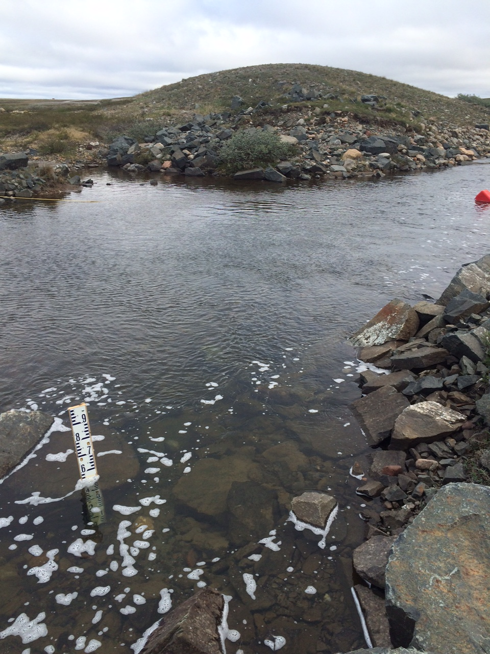
Figure 1: Staff Gauge Installed at Char River

On July 13, 2015, Golder field staff demonstrated to GN-CGS staff how to remove the data loggers, download the data, and reinstall the loggers. After the data loggers were re-installed on July 13, 2015, it was supposed to remain in place until prior to freeze-up in October 2015. The data collected over the open water season would be downloaded by GN-CGS and used by Golder to calibrate the theoretical rating curves and provide accurate information on flow rates and water depths at various cross-sections in Char River.
On October 8, 2015, GN-CGS removed the data loggers from the water. Once the information was downloaded, it was apparent that the data collection had stopped on July 15, 2015. After the data was sent to Golder, they determined that their field staff had incorrectly programmed the data loggers to record at intervals of 10 seconds which caused the memory to reach capacity on July 15, 2015 rather than have enough storage space to collect information until October.
Because the data logger information could not be retroactively collected, the July 10 to 15, 2015 data and measurements taken by the Golder field staff, was used to calibrate in the final version Char River hydrological assessment. The Technical Memorandum: Char River Theoretical Rating Curve Based on Field Data was submitted to the NWB on February 16, 2016 as Appendix B of the Nipissar Lake and Lower Landing Lake Water Balance Assessment.
The technical memo states that a water depth of 0.5 m at the location of the intake corresponds to a staff gauge level of slightly below 0.6 m. Refer to the following figure for the theoretical rating curve.
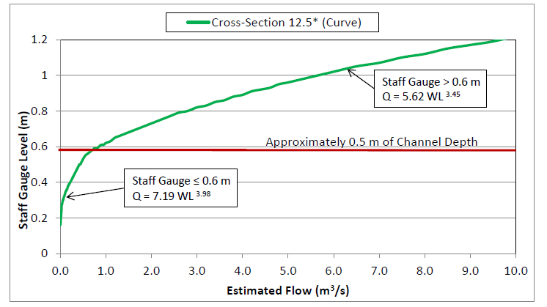
Figure 2: Char River Theoretical Rating Curve (from Technical Memorandum: Char River Theoretical Rating Curve Based on Field Data, Golder, February 16, 2016)

Based on the rating curve developed, a water depth of 0.5 m would result in a flow rate of approximately 0.7 m³/s. The 10% DFO flow allowance corresponding to this water depth is approximately 0.07 m³/s, which is greater than the maximum pumping capacity of the pump located at Char River of 0.04 m³/s.
On-going hydrological monitoring of Char River will be done by the annual re-installation of the data logger each spring. The data loggers will be re-programmed to record water level at a larger time interval so that they record information for the entire open water season once re-installed.

Volume Pumped from Char River
Monitoring of the volume of water pumped from Char River to Nipissar Lake is done using a flow meter installed off the pump at Char River. The flow meter was installed on June 18, 2015 prior to starting the seasonal pumping from Char River.
Pictures of the flow meter can be found below.
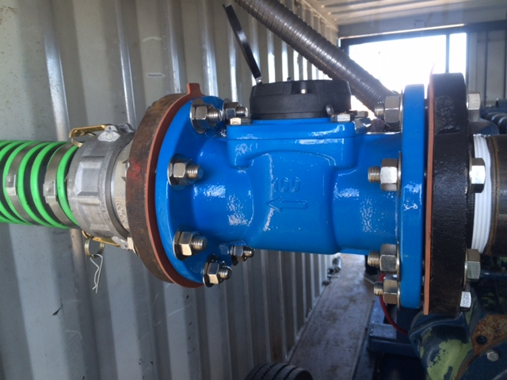
Figure 3: Side View of Flow Meter at Char River
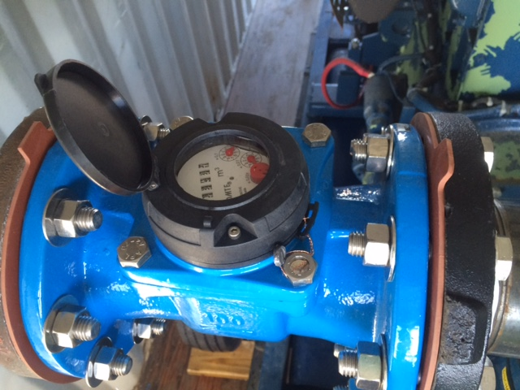
Figure 4: Top View of Flow Meter at Char River

Water Pumped 2015
Daily readings were taken from the flow meter and recorded on a logsheet and were provided to the NWB as part of the 2015 Third Quarter Report, and will be included in the Annual Report.
Pumping from Char River commenced on June 18, 2015 and was stopped on September 11, 2015. The total volume of water pumped during this 86 day period was 243,644 m³, or an average of 2833 m³/day. Large amounts of rain in July and August resulted in higher than normal water levels in Char River, allowing pumping to continue for longer than expected. A copy of the daily flow meter readings of Char River water pumped to Nipissar Lake can be found in Appendix C.
Monitoring of the flow meter will take place when water is transferred from Char River to Nipissar Lake in 2016 and future years. Daily readings will be provided to the NWB as part of the applicable Quarterly and Annual Reports.

Water Pumped 2016
Pumping from Char River commenced on June 21, 2016 and was pumped intermittently until October 6, 2016. Pumping was stopped July 29, 2016 due to low water levels in Char River and then restarted again on August 3, 2016. Pumping was then stopped due to low water levels on August 16, 2016. There was significant autumn rain in Rankin Inlet and pumping began again on September 6, 2016 until it was stopped for the season on October 6, 2016.
The flow meter stopped working on July 25, 2016, but worked intermittently over the next few weeks. A new flow meter was ordered but did not arrive before pumping was stopped for the season. The total estimated volume of water pumped during the 77 pumping days in 2016 was 210,000 m³, or an average of 2727 m³/day. A copy of the flow meter readings of Char River water pumped to Nipissar Lake can be found in Appendix D.

Water Pumped 2017
Pumping from Char River commenced on June 1, 2017. A new flow meter was installed before pumping began. Daily readings are being taken from the flow meter and recorded on a logsheet to be provided to the NWB.

Water Chemistry Monitoring
As per Part H, Item 1 of Amendment No. 1, the Monitoring Program shall include annual water chemistry sampling at Nipissar Lake, Lower Landing Lake, and Char River. The Monitoring Program Station Numbers and corresponding GPS coordinates can be found in the following table.
Table 1: Water Chemistry Monitoring Program Stations
Monitoring Program Station Number | Description | GPS Coordinates
GRA-1 | Raw water supply from Nipissar Lake prior to treatment | 62° 49’ 24” N  92° 6’ 53” W
GRA-6 | Char River Water pumped to Nipissar Lake | 62° 51’ 35” N  92° 9’ 3” W
GRA-7 | Lower Landing Lake | 62° 51’ 40” N  92° 9’ 13” W

The locations of the Nipissar Lake, Lower Landing Lake, and Char River Monitoring Program Stations are displayed in the following figure.
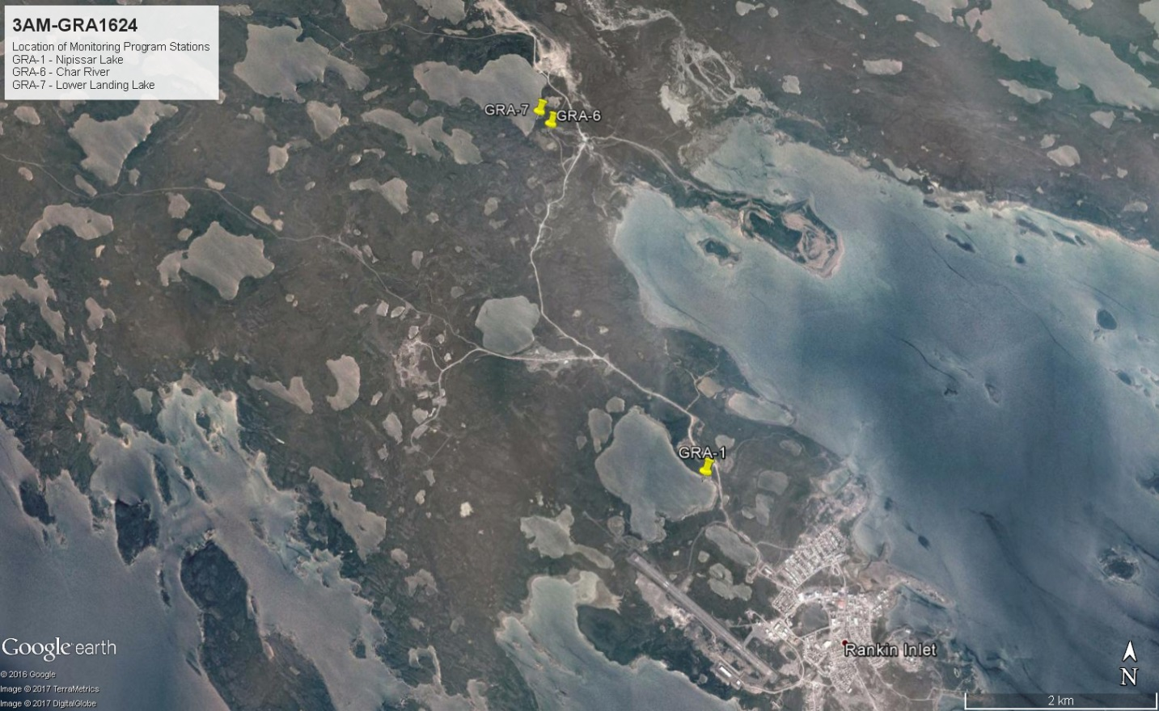
Figure 5: Locations of Monitoring Program Stations GRA-1, GRA-6 and GRA-7

Water Chemistry Data 2014
Water samples were sent to ALS Environmental in Winnipeg on June 24 and October 7, 2014.
The Summary of Water Chemistry Analysis 2014 (Appendix E) confirms that all parameters analyzed for Nipissar Lake, Char River and Lower Landing Lake are within the maximum acceptable concentrations, as well as aesthetic objectives and operational guidance values, of the Guidelines for Canadian Drinking Water Quality.

The Summary of Hydrocarbon Contamination Analysis 2014 (Appendix F) confirms there is no indication of hydrocarbon presence in either Char River or Lower Landing Lake. BTEX, Total Hydrocarbon, and Polyaromatic Hydrocarbon results all came back as being under the detection limit, and within Guidelines for Canadian Drinking Water Quality.

Certificates of Analysis for these results are found in Appendix G and H.
The Guidelines for Canadian Drinking Water Quality, October 2014 can be found in Appendix I.

Water Chemistry Data 2015
Water samples were collected from Nipissar Lake, Char River and Lower Landing Lake at Monitoring Program Stations GRA-1, GRA-6 and GRA-7, respectively, on June 24, 2015 and analyzed for the parameters outline in Part H, Item 14 of the Water Licence. These samples were sent to ALS Environmental in Winnipeg for analysis. The Summary of Water Chemistry Analysis 2015 (Appendix J) confirms that all parameters analyzed for Nipissar Lake, Char River and Lower Landing Lake are within the maximum acceptable concentrations, as well as aesthetic objectives and operational guidance values, of the Guidelines for Canadian Drinking Water Quality.
The Summary of Hydrocarbon Contamination Analysis 2015 (Appendix K) confirms there is no hydrocarbon presence in Nipissar Lake, Char River or Lower Landing Lake. BTEX, Total Hydrocarbon, and Polyaromatic Hydrocarbon results all came back as being under the detection limit, the same as results for 2014.

Certificates of Analysis for these results are found in Appendix L and M. The sample bottle for polyaromatic hydrocarbons (PAHs) from Nipissar Lake, GRA-1, broke in transit to the lab and had to be resampled.

Water Chemistry Data 2016
Water samples were collected from Nipissar Lake, Char River and Lower Landing Lake at Monitoring Program Stations GRA-1, GRA-6 and GRA-7, respectively, on June 29, 2016 and analyzed for the parameters outline in Part H, Item 14 of the Water Licence. These samples were sent to ALS Environmental in Winnipeg for analysis. The Summary of Water Chemistry Analysis 2016 (Appendix N) confirms that all parameters analyzed for Nipissar Lake, Char River and Lower Landing Lake are within the maximum acceptable concentrations, as well as aesthetic objectives and operational guidance values, of the Guidelines for Canadian Drinking Water Quality.
The Summary of Hydrocarbon Contamination Analysis 2016 (Appendix O) confirms there is no hydrocarbon presence in Nipissar Lake, Char River or Lower Landing Lake. BTEX, Total Hydrocarbon, and Polyaromatic Hydrocarbon results all came back as being under the detection limit, the same as results for previous years.

Certificates of Analysis for these results are found in Appendix P. There was a lab accident with the polyaromatic hydrocarbons (PAHs) bottle from Char River, GRA-6, and the lab was unable to report the analysis.

Water Chemistry Data 2017
Water samples were collected from Nipissar Lake, Char River and Lower Landing Lake at Monitoring Program Stations GRA-1, GRA-6 and GRA-7 on June 5, 2017. This analysis is currently being completed by the lab and will be included in the applicable Quarterly and Annual Reports.

Water Chemistry Assessment
The water chemistry for Nipissar Lake, Char River and Lower Landing Lake is very similar. No impacts on the water quality of Nipissar Lake have been apparent or are anticipated.
Indigenous and Northern Affairs Canada (INAC), formerly Aboriginal Affairs and Northern Development Canada (AANDC), submitted a review of the 2014 water chemistry data to the NWB on October 23, 2014 stating:
“The water chemistry results indicate that there is no significant difference between the three different waterbodies on any of the parameters tested and that all three waterbodies have water chemistry that meets the guideline for drinking water standards in Canada”
and:
“At this time AANDC is satisfied that the water chemistry of all three waterbodies of similar quality as well as being suitable for drinking and poses no risk to the residents of Rankin Inlet”.
A copy of this Memorandum is available in Appendix Q.
Review of the 2015 and 2016 water chemistry data for Nipissar Lake, Char River and Lower Landing Lake has remained very similar. Annual sampling at these Monitoring Program Stations will confirm the water quality in Nipissar Lake is not being negatively impacted by the transfer of water.

In-Stream Flow Objectives for Char River
As per Part C, Item 11 of Water Licence No. 3AM-GRA1015 Amendment No. 1, the in-stream flow objectives for Char River including a flow based low cut-off limit of 10% of the instantaneous flow and 0.5 m minimum flow depth in the Char River, at which point no further water is authorized to be withdrawn from Char River.
Refer to Section 2 for details on how these flow objectives are being monitored.
The Technical Memorandum: Char River Theoretical Ratings Curves found in Appendix B states that flow depths of 0.5 m may result in mean channel velocities that would present an impediment to fish passage for some species, and that in the experience of Golder, much lower flow depths can provide fish passage.

Details of Char River on-going viability assessment
The Technical Memorandum: Char River Theoretical Rating Curve Based on Field Data was submitted to the NWB on February 16, 2016 as Appendix B of the Nipissar Lake and Lower Landing Lake Water Balance Assessment.
Due to the in-stream flow objectives imposed by Amendment No. 1, it is anticipated that sufficient volumes to meet water use requirements will not be available from Char River during average conditions because flow depth objectives can only be met for approximately 50 days each year.
Refer to Section 2 for details on how the flow objectives for Char River are being monitored and Section 6 for details on options for a long-term alternative water source to replenish Nipissar Lake.

Mitigation options and procedures
When flow in Char River is insufficient to meet the in-stream pumping objectives, the annual pumping from Char River to Nipissar Lake will be stopped.
GN-CGS is currently looking at options for a long-term alternative water source to replenish Nipissar Lake. CGS contracted Golder Associates to complete a water balance study for Lower Landing Lake during summer/fall 2015. This study includes details on the recharge rate and available water in Lower Landing Lake, the impact withdrawing water from Lower Landing Lake will have on Char River, and the volume of water required to be pumped to Nipissar Lake to meet the natural recharge deficit caused by increasing water consumption.
The Nipissar Lake and Lower Landing Lake Water Balance Assessment was submitted to the NWB on February 16, 2016. Due to the large size of the report, it is not included as an appendix of this Plan.
The Lower Landing Lake watershed is significantly larger than the Nipissar Lake watershed, cover approximately 66.9 km² and 3 km², respectively. The larger watershed area of Lower Landing Lake accumulates more precipitation in the water balance than Nipissar Lake.
Based on this report, under historic and climate change scenarios, Lower Landing Lake is estimated to have sufficient supplementary water supplies to accommodate the water deficit from Nipissar Lake under low and moderate consumption rates (1,600 m³/day and 3,300 m³/day, respectively).
The total outflow (surplus) from Lower Landing Lake under median historic climatic conditions is approximately 10 million m³/year. If the total outflow was able to be utilized for consumption, it could support consumption of approximately 40,000 people, based on the current per capita consumption rate of 0.68 m³/person/day (approximately 1900 m³/day).
Under extreme climatic conditions (lowest historic rainfall runoff and snowfall accumulation) and a maximum duration winter, winter consumption will exceed the available active winter storage capacity of Nipissar Lake with a daily consumption rate of approximately 3,900 m³. Based on the current per capital consumption rate of 0.68 m³/person/day, the daily consumption will reach 3,900 m³ in approximately 2062 (45 years).
Lower Landing Lake is a valid option as a supplementary water source for Rankin Inlet far beyond the 7 year time frame of the current Licence. Full details of the water balances, predicted Nipissar Lake water supply deficits under various climate regimes, and water taking rates are presented in the Nipissar Lake and Lower Landing Lake Water Balance Assessment.

Revised Plan
As per Part C, Item 11 of Water Licence No. 3AM-GRA1015 Amendment No. 1, a revised Water Pumping Adaptive Management Plan was to be submitted to the NWB within ninety (90) days of completion of the 2015 hydrological field study. Due to the delay in receiving the water balance assessment from Golder, the revised Water Pumping Adaptive Management Plan was submitted to the NWB on February 16, 2016.
The Water Pumping Adaptive Management Plan will be reviewed annually and modified as necessary, with revised versions being submitted to the NWB within the Annual Reports.

References
AANDC (2014). Aboriginal Affairs and Northern Development Canada’s Technical Review of additional
information submitted as per the public hearing proceedings which took place on Sept 25, 2014 by the Government of Nunavut, Department of Community and Government Services (GN-CGS) for the Seasonal Replenishment of Nipissar Lake. Iqaluit, Nunavut.

Golder Associates (2016). Nipissar Lake and Lower Landing Lake Water Balance Assessment. Edmonton, Alberta.

Golder Associates (2015). Technical Memo: Char River Theoretical Rating Curves. Edmonton, Alberta.

Health Canada (2014). Guidelines for Canadian Drinking Water Quality—Summary Table. Water and Air Quality Bureau, Healthy Environments and Consumer Safety Branch, Health Canada, Ottawa, Ontario.

Nunavut Water Board (2014). 3AM-GRA1015 Type “A” Licence Amendment No. 1. Gjoa Haven, Nunavut.

Appendixes

Appendix A – Water Licence No. 3AM-GRA1015 Amendment No. 1

Appendix B – Technical Memo: Char River Theoretical Rating Curves, July 20, 2015

Appendix C – Char River Water Pumped to Nipissar Lake 2015

Appendix D – Char River Water Pumped to Nipissar Lake 2016

Appendix E – Summary of Water Chemistry Analysis 2014

Appendix F – Summary of Hydrocarbon Contamination Analysis 2014

Appendix G – Certificate of Analysis June 24, 2014

Appendix H – Certificate of Analysis October 7, 2014

Appendix I – Guidelines for Canadian Drinking Water Quality, Summary Table, October 2014

Appendix J – Summary of Water Chemistry Analysis 2015

Appendix K – Summary of Hydrocarbon Contamination Analysis 2015

Appendix L – Certificate of Analysis June 24, 2015

Appendix M – Certificate of Analysis June 30, 2015

Appendix N – Summary of Water Chemistry Analysis 2016

Appendix O – Summary of Hydrocarbon Contamination Analysis 2016

Appendix P – Certificate of Analysis June 29, 2016

Appendix Q – AANDC Memorandum on Nipissar Lake, Lower Landing Lake and Char River Water Chemistry Data, October 23, 2014

