To: Canadian Wildlife Service and Wildlife Enforcement Division
Vessel: MV Silver Explorer
Date: 28th August, 2016
Duration: 2.5 hours
Landing at Sermilik, Bylot Island
Map
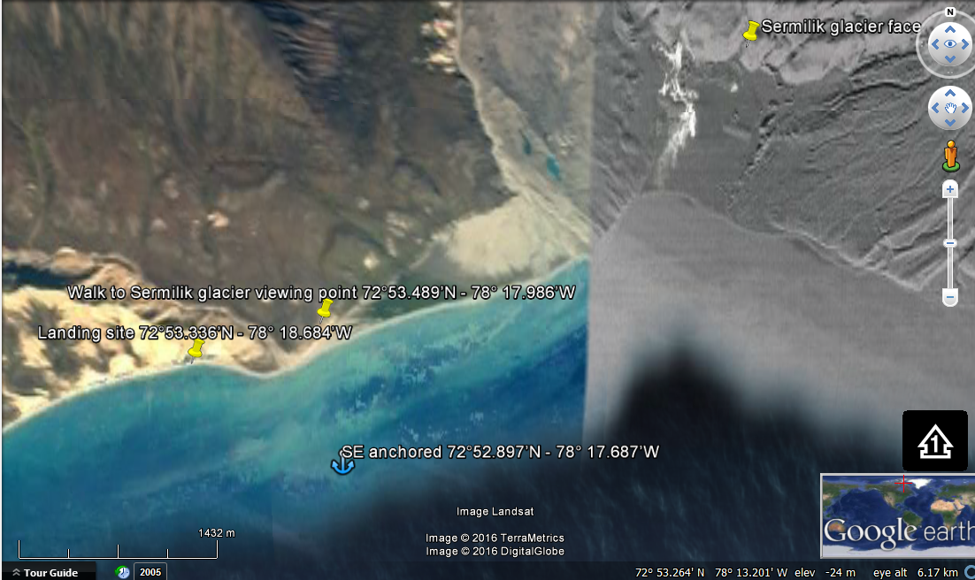
GPS COORDINATES:
LANDING SITE
72°53.336’N - 78° 18.684’W

SILVER EXPLORER ANCHORAGE
72°52.897’N - 78° 17.687’W

GLACIER VIEWING POINT
72°53.489’N - 78° 17.986’W

WILDLIFE SIGHTINGS:
Harp seals (6), Northern fulmar (lots), Greater snow goose (hundreds), Glaucous gull (5), Black-legged kittiwakes (lots), Brunnich guillemot (15), Arctic fox (2), Rough-legged hawk (1), Arctic tern (8).
SUMMARY OF ACTIVITIES:
Short hike heading east towards glacier viewing point, approximately 2 kilometers (return trip to landing site). The walk from the landing site started on a sandy, partly gravel beach before reaching tundra which is partly uneven with an easy elevation gain. We set flagged perimeters within the beach area that guests can walk as much or as little as they wish to go back landing site.

