To: Canadian Wildlife Service and Wildlife Enforcement Division
Vessel: MV Silver Explorer
Date: 4th September, 2016
Duration: Ship cruise 2 hours and Zodiac cruise 2 hours
Map: Zodiac cruising Isabella Bay Island
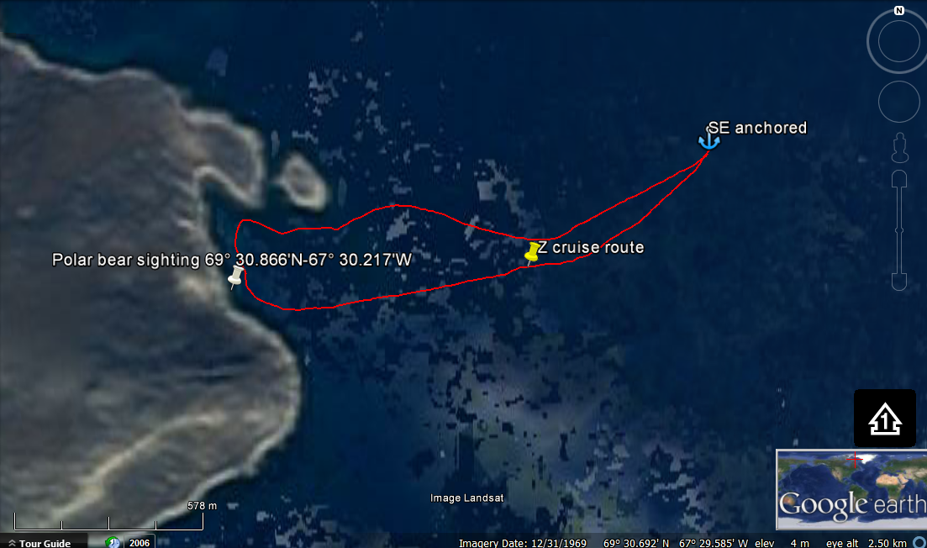
GPS COORDINATES:
POLAR BEAR SIGHTING
69°30.866’N-67°30.217’W

SILVER EXPLORER ANCHORAGE
69° 31.096'N - 67° 27.974'W

WILDLIFE SIGHTINGS:
From Zodiac cruising: Polar bear (1), Snowy Owl (1), Bearded Seal (1)
From Ship cruising: Bowhead whales (15+) and Orca (8)

SUMMARY OF ACTIVITIES:
Zodiac cruise from ship’s anchorage cruising west towards Isabella Bay Shoreline about 3 kilometers return trip. On ships cruising inside Isabella bay pods of Bowhead and Orca whales were sighted, guests were invited to the outer decks.

