Locations:

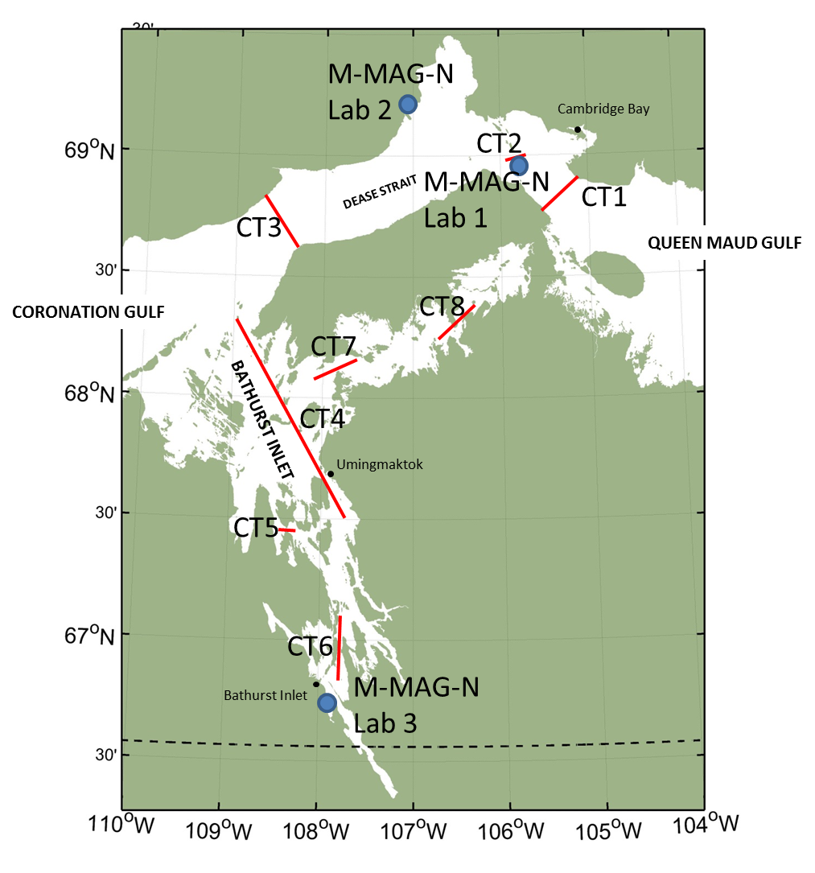
Figure 1: Proposed CAT-TRAIN-ICE sampling transects (red lines) and the proposed locations of ARF’s M-MAG-N labs (blue dots, see NPC# 148438)

Land use:
- Scientific Research
- Marine-Based Activities

Licensing/Screening Agencies Required:
- Ekaluktutiak Hunters & Trappers Organization – General approval
- Kugluktuk Hunters & Trappers Organization – General Approval
- Nunavut Planning Commission – Project Screening
- Nunavut Impact Review Board – Environmental impact review
- Fisheries and Oceans Canada – Biological oceanographic research
- Nunavut Research Institute – Oceanographic based research

Schedule:
Program Start: 3-weeks within the period of mid April to the end of May 2017
Research Activities: Transects will be sampled in order of their label (CT1-CT8). It is possible that time will not permit sampling of CT7 and 8.

Personnel on site:

 | Estimated Number of Personnel | Estimated Number of Days on site | Total Number of person days
CAT-TRAIN-ICE | 16 | 21 | 336

Equipment use on site:
- Cat-train (1 Snowcat + 5 trailer)
  - Mobile Marine-Archaeological-Geological Network (M-MAG-N) portable labs (x3; 6m x 2.5m x 2.5m): Temporary structure, which will serve as a research space. Fueled by wind, solar panel and back-up diesel generator. These will be distributed at different locations along the track, which are part of a separate CAT-TRAIN land use NPC Application (#148438)
  - 1 accommodation trailer
  - 1 kitchen trailer
- Snowmobiles (x5-6): Transportation of personnel and equipment
- Ice Auger (x2): Used for drilling holes in the ice
- Core Barrel (x2): Used for sampling sea ice
- CTD (x1): Used to take conductivity, temperature, and depth measurements
  - Light and fluorescence sensor attached
- Niskin Bottles (x4): water sample collection
- Kemmerer bottle (x1): water sample collection

Fuel use on site:
- Gasoline: 2x 200L (400L total), Supply for snowmobiles and ice augers.
- Diesel: 6x 200L (1200 total), Supply for cat-train
- Naphtha (Coleman fuel): 1x 1L (1L), Supply for Coleman heater for sampling tent

Hazardous materials and chemicals use on site:
- Glutaraldehyde 1x 60 ml, preservation of algal samples
- Lugol’s Acid 1x 60 ml, preservation of algal samples
- Hydrochloric Acid (HCl) 1x 800 ml, used to clean sampling equipment (i.e. water sampling syringes)
- Mercuric Chloride 1x 15 ml, used for preserving seawater samples

Expected Environmental Impacts:

CAT-TRAIN-ICE Project:

We expect this project to have a very minimal environmental impact, as waste products and all other foreign items/objects (excluding portable labs) will be taken back with us to Cambridge Bay for proper disposal. The project will have a cat-train, with one tracked vehicle towing 5 trailers, which will consist of 3 portable labs (M-MAG-N), 1 accommodation trailer and 1 kitchen trailer. Five to six snowmobiles will be present to transport equipment and personnel to and from the cat-train, sample stations along the transects (CT1-CT8), and to survey the sea ice before the cat-train arrives. Ice augers and core barrels will be used to drill a small number of holes to sample sea water and sea ice, thus having a minimal impact on the sea ice structure. Support fuel for the snowmobiles and ice augers (gasoline, diesel and Naphtha (Coleman) fuel) will be stored on the cat-train. To mitigate further environmental impacts, an emergency spill response plan has been set in place, with research personnel being trained in spill response prior to leaving Cambridge Bay.

Water Consumption:

1 m³ daily amount (total 16 people), water storage tank.

Waste Management:

Type of waste | Amount | Method of disposal | Additional treatment
Sewage (Human/ greywater) | 0-5kg/day | Placed in holding and brought back to Cambridge Bay | Portable labs (M-MAG-N) have composting toilets.
Engine oil changes |  | Taken to Cambridge Bay for disposal at Kitunan Corporation | n/a
Recyclables |  | Taken to Cambridge recycling facility | n/a
Garbage |  | Disposed of in Cambridge Bay Landfill | n/a

