CAT-TRAIN-ICE Project:

Site: The proposed CAT-TRAIN-ICE project will occur within the governing area of Cambridge Bay, NU. Sampling is proposed to occur along tidal straits within Dease Strait and Bathurst Inlet, accessed via snowmobile from a cat-train that will follow a path on the sea ice yet close to the shore (see Figure 1).

Site Location: Maximum Latitude: 69.2°, Minimum Latitude: 66.5°
Maximum Longitude: -110°, Minimum Longitude: -104.8°

Persons in Charge:
Brent Else
Assistant Professor, University of Calgary
Work: 1-403-220-2484, Cell: 1-867-983-5454, email: belse@ucalgary.ca

Adrian Schimnowski
CEO / Operations Director, Arctic Research Foundation
Work: 1-204-470-5408, email: adrian@arcticresearchfoundation.ca

CJ Mundy
Associate Professor, University of Manitoba
Work: 1-204-272-1571, Fax: 1-204-474-8129, email: CJ.Mundy@umanitoba.ca

Person Responsible for Activating Spill Plan:
Brent Else, Adrian Schimnowski, CJ Mundy, and other cat-train crew leaders

Spill Plan Effective Period: Mid April to end of May, 2017

Description of field site:
Researchers, local guides, cat-train crew, and research equipment will come from Cambridge Bay, Nunavut, via cat-train and snowmobiles with a goal to sample along the tidal transects identified in Figure 1. The cat-train will consist of three Arctic Research Foundation (ARF) Mobile Marine-Archaeological-Geological Network (M-MAG-N) portable labs to be deployed at designated locations (See NPC# 148438), an accommodation trailer for project participants, and a kitchen/storage trailer. It is noted that ARF’s M-MAG-N labs are powered by green energy (wind and solar panel) and equipped with composting toilets. At least one of the labs will be used during the cat-train transit to process oceanographic samples collected enroute. Field personnel (16) will lodge in the accommodation trailer attached to the cat-train and eat in the kitchen trailer.

Fuel will be stored on the cat-train and will not be stored on or in the M-MAG-N labs. The fuel types used for this project include: 2 barrels of gasoline (400L) for snowmobile and ice auger support, diesel (1200L) for the cat-train, and Naphtha (Coleman) fuel (1L) to heat a sampling tent. Spill kits, with absorbent materials will be kept in close proximity to the stored fuel in the event of an emergency spill. Appropriate MSDS sheets, will be kept in a visible and known location to all personnel. Personnel will also be trained in the proper handling (pouring and storing) of fuel and emergency spill response protocols prior to leaving Cambridge Bay.

Solid waste materials such as human waste, garbage and recyclables will be stored on the cat-train and brought back to Cambridge Bay to the appropriate treatment facility.

Camp Spill Kit1 Contents:
1 - 10' PIG® Blue Absorbent Sock
4 - 48" PIG® Blue Absorbent Sock
15 - PIG® Absorbent Mat Pad
2 - PIG® Absorbent Pillow (PIL201)
5 - "Caution - Handle with Care" Polyethylene Disposal Bags
6 - Tamperproof Seal Label
1 - Instructions

General Actions:
In the event of an accidental emergency spill on land, the following response plan will be followed:
- Notify cat-train crew leader of the spill and its location so that they can activate the spill plan
- Do not flush materials into water courses
- Ensure berm is performing to stop any movement of fuel
- Spills will be inherently small because little is stored at the site, so use absorbent materials in spill kit to soak up
- Notify PCSP via mobile phone or satellite phone, and have them notify the Spill Line
- Transport contaminants back to Cambridge Bay for disposal
- Fill out the attached NT-NU Spill Report Form (available at: http://www.gov.nu.ca/environment/documents/nt-nu-spill-report-form-pdf)

In the event of an accidental emergency spill on snow/ sea ice, the following response plan will be followed:
- Notify cat-train crew leader of the spill and its location so that they can activate the spill plan
- Contain and clean-up spill by collecting contaminants by scrapping snow and ice to remove spill residue
- Add absorbent material to containment collection container
- Notify PCSP via mobile phone or satellite phone, and have them notify the Spill Line
- Transport contaminants back to Cambridge Bay for disposal
- Fill out the attached NT-NU Spill Report Form (available at: http://www.gov.nu.ca/environment/documents/nt-nu-spill-report-form-pdf)

Contacts:
In the event of a spill, the following agencies must be contacted:

PCSP in Resolute: (867) 252-3872, or use 2-way radio

24-hour Nunavut Spill Line: (867) 920-8130 Ph., (867) 873-6924 Fx

Peter Kusugac,
INAC Manager of field operations: (867) 975-4295 Ph, (867) 975-6445 Fx

Environment Canada in Iqaluit: (867) 975-4644

Department of Fisheries and Oceans, Telephone: (519) 383-1813 or
Central and Arctic Regional Office Toll-Free 1(866) 290-3731

Kitikmeot Inuit Association (867) 983-2458

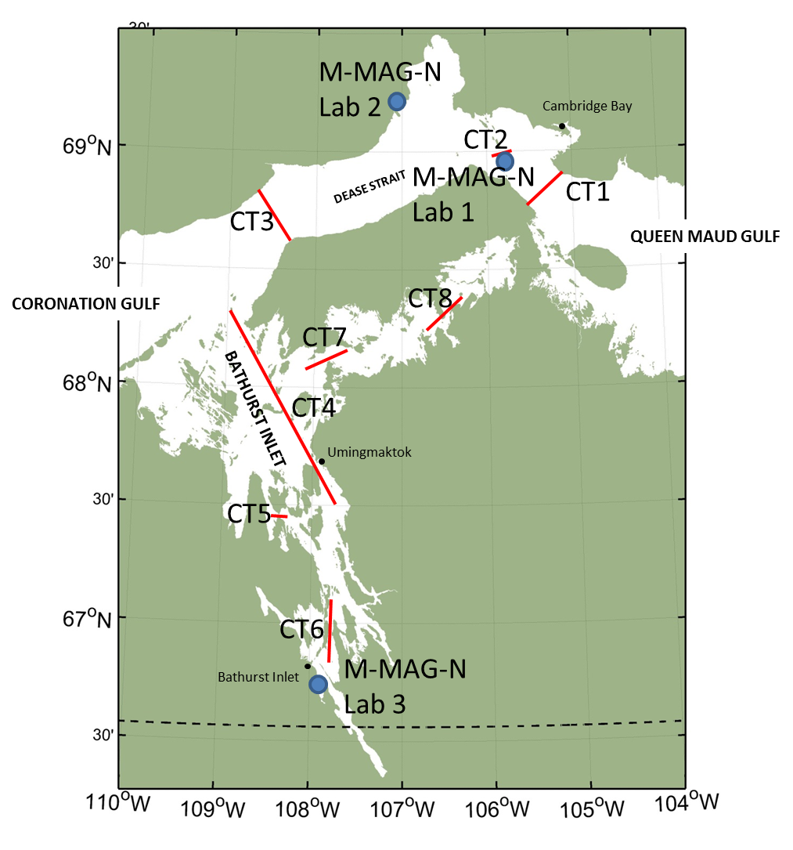
Figure 1. Proposed CAT-TRAIN-ICE sampling transects (red lines) and the proposed locations of ARF’s M-MAG-N labs (blue dots, see NPC# 148438)

