Report on 2020 Research Activities

Team Members:
Brent Else (Associate Professor, Project Leader)
Trish Stadnyk (Associate Professor)
Megan Leung (Graduate Student, University of Calgary)
Shawn Marriott (Research Assistant)
Richard Sims (Postdoctoral Fellow)
Samantha Jones (PhD Student)
Zoe Walker (Undergraduate Student)

Research Title: “Weather, Ice, Ocean, and Freshwater Measurements to Understand Greenhouse Gas Cycles and Aquatic Ecosystems”

Project Overview and Objectives: This project tries to understand how greenhouse gases move through the Arctic environment. Greenhouse gases are the cause of climate change, and most people know that humans make them when we do things like drive cars, or heat our homes. But, greenhouse gases are also a natural part of ecosystems. One important place to find natural greenhouse gases like methane (CH₄) and carbon dioxide (CO₂) is in freshwater and seawater, where they exist as dissolved gases. CO₂ and CH₄ are important parts of these ecosystems, because some things that live in the water make these gases, while others use them. For example, algae and other plants take CO₂ out of the water to make oxygen, while certain types of bacteria use up oxygen and make CH₄. We want to study how gases like CO₂ and CH₄ work in these systems, and how those gases might eventually get into the atmosphere. It is challenging to do a good job of this in the Arctic, because we need to make these measurements all year-round.

A second objective of this project is to find way to make our science useful to northern communities. We have been able to do this in the past. For example, we measure greenhouse gases at weather stations, and so we have worked with the HTO to set up weather stations at important locations. Data from those weather stations can be accessed online, and used when traveling. We think our measurements of dissolved gases in freshwater and seawater might also be interesting to the community, because there may be important links to wildlife. For example, spots that have high dissolved methane also usually have low dissolved oxygen, and these are places that fish like Arctic Char will avoid. Also, human impacts like sewage disposal in Cambridge Bay may affect greenhouse gases in the ocean. We are committed to working with the HTO and other stakeholders to make our research relevant.

2020 Activities
Data Collection Dates: January 01 – Dec. 31, 2020
Locations: Cambridge Bay and Surrounding Areas.

Normally, we have three weather stations working near Cambridge Bay (see photos and map below). The big weather station was damaged by ice in spring 2019, and we were unable to repair it because of travel restrictions. The two small community weather stations also stopped working in spring 2020, and have not yet been repaired. We were planning to set up some new community weather stations, but could not do it because of travel restrictions. When they are working, the community weather stations measure air temperature, wind speed, wind direction, relative humidity, and pressure. They report every hour, and the data can be viewed at https://people.ucalgary.ca/~belse/Brent_Else/WX.html and at http://siku.org. At the Qikirtaarjuk Island station, we also measure incoming energy (from the sun and atmosphere), and carbon dioxide in the atmosphere.

In most years we collect seawater, freshwater, and sea ice samples, to help us understand how the atmosphere interacts with water or ice surfaces. They are also used to study how water moves through the landscape and into the ocean. Water and ice samples are preserved and shipped back to our laboratory at the University of Calgary, where we analyze them for salinity, pH, CO₂, CH₄, and isotopic composition. At each of our water collection locations, we typically measured ice thickness, snow depth (in the winter), water temperature, salinity, dissolved oxygen, and chlorophyll-a content. The locations where we collect seawater are shown in the attached map. When we are working onboard the R/V Martin Bergmann, we also use an “underway system”, which measures pH, CO₂, salinity, and water temperature while the ship is travelling. During the Bergmann cruise, we also collaborate with researchers from Environment and Climate Change Canada (Project leader: Jane Kirk) who collects seawater samples to monitor mercury and persistent organic pollutants as part of their Northern Contaminants Program project: “Community based seawater monitoring for organic contaminants and mercury in the Canadian Arctic”

In past years, we also collected water samples in the Greiner Lake watershed. We use instruments to measure water temperature, pH, dissolved oxygen, total suspended solids, and conductivity. Water samples are used to measure dissolved CO₂ and CH₄, and stable water isotopes.

Unfortunately, in 2020 we were unable to accomplish many of these activities. We did set up some instruments on the sea ice to measure seawater pH and CO₂ in January, before any travel restrictions were in place. Some seawater samples were collected then. Fortunately, local community members were able to retrieve the instruments in May, before the instruments were lost. The community members also collected some seawater samples at that time. During the summer, some freshwater samples were collected in the Greiner Lake watershed by community members for stable isotope analysis.

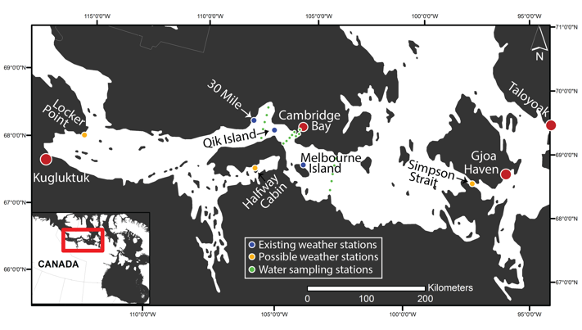
Map of existing weather stations, possible new weather stations (to be confirmed with community consultation), and water/ice sampling stations.
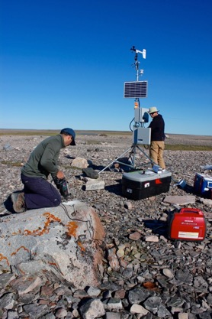 | 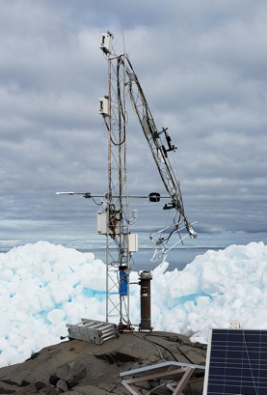
The weather station at 30 Mile (a similar weather station is located at Melbourne Island), and this will be the type of new station we install this year. | The weather station at Qikirtaarjuk Island (labelled “Qik Island” on the map), after it was damaged by ice (photo by Francis Emingak).
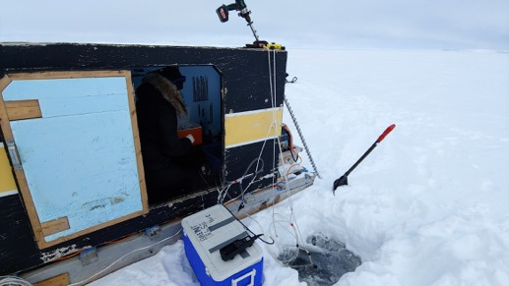  This is what our lake sampling usually looks like. We drill a small hole, then pump water up to our instruments. | 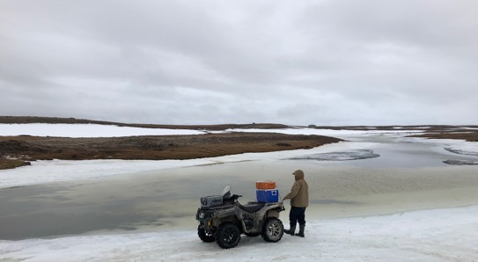  Sampling at Freshwater Creek in past years with Francis Emingak, early in the spring. | 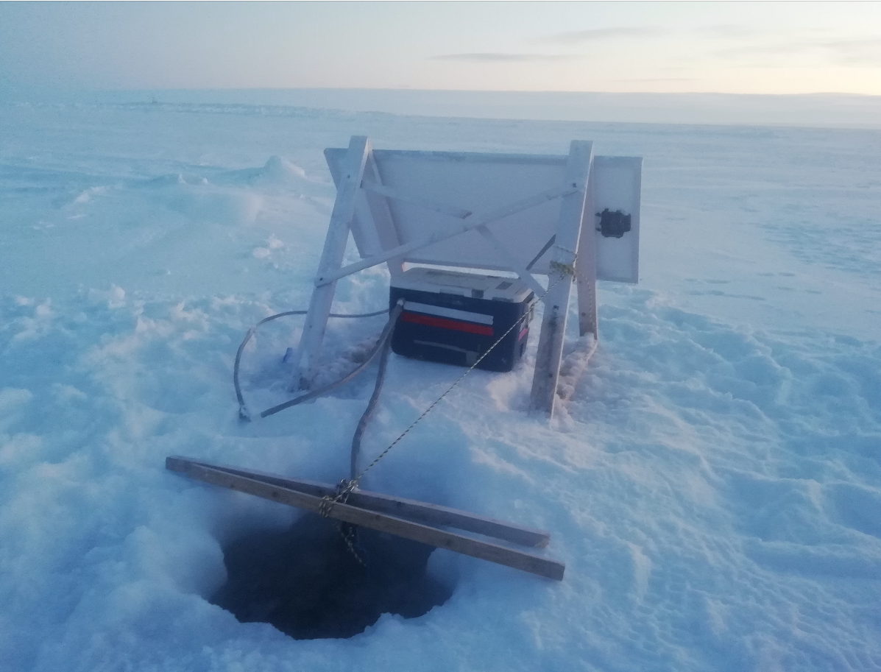  The sea ice instruments we deployed this year.
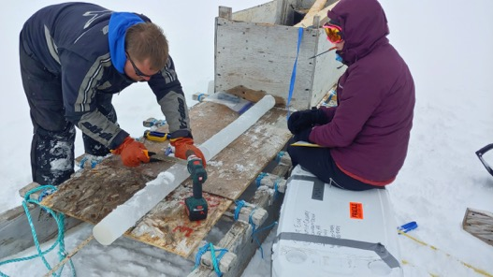  Collecting sea ice samples in 2019 | 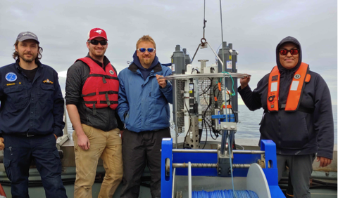  Sampling on the R/V Martin Bergmann in 2019 | 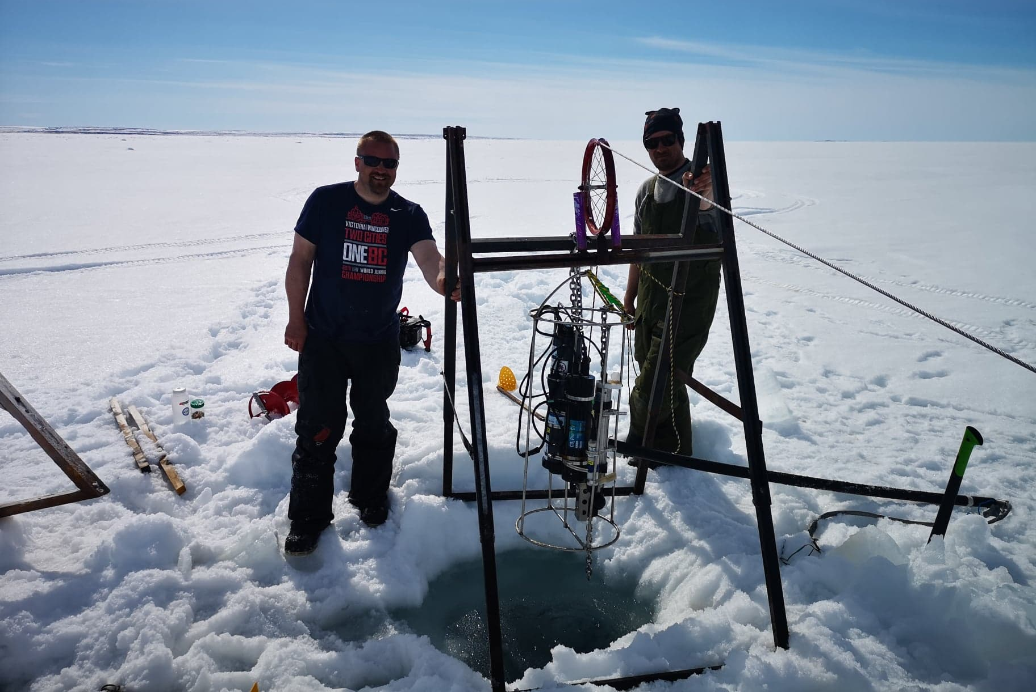  Community members retrieving the instruments while we were stuck in Calgary (photo by Shawn Marriott).

Planned Activities for 2020-2021

Team Members:
Brent Else (Associate Professor, Project Leader, University of Calgary)
Anna Michel (Associate Scientist, Woods Hole Oceanographic Institution)
Trish Stadnyk (Associate Professor, University of Calgary)
Jane Kirk (Environment and Climate Change Canada)
Casey Hubert (Associate Professor, University of Calgary)
CJ Mundy (Associate Professor, University of Manitoba)
Shawn Marriott (Research Assistant, University of Calgary)
Elise Imbeau (Research Assistant, University of Calgary)
Zoe Walker (Graduate Student, University of Calgary)
Megan Leung (Graduate Student, University of Calgary)
Christina Braybrook (Graduate Student, University of Calgary)
Samantha Jones (Graduate Student, University of Calgary)

Planned Activities for 2021: We hope to be able to do research near Cambridge Bay this spring. However, we understand how important it is to keep COVID-19 out of Nunavut communities, and we share that priority with Nunavummiut. We will abide by all public health orders regarding travel to Nunavut, and observe any COVID-19 restrictions or guidelines while in Nunavut. Following NRI guidance, our current plan is to ask the Cambridge Bay town council to endorse our travel to the region, and then apply to Nunavut’s Chief Public Health Officer for permission to enter an isolation hub. We will complete the isolation and follow any other instructions from the Chief Public Health Officer before entering Nunavut. The University of Calgary has a strong record of dealing with COVID-19, and requires a detailed safety plan for fieldwork. That plan has been attached as an appendix to this report.

If we are permitted entry to Nunavut, we will try to do the research activities that were approved for our 2020 license. Most activities are similar to what we have done in the past.

1. Weather Stations
In the coming year, we will repair the three weather stations near Cambridge Bay. Our research assistants will visit the stations through the year. We will hire at least one more student from Nunavut Arctic College’s Environmental Technology Program (ETP) to help with the weather stations. We just finished an outreach video to advertise the weather station project. It is available at: https://vimeo.com/362146773. We have one new weather station to be set up in the Cambridge Bay region. We have requested HTO input for where to place the new weather station. A while ago it was suggested to put it at Halfway Cabin, but we did not get a final decision from the HTO. We will likely need to hire HTO guides to help install this station.

2. Ocean Sampling
We will continue to collect samples in 2020-2021 using the sea ice in winter and small boats (including the R/V Martin Bergmann) in summer. Most of these will be seawater and ice samples collected for our lab to measure CH₄, CO₂, oxygen, temperature, and salinity. We will also collect some water, ice, and sediment samples for our collaborators (Dr. Casey Hubert, University of Calgary, Dr. C.J. Mundy, University of Manitoba, Dr. Jane Kirk, ECCC) to study algae, microbes and contaminants. Our activities will have minimal impacts. On sea ice, the only disturbances we will make are auger holes (10”). We will not be carrying much chemicals, so the risk of a spill is low. We will take care with snowmobiles, generators, and boats to minimize the risk of fuel or oil spills.

3. Freshwater Sampling
We would like to collect water samples from more lakes and rivers on Victoria Island. Lake water will be collected in the winter by traveling to sites with a side-by-side ATV, and drilling holes in the ice, just like we do on sea ice. In summer, we will collect water samples from the banks of lakes/rivers, or from small boats. Our collaborators at the U of C (Dr. Stadnyk) will be involved in water collection. We would also like to collect some sediment from lakes for one of our collaborators (Dr. Hubert) to help us understand where the methane in lakes comes from. For lakes and rivers, we will collect water by driving up to the shore (or flying to the shore in a helicopter), and then pumping water using a small pump. Like our ocean sampling, lake and river sampling will have minimal impacts. The only disturbance we will make is 10” auger holes in the ice. We will continue to be careful to avoid spills. In addition to working in the Greiner Lake watershed, we also would like to collect samples from the Fergusun Lake watershed, the Kitikga Lake watershed, and lakes near the Jayko River and Albert Bay. In addition to Freshwater Creek, we would like to sample river water from the Jayko, Ekalluk, Surrey, and Halokvik Rivers, as well as other rivers that go into Wellington Bay. We may place some sensors under the ice in Greiner Lake, and in Freshwater creek. These sensors measure dissolved gases like O₂, CO₂ and CH₄.

4. Outreach Activity/Knowledge Co-Generation Session

We plan to host a knowledge sharing session where members of our research team and a group of community members look at scientific data collected in Greiner Lake, Freshwater Creek, and the coastal ocean in Cambridge Bay and work together to make interpretations based on the results. Research results will be presented using maps and images and the session will allow discussion and annotation of the maps and images to make changes, improvements, or additions based on local knowledge and views. The session may also be used to propose new study sites or research activities based on community priorities. The outcomes will be included in a PhD thesis and related academic publications and the participants in the session will be co-authors (if they wish) on the publications/products that arise from the session. We received ethics approval for this knowledge co-generation activity in the spring of 2020 (REB19-2110) and will work with the University ethics board to implement additional COVID risk mitigations and modifications.

