Unipkaaq 2020-mi Ilituqhainikut Hulijutit

Ikayuqtiriini Ilauyut:
Brent Else (Ilagiyaa Ayugituup, Havaami Hivuliqhuqtit)
Trish Stadnyk (Ilagiyaa Ayugituup)
Megan Leung (Aniguqhihimayuq)
Shawn Marriott (Aunaiyaiyit Ikayuqti)
Richard Sims (Ilihatiaqtaaqtuq Inuk)
Samantha Jones (PhD-nigiamini Ilihaqtut)
Zoe Walker (Aniguqhihimayuq)

Ilituqhainiup Atia: “Hila, Hiku, Taqyuq, Immiktaakhalu Naunaiyaqniginik Kagiqhiyaagani Halumailruut Puyuit Aulaniginik, Immaqmilu Uumayuvaluit Nunagiyailu”

Havaami Qanuriniga Pijutauyulu: Una havaaq kagiqhijutaunahuaqtuq qanuq halumailruvaluit puyuit aulaniqaqmagaa Ukiuqtaqtumi avatauyumi. Halumailruvaluit puyuit pijutauyut hilap aalaguqnigani, amigaitulu inuit qauyimayut inuit hanavaktainik akhaluutituraagapta, uunaqhiyaaganilu iglugiyavut. Kihiani, halumailruvaluit puyuit inmiknik ilagikmiyaa nunagiyauyuni. Atauhiq atuqniqaqtuq inihaq nanihiyaagani halumailruvaluknik puyuqnik kasiliitut (CH₄) kasiliivaluknit puyuit (CO₂) immiktaakhaniituq taqyumilu, nugutuni puyuqni. CO₂-guyut and CH₄-guyulu atuqniqatiaqtut nunagiyauyuni, ilagit immaqmi umayut hanavakmata ukuniga puyuqnik, ilagita atuqpaktainik. Imaituq, aqayavaluit ahiilu nautiaq CO₂-mik pivaktut immaqmit aniqhaaktagakhanik, atautikut ahiinik halumailruvaluit atuqpaktut aniqhaaktagahanik hanalutiklu CH₄-mik. Ilituqhaiyumayugut qanuq puyuvaluknik ajikutainik CO₂-guyut CH₄ –guyulu aulanignik ukunani atuqtuni, qanuqlu ukua puyuit hatqiqpalianiginik hilainaqmut. Akhuuknaqtuq havaaritiariagani una Ukiuqtaqtumi, ukua naunaiyariaqaraptinik ukiugaaluk tamaat.

Tukliuyuq pijutauyut uumani havaami nanihiyaagani ukua naunaiyautivut nakurutauyaagani ukiuqtaqtumi nunagiyauyuni. Taimailiuqhimayugut ukiuni atuqhimayaptikni. Imaa, naunaiyaqtavut halumailruvaluit puyuit hilaliqivikni, havaqatigihimayavut HTO-guyut napaktiriyaagani hilaliqivikhanik atuqniqaqluaqtuni inikhani. Naunaiyautut ukunanga hilaliqiviknit takuyaulaaqtut qaritauyami qungiakhami atuqtaulutiklu aulaaqniqmi. Ihumayugut naunaiyautivut nuguyunik puyuvaluknik immiqtaqvikmi taqyumilu ihumagiyauniarunaqhivut nunagiyauyunit, ukua atuqniqaqtumi uiguulaaqmata uumayunut. Imaa, inigiyauyut nuguhimayunik kasiliivaluknik piqainaqpaktulu nuguhimayunik aniqhaaktagakhanik, ukualu inigiyauyut Iqaluit ajikutait Iqalukpiit kitpaavigiyumagitait. Ilaalu, inuit aktuqniginik annaguuqviktut Iqaluktuutiami aktuqniqalaaqtut halumailrunik puyuqnik taqyumi. Tuniqhimayugut havaqatigiyaagani HTO-kut ahiilu ilauyut ukua ilituqhautivut nakurutauyaagani.

2020 Hulijutit
Naunaipkutinik Katitiriviit Ubluini: Ubluqtuhirvia 1 - Ubluiqtirvia 31, 2020
Inigiyauyuni: Iqaluktuutiami Hanialilu Nunani.

Atuqpaknirhaq, piqaqtugut pingahunik hilaliqivit havaktut haniani Ikaluktutiak (takulugu piksa nunauyaqlu ataani). Tamna angiyuq hilaliqivik ahiruqhimayuq hikumin upinngaangani 2019, hanalaitavutlu piplugu aularniqmun pittailitit. Tapkuak malruk mikiyuk hilaliqivik aturuiqtuktauq upinngaangani 2020, hulilu hanayauhimaittuk. Parnaiyaiyugut ihuaqhaqni ilai nutat nunalikni hilaliqivit, kihimik pilaitmiyut piplugu aularniqmun pittailitit. Atuliqata, tapkuat nunalikni hilaliqiviit uukturaqtai hila uunaqnia, anuritunia, anurip humingaqnia, kinipania hilap, akhuqtiginialu. Tapkuat tuhaqhitaiyut ikaraq tamaat, tapkuatlu tuhagakhat takuyaulat talvani https://people.ucalgary.ca/~belse/Brent_Else/WX.html and at http://siku.org. Qikirtaarjuk-mi Qigiqtami hilaliqivik, naunaiyaqtavulu aularigutit qauyut (hiqiniqmit hilainaqmilu), unalu halumailruuq puyuq pauvaluq hilainaqmi.

Amihuniqhani ukiuni katitpaktavut tariup imaa, imigaulaq imaa, tariupolu hikua naunaiyagakhat, ikayuriangitigut kangiqhimani qanuq tahamna hilavut piqatauni imaqmun uvaluniit hikup qangi. Tapkuat atuqtaukmiyut naunaiyaqni qanuq imaq ingutaqnia nunakkut tariumun. Immaq hikulu naunaiyagakhat tutqumayauyut aulaqtitauplutiklu naunaiyaiviptingnut talvani University-nga Calgary, talvani naunaiyaqtavut tariuquqtuni, pH, CO₂, CH₄, tapkuatlu akuhimaniriyai hanatyuhit. Atuni imaqmun katitiqviptingni inait, atuqpakniqhavut uuktuqni hikup ibyunia, aputyaqnia (ukiumi), immap uunaqnia, tariuqaqnia, akuhimani aniqhaktugaulat, tamnalu chlorophyll-a piqaqnit. Tapkuat inait katitiqvigiyavut tariup imaa takukhauyut attataqhimayumi nunauyaqmi. Havakkangapta uhiupluta talvani R/V Martin Bergmann, atuqpakmiyavuttauq tamna “immap tataagurtuq havagut”, tapkuat uukturaqtai pH, CO₂, tariuqaqnia, immaplu uunaqnia umiaqpak ingilratitlugu. Atuqtilugut Bergmann-kut umiaqtuqniq, havaqatiqaqhimayugut ilituqhaiyinik Avatiliqiyinit Hilaaplu Aalaguqnigagut Kanatami (Havaami hivuliqhuqti: Jane Kirk) katitirihimayut taqyumit immaqmik ilituqhagakhanik amiriyaagani mercury-mik havivaluqaqmagaa takuukhauginaqtulu nunamit halumairluut ilagiyaanik Ukiuqtaqtumi Halumailrut Havaamik havaami: “Nunagiyauyumit taqyumi immaqmik amirinigagut nunamit halumailrunik mercury-miklu havivaluknik Kanatamiut Ukiuqtaqtuani”

Hivuani ukiuni, katitiqmiyavuttauq immat naunaiyaqni talvani Ikaluktutiak Tahiq imaqaqnit. Atuqtavut ihuaqutit naunaiyariagani immap niklaumaniganik, pH-giyaaniik, anikhaagakhat nuguniginik, tamaita immaqmiitut hitiyut, aulayaaqviunigilu. Immaq atuqtauyuq uukturaqni akuhimani CO₂ tamnalu CH₄, hunniumaitni immap akuvigihimanit.

Mamianaugaluaq, 2020-mi pitalaitnaptigu amihut tahapkuat huliniit. Ihuaqhaqhimayavut ilai hanalrutit tariup hikuani uukturaqninut tariup immaa pH tamnalu CO₂ talvani Januari, hivuani aularniq pittailiyautitnagit. Ilai tariuq immai naunaiyaqni katitiqtauyut talvuuna. Quanarunartuq, nunalikni ilauyut pitaqhimayai tapkuat hanalrutit talvani Mai, hivuani hanalrutit tammaiyautitnagit. Tapkuat nunalikni ilauyut katitiqmiyai ilai tariuqmi immai naunaiyautit talvuuna. Auyautitlugu, ilai imigaulat imait naunaiyaqni katitiqtauyut talvani Ikaluktutiak Tahiq imaqaqnia nunaliuyumi ilauyunit hunniumaitninut avugiyauviuni qauyihaqni.

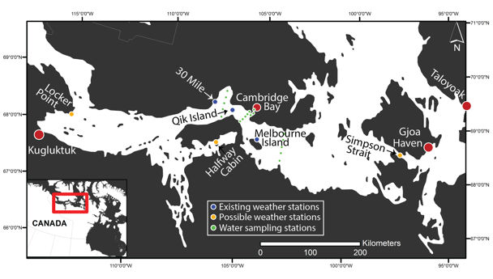
Nunauyaq taja hilaliqiviqaqtunik havakviknik, nutaat hilaliqivikhauyut ahu (naunaiqniaqut nunagiyauyuniitut uqaqvigilraaqlugit), immaqmik hikumiklu ilituqhaivikhat havakviit.
 | 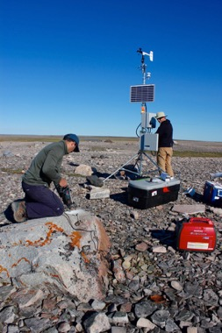 | 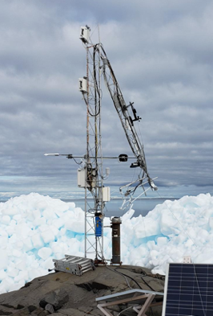
 | Hilaliqivik Halukvikmi (30 Mile) (ajikutaa hilaliqiviup iniqaqtuq Qigiqtaqyuami (Melbourne Islan), taimaituuniaqtut nutaat hilaliqiviit iliuraqtakhavut talvani ukiumi). | Hilaliqivik havakvik Qikirtaarjuk-mi (attigauyuq “Qik Qigiqtamik” nunauyami) (Francis Emingak)

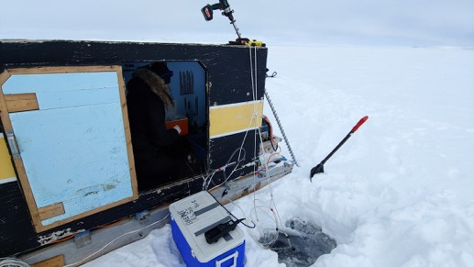  Uva tahikmik naunaiyagavut iniginik. Ikuutaqtugut mikiyumik aglumik, papiqtaqut immaq naunaiyautiptiknut. | 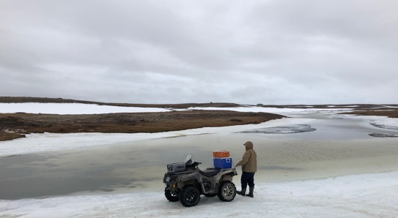  Naunaiyaqniga Immiktaqvikmik Kuugani Francis Emingak-lu, upingaalihaami. | 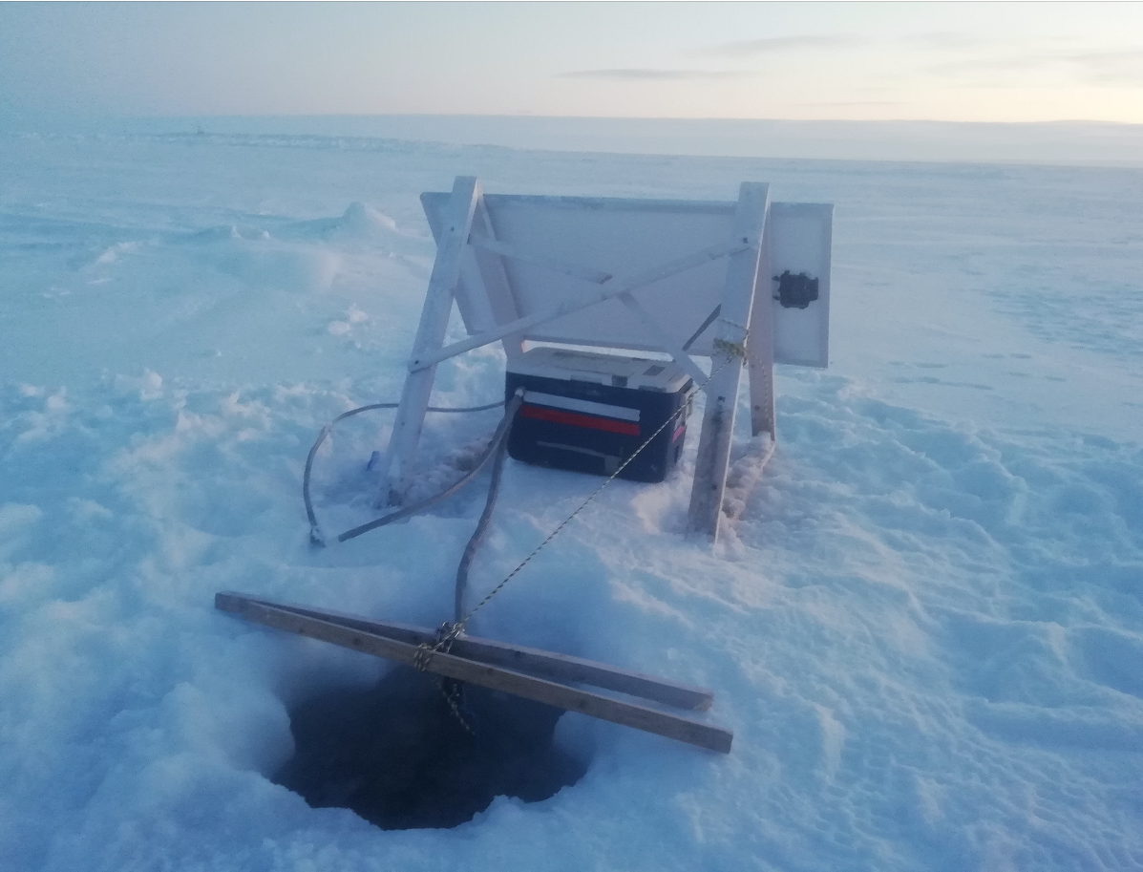  Tamna tariup hikua hanalrutit iliuqaqtauyut uumani ukiumi.
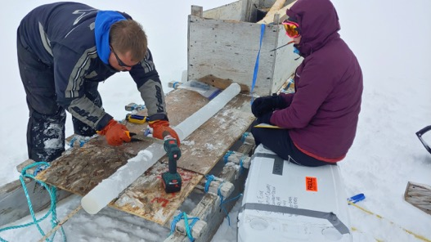  Katitiriyut taqyumi hikumik naunaiyagakhanik | 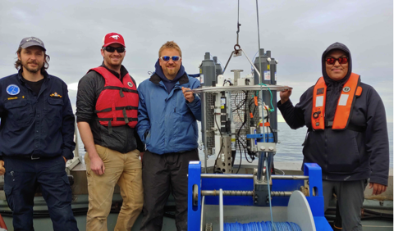  Immaqnik ilituqhainiat R/V Martin Bergmann –mit umijamit | 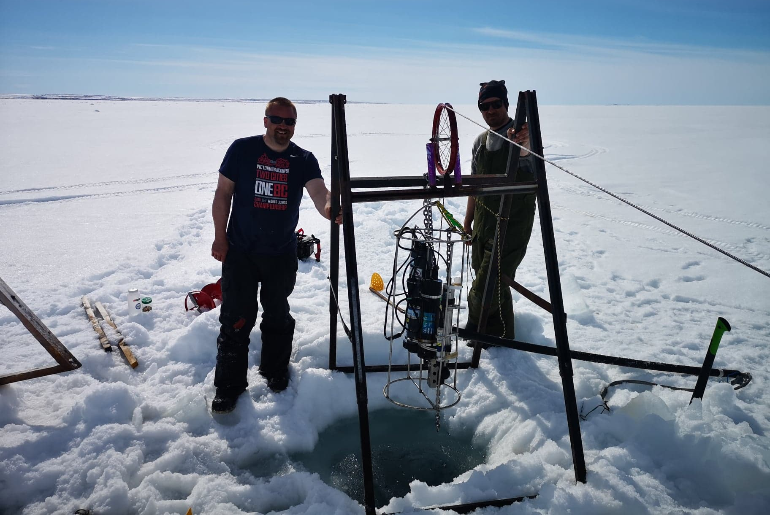  Nunaikni ilauyut pitaqtai tapkuat hanalrutit ayuqhihimatitlugit talvani Calgary (piksaliuqta Shawn Marriott).

Upalugaiqtut Hulijutikhat 2020-2021-mi

Ikayuqtiriini Ilauyut:
Brent Else (Ilagiyaa Ayugituup, Havaami Hivuliqhuqtit, Ilihaqpaaliqvikmi Calgary-mi)
Anna Michel (Ikayuqti Naunaiyaiyuni, Woods Hole Oceanographic-mi Havakviuyumi)
Trish Stadnyk (Ilagiyaa Ayugituup, Ilihaqpaaliqvikmi Calgary-mi)
Jane Kirk (Avatiliqiyinit Hilaaplu Aalaguqnigagut Kanatami)
Casey Hubert (Ilagiyaa Ayugituup, Ilihaqpaaliqvikmi Calgary-mi)
CJ Mundy (Ilagiyaa Ayugituup, Ilihaqpaaliqvik Manitoba-mi)
Shawn Marriott (Aunaiyaiyit Ikayuqti, Ilihaqpaaliqvikmi Calgary-mi)
Elise Imbeau (Aunaiyaiyit Ikayuqti, Ilihaqpaaliqvikmi Calgary-mi)
Zoe Walker (Aniguqhihimayuq Ilihaqtuq, Ilihaqpaaliqvikmi Calgary-mi)
Megan Leung (Aniguqhihimayuq, UIlihaqpaaliqvikmi Calgary-mi)
Christina Braybrook (Aniguqhihimayuq, UIlihaqpaaliqvikmi Calgary-mi)
Samantha Jones (Aniguqhihimayuq, UIlihaqpaaliqvikmi Calgary-mi)

Upalugaiqtut Hulijutikhat 2021-mi:

Niriuktugut pilariakhavut naunaiyainiq haniani Ikaluktutiak upinngaaq. Kihiumik, kangiqhimayugut qanuq atuqpiaqtiginia pihimania tahamna Qalakyuarniq-19 itiqtailinia Nunavutmi nunnaliuyut, atuqatigutivuttauq tamna hivulliutyaqnia taphapkununga Nunavummiut. Malikhaqniaqtavut tamaita inungnut aaniaqtailiniq aturiaqaquyauyut piplugu aularniq Nunavutmun, malikhaqnilu kitutliqak Qalakyuarniq-19 pittailitit uvaluniit hivulirutit nayullaklugu Nunavut. Malikhugit NRI hivulirutit, tatya parnautivut apirini Ikaluktutiak nunalia katimayit angiqnit aularnivut tahamunga nunaliit avikhimanianut, talvangatlu tukhiqviginia Nunavutmi Ataniuyuq Inungnut Aaniaqtailiniq Havakti pilarutmik itiqnia iliikkuqvik aktuattailivik. Iniqtiqniaqtavut tamna ilikkuqvik aktuattailivik maliklugitlu kitutliqak ahii tiliurutit taphumanga Ataniq Inungnut Aaniaqtailiniq Havakti itiqniahaqlugu Nunavut. Tamna University-nga Calgary pihimayuq akhut huliqini Qalakyuarniq-19, piyaqaqnilu unnirtuttiaqni hivuranaitniqmun parnaut maniqami havat. Tamna parnaut attataqhimayuq atattaqhimania uumunga tuhaqhitaut.

Pilaqtitaugupta itiqnia Nunavutmun, pinahuaqniaqtavut naunaiyainiq huliniit angiqtauhimayut 2020 laisaptingnut. Amihuniqhat huliniit ayyikkipyaktut pihimayaptingnut hivuani.

1. Hilaliriviit
Atuqtuukhami ukiumi, atuqhimaaqniaqtavut pigahuut hilaliqiviit haniani Iqaluktuutiap. Ilituqhainiqmik ikayuqtigiyavut takuyaqtuiniaquut hilaliqiviknik atuqnigani ukiup. Havaktitiniaqtugut atauhiugaluamik ilihaqtumik Nunavumi Ukiuqtaqtumi Ilihaqpaaliqvikmit Avatauyumik Naunaiyai-nikut Havaamit(ETP) ikayuriagani hilaliqivikni havakvikni. Inihilihaaqtugut upipkaijutikhamik qungiamik takuupkaiyaaptikni hilaliqivikmik havaamik. Qahaktuq uvani: https://vimeo.com/362146773 -mi. Atauhiqmik huli hilaliqivikhamik napaqtiriyariaqaqtugut Iqaluktuutiami nunami. Tuukhiqhimayugut HTO-kut tuhaqvigiyaagani uvuuna humuut iliyaagani nutaaq hilaliqivikhaq. Qaganuaq ihumagiyauyuq iliyaagani Tikiyaqtuqnigani Iglunuami, kihiani kiguliqmik ihumaliurutimik pigitugut HTO-kunit. Havaktitiniarunaqhiyugut HTO-kuni aulaaqtitiyunit napaktiriyaagani uumiga igluqpakmik.

2. Taqyumik Nauyaiyainiq
Katitirihimaaqtugut naunaiyagakhanik 2020-mit 2021-mut atuqhugut taqyumi hiku mikiyulu qainat (unalu R/V Martin Bergmann umiaq) auyami. Amigainiqhat ukua taqyumi immaqnik hikuniklu naunaiyagakhanik katitiqtauyut ilituqhaiviptikni naunaiyagakhat CH₄,-mik CO₂-miklu, anikhagakhanik, niklaumaniganik, taqyuqaqniganiklu. Katitiriniaqtugulu ilaganik immaqmik, hikumik, hiuqaniklu naunaiyagakhanik ikayuqtiptiknit (Taakti Casey Hubert, Ilihaqpaaliqvikmi Calgary-mi & Dr.-mi C.J. Mundy-mit, Ilihaqvikyuamit Manitoba-mi, Dr. Jane Kirk, Avatiliqiyinit Hilaaplu Aalaguqnigagut Kanatami) ilituqhariagani nauhimayut uumayunuilu. Hulijutivut mikiyumik aktuqniqaqniaqtut. Taqyumi hikumi, aktuqniriyavut ukuaginait ikuutaqnirit agluanik (10-inches-guniaqtut). Nakhalaitugut amihunik kumiyaaqtunik, ihumaluknaqniga kuviiniq mikiyuq. Munariniaqtavut sikiitut, igniqutit alruyaqtuutit, qainalu mikiniqhauyaagani ihumaluknaqniga uqhuit kiniqtuluniit kuvinigit.

3. Immiktaakhanik Naunaiyaqnigit
Katitiriyumayugut immaqnik naunaiyagakhanik amigaitqiyanit tahiqnit kuukanilu Kiiliniqmi. Tatinit immaq katitiqtauniaquq ukiumi aulaaqlutik inikhamut akhaluutinuakut, ikuutaqlutik aglunuanik hikumi, taimaatauq taqyumi hikumi pijutiptiknik. Auyami, katitiriniaqtugut naunaiyagakhanik hinaanit tattit kuuvaluilu, mikiyumiluniit qainanit. Ikayuqtigiyavut Ilihaqvikyuami Calgary-mi (Taakti Stadnyk) ikayuqniaqaatigut immaqmik katitiriyaagani. Katitiriyumayugulu ilaginik hiuqanik tattinit kivgaqtuqlugu ikayuqtiriyaquut (Taakti Hubert) ikayuriagani kagiqhiyaagani humigaaqnignik uqhuvaluit tattini. Kuukani, katitiriniaqtugut immaqmik hinaanut akhaluutituqluta (tikmilutaluniit hinaanut halikaaptakut), papiklutalu immaqmik atuqlugu mikiyuq papaut. Taimaatauq taqyumi naunaiyainiqmik, tahiqmik kuukmiklu naunaiyainiq mikiyumik aktuqniqaqniaqtuq. Aktuqniriyavut ukuaginait ikuutaqnirit agluanik 10-inches-guniaqtut. Munarinuaqtugut kuviigitaaptikni hunanikliqaa. Ilagiyaanik havagiami Ikaluktuutiami Tahiqmi immaqaqnigani, katitiriyumayugulu naunaiyagakhanik Tahiqyuamit immavaluknik, Kitiqamit immavaluknik, tattinilu haniani Jayko-mi Kuukamit, Tunuunganilu Iqaluktuutiap, Albert Bay-mi. Ilagiyaani Immiqtaqviup Kuuganit, naunaiyaiyumayugut kuukanit immaqnik Jayko-mit, Iqaluktuumit, Surrey-mit, Halukvikmi Kuukanit, ukunangalu kuuvaluknik talvuga Iqaluktuumut kuuktunit. Iliurainiarunaqhivugut ilituqhautinik ataani hikuup Iqaluktuutiami, Immiqtaqviuplu kuunuaganit. Ukua ilituqhautit naunaiyautit piyuvaluknik ajikutainik O₂-guyut, CO₂-guyut CH₄-lu.

4. Aturahuaqtitni Huliniit/Ilihimani Kinguvaarit Katitvia

Parnaktugut atuqtitnia ilihimanit atuqatugikni katitniq tapkuat ilauyut naunaiyainiptingnut havaqatigit tapkuatlu ilagit nunalikni ilauyut takuni naunaiyainiq tuhagakhat katitauyut talvani Ikaluktutiak Tahiq, Imigaulaq Immaq Kuugauyaq, tahamnalu tariup hinaa Iqakuktutiakmi havaqatiginilu piyauni tukiliurutit piplugit tapkuat qanuritnit. Naunaiyainiq qanuritni hatqiqtitauniat atuqlugit nunauyat piksatlu tapkuatlu katitnit pilaa uqaqatigikni titiqpalianilu nunauyat piksatlu allanguqtaunikhat, nakuuhivalliqnit, uvaluniit ilagiaqni piplugit nunalikni ilihimanii tautuknilu. Tamna katitniq atuqtaulaqmiyuq uuktutauninut nutat naunaiyaqni inait uvaluniit naunaiyainiq huliniit piplugit nunalikni hivulliutyaqnit. Tapkuat qanuritnit ilaliutiyauniat talvani PhD Unipkaliangit ilihautit turangayutlu iliharniq makpiraliugat piqataunitlu katitnini titiraqatigikniat (piyumakpata) tapkunani makpiraliuqni/hanayauni hatqiqtut tapkunanga katitnit. Pitaqtavut nakuanut angiqtaunit uumunga ilihimanit kinguvariinut huliniit upinngaangani 2020 (REB19-2110) havaqatigikniatlu tapkununga University-nga nakuatuqnit katimayit atuqpalianinut ilagiarutit Qalakyuarniq hivuranaqnit ihuaqhautit allanguqpalirutitlu.

