FUEL MANAGEMENT PLAN

MEADOWBANK PRECIOUS METAL PROPERTY
NUNAVUT, CANADA

Prepared for:
5530 Nunavut Inc.

Prepared by:


Effective Date: June 1, 2017
Contents
1 Introduction 1
1.1 Contact Details 1
1.2 Purpose and Scope 1
1.3 Other Plans 1
1.4 Property and Camp Description 1
2 Fuel Inventory 2
3 Storage and Containment 3
4 Fuel Transportation and Transfer 3
5 Signs, Labels, and Inspections 4
6 Spill Kits 4
7 Applicable Legislation and Guidelines 4
7.1 Federal 5
7.2 Territorial 5
Tables
Table 2.1: Inventory of Fuels to be Stored on Site 2
Appendices
Appendix 1: Figures 6
Appendix 2: Daily Fuel Inspection Record 8

Introduction
This Fuel Management Plan (FMP) applies to mineral exploration activities conducted by, or on behalf of 5530 Nunavut Inc. (the “Company”) on the Meadowbank Precious Metal Property (the “Property”), Nunavut, Canada.
This FMP will come into effect June 1 2017, pending approval. Copies and updates to this plan may be obtained via the Company or APEX Geoscience Ltd. (“APEX”).

Contact Details
5530 Nunavut Inc. | APEX Geoscience Ltd.
2205-1211 Melville Street | 110-8429-24 Street NW
Vancouver, BC V6E 0A7 | Edmonton, AB T6P 1L3
Tel: (778) 389-7274 | Tel: (780) 467-3532
Fax: (780) 467-4025
www.apexgeoscience.com

Purpose and Scope
The primary objective of the Meadowbank Precious Metal Property FMP is to provide straightforward procedures for the storage and handling of fuels for the purpose of reducing the risk of environmental contamination and to ensure the health and safety of all personnel from the accidental release of deleterious materials. The FMP includes the following:
Promote safe handling and use of all types of fuel.
Reduce the likelihood of spills of all types of fuel.
Identify responsibilities and procedures for all staff and contractors.
Provide site specific information about the facilities and contingencies in place.
Comply with federal and territorial government regulations and guidelines pertaining to transportation, storage, handling and disposal of any type of fuel.

Other Plans
The FMP should be considered as a part of the Property wide management system. Other management plans in place at the Meadowbank Precious Metal Property include:
Abandonment and Restoration Plan (ARP)
Emergency Response Plan (ERP)
Environmental Management Plan (EMP)
Spill Prevention and Response Plan (SPRP)
Waste Management Plan (WMP)

Property and Camp Description
The Meadowbank Precious Metal Property is located in the Kivalliq Region of Nunavut, within the 1:250,000 scale NTS map sheets, 66A and 66H. The Property is approximately 30 to 100 km north of the community of Baker Lake. The Property consists of three project areas: Area A to the north, Area B in the centre and Area C to the south (Figure 1 in Appendix 1).
The proposed exploration program will be supported by a temporary, 6 to 10 person exploration camp. The program is anticipated to commence June 15th, 2017 and run for 6 weeks (42 days). INAC, NWB and NIRB will be notified 30 days prior to the establishment of the camp and fuel cache. Personnel and cargo will be transported to the camp along the Agnico-Eagle Meadowbank Road and then flown to site via helicopter. Structures for the proposed camp may include 4 sleeper tents, 1 kitchen, 1 dry, 1 generator shack, and 1 outhouse. The majority of the structures will be insulated Weatherhaven tents, or similar, with tarp floors (Figure 2 in Appendix 1).
A fuel cache of less than 4,000 L (approximately 19 drums) will be established on stable ground near the camp, primarily to store diesel and jet fuel. Small quantities of gasoline and propane will also be stored. Small temporary fuel caches (less than 4,000 L), may also be required to supply the drilling and exploration programs. Within 30 days of the establishment of any temporary fuel cache, the appropriate agencies will be notified of the details of the cache including: GPS location, fuel type, container sizes, method of storage and proposed date of removal. The temporary fuel cache GPS locations will also be included in the annual reports submitted to the INAC, NWB and NIRB.
The proposed 2017 exploration activities for the Meadowbank Precious Metal Property include prospecting, till sampling and ground geophysical surveys. The intent of the 2017 exploration program is to delineate targets for diamond drilling. As soon as targets are identified for drilling INAC, NWB and NIRB will be notified and supplied with locations and maps. All exploration work and drilling will be strictly confined to the Areas A, B and C (Figure 1 in Appendix 1).

Fuel Inventory
A main fuel cache will be established proximal to the camp, primarily to store diesel and jet fuel, with smaller quantities of gasoline and propane. Small fuel caches will also be established at drill sites while drilling is in progress. These temporary caches will store small amounts of diesel and propane, as needed for drilling. Other hazardous materials found on site may include small quantities of various lubricants/oil/grease for drilling and maintenance of motorized equipment, cleaning products, and waste oil.
Diesel, jet fuel, and gasoline will be stored in 205 litre (L) steel drums. Propane will be stored in 100 pound (lb) cylinders equipped with pressure relief valves. Waste oil will be sealed in 205 L steel drums and removed from camp for proper disposal.
Table 2.1: Inventory of Fuels to be Stored on Site
Material | Container | Maximum On Site*
Diesel | 205 L Drum | 8 Drums
Jet Fuel (Jet A or Jet B) | 205 L Drum | 10 Drums
Gasoline | 205 L Drum | 1 Drum
Propane | 100 lb Cylinder | 2 Cylinders
*Pending approval from AANDC, NWB and NIRB.

The Project Supervisor is responsible for maintaining a detailed fuel and hazardous material inventory, and is in charge of overseeing the maintenance and monitoring of all fuel and hazardous material caches.

Storage and Containment
All fuels and other hazardous materials will be stored within “Arctic Insta-Berms”, or similar products, for secondary containment. These types of berms utilize chemical and fire resistant fabric (generally polyurethane coated nylon or vinyl coated polyester material) designed for extreme arctic temperatures and puncture resistance. “RainDrain” or similar hydrocarbon filtration systems will be used to safely remove any water collected inside the berms, and as a safeguard against any potential overflows of contaminated water.
Fuel drums will be stored on their sides in organized rows with the bungs in the three o’clock and nine o’clock positions. Drums will be stood upright 1 to 2 days prior to use in order to allow any contaminants to settle. Daily inspections will be conducted to identify any damaged or leaking containers. In the event that a leak is discovered, the substance will either be used immediately or transferred to an undamaged container.
Propane cylinders will be equipped with a pressure release valve that opens and closes to prevent a buildup of excessive internal pressure. Labels, showing data such as date of manufacture and re-testing dates, will be applied to the collar of the cylinders. Propane is non-toxic and will not contaminate soil, however secondary containment berms will be used for storage as a precaution. All propane cylinders will be secured for safety and stored away from any sources of ignition.
All fuel storage and fuel transfer areas will be located a minimum distance of 31 m from the normal high water mark of any water body. Spill kits and firefighting equipment will be strategically located near where any hazardous materials are stored or transferred, at all drill sites, in the helicopter(s), and at other locations throughout the camp.

Fuel Transportation and Transfer
All fuel will be mobilized to camp first by truck along the Agnico-Eagle Meadowbank Road and then slung to site by helicopter. Drums will be inspected prior to being transferred to camp to identify any defects (i.e. torn, missing, or twisted gaskets, etc.); a second inspection will be performed upon arrival at camp. Regulations outlined in the Transportation of Dangerous Goods Act, and other relevant legislation, will be observed at all times during transport. Fuel drums will be slung by helicopter as needed to drill sites. All drums will be inspected for leaks and defects prior to and after helicopter transport. Empty drums will be removed from site for proper disposal.
Electric or hand wobble pumps equipped with filtration devices will be used for the transfer of diesel, jet fuel, and gasoline from their storage containers directly to their end-use fuel tanks. Portable drip trays or mini-berms will be used to mitigate the risk of any spillage, and fully stocked spill kits will be available at all refueling stations. Proper grounding procedures will always be used during fuel transfer while using an electric pump. Cigarette smoking, sparks, open flames, and any potential ignition sources are prohibited within 100 m of any fuel storage site and at all times during fuel transfer.
When transferring fuel, the drum will be stood upright and blocked with the high side at 12 o’clock, the bung at 3 o’clock, and the vent at 9 o’clock to prevent water or dirty fuel from reaching the openings. The standpipe will be placed in a manner so that it will not be able to reach the lowest point in the drum, thus ensuring any contaminants will remain in the drum.
Any personnel who are required to handle or store fuel will receive appropriate training, including instruction in the operation and maintenance of fuel transfer and storage equipment. All on-site personnel will receive training as outlined in the Meadowbank Precious Metal Property “Spill Prevention and Response Plan”.

Signs, Labels, and Inspections
All drummed fuel will be clearly labeled in accordance with the Workplace Hazardous Materials Information System (WHMIS) and other applicable legislation. Labels will include, but not limited to, the type of fuel, safe handling procedures, reference to Material Safety Data Sheets (MSDS), company name, and the date of delivery to site. Signs with the same information, along with MSDS for each fuel type will be posted at each fuel storage or transfer site. “No Smoking” signs will be posted at each fuel cache, drill site, and fuel transfer area.
All fuel drums will be inspected upon arrival at camp, and before and after helicopter transport. Monitoring of drums, fuel transfer equipment, and fuel caches will be ongoing during the exploration program. Daily inspections will be conducted to identify any damaged or leaking containers, and the findings reported in the “Daily Fuel Inspection Record”. Any damage discovered during or as a result of transport will also be recorded. Any leaks or spills will be reported and contained as outlined in the Meadowbank Precious Metal Property “Spill Prevention and Response Plan”. A copy of the Daily Fuel Inspection Record is attached in Appendix 2.
The Project Supervisor is responsible for supervising the monitoring and inspection program, and keeping a detailed inventory of all fuel and other hazardous materials on site.

Spill Kits
Spill kits will be located at each fuel cache, storage area, and refueling station. See the Meadowbank Precious Metal Property “Spill Prevention and Response Plan” for further details regarding spill kits, and spill response and reporting procedures.

Applicable Legislation and Guidelines
Acts, regulations, and legislation that apply to the storage, handling, and transport of fuel are presented in the following

Federal
Canadian Centre for Occupational Health and Safety Act
Canadian Environmental Protection Act
Fisheries Act
Nunavut Waters and Nunavut Surface Rights Tribunal Act
Transportation of Dangerous Goods Act
National Fire Code of Canada
Northern Land Use Guidelines
Workplace Hazardous Materials Information System (WHMIS)
CCME Environmental Codes of Practice for Aboveground and Underground Storage Tank Systems Containing Petroleum and Allied Petroleum Products
Storage Tank Systems for Petroleum Products and Allied Petroleum Products Regulations
Guidelines for Spill Contingency Planning (AANDC)

Territorial
Fire Prevention Act
Environmental Protection Act
Mine Health and Safety Act and Regulations
Safety Act
Nunavut Occupational Health and Safety Regulations
Environmental Guideline for the General Management of Hazardous Waste

Appendix 1: Figures

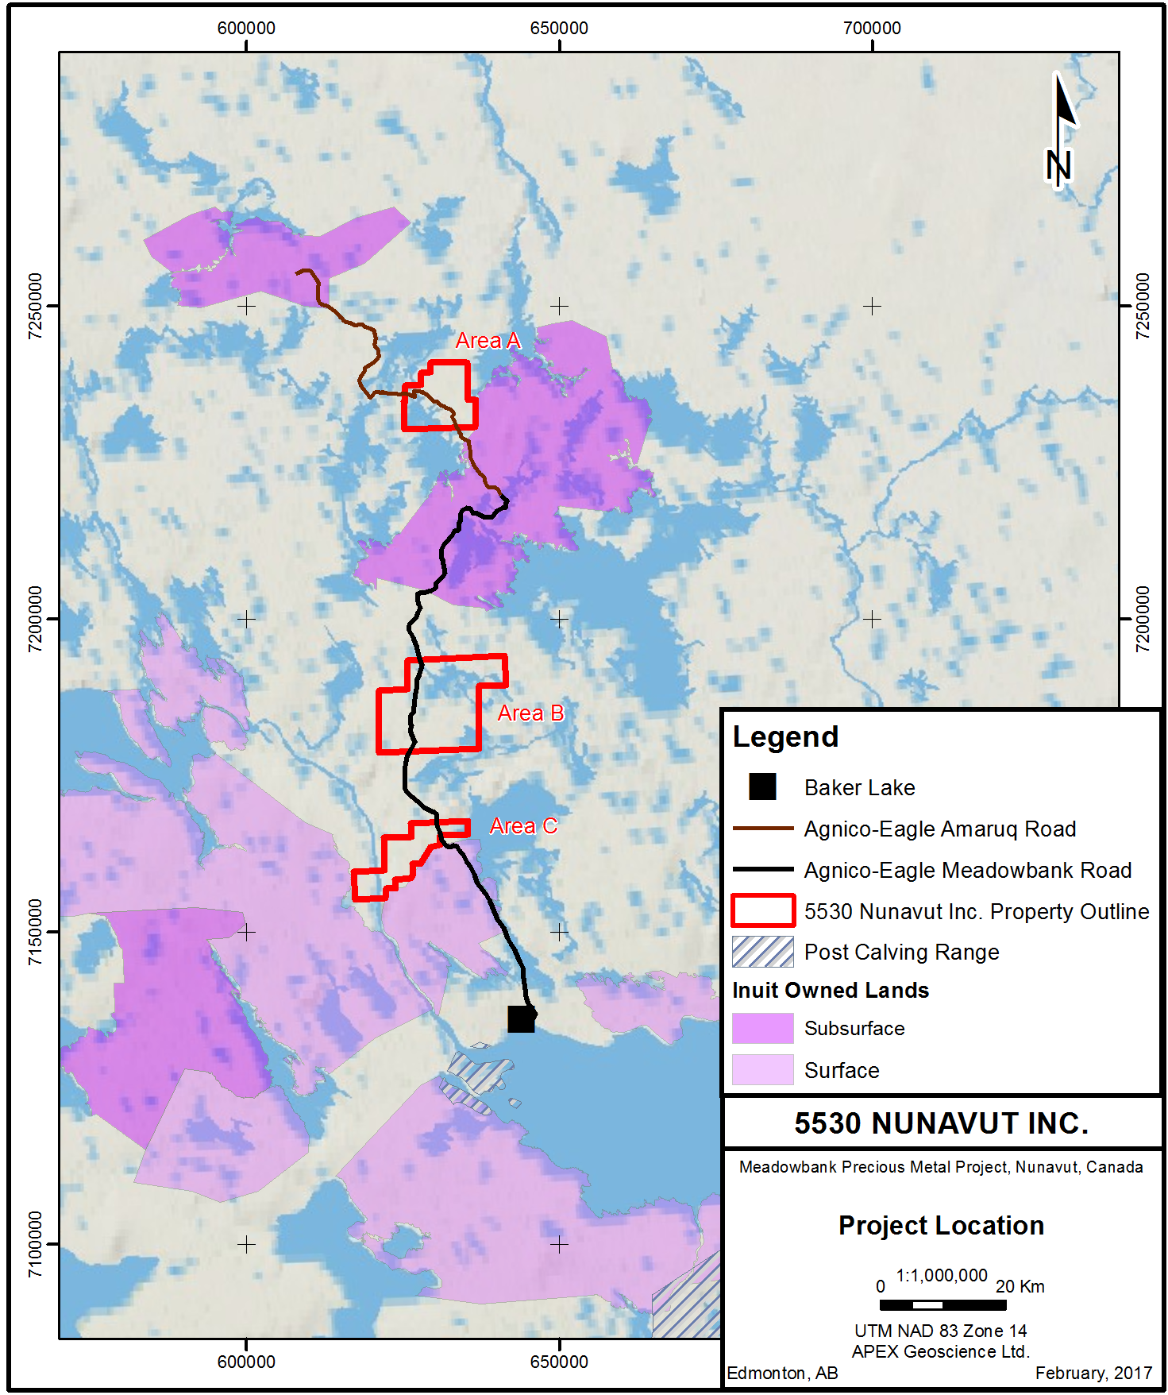

Appendix 2: Daily Fuel Inspection Record



