WASTE MANAGEMENT PLAN

MEADOWBANK PRECIOUS METAL PROPERTY
NUNAVUT, CANADA

Prepared for:
5530 Nunavut Inc.

Prepared by:


Effective Date: June 1, 2017

Contents
1 Introduction 1
1.1 Contact Details 1
1.2 Purpose and Scope 1
1.3 Environmental Policy 1
1.4 Other Plans 2
1.5 Property and Camp Description 2
1.6 Applicable Legislation and Guidelines 3
1.6.1 Federal 3
1.6.2 Territorial 3
2 Waste Management 3
2.1 Definition of Wastes 3
2.2 Waste sources 4
2.3 Waste Management Activities 5
2.4 Waste Recovery and Reuse 5
3 Waste Classification and Disposal Plan 6
3.1 Hazardous Wastes 6
3.1.1 Used Oil 6
3.1.2 Hydraulic Fluid 6
3.1.3 Contaminated or Expired Fuels 6
3.1.4 Solvents 6
3.1.5 Contaminated Soil, Snow, and Ice 7
3.1.6 Used Rags and Sorbents 7
3.1.7 Empty Hazardous Material Containers and Drums 7
3.1.8 Waste Batteries 7
3.1.9 Aerosol Cans 7
3.1.10 Fluorescent Bulbs and Tubes 8
3.2 Inert Non-Combustible Solid Wastes 8
3.2.1 Tires and Other Rubber Materials 8
3.2.2 Scrap Metal and Glass 8
3.2.3 Electronics 8
3.2.4 Vehicles and Other Mechanical Equipment 8
3.3 Inert Combustible Solid Wastes 8
3.3.1 Food Waste and Packaging 8
3.3.2 Paper and Cardboard 9
3.3.3 Waste Lumber 9
3.4 Sewage 9
4 Site Facilities 9
4.1 Hazardous Waste Storage Area 9
4.2 Incinerator 10
5 Training 10
6 Inspection and Monitoring 10

Tables
Table 2.1: Non - hazardous (Inert) Wastes 4
Table 2.2: Hazardous Wastes and Pollutants 5
Table 2.3: Waste Recovery and Reuse Opportunities 6
Appendices
Appendix 1: Figures 11
Appendix 2: Example Daily and/or Weekly Hazardous Waste Containment Inspection Record 13

Introduction
This Waste Management Plan (WMP) applies to mineral exploration activities conducted by, or on behalf of, 5530 Nunavut Inc. (the “Company”) on the Meadowbank Precious Metal Property (the “Property”), Nunavut, Canada.
The WMP will come into effect June 1 2017, pending approval. Copies and updates to this plan may be obtained via the Company or APEX Geoscience Ltd. (“APEX”).

Contact Details
5530 Nunavut Inc. | APEX Geoscience Ltd.
2205-1211 Melville Street | 110-8429-24 Street NW
Vancouver, BC V6E 0A7 | Edmonton, AB T6P 1L3
Tel: (778) 389-7274 | Tel: (780) 467-3532
Fax: (780) 467-4025
www.apexgeoscience.com

Purpose and Scope
The primary objective of the Meadowbank Precious Metal Property WMP is to provide employees and contractors with operational guidelines to minimize the generation of wastes and facilitate the collection, storage, transportation, and disposal of wastes while minimizing adverse effects on the environment. The WMP includes the following:
A summary of regulatory requirements.
Potential waste minimization, recycling, and reuse options.
Methods for collection, storage, and disposal of hazardous and non-hazardous wastes.
Ways to minimize environmental impacts.
Training, inspection, and monitoring efforts.

Environmental Policy
5530 Nunavut Inc. is firmly committed to the protection and conservation of the natural environment, and to ensuring the health and safety of all employees, contractors, and people in surrounding communities. The environmental policy for the Meadowbank Precious Metal Property is to:
Develop the Property in a socially and environmentally responsible manner.
Fully comply with all applicable environmental legislation and regulations.
Work in cooperation with federal, territorial, and local governments, as well as other relevant regulatory bodies, and the general public, on all aspects of environmental protection and policy.
Assess and mitigate any potential environmental impacts and minimize risks to the health and safety of all employees, contractors, and the general public.
Ensure contractors operate according to the Meadowbank Precious Metal Property environmental policies and procedures.
Employ an emergency response plan to reduce impacts of unforeseen events.
Provide ongoing instruction on Meadowbank Precious Metal Property environmental policies and spill prevention and response plans for all employees and contractors.
Keep employees, contractors, inspectors, government, and regulatory bodies informed of any changes at the site or with Property activities.

For further detail regarding environmental policy, please refer to the Meadowbank Precious Metal Property “Environmental Management Plan”.

Other Plans
The WMP should be considered as a part of the Property wide management system. Other management plans in place at the Meadowbank Precious Metal Property include:
Abandonment and Restoration Plan (ARP)
Emergency Response Plan (ERP)
Environmental Management Plan (EMP)
Fuel Management Plan (FMP)
Spill Prevention and Response Plan (SPRP)

Property and Camp Description
The Meadowbank Precious Metal Property is located in the Kivalliq Region of Nunavut, within the 1:250,000 scale NTS map sheets, 66A and 66H. The Property is approximately 30 to 100 km north of the community of Baker Lake. The Property consists of three project areas: Area A to the north, Area B in the centre and Area C to the south (Figure 1 in Appendix 1).
The proposed exploration program will be supported by a temporary, 6 to 10 person exploration camp. The program is anticipated to commence June 15th, 2017 and run for 6 weeks (42 days). INAC, NWB and NIRB will be notified 30 days prior to the establishment of the camp and fuel cache. Personnel and cargo will be transported to the camp along the Agnico-Eagle Meadowbank Road and then flown to site via helicopter. Structures for the proposed camp may include 4 sleeper tents, 1 kitchen, 1 dry, 1 generator shack, and 1 outhouse. The majority of the structures will be insulated Weatherhaven tents, or similar, with tarp floors (Figure 2 in Appendix 1).
A fuel cache of less than 4,000 L (approximately 19 drums) will be established on stable ground near the camp, primarily to store diesel and jet fuel. Small quantities of gasoline and propane will also be stored. Small temporary fuel caches (less than 4,000 L), may also be required to supply the drilling and exploration programs. Within 30 days of the establishment of any temporary fuel cache, the appropriate agencies will be notified of the details of the cache including: GPS location, fuel type, container sizes, method of storage and proposed date of removal. The temporary fuel cache GPS locations will also be included in the annual reports submitted to the INAC, NWB and NIRB.
The proposed 2017 exploration activities for the Meadowbank Precious Metal Property include prospecting, till sampling and ground geophysical surveys. The intent of the 2017 exploration program is to delineate targets for diamond drilling. As soon as targets are identified for drilling INAC, NWB and NIRB will be notified and supplied with locations and maps. All exploration work and drilling will be strictly confined to the Areas A, B and C (Figure 1 in Appendix 1).

Applicable Legislation and Guidelines
Acts, regulations, and legislation that relate to waste management in Nunavut are listed below:

Federal
Canadian Centre for Occupational Health and Safety Act
Canadian Environmental Protection Act
Fisheries Act
Nunavut Waters and Nunavut Surface Rights Tribunal Act
Transportation of Dangerous Goods Act
National Fire Code of Canada
Northern Land Use Guidelines
Workplace Hazardous Materials Information System (WHMIS)
CCME Environmental Codes of Practice for Aboveground and Underground Storage Tank Systems Containing Petroleum and Allied Petroleum Products
Storage Tank Systems for Petroleum Products and Allied Petroleum Products Regulations
Guidelines for Spill Contingency Planning (AANDC)

Territorial
Fire Prevention Act
Environmental Protection Act
Mine Health and Safety Act and Regulations
Public Health Act
Safety Act
Nunavut Occupational Health and Safety Regulations
Environmental Guideline for the General Management of Hazardous Waste

Waste Management

Definition of Wastes
Waste at the Meadowbank Precious Metal Property is considered to be any material or substance that can no longer be used for its intended purpose, and is destined for recycling, disposal, or storage. Hazardous wastes are broadly defined by the Nunavut Department of Environment’s Environmental Guideline for the General Management of Hazardous Waste as being “any unwanted material or products that can cause illness or death to people, plants and animals”. Hazardous wastes may include waste petroleum products, solvents, paints, waste chemicals, batteries, and any combination of hazardous and non-hazardous materials (i.e. mixed waste).
The responsibility for proper waste management rests with the waste generator and should be budgeted for accordingly, as a cost of doing business.

Waste sources
Tables 1 and 2 provide a summary of the expected types of hazardous and non-hazardous (inert) wastes to be generated at the Meadowbank Precious Metal Property.
Table 2.1: Non - hazardous (Inert) Wastes
Waste Type | Examples | Estimated Quantity Generated | Treatment/Disposal Method
Sewage | Human waste | ~ 0.05 (m³/day) | latrine (lime)
Camp greywater | Water from kitchen and sinks, showers) | ~ 2 (m³/day) | Sumps located adjacent to camp; allowed to percolate into overburden; minimum distance of 31 m from nearby water sources
Combustible solid waste | Food wastes, paper, untreated wood | ~ 0.05 (m³/day) | Back hauled to Baker Lake until a larger camp is required then it will be incinerated
Incinerator ash | Ash from the incinerator | negligible | Stored in sealed containers, removed and taken to approved disposal site
Non-combustible solid waste, bulky items, scrap metal | Scrap metal (ie. empty drums, nails/screws), glass (ie. bottles, jars), rubber products (ie. tires, floor mats), plastics (ie. bottles, packaging, bags), non-hydrocarbon contaminated equipment (ie. motors, fans, heaters, pumps, screens) | Variable | Stored in sealed containers, removed and taken to approved recycling or disposal site
Hazardous waste or oil | Used oil | ~ 0.005 (m³/day) | Stored in sealed containers, removed and taken to approved disposal site
Contaminated soil/water | Hydrocarbons | Variable/ negligible | Stored in sealed containers, removed and taken to approved disposal site
Drilling Greywater | Drill cuttings &  water | ~ 20 m³/day per drill | Sump located adjacent to drillhole; allowed to percolate into overburden; minimum distance of 31 m from nearby water sources

Table 2.2: Hazardous Wastes and Pollutants
Waste Type | Examples
Petrochemicals | Diesel, jet fuel, gasoline, various oils
Solvents | Varsol, cleaning products
Contaminated soil | Contaminated soil/snow/water
Electronics | Computer parts, circuit boards, transformers
Fluorescent tubes | Regular and compact fluorescent tubes
Batteries | Dry cell batteries, button batteries, lead-acid based batteries

Waste Management Activities
Waste management operations at the Meadowbank Precious Metal Property comprise a number of activities with the common goal of reducing the amount of waste generated on site and to ensure that any wastes created are reused, recycled, or disposed of in a responsible manner. Wastes will be separated at the source into a number of categories including: organics (food wastes), materials for incineration, inert recyclables, inert non-combustible materials, and various hazardous materials. Materials that cannot be incinerated or burned will be stored in appropriate containers until they can be removed from site for treatment and/or disposal at an accredited facility.

Waste Recovery and Reuse
Recovery and reuse options at the Meadowbank Precious Metal Property are limited due to the site’s remote location, and are restricted largely by the technology and equipment available on the Property. However, any available opportunity for waste recovery and reuse will be taken. Table 3 lists several potential waste recovery and reuse opportunities for the Meadowbank Precious Metal Property.

Table 2.3: Waste Recovery and Reuse Opportunities
Waste Type | Process
Used oil | Collected, filtered, and used in an authorized waste oil burner
Hydraulic oils | Filtered and cleaned for reuse
Waste fuel | Collected, filtered, and used in an authorized waste fuel burner
Metal | Suitable pieces repurposed
Wood | Suitable pieces repurposed

Waste Classification and Disposal Plan

Hazardous Wastes
All opportunities will be taken to reuse or recycle hazardous waste materials. All hazardous wastes will be placed in sealed containers and stored within “Arctic Insta-Berms”, or similar, for secondary containment until they can be reused or backhauled for recycling or disposal. A hazardous waste storage area will be established adjacent to the main fuel cache.

Used Oil
Waste lubricating oils, from vehicles, generators, pumps, or other equipment will be collected and stored in labeled 205 L steel drums. Although used oil may be combusted in specifically designed burners for heat generation, at this time it is not known if any waste oil burners will be on site at the Meadowbank Precious Metal Property, therefore, waste oil will be backhauled to a registered hazardous waste receiver.

Hydraulic Fluid
Whenever possible, hydraulic fluids will be filtered and reprocessed for reuse. Hydraulic fluid that cannot be reprocessed will be sealed in labeled 205 L steel drums and stored in the hazardous waste storage area until the product can be backhauled to a registered hazardous waste receiver.

Contaminated or Expired Fuels
Contaminated or expired fuels, such as Jet B aviation fuel, should remain clearly labeled and tightly sealed in their original containers within the fuel storage area. The fuels will be moved to the hazardous waste storage area for backhaul to a registered hazardous waste receiver.

Solvents
Whenever possible, non-toxic alternatives will be used in place of petroleum based solvents. Excess or waste solvents will be packaged in clearly labeled, original, tightly sealed containers, or manufactured containers designed for solvent transport. Waste solvents will be stored in the hazardous waste storage area until backhauled to a registered hazardous waste receiver.

Contaminated Soil, Snow, and Ice
Any contaminated soil, snow, or ice will be cleaned up immediately in accordance with the Meadowbank Precious Metal Property “Spill Prevention and Response Plan.” All contaminated soil, snow, and ice will be sealed in 205 L steel drums and stored in the hazardous waste storage area to await backhaul to a registered hazardous waste receiver.

Used Rags and Sorbents
Used rags and sorbents will be placed in clearly labeled, tightly sealed containers, such as 205 L steel drums, and stored in the hazardous waste storage area until disposal or backhaul is possible. Rags and sorbent pads will be incinerated on site. Granular sorbent will be stored in drums and backhauled to a registered hazardous waste receiver.

Empty Hazardous Material Containers and Drums
Empty containers will be stored in a designated area and returned to the supplier. Drums may alternatively be drained, air dried, backhauled to a recycling facility. Any residual fuels drained will be consolidated into drums and backhauled to a registered hazardous waste receiver.

Waste Batteries
Generation of waste batteries will be reduced by properly maintaining batteries to prolong life and by replacing non-rechargeable batteries with rechargeable alternatives whenever possible. Even with proper maintenance, all batteries will eventually deteriorate and reach the end of their useful life. Waste batteries must be properly handled to avoid spillage of corrosive materials and the release of metals into the environment.
Dry cell batteries are used in equipment such as hand-held radios and GPS units, flashlights, and cameras. Some of these types of devices utilize rechargeable battery packs, but others use general dry cell battery types such as AAA to D cells, 6 or 9 volt consumer batteries, and button batteries. Specific containers will be set up in the office, common spaces, and drill sites to collect dry cell batteries. The batteries will be placed in appropriate shipping containers and backhauled to an off-site recycling facility.
Waste lead acid batteries and rechargeable batteries will be temporarily stored in a 205 L plastic drum, within the hazardous waste storage area. These types of batteries can only be stored in this manner in quantities of 1000 kg or less and for periods of less than 180 days. All waste lead acid and rechargeable batteries will be backhauled from site as necessary to conform to regulations.

Aerosol Cans
Use of aerosol cans at the Meadowbank Precious Metal Property will be limited. Whenever possible, alternatives, such as spray bottles, will be used in place of aerosol cans. Any waste aerosol cans will be collected in specific containers around camp and at drill sites. The cans will be stored in the hazardous waste storage area until backhauled for disposal.

Fluorescent Bulbs and Tubes
Waste fluorescent bulbs and tubes will be packaged in their original (or equivalent) containers and stored in a watertight enclosure in the hazardous waste storage area until backhauled to a hazardous waste recycling or disposal company. Fluorescent bulbs and tubes are considered hazardous waste if broken, and should be handled accordingly.

Inert Non-Combustible Solid Wastes
Labeled bins will be provided at various locations around camp and at drill sites for each type of waste listed below. Effort will be taken to reuse or repurpose any materials before disposal is considered.

Tires and Other Rubber Materials
Waste tires, hoses, and other rubber materials that cannot be repaired or repurposed will be backhauled for recycling or disposal.

Scrap Metal and Glass
Scrap metal and glass will be repurposed for alternative uses whenever possible. Any residual metal or glass that cannot be reused will be placed in 205 L steel drums and backhauled for recycling.

Electronics
Electronics and electrical equipment will be collected and stored in sealed containers within the hazardous waste storage area and removed from site for recycling or disposal.

Vehicles and Other Mechanical Equipment
Vehicles and other mechanical equipment, such as generators, that are no longer usable, will be removed from site for refurbishment or recycling/disposal. Vehicles and equipment awaiting backhaul will be stored in a specially designated, bermed area.

Inert Combustible Solid Wastes
When the camp expands and requires the combustion of waste (ie. when a drilling program commences), the Meadowbank Precious Metal Property will use a batch feed dual-chamber controlled air incinerator to dispose of combustible solid wastes. All combustible wastes will be burned in accordance with applicable federal and territorial regulations and the Nunavut Department of Environment Guideline for the Burning and Incineration of Solid Waste.

Food Waste and Packaging
Dedicated steel bins, lined with plastic garbage bags, will be provided for the collection of food waste and packaging at a number of locations throughout camp and at drill sites. The bins will be secured in place and use locking lids to avoid interference by wildlife. Food waste and packaging will be incinerated daily to minimize the attraction of wildlife. Waste oil and grease collected from the kitchen will be stored in sealed plastic pails, and remain in the kitchen until transferred to the incinerator for immediate disposal.

Paper and Cardboard
Use of electronic methods for communication will be encouraged at the Meadowbank Precious Metal Property to minimize the amount of paper used. Effort will be taken to restrict the amount of corrugated cardboard coming to site, and waste cardboard will be reused as needed, possibly as packaging for backhauled materials. Specific containers, located throughout camp, will be used to collect paper and cardboard. Waste paper and cardboard will be incinerated.

Waste Lumber
Whenever possible, lumber will be reused at the Meadowbank Precious Metal Property. Excess waste lumber will be stored in appropriate areas and either backhauled or burned in a burned when the camp is completely removed.

Sewage
The Meadowbank Precious Metal Property camp will utilize privy pits (outhouses), which will be located at least 31 m away from a water body. To control sewage pathogens, outhouses will be periodically treated with lime. When full, the pits will be covered with at least 30 cm of compacted soil.

Site Facilities

Hazardous Waste Storage Area
The hazardous waste storage area will be located adjacent to the main fuel cache, away from any structures and a minimum of 31 metres from the normal high water mark of any water body. It will be used for storage of any hazardous wastes until they can be backhauled for recycling or disposal. All hazardous wastes will be sealed in appropriate, clearly labeled, watertight containers, such as 205 L steel or plastic drums.
All containers housing hazardous waste will be stored within “Arctic Insta-Berms”, or similar, for secondary containment. These types of berms utilize chemical and fire resistant fabric (generally polyurethane coated nylon or vinyl coated polyester material) designed for extreme arctic temperatures and puncture resistance. “RainDrain” or similar hydrocarbon filtration systems will be used to safely remove any water collected inside the berms, and as a safeguard against any potential overflows of contaminated water.
All waste storage areas will be clearly marked and labeled with appropriate signage. Within the storage area, wastes will be segregated by type, and labeled to ensure safety for handlers and appropriate disposal.

Incinerator
When the size of the camp requires an incinerator (ie. when drilling commences), the Property will utilize a batch feed dual-chamber controlled air incinerator to dispose of combustible solid wastes. These types of incinerators typically produce the highest quality burn, with the least amount of ash and airborne particles.
All combustible wastes will be incinerated in accordance with applicable federal and territorial regulations and the Nunavut Department of Environment Guideline for the Burning and Incineration of Solid Waste

Training
All on site management and any personnel required to handle hazardous wastes must have valid First Aid, WHMIS, and Transportation of Dangerous Goods (TDG) training. Site and job-specific training will be provided to all personnel who are required to handle waste materials. All employees and contractors will receive training in emergency response and spill response, as outlined in the Meadowbank Precious Metal Property “Emergency Response Plan” and “Spill Prevention and Response Plan”, respectively.
Personnel responsible for operating or maintaining the incinerator will receive hands on training to ensure the equipment is operated safely and efficiently.

Inspection and Monitoring
Inspections of the hazardous waste storage area and other waste storage facilities will be conducted daily. Daily inspections will include an assessment of the condition of waste receptacles and storage containers, checking for any damaged or leaking containers or berms, and ensuring that waste is collected and stored in the correct containers and storage areas. More detailed weekly inspections will be conducted to ensure the hazardous waste inventory is up to date, secondary containment is in place and in good condition, and spill kits are fully stocked and available. These inspections will be completed in conjunction with those outlined in the Meadowbank Precious Metal Property “Fuel Management Plan.” An example of a daily/ weekly Inert and Hazardous Waste Containment Inspection form is attached in Appendix 2. Any leaks or spills will be treated as outlined in the “Spill Prevention and Response Plan.”
The Project Supervisor is responsible for supervising the monitoring and inspection program, and keeping a detailed inventory of all hazardous wastes on site.

Appendix 1: Figures

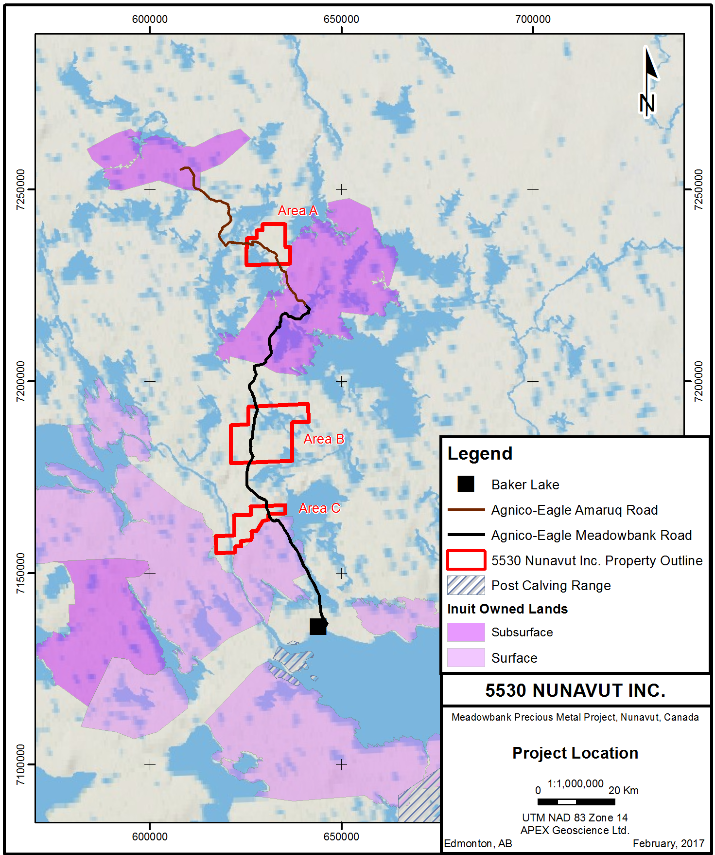

Appendix 2: Example Daily and/or Weekly Hazardous Waste Containment Inspection Record



