ABANDONMENT AND RESTORATION PLAN

MEADOWBANK PRECIOUS METAL PROPERTY
NUNAVUT, CANADA

Prepared for:
5530 Nunavut Inc.

Prepared by:


Effective Date: June 1, 2017

Contents
1 Introduction 1
1.1 Contact Details 1
1.2 Purpose and Scope 1
1.3 Other Plans 1
1.4 Property and Camp Description 1
2 Schedule 2
3 Detailed Infrastructure 3
3.1 Proposed Camp 3
3.1.1 Structures 3
3.1.2 Other Camp Infrastructure 3
3.1.3 Vehicles 3
3.1.4 Drilling Equipment 3
4 Seasonal Shut downs 4
4.1 Inspection and Documentation 4
4.2 Buildings, Content, and Fuel 4
4.3 Waste 4
4.4 Seasonal Restoration 5
5 Final Abandonment and Restoration 5
5.1 Inspection and Documentation 5
5.2 Buildings, Content, and Fuel 5
5.3 Waste 6
5.4 Restoration 6
6 Post Closure Site Monitoring 6
7 Emergency Contact Information 6
Tables
Table 7.1: Emergency Contact Information 6
Appendices
Appendix 1: Figures 8
Appendix 2: Seasonal Camp Shutdown Inspection Record 10
Appendix 3: Example Camp Inventory Record 12

Introduction
This Abandonment and Restoration Plan (ARP) applies to mineral exploration activities conducted by 5530 Nunavut Inc. (the “Company”) on the Meadowbank Precious Metal Property (the “Property”), Nunavut, Canada.
This ARP will come into effect June 1, 2017, pending approval. Copies and updates to this plan may be obtained via the Company or APEX Geoscience Ltd. (“APEX”). The ARP will be replaced, upon approval, if there are any significant changes to the activities outlined in the existing permits which warrant changes to the ARP. Minor changes will be submitted as an addendum to the ARP and submitted to the distribution list as required.

Contact Details
5530 Nunavut Inc. | APEX Geoscience Ltd.
2205-1211 Melville Street | 110-8429-24 Street NW
Vancouver, BC V6E 0A7 | Edmonton, AB T6P 1L3
Tel: (778) 389-7274 | Tel: (780) 467-3532
Fax: (780) 467-4025
www.apexgeoscience.com

Purpose and Scope
The purpose of the Meadowbank Precious Metal Property ARP is to provide guidelines to follow during seasonal shutdown and final abandonment of the Property, in order to return exploration sites to as near as possible to natural conditions.

Other Plans
The ARP should be considered as a part of the property wide management system. Other management plans in place at the Meadowbank Precious Metal Property include:
Emergency Response Plan (ERP)
Environmental Management Plan (EMP)
Fuel Management Plan (FMP)
Spill Prevention and Response Plan (SPRP)
Waste Management Plan (WMP)

Property and Camp Description
The Meadowbank Precious Metal Property is located in the Kivalliq Region of Nunavut, within the 1:250,000 scale NTS map sheets, 66A and 66H. The Property is approximately 30 to 100 km north of the community of Baker Lake. The Property consists of three project areas: Area A to the north, Area B in the centre and Area C to the south (Figure 1 in Appendix 1).
The proposed exploration program will be supported by a temporary, 6 to 10 person exploration camp. The program is anticipated to commence June 15th, 2017 and run for 6 weeks (42 days). INAC, NWB and NIRB will be notified 30 days prior to the establishment of the camp and fuel cache. Personnel and cargo will be transported to the camp along the Agnico-Eagle Meadowbank Road and then flown to site via helicopter. Structures for the proposed camp may include 4 sleeper tents, 1 kitchen, 1 dry, 1 generator shack, and 1 outhouse. The majority of the structures will be insulated Weatherhaven tents, or similar, with tarp floors (Figure 2 in Appendix 1).
A fuel cache of less than 4,000 L (approximately 19 drums) will be established on stable ground near the camp, primarily to store diesel and jet fuel. Small quantities of gasoline and propane will also be stored. Small temporary fuel caches (less than 4,000 L), may also be required to supply the drilling and exploration programs. Within 30 days of the establishment of any temporary fuel cache, the appropriate agencies will be notified of the details of the cache including: GPS location, fuel type, container sizes, method of storage and proposed date of removal. The temporary fuel cache GPS locations will also be included in the annual reports submitted to the INAC, NWB and NIRB.
The proposed 2017 exploration activities for the Meadowbank Precious Metal Property include prospecting, till sampling and ground geophysical surveys. The intent of the 2017 exploration program is to delineate targets for diamond drilling. As soon as targets are identified for drilling INAC, NWB and NIRB will be notified and supplied with locations and maps. All exploration work and drilling will be strictly confined to the Areas A, B and C (Figure 1 in Appendix 1).

Schedule
The 2017 exploration program is projected to start June 15 and run for 6 weeks (42 days). Prior to subsequent years program commencements all the regulatory authorities and will be notified and supplied with updated schedules.
As a generalized guide for future timing of activities, equipment and supplies, including camp construction materials, will be mobilized in the spring. It is expected that camp construction will take approximately 1 week. Fieldwork, including mapping, prospecting, geochemical sampling, and ground geophysical surveys can be expected to commence as soon as camp construction begins and run through July and August. Drilling will commence as soon as targets are identified and all equipment can be mobilized, most likely at the beginning of July and may have the potential to continue through the winter. As best as possible, camp location and drilling of targets will be timed appropriately to accommodate for caribou migration and calving timing and areas.
Exploration programs which include geological mapping, prospecting, geochemical sampling, ground geophysical surveys and drilling are anticipated for 3 to 4 subsequent years, depending on each of the previous year’s results.
Final abandonment and restoration will commence as soon as possible after it has been determined that the project does not warrant further exploration or following commercial production. The duration of the final abandonment and restoration is dependent on the scale of infrastructure on site and on environmental parameters (physical, biological, and socio economic). All abandonment and restoration work will be completed prior to the date of expiry of any existing or future applicable land use permits and water licenses.

Detailed Infrastructure

Proposed Temporary Camp
The following is a list which details the structures, equipment and vehicles that may be constructed or stored at the proposed temporary camp. Prior to construction of a more permeant camp INAC, NWB and NIRB will be notified and an amendment application will be submitted to allow for greater water usage.

Structures
4 | 12’x16’ insulated Weatherhaven tents (or similar) on tarp flooring to serve as sleeper tents and a medical tent
2 | 16’x20’ insulated Weatherhaven tents (or similar) on tarp flooring to serve as a kitchen and dry. The dry will contain 1 sink and 1 shower.
1 | 14’x16’ Weatherhaven tent (or similar) on tarp flooring to serve as housing for a 50kW diesel generator plus backup generator.
1 | 5’x5’ wooden outhouse structures

Other Camp Infrastructure
2 | Water tanks (1 for kitchen and 1 for dry)
2 | Water pumps with fish screens and hose line
1 | Small camp fuel cache, with Insta-Berm (or similar) secondary containment.

Vehicles
1 |  | Helicopter (A-Star, Bell 407, or longRanger)

Drilling Equipment
2 |  | Zinex A5 (or similar) diamond drill complete with motor, gear box, drill head, tower, overshot, skids, and housing
4 |  | Supply pump with shack
2 |  | Mix tank with pressure pump
6 |  | Coil heater
6 |  | Fuel tank
6 |  | Fly basket for drill equipment, spares, supplies, etc.
400 |  | 3 metre NQ drill rods
50 |  | NQ casing (various sizes)
150 |  | 100’ hose line

Seasonal Shut downs

Inspection and Documentation
It is anticipated that the temporary fly camp will be completely removed at the end of the 2017 exploration program. If drilling targets are identified on the project a larger and more permeant camp will be required. Prior to a seasonal shutdown of a permeant camp, a complete inspection of all areas will be conducted. Photographs will be taken to document the conditions prior to leaving the site, and will be archived along with photos taken at the beginning of each season. Copies of these photos will be included as part of the Meadowbank Precious Metal Property Annual Report. A copy of the Seasonal Camp Inspection Record is attached in Appendix 2.

Buildings, Content, and Fuel
A full inventory of all structures, equipment, fuel, and other supplies will be taken at the beginning and end of each exploration season. An example of the Camp Inventory Record is attached in Appendix 3.
All food, fuel, wastes, empty fuel drums, and valuable or sensitive equipment will be removed from site. A few wooden structures will be left at the camp. All structures to be left on site will be winterized, closed off, and secured. One structure will be designated to house any chemicals or other hazardous materials that are not suited to outdoor storage. All water tanks and pipes will be drained at the end of each season. Pumps and hoses will be drained and stored inside a secured structure. All mechanical equipment, including vehicles, drill equipment, and generators will be winterized and stored in berms for secondary containment. When possible, the equipment and berms will be fully covered.
All remaining fuel and empty drums will be removed from site.

Waste
All 2017 wastes will separated into combustible, recyclable or hazardous and backhauled for proper disposal. When a larger and more permanent camp is required the following waste treatments will be used:
Combustible Waste: All combustible waste will be incinerated in accordance with the Nunavut Environmental Guideline for the Burning and Incineration of Solid Waste. Any residual waste (ash) will be placed in sealed containers and backhauled for proper disposal.
Non-Combustible, Recyclable and Hazardous Waste: All non-combustible, recyclable and hazardous wastes will be sealed in appropriate containers and backhauled to Yellowknife for proper disposal.
Grey Water: Camp greywater will be stored and treated in an excavated sump, which will allow for slow infiltration into the soil and will be located at least 31 m away from the high water mark of any water body. If available, coarse gravel will be placed in the bottom of the sump to provide filtration, and supports will be built on the sides to prevent slumping. Filters will be installed on kitchen drains to ensure solid food wastes do not enter the sumps and have the potential to attract wildlife. When full, greywater sumps will be covered with enough material to allow for future ground settlement.
Sewage: Privy pits (outhouses) will be located at least 31 m away from a water body. To control sewage pathogens, outhouses will be periodically treated with lime. When full, the pits will be covered with at least 30 cm of compacted soil.
Contaminated soils/snow: All contaminated soil will be stored in empty 205 liter drums, and will be transported to Yellowknife for proper disposal.
Empty barrels/ fuel drums: Empty drums will be collected and transported to Yellowknife either for disposal at an approved site or for refilling.
For more information on waste generation and management see the Muskox Diamond Property “Waste Management Plan.”

Seasonal Restoration
Any contaminated areas around the camp or drill sites will be treated in accordance with the Meadowbank Precious Metal Property “Spill Prevention and Response Plan.” Any washed out areas will be filled and re-contoured to natural levels. Any areas of disturbed vegetation, including camp, fuel caches or drill sites will be photographed and managed as per recommendation of the INAC inspector. Remediation procedures might include fertilization to encourage re-growth.

Final Abandonment and Restoration

Inspection and Documentation
Prior to final abandonment, a thorough inspection of all areas will be conducted. Any contaminated areas around the camp or drill sites that have gone unnoticed will be treated as per the “Spill Prevention and Response Plan.” Photographs will be taken to include in the final reports submitted to the INAC Inspector and as part of the Annual Report submitted to the INAC, NWB and NIRB. All relevant regulatory agencies will be notified upon final abandonment of the Property.

Buildings, Content, and Fuel
Prior to land use permit, claim or lease termination, all structures, equipment, supplies, and fuel will be removed from the Property with the exception of the drill core stacks, which will be permanently secured on site.
Any wooden floors will be burned in accordance with the Nunavut Environmental Guideline for the Burning and Incineration of Solid Waste, and tent sites may be fertilized, as per recommendation by the Inspector, to encourage re-vegetation. The open burning of structures will only occur after approval from INAC and NWB. A request letter will be submitted to the regulating authorities, which will include the characteristic and volume of material to be burned.
Any materials of value on site will be salvaged. Local businesses and residents will have the opportunity to salvage any remaining materials that will otherwise be disposed of.
Drills and drilling equipment will be dismantled, packaged, secured, and shipped as per the drill contract. All drill casing will be removed from the ground or cut down to ground level if removal is not possible.
All remaining fuel and empty drums will be removed from site. The soil under and surrounding any area where fuel was stored will be thoroughly inspected for any contamination and photographs will be taken.

Waste
All wastes will be disposed of in accordance with the Meadowbank Precious Metal Property “Waste Management Plan” and any contamination will be treated as per the “Spill Prevention and Response Plan”. Sumps will be inspected to ensure there is no leaching or run-off. Back filling and leveling will be employed as necessary.

Restoration
Tent sites, drill sites, and any other areas disturbed by activities related to exploration at the Muskox Diamond Property will be fertilized as recommended by INAC Inspector to encourage re-vegetation. Eroded or washed out areas related to exploration activities will be filled and re-contoured to natural levels. Any contaminated areas around the camp or drill sites that have gone unnoticed will be treated as per the “Spill Prevention and Response Plan.”

Post Closure Site Monitoring
After reclamation is complete, annual monitoring may take place. If required, the monitoring may consist of soil and water testing, measuring and documenting plan re-growth, examining potential run-off and erosion problems, and checking the stability and condition of the core boxes. Reports, including photographs, will be submitted to the appropriate regulatory bodies. The monitoring will continue as long as the regulating bodies deem it necessary.

Emergency Contact Information
Table 7.1: Emergency Contact Information
Contact | Telephone Number
Rob L’Heureux, Vice President and Project Supervisor - APEX Geoscience Ltd. | 780-439-5380 (office)  780-916-5482 (mobile)
Fabio Capponi (5530 Nunavut Inc.) | (778) 389-7274 (mobile)
INAC (Nunavut) | 1-800-567-9604
INAC Manager of Field Operations | (867) 975-4295 (phone)  (867) 979-6445 (fax)
Nunavut Water Board | 867-360-6338
Environment Canada | 867-975-4644  24-hr page: 867-766-3737
DFO (Central and Arctic Branch) | 519-383-1813
Government of Nunavut Department of Environment | 867-975-7700 (Iqaluit)

Appendix 1: Figures

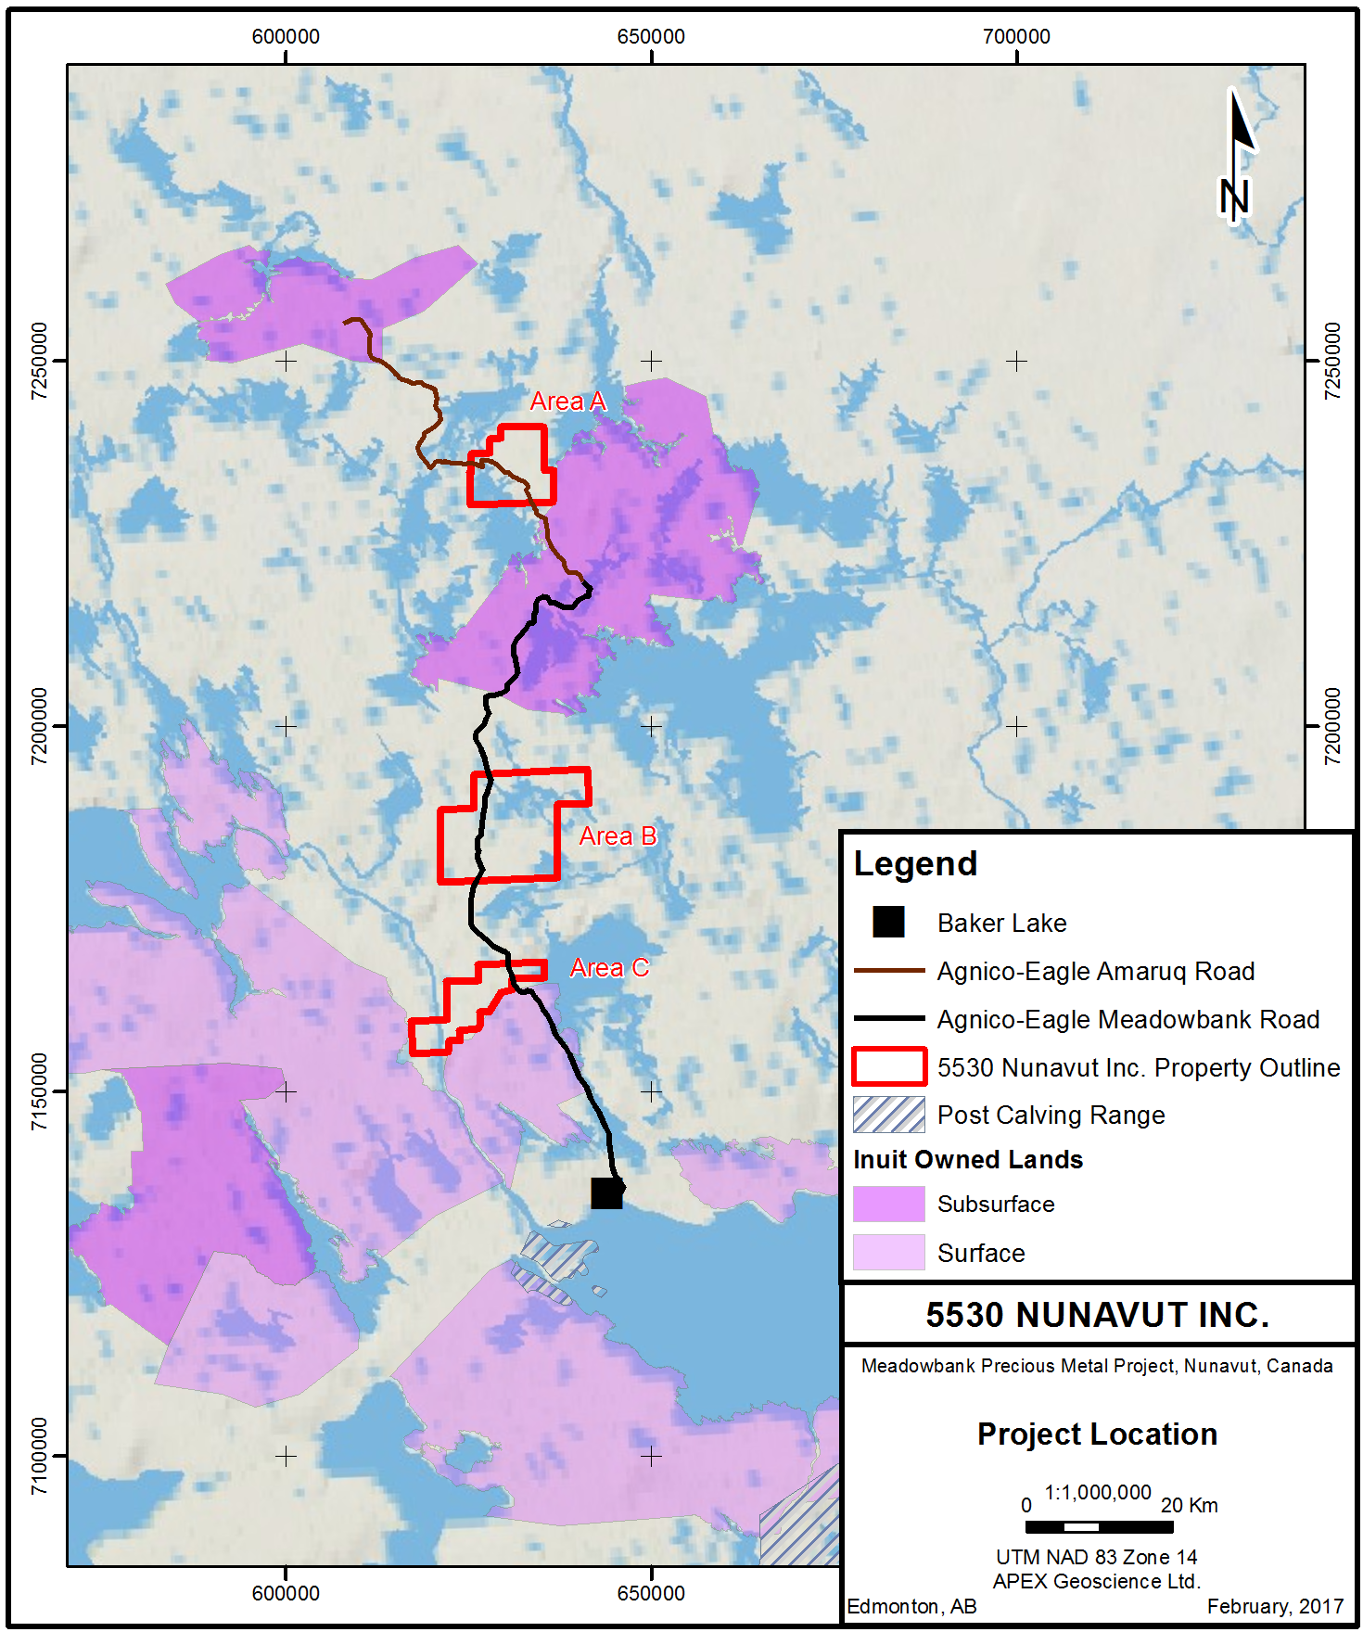

Appendix 2: Seasonal Camp Shutdown Inspection Record

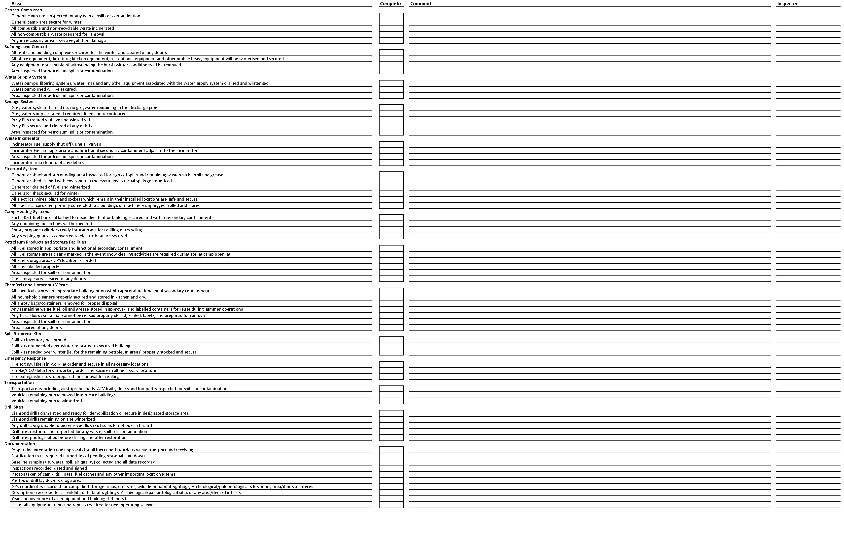

Appendix 3: Example Camp Inventory Record



