Institute of Ocean Sciences
9860 West Saanich Road
Sidney, B.C. Canada
V8L 4B2
Institut des Sciences de la Mer

9860 West Saanich Road
Sidney, B.C. Canada
V8L 4B2
1 Feb 2018


ᒧᓴ ᑰᑦ
ᖃᐅᔨᓴᕐᓂᕐᒧᑦ ᑲᒪᔨ
ᓄᓇᕗᒻᒥ ᖃᐅᔨᓴᖅᑐᓕᕆᔨᒃᑯᑦ (NRI)
ᐃᖃᓗᐃᑦ, ᓄᓇᕗᑦ
X0A 0H0

ᐃᔅᓯᕙᐅᑕᖅ
ᓄᓇᕗᒻᒥ ᐱᕙᓪᓕᐊᔪᓄᑦ ᖃᐅᔨᓴᖅᑏᑦ ᑲᑎᒪᔨᖏᑦ (NIRB)
P.O Box 1360
ᐃᖃᓗᑦᑑᑦᑎᐊᖅ, ᓄᓇᕗᑦ
X0B 0C0

ᐱᔾᔪᑎᒋᔭᖓ: ᓱᓇᒃᑯᑖᓂᒃ ᖃᐅᔨᓴᕐᓂᕐᒧᑦ ᓚᐃᓴ #0402817N-M 2017 ᐅᑭᐅᑕᒫᑦ ᐅᓂᒃᑳᓕᐊᑦ ᐊᒻᒪᓗ 2018 ᐸᕐᓇᐅᑎᑦ.

ᓄᓇᕗᒻᒥ ᖃᐅᔨᓴᖅᑐᓕᕆᔨᒃᑯᓐᓄᑦ, ᓄᓇᕗᒻᒥ ᐱᕙᓪᓕᐊᔪᓄᑦ ᖃᐅᔨᓴᖅᑏᑦ ᑲᑎᒪᔨᖏᑦ ᐊᒻᒪᓗ ᐱᔪᒪᔪᑦ ᐃᑲᔪᖅᑎᒌᖑᔪᓄᑦ,

ᑖᔅᓱᒧᖓ ᑎᑎᕋᖅᑕᐅᓯᒪᔪᒧᑦ, ᐅᓂᒃᑳᒐᔅᓴᓕᐅᖅᓯᔪᒍᑦ 2017 ᑕᕆᐅᒥ-ᐊᔾᔨᓕᐅᖅᓯᓂᖅ ᖃᐅᔨᓴᕈᑎᔅᓴᓂᒃ ᐊᒻᒪᓗ ᓱᓇᒃᑯᑖᓂᒃ ᖃᐅᔨᓴᕐᓂᕐᒧᑦ ᕿᑎᕐᒥᐅᑦ ᑕᕆᐅᖓᓂ, ᐱᓕᕆᐊᕆᔭᐅᓚᐅᖅᑐᑦ ᐅᑭᐅᖅᑕᖅᑐᒥ ᓱᓇᒃᑯᑖᓂᒃ ᖃᐅᔨᓴᕐᓂᕐᒧᑦ ᑐᙵᕝᕕᒃᑯᑦ RV ᒫᕐᑎᓐ ᐳᒡᒪᓐ ᐊᐅᓚᓂᐊᖅᑐᑦ ᐃᖃᓗᑦᑑᑦᑎᐊᒥᑦ. ᑕᒪᒃᑯᐊ ᐱᓕᕆᐊᕆᔭᐅᔪᑦ ᐱᐊᓂᑦᑎᐊᓚᐅᖅᑐᑦ ᐊᒥᓱᓄᑦ ᐅᑭᐅᓄᑦ ᓄᓇᕗᒻᒥ ᖃᐅᔨᓴᖅᑐᓕᕆᔨᒃᑯᑦ ᓚᐃᓴ ᓈᓴᐅᑎᖓᒍᑦ: 0402817N-M. ᓇᓗᓇᐃᖅᓯᖃᑕᐅᓯᒪᔪᒍᑦ ᐸᕐᓇᐅᑎᒋᓂᐊᖅᑕᑦᑎᓐᓂᒃ ᑖᔅᓱᒧᖓ ᐅᑭᐅᖓᓄᑦ, 2018 ᓇᔪᕐᕕᐅᔪᒥ ᐊᐅᔭᒃᑯᑦ, ᓚᐃᓴᒋᔭᖓᒍᑦ. ᓱᓇᒃᑯᑖᓂᒃ ᖃᐅᔨᓴᕐᓂᕐᒧᑦ ᐃᓱᒫᓘᑎᖃᖅᑐᑦ ᑐᑭᓯᐊᔪᓐᓇᕐᓂᕐᒧᑦ ᑕᕆᒥ-ᐊᔾᔨᓕᐅᖅᓯᓂᕐᒧᑦ ᕿᑎᕐᒥᐅᑦ ᑕᕆᐅᖓᓂ ᐊᒻᒪᓗ ᖃᐅᔨᓴᕐᓗᓂ ᖃᓄᐃᓕᓲᖑᓂᖏᑦ ᐊᐅᓚᕙᓪᓕᐊᓂᖏᓐᓄᑦ ᑕᕆᐅᑉ ᐆᒪᔪᑎᖏᓐᓂᑦ ᑰᒃᑐᒃᑯᑦ ᐊᒻᒪᓗ ᑎᓂᓂᖓᓄᑦ-ᐊᐅᓚᓂᖏᑦ ᐊᑯᕙᓪᓕᐊᔪᑦ ᑐᐊᑦᑐᒃᑯᑦ ᐊᒻᒪᓗ ᐃᒃᑲᑦᑐᒃᑯᑦ ᑰᒃᑐᓂ. ᑕᐃᒫᒃ ᑖᔅᓱᒧᖓ ᐱᔾᔪᑎᖃᖅᑐᒍᑦ ᑕᕆᐅᒃᑯᑦ-ᐊᔾᔨᓕᐅᕆᓂᕐᒧᑦ ᐆᑦᑐᕋᕐᓂᖅ ᓄᓇᒋᔭᐅᔪᓕᒫᓂ ᐊᒻᒪᓗ ᑐᕌᖅᓯᒪᔭᐅᔪᒃᑯᑦ ᖃᐅᔨᓴᕈᑕᐅᔾᔪᓯᔅᓴᓂᒃ ᑰᒻᒥ ᐊᒻᒪᓗ ᑰᑉ ᖃᓂᐊᑕ ᐃᓱᒪᒋᔭᑦᑎᒍᑦ ᐱᕚᓪᓕᔪᓐᓇᖁᓪᓗᒋᑦ ᐆᒪᔪᓕᕆᓂᕐᒧᑦ ᐱᕙᓪᓕᐊᔾᔪᑎᔅᓴᓂᒃ.

2017 ᐅᑭᐅᑕᒫᒧᑦ ᓇᐃᓈᖅᓯᒪᔪᑦ ᐅᓂᒃᑳᓕᐊᑦ:
ᕿᒥᕈᐊᖅᑕᕗᑦ ᕿᑎᕐᒥᐅᓂ ᑕᕆᐅᖓᓂ 2017 ᐅᑯᐊᖑᔪᑦ:
1. ᐊᑯᓂᐅᙱᑦᑐᒃᑯᑦ ᐅᓪᓗᑕᒫᑦ-ᐃᖏᕐᕋᖃᑦᑕᕐᓂᖅ ᕕᓐᓖᓴᓐ ᕿᑭᖅᑕᖏᓐᓄᑦ ᕿᓚᔅᓯᒪᔪᒃᑯᑦ ᐊᐅᓚᓂᖓᓄᑦ. ᓇᔪᕐᕕᐅᔪᑦ ᑕᑯᔅᓴᐅᔪᑦ ᐊᔾᔨᙳᐊᓂ 1. ᑖᒃᑯᐊ ᕿᓚᒃᓯᒪᔪᒥᒃ ᖃᐅᔨᓴᕈᑎᔅᓴᓂᒃ ᐆᑦᑑᑎᔅᓴᓂᒃ ᐃᒪᐅᑉ ᐊᐅᓚᓂᖓᓄᑦ, ᐅᐊᔭᒨᖅᑐᓄᑦ ᖃᐅᔨᓴᕐᓂᖅ ᖁᐃᔭᕐᓇᖅᑐᓂᙶᖅᑐᓂᒃ ᐊᒻᒪᓗ ᐃᖃᓗᓐᓂ, ᐃᒃᑮᕐᓇᕐᓂᖏᓐᓄᑦ ᑕᕆᐅᖃᕐᓂᖓ, ᐃᒪᐅᑉ ᐱᒡᒍᓂᖓ, ᐱᕈᖅᓯᐊᑦ ᓯᕿᓂᒃᑯᑦ ᓂᕿᒋᕙᒃᑕᖏᑦ, ᐃᑯᒪᓂᖓ ᐊᐅᓚᓂᖓ, ᐃᒪᙳᖅᓯᒪᔪᑦ ᐊᒻᒪᓗ ᐃᒪᐅᑉ ᐊᑖᓂᑦ ᐃᓱᒪᒋᔭᐅᔪᓗᒃᑖᓄᑦ ᐃᑭᒧᑦ. ᐃᓚᒋᐊᕐᓗᒋᑦ ᕿᓚᒃᓯᒪᔪᒥᑦ ᐃᓕᔭᐅᓚᐅᖅᑐᑦ ᑕᕕᓐ ᐊᒻᒪᓗ ᔪᓂᐊᓐ ᐃᒪᖓ CCGS ᓲᕐ ᕕᓕᐊᒻ ᓗᐊᕆᐄ ᐅᒥᐊᕐᔪᐊᖓᒍᑦ ᖃᐅᔨᓴᕐᓗᒋᑦ ᐊᐅᓚᓂᖏᑦ ᐃᒪᒧᑦ ᕿᑎᕐᒥᐅᑦ ᑕᕆᐅᖓᓂ ᐊᒻᒪᓗ ᐊᑦᒧᓯᓐ ᒐᕝ ᐃᒪᖓᒍᑦ.
2. ᒪᕐᕉᒃ ᐊᑯᓂᐅᓂᖅᓴᐅᔪᒃᑯᑦ ᕿᒥᕐᕈᐊᕐᓂᖅ ᕿᑎᕐᒥᐅᑦ ᑕᕆᐅᖓᓂ. ᓯᕗᓪᓕᖅᐹᖅ 20-29-ᒧᑦ ᐅᒡᒍᓯ ᖃᐅᔨᓴᕈᑎᔅᓴᓂᒃ ᑲᑎᖅᓱᐃᓗᓂ ᕕᓪᓕᓴᓐ ᕿᑭᖅᑕᖏᓐᓂ, ᑏᔅ ᐃᒪᖓᓂ ᐊᒻᒪᓗ ᑐᒃᑐᖅᓯᐅᕐᕕᒻᒥ; ᐊᒻᒪᓗ ᑐᓪᓕᖓ 03-14 ᑎᓯᐱᕆ, ᖃᐅᔨᓴᕈᑎᔅᓴᓂᒃ ᑲᑎᖅᓱᐃᓂᖅ ᑯᐃᓐ ᒪᐅᑦ ᒐᕝ, ᓯᑉᓴᓐ ᐃᒪᖓᓂ, ᕋᔅᒥᐅᓴᓐ ᓄᓇᖓ, ᐅᒃᑯᓯᒃᓴᓕᒃ ᐊᒻᒪᓗ ᕇ ᐃᒪᖓ. ᓇᔪᕐᕕᐅᔪᑦ, ᐊᔾᔨᒌᙱᑦᑐᒃᑯᑦ ᑲᑎᖅᓱᐃᓂᖅ ᖃᐅᔨᓴᕈᑎᔅᓴᓂᒃ, ᐊᒻᒪᓗ ᐅᒥᐊᕐᔪᐊᖅ ᑕᑯᔅᓴᐅᔪᑦ ᐊᔾᔨᙳᐊᓂ ᐊᒻᒪᓗ ᑎᑎᕋᖅᓯᒪᔪᓂ 1-4.

ᑎᑎᕋᖅᓯᒪᔪᑦ/ᖃᐅᔨᓴᕈᑎᔅᓴᐃᑦ ᑲᑎᖅᓱᖅᑕᐅᓯᒪᔪᑦ ᐅᑯᐊᖑᔪᑦ:
a) ᖃᐅᔨᓴᕐᓂᖅ ᐊᐅᓚᓂᖓᓂᒃ ᐊᒻᒪᓗ ᓄᓇᐅᑉ-ᓱᕋᕐᓇᖅᑐᖃᕐᓂᖏᓐᓄᑦ ᓇᔪᕐᕕᐅᔪᑦ ᑕᕆᐅᑉ ᐃᒪᖓᓂ ᖃᐅᔨᓴᕈᑎᔅᓴᓂᒃ ᐊᑐᕐᓂ ᐃᓕᔭᐅᔪᖅ ᐅᒥᐊᕐᔪᐊᒥᑦ ᐊᒻᒪᓗ ᐃᒪᒥᒃ ᖃᐅᔨᓴᕈᑎᔅᓴᓂᒃ ᑲᑎᖅᓱᐃᓂᖅ;
b) ᑲᑎᖅᓱᐃᓂᖅ ᓴᐅᔭᐅᓯᒪᔪᓂᒃ ᖃᐅᔨᓴᕈᑎᔅᓴᓂᒃ ᐆᑦᑐᕋᕐᓗᒋᑦ ᕿᒪᒃᑕᐅᓯᒪᔪᒥᓂᕐᓂᑦ ᐊᒻᒪᓗ ᐊᖏᓂᖓᑕ ᑕᕆᐅᑉ ᓇᑎᐊᑕ ᐆᒪᓂᖓ;
c) ᒥᑭᔪᓂᑦ ᒪᑦᑎᑕᐅᑎᓂᒃ ᐊᑐᕐᓂᖅ ᑲᑎᖅᓱᐃᓗᓂ ᒥᑭᔪᕋᓛᑦ ᐆᒪᔪᓂᒃ ᖃᐅᔨᓴᕈᑎᔅᓴᓂᒃ;
d) ᑲᑎᖅᓱᐃᓂᖅ ᖃᐅᔨᓴᕈᑎᔅᓴᓂᒃ ᑰᑉ ᐃᒪᖓᓂᑦ ᖃᓂᐊᑕ ᓄᓇᐅ-ᓱᕋᕐᓇᖅᑐᓂᒃ ᐃᓚᔅᓴᓂᓐᓄᑦ ᖃᐅᔨᓴᕐᓂᖅ ᐊᖏᓂᖅᓱᓂᑦ ᑰᓐᓂᙶᖅᑐᓂᒃ ᐊᒻᒪᓗ ᖃᐅᔨᓴᕐᓗᑕ ᓄᓇᒥᑦ-ᑕᕆᐅᒧᑦ ᑲᑎᕙᓪᓕᐊᓂᖏᓐᓂ;
e) ᐃᓕᓯᓗᓂ ᖄᖓᑕ ᒪᑦᑎᑕᐅᑎᓂᒃ ᐆᑦᑐᕋᕐᓗᓂ ᖄᖓᑕ ᒪᓕᑦᑐᓂᒃ ᐊᒻᒪᓗ ᓇᓗᓇᐃᖅᓯᒋᐊᕐᓗᑕ ᑲᑎᕙᓪᓕᐊᓂᖏᑦ ᐊᔾᔨᒌᙱᑦᑐᒃᑯᑦ ᐃᓚᒌᒃᑐᓄᑦ ᑕᕆᐅᒥ;
f) ᐃᓕᓯᓗᓂ ᒥᑭᔪᓂᑦ ᓇᐃᑦᑐᓂᒃ ᕿᓚᒃᓯᒪᔪᒥᑦ (ᓇᓂᔭᐅᔪᑦ ᕿᒥᕐᕈᐊᖅᑎᓪᓗᒋᑦ) ᐆᑦᑐᕋᐅᑕᐅᓗᑎᒃ ᓄᓇᒋᔭᐅᔪᒥ ᐅᓕᓐᓂᖓᓄᑦ ᐊᐅᓚᓂᖏᑦ ᐊᒻᒪᓗ ᑲᑎᔭᐅᕙᓪᓕᐊᔪᑦ;
g) ᓇᑭᙶᖅᓯᒪᓂᖓᒍᑦ ᐊᒥᓲᕙᓪᓕᐊᓂᖏᑦ ᓇᓚᐅᑦᑕᐅᖅᑖᖅᓯᒪᔪᒃᑯᑦ ᐅᒥᐊᕐᔪᐊᒥ ᐆᓇᖅᑎᑕᐅᕙᓪᓕᐊᔪᑦ ᐃᒪᑉ ᖃᐅᔨᓴᕈᑕᐅᓂᐊᖅᑐᑦ.

ᑲᑎᖅᓱᖅᑕᐅᔪᑦ ᖃᐅᓯᔭᖅᑕᐅᓂᐊᖅᑐᑦ ᑕᒪᒃᑮᓐᓂ ᐃᒻᒥᒃᑰᖓᔪᒃᑯᑦ ᐃᓚᖃᖅᑐᑦ ᐃᓕᓯᓗᑎᒃ CTD/Rosette ᑎᑎᕋᖅᐸᓪᓕᐊᓗᒋᑦ ᑕᕆᐅᑉ ᖄᖓᓂᑦ ᑕᕆᐅᑉ ᓇᑎᐊᓄᑦ ᐊᒻᒪᓗ ᑲᑎᖅᓱᐃᓗᓂ ᐃᒪᐃᑦ ᖃᐅᔨᓴᕈᑕᐅᓂᐊᖅᑐᓂᒃ, ᐃᓕᓯᓗᓂᓗᓂ ᐃᒪᐅ ᐊᑖᓄᑦ ᐊᔾᔨᓕᐅᕈᑎᒥᒃ ᓂᐱᓕᐅᕐᓗᒍ ᑕᕆᐅᑉ ᓇᑎᐊᑕ, ᐃᓕᓯᓗᓂ ᑎᒍᓯᓲᖑᔪᒥᑦ ᓴᓇᓯᒪᔪᒥᒃ ᑲᑎᖅᓱᐃᓗᓂ ᓴᐅᔭᐅᓯᒪᔪᒥᓂᕐᓂᑦ, ᐊᒻᒪᓗ ᐃᓕᓯᓗᓂ ᒥᑭᔪᓂᑦ ᒪᑦᑎᑕᐅᑎᓂᑦ ᐆᒪᔪᕋᓛᓂᑦ ᑲᑎᖅᓱᐃᓗᓂ. ᑲᔪᓰᓐᓇᖅᑐᒍᑦᑕᐅᖅ ᐊᐅᓚᑕᐅᔪᑦ ᓴᓇᔭᐅᕙᓪᓕᐊᓯᒪᔪᑦ ᓴᓇᕐᕈᑕᐅᓂᐊᖅᑐᒥᑦ, ᐱᔪᓐᓇᐅᑎᑕᖃᖅᑎᑦᑎᓪᓗᓂ ᐆᑦᑐᕋᖅᑎᓪᓗᑕ ᖃᐅᔨᓴᕐᓗᒋᑦ ᓱᕈᕐᓇᖅᑐᓂᒃ ᐃᓚᔅᓴᓂᒃ ᐊᒻᒪᓗ ᐃᓚᒋᔭᖏᓐᓂᑦ ᓇᑭᙶᕐᓂᖏᓐᓂᑦ ᑕᕆᐅᑉ ᐃᒪᖓᓂᑦ ᓇᑭᑐᐃᓐᓇᖅ R/V ᒫᑎᓐ ᐳᒃᒪᓐ ᐃᖏᕐᕋᑎᓪᓗᒍ. ᐊᐅᓚᑦᑎᔨ ᓱᓇᒃᑯᑖᓂᒃ ᖃᐅᔨᓴᖅᑎᔅᓴᐃᑦ ᑖᒃᑯᓄᖓ ᐱᓕᕆᐊᕆᔭᐅᔪᓄᑦ ᑯᕆᔅᑎᓇ ᐳᕋᐅᓐ. ᖃᐅᔨᒋᐊᕐᕕᒋᔭᐅᔪᓐᓇᖅᑐᖅ ᑐᑭᓯᐊᔾᔪᑎᔅᓴᒃᑲᓐᓂᕐᓂᒃ ᐱᔪᒪᔪᖃᕐᓂᖅᐸᑦ.

2018 ᐸᕐᓇᐅᑎᑦ:
ᐸᕐᓇᐅᑎᒋᔭᕗᑦ 201-ᒧᑦ ᕿᒥᕐᕈᐊᕐᓂᕐᒧᑦ ᐅᒥᐊᖅᑐᕐᓗᓂ RV ᒪᕐᑎᓐ ᐳᒃᒪᓐ ᑕᑯᔅᓴᐅᔪᑦ ᐊᔾᔨᙳᐊᓂ 5. ᑐᕌᖅᓯᒪᔭᕗᑦ ᖃᐅᔨᓴᖅᑕᐅᓂᐊᖅᑐᓂᒃ ᑲᑎᖅᓱᐃᓂᕐᒧᑦ ᑖᔅᓱᒧᖓ ᐅᑭᐅᖓᓄᑦ ᕿᒥᕐᕈᐊᕐᓂᕐᒧᑦ ᐅᒥᐊᕐᔪᐊᒃᑯᑦ RV ᒪᕐᑎᓐ ᐳᒃᒪᓐᑯᑦ ᕕᓐᓕᓴᓐ ᕿᑭᖅᑕᖓᓄᑦ, ᑯᐃᓐ ᒪᐅᑦ ᒐᕝ, ᑯᕈᓂᓴᓐ ᒑᕝ, ᑐᒃᑐᖅᓯᐅᕐᕕᒻᒧᑦ ᐊᒻᒪᓗ ᑯᐃᓐ ᒧᑦ ᒐᕝᒧᑦ. ᖃᑯᑎᒃᑰᓂᖓᓂ ᐊᒻᒪᓗ ᓯᓚ ᖃᓄᐃᙱᓐᓂᖓᓄᑦ, ᐱᐊᓂᒃᓯᒪᙱᑦᑐᓂᑦ ᐸᕐᓇᐅᑎᖃᖅᑐᒍᑦᑕᐅᖅ ᑕᑭᓪᓕᕆᐊᕐᓗᒍ ᕿᒥᕐᕈᐊᕐᓂᕐᒧᑦ ᕕᒃᑐᐊᕆᔭᐅᑉ ᐃᒪᖓᓂ ᐊᒻᒪᓗ ᓯᑉᓴᓐ ᐃᒪᖓᓂ ᐅᒃᑯᓯᒃᓴᓕᖕᒧᑦ/ᕋᔅᒥᐅᓴᓐ ᐃᑭᕋᓴᖓᓄᑦ/ ᓯᓐᑦ ᕈᔅ ᓄᓇᖓᓂ. ᕿᒥᕐᕈᐊᖅᑎᓪᓗᑕ, ᐸᕐᓇᒃᓯᒪᔪᒍᑦ ᑲᑎᖅᓱᐃᓗᑕ ᖃᐅᔨᓴᕈᑎᔅᓴᓂᒃ ᑰᑉ ᐹᖓᑕ ᖁᕐᓗᖅᑐᒥ ᑰᖓᓂ, ᓇᐹᖅᑐᑦ ᑰᖓᓂ, ᕼᐅᑦ ᑰᖓᓂ, ᐴᓐᓴᐃᑦ ᐅᐊᓕᓂᕐᒥ ᑰᒃ, ᐃᓕᔅ ᑰᖓ ᐊᒻᒪᓗ ᑲᓖᑦ ᑰᖓ ᐊᒻᒪᓗ ᐱᓕᕆᐊᕆᓗᒋᑦ ᑐᕌᔭᐅᔪᑦ ᓱᓇᒃᑯᑖᓂᒃ ᖃᐅᔨᓴᕐᓂᕐᒧᑦ ᐅᓕᖃᑦᑕᕐᓂᖏᑦ ᐃᒪᖏᑦ ᕕᓐᓕᓴᓐ ᕿᑭᖅᑕᖏᓐᓂ ᐊᒻᒪᓗ ᑐᒃᑐᒃᓯᐅᕐᕕᒻᒥ. ᑕᒪᓐᓇ ᑲᔪᓯᓐᓂᖓᓄᑦ ᐱᓕᕆᐊᔅᓴᖅ 2017-ᖑᑎᓪᓗᒍ, ᐸᕐᓇᐅᑎᒋᓚᐅᖅᑕᕗᑦ ᖃᐅᔨᓴᕈᑎᔅᓴᐃᑦ ᑲᑎᖅᓱᑕᐅᓯᒪᔪᑦ, ᓴᓇᕐᕈᑏᑦ ᐊᒻᒪᓗ ᖃᓄᐃᓕᐅᕐᓂᕆᔭᐅᔪᑦ ᐊᔾᔨᒌᑐᐃᓐᓇᖅᑐᑦ. ᐱᓕᕆᐊᔅᓴᕗᑦ RV ᒪᑎᓐ ᐳᒃᒪᓐ ᐱᓕᕆᓂᐊᖅᑕᕗᑦ 1 ᐅᒡᒍᓯ 2018 ᐊᒻᒪᓗ 30 ᓯᑎᐱᕆ 2018-ᒧᑦ ᐊᒻᒪᓗ ᐃᓚᒋᔭᐅᓂᐊᖅᑐᑦ ᑎᑎᕋᖅᓯᒪᔪᑦ ᓇᓗᓇᐃᒃᑯᑕ 7 ᐊᑖᓂ.
ᐃᓚᒋᐊᕐᓗᒋᑦ ᐊᐅᔭᒃᑯᑦ ᑕᕆᐅᒥ-ᐊᔾᔨᓕᐅᕆᓂᕐᒧᑦ ᖃᐅᔨᓴᕈᑎᔅᓴᐃᑦ ᑲᑎᖅᓱᖅᑕᐅᓯᒪᔪᑦ ᐸᕐᓇᒃᓯᒪᔪᒍᑦ ᑭᓪᓕᖃᖅᑐᓂᒃ ᐅᑭᐅᒧᑦ ᑎᑭᓪᓗᒍ ᑕᕆᐅᒥ-ᐊᔾᔨᓕᐅᕆᓂᕐᒧᑦ ᖃᐅᔨᓴᕈᑎᔅᓴᐃᑦ ᑲᑎᖅᓱᖅᑕᐅᓂᖅᑐᑦ 2018-ᒥ ᓇᓗᓇᐃᖅᑕᐅᓯᒪᔪᒃᑯᑦ ᐃᑲᔪᖅᑕᐅᓂᐊᖅᑐᑦ CAT-TRAIN-ᑯᓐᓄᑦ ᐊᒻᒪᓗ ᐱᕙᓪᓕᐊᓗᓂ ᐊᖅᑯᑎ ᐊᑐᕐᓗᒍ CAT-TRAIN-ᑯᓐᓄᑦ ᐃᒻᒪᖄ ᒪᔨ ᐊᑯᓐᓂᖓᓂ ᐊᒻᒪᓗ ᐊᐃᕆᓕ ᓄᙳᐊᓄᑦ ᑎᑭᓪᓗᒍ. ᑕᒪᓐᓇ ᑲᑎᖅᓱᖅᑕᐅᓯᒪᔪᑦ ᖃᐅᔨᓴᕈᑎᔅᓴᐃᑦ ᐊᑐᐃᓐᓇᐅᔪᑦ ᐱᐊᓂᑕᐅᓯᒪᑉᐸᑕ NIRB-ᑯᓐᓄᑦ ᑐᔅᓯᕋᐅᑎ ᓈᓴᐅᑎᖓ 125210 ‘CAT-TRAIN: ᑲᓇᑕᐅᑉ ᐅᑭᐅᖅᑕᖅᑐᖓᓂ ᐅᓕᖃᒃᑕᕐᓂᖓᓄᑦ ᐊᖅᑯᑎ ᓱᓇᒃᑯᑖᓄᑦ ᖃᐅᔨᓴᕐᓂᕐᒧᑦ ᐊᒻᒪᓗ ᓴᓇᕝᕖᑦ ᐃᑲᔪᖅᑎᒌᒃᑐᑦ (2018-2020)’. ᑲᑎᖅᓱᖅᑕᐅᓯᒪᔪᑦ ᖃᐅᔨᓴᕈᑎᔅᓴᐃᑦ ᑭᒡᓕᖃᕋᔭᖅᑐᑦ ᖃᐅᔨᓴᕐᓗᒋᑦ ᐊᐳᑎ/ᓯᑯ ᓯᓕᓐᓂᖓᓄᑦ, CTD cast ᐱᓕᕆᐊᕆᓂᕐᒧᑦ ᐊᒻᒪᓗ ᑲᑎᖅᓱᐃᓂᖅ ᐃᒪᐃᑦ ᖃᐅᔨᓴᕈᑎᔅᓴᖏᓐᓂᑦ. ᑐᕌᖅᑕᐅᓯᒪᔪᑦ ᐊᖅᑯᑎᔅᓴᒧᑦ CAT_TRAIN-ᒧᑦ ᑕᑯᔅᓴᐅᔪᖅ ᐊᔾᔨᙳᐊᒥ 6 ᐊᒻᒪᓗ ᐃᓚᒋᔭᐅᓚᐅᖅᑐᑦ ᕿᒥᕐᕈᐊᖅᑎᓪᓗᒋᑦ ᑎᑎᕋᖅᓯᒪᔪᑦ ᓇᓗᓇᐃᒃᑯᑕᖅ 8-ᒥ.

ᓇᓗᓇᐃᔭᐃᓂᖅ:
ᐊᑐᖅᑐᒍᑦ ᐊᔾᔨᒌᙱᑦᑐᑎᒍᑦ ᑕᕆᐅᒥ-ᐊᔾᔨᓕᐅᕆᓂᕐᒧᑦ ᓴᓇᕐᕈᑏᑦ ᐊᒻᒪᓗ ᐅᑭᐅᒧᓗᑦᑖᖅ ᕿᓚᒃᓯᒪᔪᒥᑦ ᐃᒪᕐᒧᐊᖅᑎᑦᑎᓗᑕ RV ᒪᕐᑎᓐ ᐳᒃᒪᓐ ᖃᐅᔨᓴᕐᓗᑕ ᑕᕆᐅᒥ-ᐊᔾᔨᓕᐅᕆᓂᕐᒧᑦ ᕿᑎᕐᒥᐅᑦ ᑕᕆᐅᐊᓂ, ᐊᐅᓚᓂᖓᓂ ᑰᑦ ᐃᒪᖓ ᑕᕆᐅᒧᑦ ᑎᑭᓪᓗᒍ ᐊᒻᒪᓗ ᐅᓕᖃᑦᑕᕐᓂᖓ ᐱᔾᔪᑎᒋᓗᒍ ᓯᓕᙱᓐᓂᖅᓴᖓᑕ ᐃᒪᖏᓐᓂ. ᑕᒪᒃᑭᖅᓯᒪᔪᑎᒍᑦ ᐸᕐᓇᐅᑎᑕᖃᖅᑐᒍᑦ ᑐᑭᓯᐊᔾᔪᑎᒋᓗᒋᑦ ᐋᖅᑭᒃᓯᒪᓂᖏᑦ ᐊᒻᒪᓗ ᐊᐅᓚᓂᖏᑦ ᓄᓇᒋᔭᐅᔪᒥ ᐆᒪᔪᖁᑎᖏᓐᓄᑦ, ᐃᓚᖃᕋᔭᖅᑐᑦ ᓄᓇᕗᒻᒥ ᓱᓇᒃᑯᑖᓕᕆᔨᒃᑯᑦ ᐊᒻᒪᓗ ᑲᓇᑕᒥ ᖁᑦᑎᑦᑐᒥ ᐅᑭᐅᖅᑕᖅᑐᒥ ᓱᓇᒃᑯᑖᓂᒃ ᖃᐅᔨᓴᖅᑐᓕᕆᔨᒃᑯᑦ ᓱᓇᒃᑯᑖᓂᒃ ᖃᐅᔨᓴᕐᓂᕐᒧᑦ ᐊᑑᑎᒋᓗᒋᑦ ᐊᑯᓂᐅᔪᒃᑯᑦ ᓄᓇᓕᕆᓂᕐᒧᑦ ᑕᕆᐅᒥ ᖃᐅᔨᓴᕐᓂᕐᒧᑦ ᐊᒻᒪᓗ ᓱᓇᒃᑯᑖᓂᒃ ᖃᐅᔨᓴᕐᓂᕐᒧᑦ.
ᑐᙵᓱᑦᑎᑦᑎᕗᒍᑦ ᐅᖃᐅᓯᔅᓴᓂᒃ, ᖃᓄᐃᓕᐅᖁᔨᙳᐊᕐᓂᕐᓂᑦ ᐊᒻᒪᓗ ᐃᓱᒪᔅᓴᖅᓯᐅᕈᑎᔅᓴᖃᕐᓂᕈᕕᑦ ᑖᔅᓱᒧᑦ ᓱᓇᒃᑯᑖᓄᑦ ᖃᐅᔨᓴᕐᓂᕐᒧᑦ ᐊᒻᒪᓗ ᖁᕕᐊᓱᒐᔭᖅᑐᒍᑦ ᐃᑲᔪᕈᓐᓇᕐᓂᕐᒧᑦ ᑖᒃᑯᓄᖓ ᓱᓇᒃᑯᑖᓄᑦ ᖃᐅᔨᓴᕐᓂᕐᒧᑦ. ᐊᐱᖅᓲᑎᔅᓴᖃᕐᓂᕈᕕᑦ, ᖃᐅᔨᒋᐊᕈᓐᓇᖅᑐᑎᑦ ᐅᕙᑦᑎᓐᓄᑦ ᐊᒻᒪᓗ ᖁᕕᐊᓱᒐᔭᖅᑐᒍᑦ ᐅᖃᖃᑎᒋᓗᑎᑦ. ᓂᕆᐅᑉᐳᒍᑦ ᐃᖅᑲᓇᐃᔭᖃᑎᒌᒋᐊᔅᓴᒧᑦ 2018-ᒥ.
ᑎᑎᕋᖅᑐᖅ,

ᑖᒃᑐ, ᐱᐅᓪ ᕕᓕᐊᒻᔅ - ᓱᓇᒃᑯᑖᓂᒃ ᖃᐅᔨᓴᓂᕐᒧᑦ ᖃᐅᔨᓴᖅᑎ.
ᐃᖃᓗᓕᕆᔩᑦ ᐊᒻᒪᓗ ᑕᕆᐅᓕᕆᓂᖅ ᑲᓇᑕᒥ
ᑕᕆᐅᒥ ᓱᓇᒃᑯᑖᓂᒃ ᖃᐅᔨᓴᖅᑐᓕᕆᔨᒃᑯᑦ ᓴᓇᕝᕕᖓᑦ
ᓴᓇᕝᕕᒃ ᑕᕆᐅᒥ ᓱᓇᒃᑯᑖᓂᒃ ᖃᐅᔨᓴᕐᓂᕐᒧᑦ
9860 West Saanich Road
Sidney, BC
V8V 4L1
ᐅᖄᓚᐅᑎ: (250) 363-6343
ᓱᒃᑲᔪᒃᑯᑦ: (250) 363-6690
ᖃᕋᓴᐅᔭᒃᑯᑦ: Bill.Williams@pac.dfo-mpo.gc.ca

ᐱᔾᔪᑎᒋᓗᒋᑦ ᐱᓕᕆᐊᔅᓴᒧᑦ ᐃᑲᔪᖅᑎᒋᔭᐅᔪᑦ:

ᐃᑎ ᑳᕐᒪᒃ, ᐃᒧᕐᑕᔅ ᓱᓇᒃᑯᑖᓂᒃ ᖃᐅᔨᓴᖅᑎ, ᐃᖃᓗᓕᕆᔩᑦ ᐊᒻᒪᓗ ᑕᕆᐅᓕᕆᓂᖅ ᑲᓇᑕᒥ ᓴᓇᕝᕕᒃ ᑕᕆᐅᒥ ᓱᓇᒃᑯᑖᓂᒃ ᖃᐅᔨᓴᕐᓂᕐᒧᑦ, ᖃᕋᓴᐅᔭᒃᑯᑦ: Eddy.Carmack@dfo-mpo.gc.ca
ᓯᑦ ᑕᓂᐅᓴᓐ, ᓱᓇᒃᑯᑖᓂᒃ ᖃᐅᔨᓴᕐᓂᕐᒧᑦ Associate ᐃᓕᓴᐃᔨᒻᒪᕆᒃ, ᓯᓚᑦᑐᖅᓴᕐᕕᒃ ᐊᓛᔅᑲ ᕕᐅᐲᒃᔅ
ᖃᕋᓴᐅᔭᒃᑯᑦ: sldanielson@alaska.edu
ᐳᑎᐅᓪ ᐳᒻ, ᐃᓕᓴᐃᔨᒻᒪᕆᒃ, ᓯᓚᑦᑐᖅᓴᕐᕕᒃ ᑐᕋᒻᓲ, ᓄᐊᕕ
ᖃᕋᓴᐅᔭᒃᑯᑦ: bodil.bluhm@uit.no
ᑯᕆᔅᑎᓇ ᐳᕋᐅᓐ, ᐅᐸᒋᐊᖅᓯᒪᔪᖅ, ᐃᖃᓗᓕᕆᔩᑦ ᐊᒻᒪᓗ ᑕᕆᐅᓕᕆᔩᑦ ᑲᓇᑕ, ᓯᓚᑦᑐᖅᓴᕐᕕᒻᒪᕆᒃ ᑕᕆᐅᒧᑦ ᓱᓇᒃᑯᑖᓂᒃ ᖃᐅᔨᓴᕐᓂᕐᒧᑦ
ᖃᕋᓴᐅᔭᒃᑯᑦ: Kristina.Brown@dfo-mpo.gc.ca
ᐊᐃᑐᕆᔭᓐ ᓯᒻᓇᐅᔅᑭ, ᐊᐅᓚᑦᑎᔨᒻᒪᕆᒃ, ᐅᑭᐅᖅᑕᖅᑐᒥ ᓱᓇᒃᑯᑖᓂᒃ ᖃᐅᔨᓴᕐᓂᕐᒧᑦ ᑐᙵᕝᕕᖓ
ᖃᕋᓴᐅᔭᒃᑯᑦ: adrian@arcticresearchfoundation.ca
ᓯ.ᔨ. ᒪᓐᑎ, ᐃᑲᔪᖅᑎ ᐃᓕᓴᐃᔨᒧᑦ, ᐆᒪᔪᓕᕆᓂᕐᒧᑦ ᑕᕆᐅᒥ-ᐊᔾᔨᓕᐅᕆᓂᖅ, ᓯᓚᑦᑐᖅᓴᕐᕕᒃ ᒫᓂᑐᐸ
ᖃᕋᓴᐅᔭᒃᑯᑦ: CJ.Mundy@umanitoba.ca
ᐳᕆᓐᑦ ᐃᐅᔅ, ᐃᑲᔪᖅᑎ ᐃᓕᓴᐃᔨᒧᑦ, ᓄᓇᓕᕆᓂᖅ, ᓯᓚᑦᑐᖅᓴᕐᕕᒃ ᒋᐅᒍᕆ
ᖃᕋᓴᐅᔭᒃᑯᑦl: belse@ucalgary.ca
ᔮᓐ ᓂᐅᓴᓐ, ᖃᐅᔨᓴᖅᑏᑦ ᓱᓇᒃᑯᑖᓂᒃ ᖃᐅᔨᓴᕐᓂᕐᒧᑦ, ᐃᖃᓗᓕᕆᔨᒃᑯᑦ ᐊᒻᒪᓗ ᑕᕆᐅᓕᕆᔨᒃᑯᑦ ᑲᓇᑕᒥ, ᓯᓚᑦᑐᖅᓴᕐᕕᒻᒪᕆᒃ ᑕᕆᐅᓕᕆᓂᕐᒧᑦ ᓱᓇᒃᑯᑖᓂᒃ ᖃᐅᔨᓴᕐᓂᕐᒧᑦ
ᖃᕋᓴᐅᔭᒃᑯᑦ: John.Nelson@dfo-mpo.gc.ca

ᐊᔾᔨᙳᐊᑦ ᐊᒻᒪᓗ ᓇᓗᓇᐃᒃᑯᑕᐃᑦ:
1. ᓄᓇᙳᐊᖅ ᑕᑯᑎᑦᑎᔪᖅ ᖃᐅᔨᓴᕈᑎᔅᓴᓂᒃ ᐊᔾᔨᒌᙱᑦᑐᑦ ᐊᒻᒪᓗ ᓇᔪᕐᕕᖏᑦ RV ᒪᑎᓐ ᐳᒡᒪᓐ ᕿᒥᕐᕈᐊᖅᑎᓪᓗᒋᑦ 2017-ᖑᑎᓪᓗᒍ 20 ᐅᒡᒍᓯᒥ 14 ᓯᑎᐱᕆᒧᑦ.

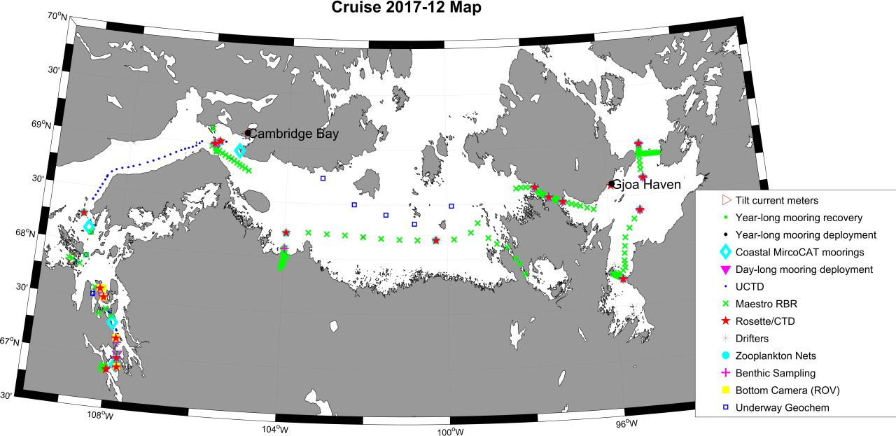

2. 2017 ᐊᖅᑯᑎᖏᑦ RV ᒪᑎᓐ ᐳᒡᒪᓐ.

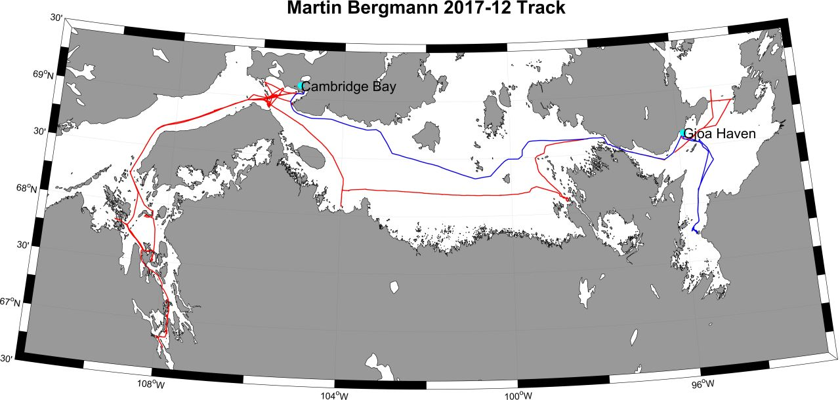
3. ᓇᓗᓇᐃᒃᑯᑕᖅ ᕿᓚᒃᓯᒪᔪᒥᑦ ᓇᔪᕐᕕᖏᑦ.
ᓇᔪᕐᕕᒃ | ᓴᓐᓂᒧᑦ | ᖁᓛᒍᑦ | ᐊᑖᓄᑦ ᐃᑎᓂᖓ
QN1-b ᕿᓚᔅᓯᒪᔪᖅ | 68.9326199 | -105.8256502 | 105
QS2 ᕿᓚᔅᓯᒪᔪᖅ | 68.9327583 | -105.8300097 | 126
UN2-a ᕿᓚᔅᓯᒪᔪᖅ | 68.9934598 | -105.8449299 | 36
UN1-b ᕿᓚᔅᓯᒪᔪᖅ | 68.9927433 | -105.843513 | 44
DS1 ᕿᓚᔅᓯᒪᔪᖅ | 69.0220313 | -105.7345725 | 88
DS3ᕿᓚᔅᓯᒪᔪᖅ | 69.0231472 | -105.7363618 | 86
DS2 ᕿᓚᔅᓯᒪᔪᖅ | 69.0213217 | -105.7368095 | 88
SC1-b ᕿᓚᔅᓯᒪᔪᖅ | 69.1314545 | -105.9477385 | 60

4. ᐊᔾᔨᙳᐊᖅ RV ᒪᕐᑎᓐ ᐳᒡᒪᓐ ᑐᒃᑐᖅᓯᐅᕐᕕᒻᒥ.
5. ᓄᓇᙳᐊᖅ ᑕᑯᑎᑦᑎᔪᖅ 2018 ᑐᔅᓯᕋᖅᑕᐅᓯᒪᔪᒃᑯᑦ ᐊᖅᑯᑏᑦ ᐊᒻᒪᓗ ᓇᔪᕐᕖᑦ ᐱᔭᐅᔪᒪᔪᑦ ᑕᕆᐅᒥ-ᐊᔾᔨᓕᐅᕆᓂᕐᒧᑦ ᖃᐅᔨᓴᕈᑎᔅᓴᓂᒃ RV ᒪᕐᑎᓐ ᐳᒡᒪᓐ ᐃᒻᒪᖄ 1 ᐅᒡᒍᓯ 2018 30 ᓯᑎᐱᕆ 2018-ᒧᑦ. ᑎᑎᕋᖅᓯᒪᔪᑦ “?” ᓇᓗᒋᔭᐅᔪᖅ ᐱᓕᕆᐊᕆᔭᐅᓗᑎᒃ ᖃᑯᑎᒃᑰᓂᖓᓄᑦ ᐊᒻᒪᓗ ᓯᑯᒧᑦ.
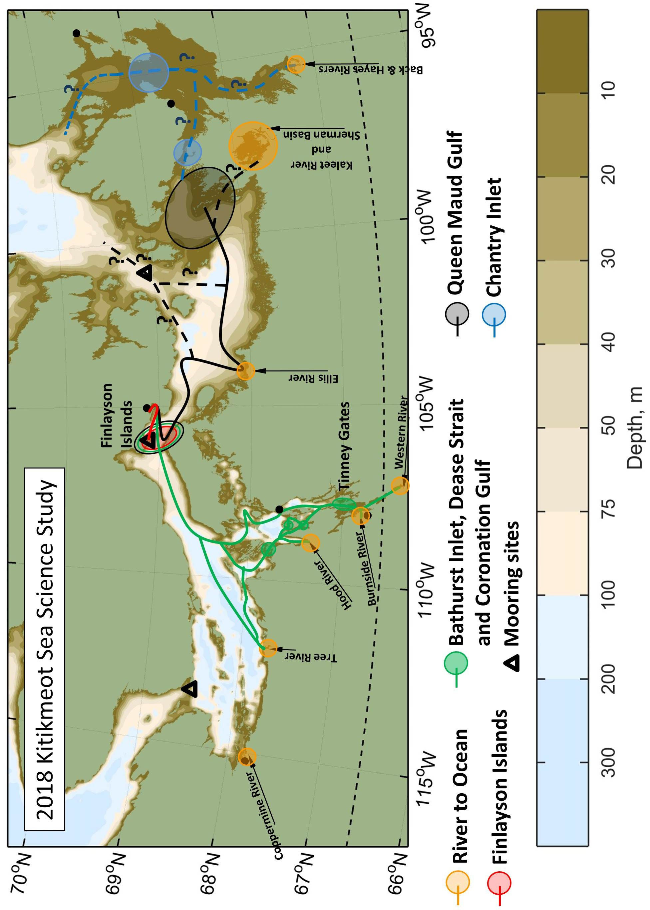
6. ᓄᓇᙳᐊᖅ ᑕᑯᑎᑦᑎᔪᖅ ᑐᔅᓯᕋᖅᑕᐅᓯᒪᔪᑦ ᐊᖅᑯᑎᖓ CAT-TRAIN-ᒧᑦ. ᐅᑭᐅᒃᑯᑦ ᑕᕆᐅᒥ-ᐊᔾᔨᓕᐅᕆᓂᖅ ᖃᐅᔨᓴᕈᑎᔅᓴᐃᑦ 2018-ᒧᑦ ᐃᑲᔪᖅᑕᐅᓯᒪᔪᑦ CAT-TRAIN-ᒧᑦ ᐊᒻᒪᓗ ᐃᖏᕐᕋᓚᐅᖅᑐᖅ ᐊᖅᑯᑎᐊᒍᑦ ᐃᒻᒪᖄ ᒪᔨ ᐊᒻᒪᓗ ᐊᐃᕆᓕᖑᓂᐊᖅᑎᓪᓗᒍ. ᑕᒪᓐᓇ ᑲᑎᖅᓱᐃᓂᖅ ᖃᐅᔨᓴᕈᑎᔅᓴᓂᒃ ᐅᑕᖅᑭᔪᑦ ᐊᖏᖅᑕᐅᓗᑎᒃ NIRB-ᑯᑦ ᑐᒃᓯᕋᖅᑕᐅᓯᒪᔪᓄᑦ ᓈᓴᐅᑎᖓ: 125210 ‘CAT-TRAIN: ᑲᓇᑕᒥ ᐅᑭᐅᖅᑕᖅᑐᒥ ᐅᓕᖃᑦᑕᖅᑐᑦ transect ᓱᓇᒃᑯᑖᓂᒃ ᖃᐅᔨᓴᕐᓂᖅ ᐊᒻᒪᓗ ᓴᓇᕖᑦ ᐃᑲᔪᖅᑎᒌᑦ (2018-2020)’
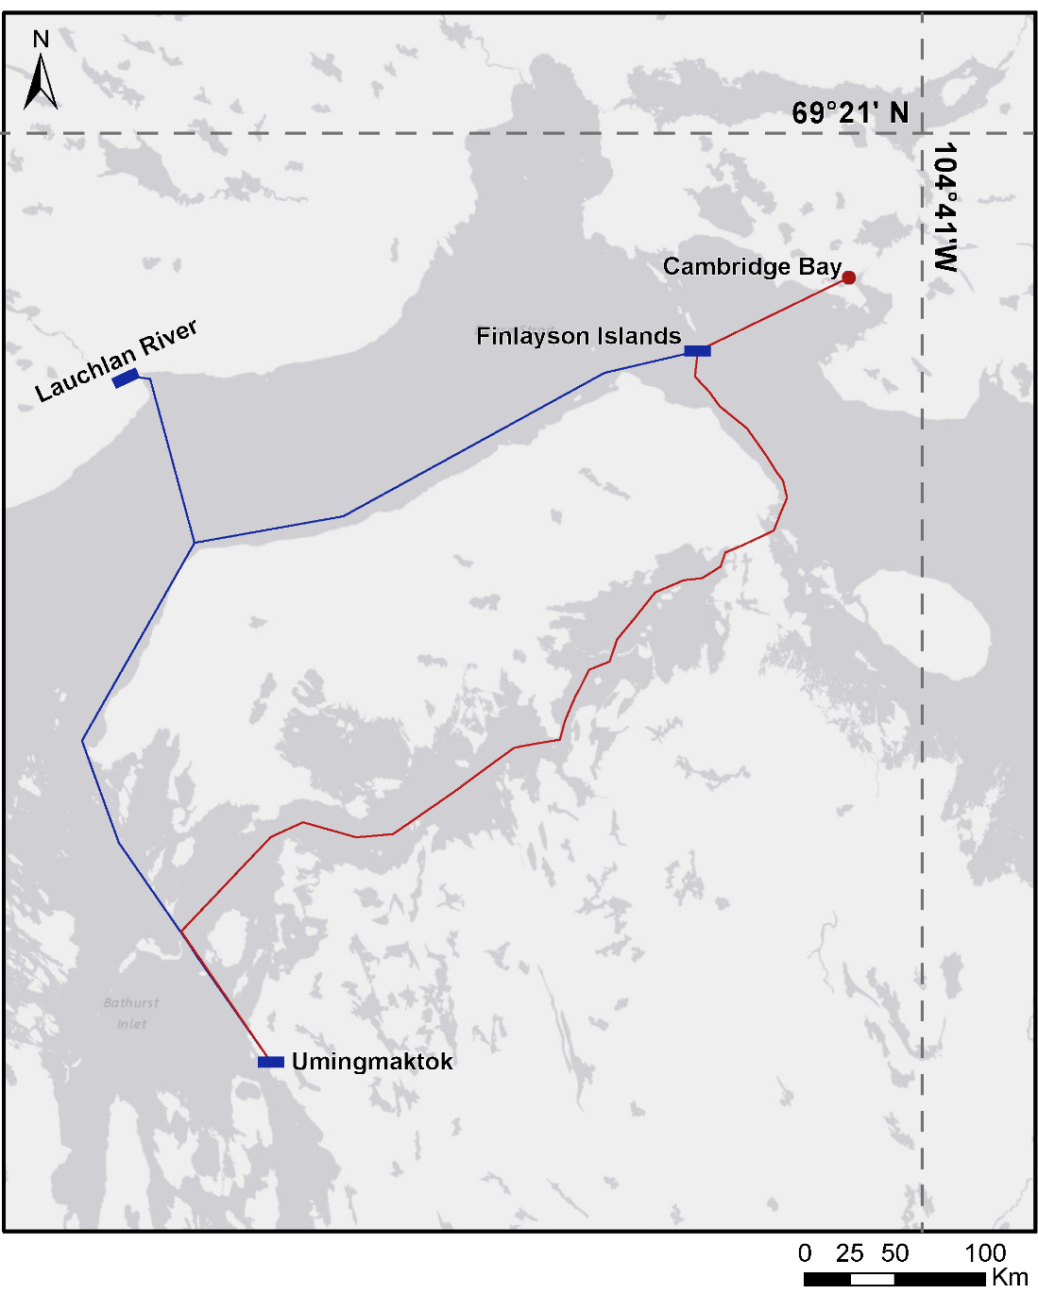

7. ᓂᕆᐅᒋᔭᐅᔪᑦ ᐃᓚᒋᔭᐅᓂᐊᖅᑐᓄᑦ ᒪᑎᓐ ᐳᒡᒪᓐ ᕿᒥᕐᕈᐊᖅᑎᓪᓗᒍ.

01 ᐅᒡᒍᓯ 2018 – 20 ᓯᑎᐱᕆ 2018 (ᐅᓪᓗᖏᑦ ᓇᓗᓇᐃᖅᑕᐅᔭᕆᐊᖃᖅᑐᑦ)
ᐃᓚᒋᔭᖅ | ᐃᖅᑲᓇᐃᔮᔅᓴᖓ | ᓯᓚᑦᑐᖅᓴᕐᕕᒃ | ᑐᕌᕆᔭᐅᔪᑦ ᓱᓇᒃᑯᑖᓄᑦ ᖃᐅᔨᓴᕐᓂᕐᒧᑦ
ᐳᕆᑦ ᐃᐅᔅ | Co-PI | ᓯᓚᑦᑐᖅᓴᕐᕕᒃ ᒋᐅᒍᕆ | ᐸᐅᑦ ᐃᒪᙳᖅᐸᓪᓕᐊᔪᓄᑦ ᐃᓚᔅᓴᐃᑦ
ᓯᑦ ᑖᓂᐅᓴᓐ | Co-PI | ᓯᓚᑦᑐᖅᓴᕐᕕᒃ ᐊᓛᔅᑲ ᕕᐅᐱᖕᒃ | ᑕᕆᐅᒥ-ᐊᔾᔨᓕᐅᕆᓂᖅ
ᐱᐅᓪ ᕕᓕᐊᒻᔅ | Co-PI | DFO | ᑕᕆᐅᒥ-ᐊᔾᔨᓕᐅᕆᓂᖅ
ᓕᓇ ᕈᑐᒪᓐ | ᐃᓕᓐᓂᐊᖅᑎ | ᓯᓚᑦᑐᖅᓴᕐᕕᒃ ᕕᒃᑐᐊᕆᔭ | ᑕᕆᐅᒥ-ᐊᔾᔨᓕᐅᕆᓂᖅ
ᐃᑎ ᑲᕐᒫᒃ | Co-PI | DFO | ᑕᕆᐅᒥ ᐆᒪᔪᓄᑦ ᐱᔾᔪᑎᓖᑦ
ᐳᑎᐅᓪ ᑉᓗᒻ | Co-PI | ᓯᓚᑦᑐᖅᓴᕐᕕ ᑐᕋᒻᓲ, ᓄᐊᕕ | ᐃᒪᓕᕆᓂᖅ ᐆᒪᔪᑦ ᐊᕙᑎᖏᓪᓗ
ᑯᕆᔅᑏᓇ ᐳᕋᐅᓐ | Co-PI | DFO | ᑰᑦ ᐊᒻᒪᓗ ᑕᕆᐅᑉ ᐊᑖᓂ ᓄᓇᓕᕆᓂᖅ
ᔮᓐ ᓂᐅᓴᓐ | Co-PI | DFO | ᐆᒪᔪᕋᓛᑦ
ᒪᐃ ᑎᑉᓯ | ᓴᓇᔨ | DFO | ᕿᓚᔅᓯᒪᔪᓂᑦ ᖃᐅᔨᓴᕐᓂᖅ/ᐃᓕᓯᓂᖅ
ᑯᕆᔅ ᒃᓛᒃ | ᓴᓇᔨ | DFO | ᕿᓚᔅᓯᒪᔪᓂᑦ ᖃᐅᔨᓴᕐᓂᖅ/ᐃᓕᓯᓂᖅ
ᐱᑐ ᕚᓐ ᐳᕆᓐ | ᓴᓇᔨ | DFO | ᕿᓚᔅᓯᒪᔪᓂᑦ ᖃᐅᔨᓴᕐᓂᖅ/ᐃᓕᓯᓂᖅ
ᓵᓐ ᒥᐅᕆᐊᑦ | ᓴᓇᔨ | ᓯᓚᑦᑐᖅᓴᕐᕕᒃ ᒋᐅᒍᕆ | ᐃᒪᓂᒃ ᖃᐅᔨᓴᕐᓂᖅ
ᐳᕋᑦᕆᒃ ᑑᒃ | ᐃᓕᓐᓂᐊᖅᑎ | ᓯᓚᑦᑐᖅᓴᕐᕕᒃ ᒋᐅᒍᕆ | ᐸᐅᑦ ᐃᒪᙳᖅᐸᓪᓕᐊᔪᓄᑦ ᓱᕈᕐᓇᖅᑐᓕᕆᓂᖅ
ᒪᕆᐊ ᐸᐅᑎᔅᑕ | ᐃᓕᓐᓂᐊᖅᑎ | ᓯᓚᑦᑐᖅᓴᕐᕕᒃ ᒋᐅᒍᕆ | ᓴᐅᔭᐅᔪᓄᑦ ᖃᐅᔨᓴᕐᓂᖅ
ᓰᓐ ᒨᕐᕕ | ᐃᓕᓐᓂᐊᖅᑎ | ᓯᓚᑦᑐᖅᓴᕐᕕᒃ ᒋᐅᒍᕆ | ᓴᐅᔭᐅᔪᓄᑦ ᖃᐅᔨᓴᕐᓂᖅ
ᑭᓐᑐᕋ ᔅᒫ | ᐃᓕᓐᓂᐊᖅᑎ | ᓯᓚᑦᑐᖅᓴᕐᕕᒃ ᒫᓂᑐᐸ | ᓴᐅᔭᐅᔪᓄᑦ ᖃᐅᔨᓴᕐᓂᖅ
ᑕᖕᔭᖕ ᐸᒃ | ᐃᓕᓐᓂᐊᖅᑎ | ᓯᓚᑦᑐᖅᓴᕐᕕᒃ ᒫᓂᑐᐸ | ᐱᕙᓪᓕᐊᓕᓵᖅᑐᑦ

8. ᓂᕆᐅᒋᔭᐅᔪᑦ ᐃᓚᒋᔭᐅᓂᐊᖅᑐᑦ 2018 CAT-TRAIN (ᐅᑕᖅᑭᔪᖅ logistical ᐊᔪᙱᔾᔪᑎᔅᓴᓄᑦ NRI ᐊᒪᓗ NIRB-ᑯᓐᓂᑦ)

15 ᒪᔨ 2018 – 30 ᐊᐃᕆᓕ 2018 (ᐅᓪᓗᐃᑦ ᓇᓗᓇᐃᖅᑕᐅᓂᐊᖅᑐᑦ)
ᐃᓚᒋᔭᖅ | ᐃᖅᑲᓇᐃᔮᔅᓴᖓ | ᓯᓚᑦᑐᖅᓴᕐᕕᒃ | ᑐᕌᕆᔭᐅᔪᑦ ᓱᓇᒃᑯᑖᓄᑦ ᖃᐅᔨᓴᕐᓂᕐᒧᑦ
ᐳᕆᑦ ᐃᐅᔅ | Co-PI | ᓯᓚᑦᑐᖅᓴᕐᕕᒃ ᒋᐅᒍᕆ | ᐸᐅᖅ ᐃᒪᙳᖅᐸᓪᓕᐊᔪᑦ ᓱᕈᕐᓇᖅᑐᓕᕆᓂᖅ
ᓵᓐ ᒥᐅᕆᐊᑦ | ᓴᓇᔨ | ᓯᓚᑦᑐᖅᓴᕐᕕᒃ ᒋᐅᒍᕆ | ᐃᒪᒧᑦ ᖃᐅᔨᓴᕈᑎᔅᓴᐃᑦ
ᒧᕆᐊ ᐸᐅᑎᔅᑕ | ᐃᓕᓐᓂᐊᖅᑎ | ᓯᓚᑦᑐᖅᓴᕐᕕᒃ ᒋᐅᒍᕆ | ᑕᕆᐅᑉ ᓯᑯᒧᑦ ᐆᒪᔪᓕᕆᓂᖅ
ᓗᐊᕋ ᑖᒪᓐ | ᐃᓕᓐᓂᐊᖅᑎ | ᓯᓚᑦᑐᖅᓴᕐᕕᒃ ᒫᓂᑐᐸ | ᐱᕙᓪᓕᐊᓕᓵᖅᑐᑦ
ᑯᐊᓐᕗ ᑭᒻ | ᐃᓕᓐᓂᐊᖅᑎ | ᐳᓵᓐ ᓄᓇᖓ U | ᐱᕙᓪᓕᐊᓕᓵᖅᑐᑦ
ᔩ-ᕼᐆᓐ ᑭᒻ | ᓱᓇᒃᑯᑖᓄᑦ ᖃᐅᔨᓴᖅᑎᒻᒪᕆᒃ | ᑯᕆᐊᓐ ᐅᑭᐅᖅᑕᖅᑐᒥ ᓯᓚᑦᑐᖅᓴᕐᕕᒃ | ᐱᕙᓪᓕᐊᓕᓵᖅᑐᑦ

