Project Title
BBC Perfect Planet - Ahiak Migratory Bird Sanctuary (Karrak Lake) - Arctic Foxes

Applicant name and contact details
Nick Jordan, Producer
Silverback Films Ltd / Perfect Planet Productions Ltd.
Silverback Films, 1 St Augustine’s Yard, Gaunts Lane, Bristol, BS1 5DE, UK
Email: nick.jordan@silverbackfilms.tv Phone: +44 (0) 117 992 7257

Sarah-Jane Walsh, Researcher / Field Director
Silverback Films Ltd / Perfect Planet Productions Ltd.
Silverback Films, 1 St Augustine’s Yard, Gaunts Lane, Bristol, BS1 5DE, UK
Email: sarah.walsh@silverbackfilms.tv Phone: +44 (0) 117 992 7277

Number of personnel and/or visitors that will be covered under the permit
There will be 4 members of crew present on location;
- Sarah-Jane Walsh – Field Director
- Alain Lusignan – Expedition Leader
- Ivo Norenberg – Camera Operator
- Tom Crowley - Camera Operator

Project Objectives
Perfect Planet is a 5-part wildlife television documentary series, which has been filmed over a 4-year period and is due to air on BBC1 in 2020. Episode 1 focuses on how changes in the distribution of sunlight across the globe drive unique animal behaviours and adaptations. Two of our key sequences will showcase how animals cope with periods of no sunlight and perpetual sunlight. We have already filmed the polar night in Ellesmere Island and now wish to film the Midnight sun in the Ahiak (Queen Maud Gulf) Migratory Bird Sanctuary. This location interests us because there is just a short 5-week window when there is no snow on the ground and it is a race against time for animals to rear their young and get ready for the rapidly approaching winter.

Our primary objective will be to film arctic foxes at an active den to document the pups in their first few weeks as they begin to explore their new world beyond their den. An additional part of our filming activities will be to document the large numbers of snow geese that nest around Karrak Lake with the aim to film predation by foxes and or other opportunistic predators such as wolves, wolverines and bears. We would also like to film some scenic landscapes with an unmanned aerial vehicle (drone) and wide shots to showcase the nesting goose colonies.

Project Location
Ahiak Migratory Bird Sanctuary
Karrak Lake Research Station - 67° 13' 59.99" N, -100° 15' 0.00" E
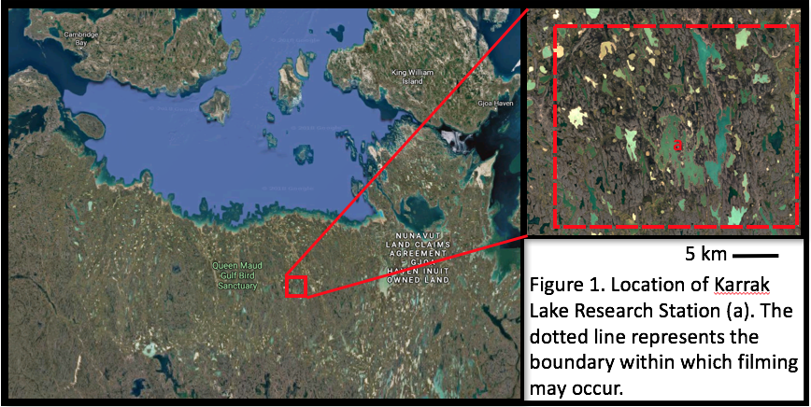

Proposed date and duration of visit to each protected area
There will be two members of the team at Karrak lake within the Ahiak Migratory Bird Sanctuary from the 15th May – 17th July 2019 and the other two members of crew will be present from the 9th June – 9th July 2019. The crew will be based at a permanent research station which has been in use ever summer since 1991 for migratory bird research. No additional camp or infrastructure will be needed. The crew will arrive will arrive when the bird research crew arrives and stay with them until they close camp on the 1st day of the research season and leave as the research station is being closed. This is the only location they will visit with the exception of stopping at Perry River to swap from a helicopter to a twin otter on departure.

Method of transportation
The crew will use commercial airlines to reach their point of entry and departure in Cambridge Bay, then charter aircraft as detailed below to reach the research station. All charter aircraft from Cambridge Bay is managed by the Polar Continental Shelf Program. These flights will be shared by the other scientific research teams who will also be working out of the research station. The flights are just used for moving people and equipment in and out of the location and not used for filming or scouting for fox den locations.

Crew 1
Outbound: Twin Otter from Cambridge Bay to Karrak Lake – 3.5-hour return flight.
Return: Helicopter from Karrak Lake to Perry River, then Twin Otter from Perry River to Cambridge Bay. We are using Perry River as a midway stop to save money on helicopter costs. a twin otter is unable to fly in to Karrak Lake due to unsuitable landing conditions.

Crew 2
Outbound: Helicopter from Cambridge Bay to Karrak Lake, a twin otter is unable to make the journey this late in the season.
Return: Helicopter from Karrak Lake to Cambridge Bay

On location crew will travel on foot and in small boats (10ft aluminium with 16 hp engines) owned by the Karrak Lake Research Station to reach the mainland from the station, which is situated on an island. The research station have 3 boats in total which are stored permanently on site. The boats can only be used once the lake melts from around the 10th June and are just used for crossing from the accommodation which is situated on an island to the main land.

Summary of activities and rationale
Karrak Lake has been the subject of an extensive Arctic Fox study over the past 20 years. Due to the knowledgeable research scientist, it is one of the best places in the world to film at an active den with fox cubs.

Arctic foxes - We will be following the advice of the scientific experts who will help us locate the best dens for filming. Filming will take place in a camouflaged blind/hide located close to the den location.

The crew will also place remotely operated camouflaged cameras to film much closer to the fox dens (less than 10m). This is already being undertaken by scientists at the same location and involves putting the camera down as quickly as possible, ideally before the pups emerge from the den to avoid disturbance and may need occasional maintenance i.e. Battery changes and memory card swaps. Opportunities to do this will be carefully chosen to avoid disturbance and under the guidance of the scientists.

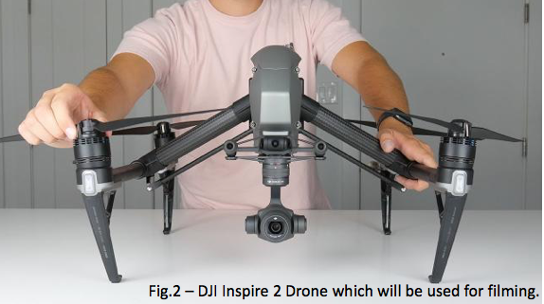

Nesting Geese - One of the objectives will be to film predation on goose nests by arctic foxes and other predators. Filming will be conducted at a distance and the crew will not approach the nest at a distance deemed to cause disturbance to the geese. The crew will attempt to showcase the scale of the goose colony using a drone (unmanned aerial vehicle). This will be done after egg laying and prior to hatching and fledging when all geese are grounded and on the nest. These flights will only be done at the strict discretion of the research scientists. Take off and landing zones will be >100m from the nesting colony and flights will be conducted at a height which does not illicit any signs of disturbance such as head cocking or leaving the nest. Flights will be conducted at an angle to the birds rather than directly overhead to reduce disturbance. The team will begin at a 100m height above the geese and if no disturbance is seen this height may be reduced. At all times during flight a spotter will watch the behaviour of the geese through binoculars. The aim of these UAV flights will be to showcase the scale of these nesting geese and so generally flight will be high and wide.

Waste disposal
The team are staying with the Karrak Lake research station who have a pre-existing waste management plan; Dry garbage is burned, food waste is buried, recyclables returned to Cambridge Bay, human waste is buried, grey water released away from open water

Potential environmental impacts and mitigation measures
The camera operators have worked with arctic foxes before and are familiar with their behaviour and how to identify signs of disturbance and or stress. The only species at risk that we expect to encounter are Reindeer, Grizzly Bear & Musk Ox. If the opportunities are available, we would also like to film the natural behaviours of these species. If it is safe to do so without disturbing the animal the crew will position themselves downwind and at a safe distance with the camera.

Measures to avoid dangerous wildlife encounters
Dangerous animals which may be encountered;
Arctic wolf (Canis lupus arctos); Grizzly bear (Ursus arctos); Wolverine (Gulo gulo); Muskox (Ovibos moschatus).

Each field team will carry a scare pistol/pencil launcher and cartridges, and each person will carry a canister of bear spray. Field teams will also carry a shotgun if necessary the expedition leader has completed the Canadian Firearms Safety Course, and holds a valid Possession and Acquisition licence,

Community consultation and involvement
We are contacting the following community groups in January once this summary is translated;
- Ekaluktutiak Hunters & Trappers Organization
- Gjoa Hunters' and Trappers' Organization
- Umingmaktok HTO

Due to time constraints it would be very difficult to hold any local talks or events however we will send each community a copy of the final program once the series is shown on television around the globe.

We will be staying in Cambridge Bay using local hotels, restaurants and taxis for crew when they pass through and supplies for the research station are also managed through Cambridge Bay.

Future plans within the protected area
We have no future plans within the Ahiak Migratory Bird Sanctuary after the completion of this trip. The end of this trip marks the end of filming for the whole series which is set to air late 2020

