Equipment
Baited remote underwater video system
This project relies mostly on a lightweight deep-sea rated remote video camera system built by SubC Imaging in Clarenville, Newfoundland and housed in an aluminum frame 1.2 m square at the bottom (see the drawing, below). The camera model is the SubC ‘Rayfin’ and it has been used to capture images of Nunavut underwater in 2015 and 2016 (see https://www.subcimaging.com/rayfin). That camera system is also connected to a deep-sea rated battery power source, an LED light, and includes parallel reference lasers to measure fish, rocks, etc. The entire system (~100 kg) is slowly lowered to the sea-bottom via a capstan winch using 9/16” rope often used for setting deep water crab fishing gear. At the surface, two floats and a high-flyer reflective device mark the location of the lander system. On the sea-bottom, the camera system records high definition images of fish, invertebrates, sea-bottom and is baited with ~1 kg of fish or squid bait. The recordings can last up to 10 hours. When the system is recovered, the video data are downloaded and saved, and the system is reset for deployment.
Star Oddi conductivity, temperature, depth (CTD) logger
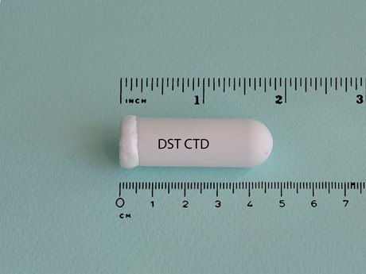
Also on the camera frame will be mounted a small (CTD logger (Starr Oddi ‘DST CTD’ https://www.star-oddi.com/products/data-loggers/salinity-logger-probe-CTD) that is battery powered, rated to >1000 m and set to record seawater conductivity temperature, and depth. This equipment is required to record these three environmental variables and is downloaded when the system is recovered.
Vemco VR2 acoustic receiver
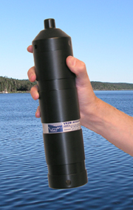
Also on the camera frame will be mounted a small Vemco ‘VR2W’ acoustic receiver that receives ‘pings’ at 69 kHz from acoustically tagged fish and records the specific identificatio n of fish that come within ~800 m of the receiver (https://www.vemco.com/products/vr2w-69khz/). This receiver has been added at the request of colleagues from DFO Winnipeg and the University of Windsor who have tagged many Greenland halibut, Arctic skates, Greenland sharks, and other fishes in the area where this lander system will be deployed and retrieved. No fish will be tagged or removed from the water during this proposed program.

