OPERATION NUNALIVUT 2020
Resolute bay & Rankin Inlet
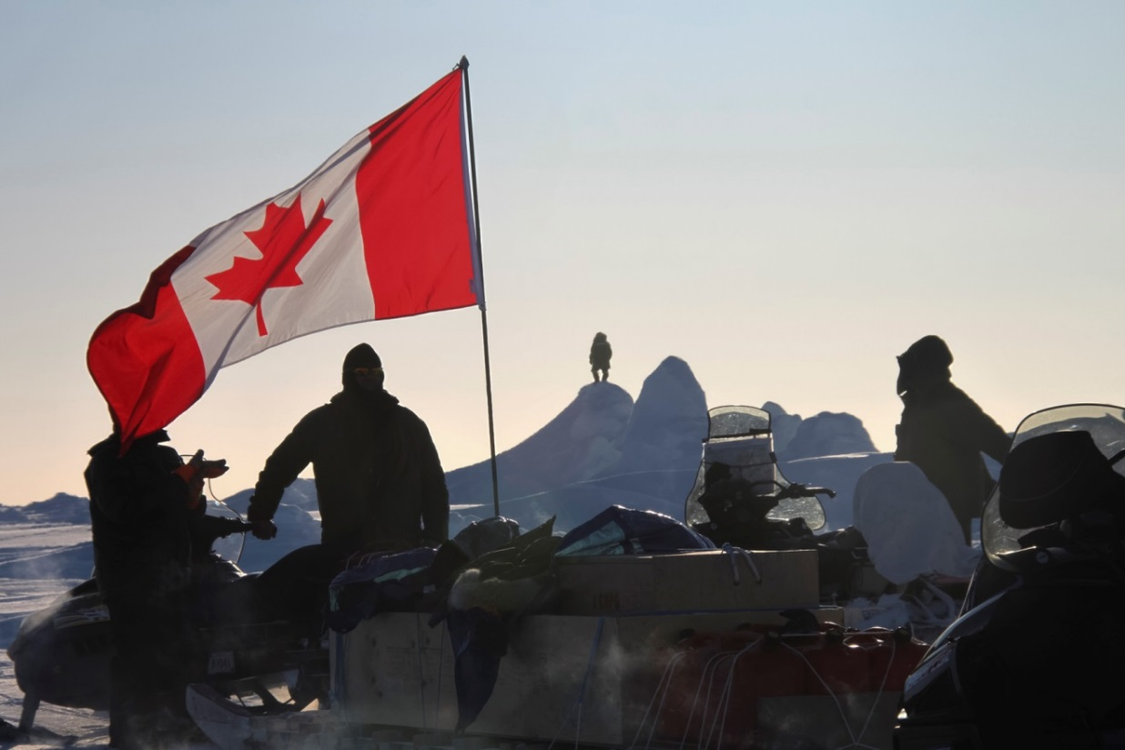
Applicant Name and Contact Information:
Lieutenant-Colonel Rob Knapik, Chief of Staff, RP Ops North
Canadian Forces Real Properties Operations Group
National Defense Headquarters, 101 Colonel By Drive
Ottawa, Ontario K1A 0K2
c/o
Major Chris Leggatt
Email: Christopher.Leggatt@forces.gc.ca
Phone: (613) 995-6680
Fax: (613) 947-3385

Co-applicant Name and Contact information:
Brigadier-General Patrick Carpentier, Commander Joint Task Force (North)
Evans Building 4816, 49 Street
Yellowknife, Northwest Territories X1A 2R3
c/o
Major Kevin Nottle
Email: Kevin.Nottle@forces.gc.ca
Phone: (867) 873-0700 Ext 6098
Fax: (867) 766-6802

GENERAL

Joint Task Force North (JTFN) will conduct Operation NANOOK-NUNALIVUT 2020 (Op NA-NU 20) from 21 February to 31 March, 2020, based out of Resolute Bay and Rankin Inlet, Nunavut (Fig 1-3) (Table 1). The overall aim is to further enhance the Canadian Armed Forces’ (CAF) knowledge and capacity to operate in austere locations and challenging environments, while allowing the CAF to demonstrate their ability to effectively respond to safety and security issues in the Arctic.

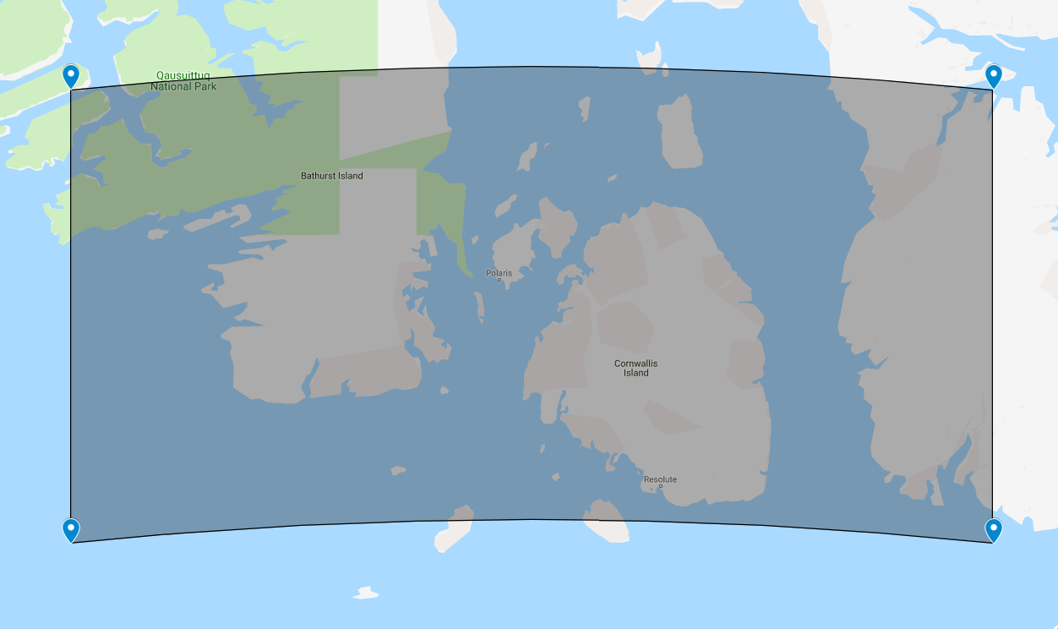
Fig 1. Area of Operation for Op NU 20, Resolute bay

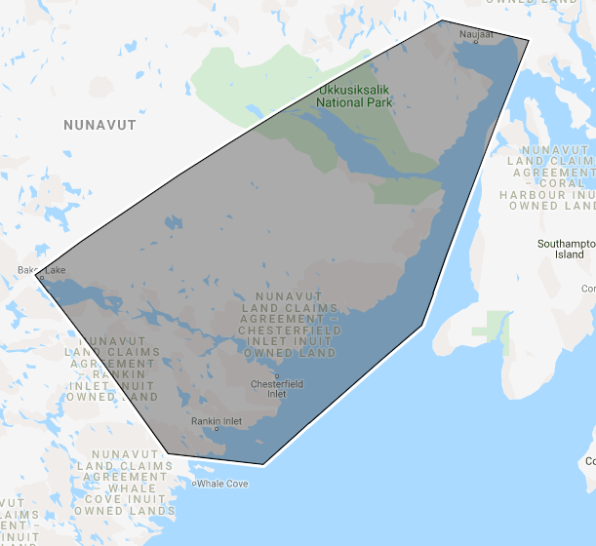
Fig 2. Area of Operation for Op NU 20, Rankin Inlet
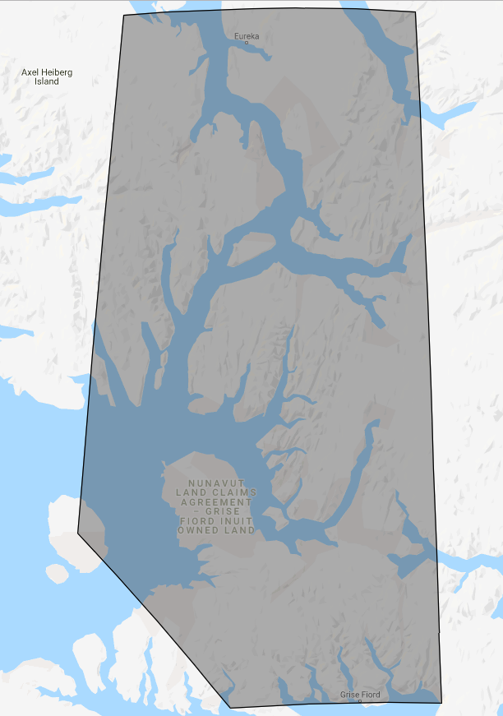
Fig 3. Area of Operation for Op NU 20, Long Range Patrol

Table 1. Op Box and Coordinates, OP NU 20
Op Box Corner Coordinates
OP Box | Corner | Latitude (DD) | Longitude (DD)
Resolute Bay Op Box | S/W | 74.50 | -102.50
Resolute Bay Op Box | S/E | 74.50 | -90.50
Resolute Bay Op Box | N/W | 76.00 | -102.50
Resolute Bay Op Box | N/E | 76.00 | -90.50
Rankin Inlet Op Box | S/W | 62.5458 , -93.1845
Rankin Inlet Op Box | S/E | 62.4274 , -91.0257
Rankin Inlet Op Box | N/W | 66.7273 , 87.0103
Rankin Inlet Op Box | N/E | 66.5453 , -85.0401
Rankin Inlet Op Box | W | 63.8486 , -87.4489
Rankin Inlet Op Box | E | 63.8486 , -87.4489
Long Range Patrol | N/W | 80.11936 , -89.22374
Long Range Patrol | S/W | 76.3717 , -86.3772
Long Range Patrol | S/E | 76.4033 , -80.7091
Long Range Patrol | N/E | 80.1354 , -81.3993
Long Range Patrol | W | 77.4337 , -90.4552

Op NA-NU 20 will conduct patrols on the land, on the sea ice, and in the air. It will consist of approximately 300 CAF personnel and will include collaboration with international partners. To facilitate the conduct of Op NA-NU 20, JTFN will establish a Task Force Headquarters in Resolute Bay consisting of approximately 10 members with an additional 40 support personnel.

In Resolute Bay, the Canadian Army will be supported by members of 1 Canadian Ranger Patrol Group (CRPG) for a total of approximately 200 personnel. Patrols will be performed on the sea ice to the in the vicinity of Resolute Bay, conducting training in arctic survival skills. Two live fire ranges will be conducted in the vicinity of Resolute.

In Rankin Inlet a dive team consisting of approximately 60 personnel will conduct under-ice diving operations with international partners. Diving operation will also focus on ice breaching capabilities.

CC-177 (Globemaster), CC-138 (Twin Otter), and CC-130 (Hercules) aircraft, based in Resolute will provide transportation, resupply and casualty evacuation services if required (Table 7).

LAND BASED EXERCISES

On approximately 20 February, a Canadian Army company supported by 1 CRPG will perform patrols from Resolute Bay and Rankin Inlet by snowmobile. Patrols up to 6 days in duration will occur over a 12 day period from 20 February to 31 March 2020. Patrols will consist of up to 90 personnel. Specific patrol routes will be identified to be utilized based on weather, ice conditions, and wildlife. The patrol routes will be defined closer to the date of the operation however flexibility will be maintained. Bivouacs will be established. The locations and pictures of bivouacs will be recorded for each location used. Fuel caches under 4000L will likely be require to accommodate the patrols. The location and pictures of the fuel cache will be recorded for each location used. Two long range patrols are planned. One from Grise Fiord to Eureka and return. The second patrol sees groups from Rankin Inlet, Baker Lake and Naujaat meeting in the vicinity of Fullerton, and returning to their home communities.

Live fire ranges will be conducted at 74.708308, -94.990846 and at 74.701099, -94.773107 in the vicinity of Resolute Bay (Fig 3) and Rankin inlet at 60.8881442, -92.0813245 during the 20 February to 31 March 2020 timeframe. Weapons to be used during the live fire range include the C7 (5.56mm rifle), C9 (5.56mm machine gun), C19 (7.62mm Rifle) and C6 (7.62mm machine gun) (Table 4). It is important to note the CAF conducts ranges in an extremely safe manner through the designation of a Range Officer in charge, Range Safety Officer and additional Range Staff as required, based on the level of the range. The Range Staff will ensure the area is free of personnel, wildlife, aircraft, or any other objects prior to conducting the range. They will ensure the range remains safe during its conduct and ensure all waste produced by the range is removed immediately.

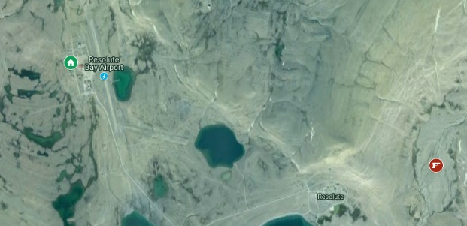
AIR OPERATIONS

At this time the composition of the air task force supporting Operation NUNALIVUT 20 is uncertain. It will likely involve CC-177, CC-130, CC-138 and CH-146 aircraft from the Royal Canadian Air Force (RCAF), and will potentially involve contracted helicopter support. Low level flying will likely occur in both Resolute Bay and Rankin Inlet. Resolute bay will be the main source of support for air operations.
Fig 3. Resolute Bay Locations, denoted by red symbol.

SEA BASED OPERATIONS

On approximately 5 March 2020, a Canadian Navy diving unit supported by the Canadian Army and 1 CRPG will perform under ice diving operation in vicinity of Rankin Inlet or Resolute Bay, depending on weather. A team of approximately 60 divers from the Fleet Diving Unit (Atlantic) will conduct under sea ice diving operation. Operations will include the placement of inert objects, such as pieces of sheet metal, on the seabed floor and the inspection and recovery of the objects placed. In order to test the capabilities of the CAF, the intent is to use specialized shape charges to cut a hole in the ice. It is important to note the CAF conducts explosive ranges in an extremely safe manner through the designation of a Range Officer in charge, Range Safety Officer and additional Range Staff, based on the level of the range. A precise location and danger area template will be produce and made available. . Explosive Ordinance Disposal will be onsite with the appropriate equipment to dispose of any Dud producing ammunition. In the absence of explosives, CAF will use conventional non kinetic methods to cut a hole through the ice Locations for ice breaching in the event that explosives are used are listed in Table 2

Table 2, List of breaching locations
Personnel on the Land | 1st – 31st March
Reslolute Bay: | 74.671229, -94.881340
Rankin Inlet: | 62.8881442, -92.0813245

INTERNATIONAL PARTICIPATION

At this time, international participation within Op NA-NU 20 is likely; a small number of international military members may observe the operation and participate in the diving activities.

ENVIRONMENTAL CONSIDERATIONS

The Polar Bear Pass National Wildlife Area lies to the west of the planned Op NA-NU 20 and will be avoided by all military activities. All activity conducted in this area is assessed as low impact and any wildlife sightings will be recorded and reported.

It is important to note the Department of National Defense/Canadian Armed Forces operates under strict environmental guidelines. In and out clearances will be conducted at each location used for resupply or bed down. Digital images of locations will be taken during and after use and will be included in the Post-Operation In/Out Clearance Report. Some of the environmental protection measures will be implemented include:

The permitting process requires detailed information regarding the nature and locations of the operation, and the information contained in the following document is all known information at the time of production. Minor variances may occur during the conduct of the operation. Such variances will be captured in a post-operation Environmental Report and will include the precise locations used during the operation, along with an overall review of the execution.

The following is a list of potential impacts which could result from the proposed activities:

Activity and vehicle traffic from the proposed activities is expected to increase ambient noise levels and may also cause minor disturbance to the wildlife within the vicinity of activity locations. However, since all activities will be temporary, impacts are expected to be minimal.

Vehicles involved in Op NA-NU 20 will release particulate into the atmosphere and contribute to greenhouse gas emissions. Air quality in the vicinity of activities may be temporarily reduced due to the increased fumes. However, due to the relatively short duration of the activity, and the use of new, lower emission vehicles, impacts to the atmosphere are expected to be minimal.

Weapon and explosive ranges are expected to increase ambient noise levels and may also cause minor disturbance to the wildlife and marine wildlife within the vicinity of activities locations. Explosive detonation on the sea ice is likely to create a shock wave that could possibly disturb or destroy marine wildlife. Mitigating factor will include limiting the usage of explosives to a single occurrence in a small precise location. Shaped charges will be used to reduce the amount of explosives required. Impacts are expected to be low.

Low level flying aircraft is expected to increase ambient noise levels and may also cause minor disturbance to the wildlife within the vicinity of aircraft low level route. However, due to the movement motion of the aircraft, impact on the wildlife are expected to be minimal.

Despite direction to ensure all waste material is to be properly contained and transported back for disposal, the potential exists for waste material produced during Op NA-NU 20 to litter property or be windblown onto surrounding locations. However, every effort will be made to ensure this does not happen; therefore, the impact is considered to be easily mitigated and insignificant.

Should a fuel leak and/or spill occur from vehicles, equipment, etc., the possibility exists for contamination of ground water resources, soil and/or surface water. However, all units traveling outside Resolute Bay or Rankin Inlet will have spill cleanup supplies, and will be instructed on their use; therefore, the potential for a malfunction and/or accident to cause any significant impact is low.

Peary Caribou are an endangered species and live in the vicinity of Resolute Bay. Dolphin and Union Caribou are a species of special concern and live in the vicinity of Resolute Bay. Human activities have the potential to disturb these animals, however any caribou seen will be avoided minimizing the potential disturbance of any individual caribou or caribou herds.
While there is potential for activities to impact the environment, mitigation measures have been established to minimize their significance. These mitigation measures include, but are not limited, to:

An environmental brief will be provided to personnel involved in the exercise to ensure they have the required general level of environmental awareness and knowledge, and are aware of requirements related to wildlife prevention, response and reporting.

Vehicle movement will be restricted in sensitive areas. In the event established trails are impassable, personnel will be instructed to use alternate routes for as limited a distance as necessary.

Individuals will be tasked to ensure waste material and litter is collected on the site prior to departing the camp location. All waste produced on site will be packed out to Resolute Bay or Rankin Inlet for proper disposal.

In order to prevent any unnecessary wildlife encounters, all waste will be appropriately contained, stored and removed from the sites as soon as possible.

All caribou will be avoided and not disturbed in any way.

Personnel will keep at least 1 km away from the boundary of the Polar Bear Pass National Wildlife Area.

Personnel will be made aware of the potential for threats from local wildlife and instructed to avoid encounters or disrupt any wildlife unless absolutely necessary.

Local treatment systems and municipal landfill or incineration will be used for the disposal of human waste. Waste generated during foot patrols or when municipal services are otherwise unavailable, will be bagged and packed out for appropriate disposal;

Local landfill or incineration will be used for the disposal of combustible waste. Disposal will occur in accordance with territorial and municipal regulations (waste will be handled by contract);

Local landfill, incineration or recycling centers, where available, will be used for the disposal of non-combustible wastes. Disposal will occur in accordance with territorial and municipal requirements (waste will be handled and disposed by contract);

All noise making activities will be limited as much as possible.

Vehicles and equipment will be maintained in good repair to prevent leakage of fuel, oil, etc.

Generators will be placed within suitable containment throughout the operation, and will be emptied for transportation;

When in Resolute Bay or Rankin Inlet, all vehicle/equipment refueling will occur in a central location. Use of spill containment items including drip pans or mobile plastic berms will be maximized during refueling.

All fuel storage systems and containers to be used in Op NA-NU 20 will be transported, stored, protected, etc. according to proper legislation, regulation, codes and guidelines.

All hazardous materials (HAZMAT) and fuel will be stored in approved storage containers and facilities, including compliant secondary containment and will be stored in accordance with municipal, territorial, and federal regulations;

HAZMAT prevention/response resources (spill pans, hydrocarbon spill pads, absorbal, etc.) will be available and ready for use if required. Spill kits will be specifically located at all fuel storage areas, vehicle maintenance areas and refueling areas.

All hazardous materials (HAZMAT), fuel storage, generator and vehicle parking areas are subject to inspection by environmental support staff. All involved elements will appoint an environmental representative, accountable for the supervision of best environmental practices;

HAZMAT waste will be appropriately packaged and transported to a suitable facility for disposal, in accordance with appropriate regulations – provided by a third party waste disposal facility if required; and,
Photographs will be taken of all training location sites, and temporary camp locations before, during and after use.

Based on all of the information available regarding the proposed Op NA-NU 20 and the surrounding environment, if designed and carried out using the knowledge of the local 1 CRPG members in to addition to the identified mitigation measures, and follow-up programs and monitoring, Op NA-NU 20 is not likely to cause any significant effect on the environment.

CAMP DETAILS

OP NU 20 HEADQUARTERS AND PATROL BASE – Resolute
It is prudent to note the establishment of the main camp in Resolute. All Op NA-NU 20 personnel will be sleeping in CAF Arctic Training Center (CAF ATC), or contracted facilities. Temporary structures will be erected on Department of National Defence (DND) lands at Crystal City to accommodate training. In Rankin Inlet personnel will be sleeping in the Personnel Accommodation Barracks. (PAB) The Forward Operating Location (FOL) will be used to store equipment and aircraft as well as conducting maintenance.

PERSONNEL

Table 3. Estimated number of person-days (number of people per day multiplied by the number of days).
Personnel on the Land | 1st – 31st March | Total Person Days
Resolute Bay | 200 | 6200
Rankin Inlet | 100 | 3100

RANGE EXERCISE AMMUNITION TO BE USED

Table 4. Weapon ranges (per range location).
Type | Quantity
.303 Cal | 600
5.56mm | 30000
7.62mm | 3000

Table 5. Explosive range.
Type | Quantity
Detonation cord | 500m
Non-electric detonator | 12
Linear shape charges | 16
M60 Igniter | 5
Time Fuze M700 | 25m
C4 block | 5

FUEL AND HAZMAT INVOLVED
Table 6. Fuel used during the operation.
Location | Diesel  (BV 206, Generators, Heaters) | Gasoline  (LOSV) | Naphtha  (Colman Stove and lanterns | Oil  (LOSV) | AV-Gas  (Aircraft)
Resolute Bay | 900L (stored in 205L drums) | 11000L (stored in 205L drums) | 500 | 250L (stored in 4L containers) | Fuel to be delivered to aircraft by contract
Rankin Inlet | 500L (stored in 205L drums) | 5000L (stored in 205L drums) | 250 | 75L (stored in 4L containers) | Fuel to be delivered to aircraft by contract

As part of OP NU 20, fuel caches of up to 3500L will occur at bivouac locations, these location will be recorded as submitted as part of a closeout report.

MAJOR EQUIPMENT INVOLVED

Table 7. Major equipment operating Op NU 20.
Equipment type and number | Size – dimensions | Proposed use | Location
2 x BV206 | L5.72m/W2.01m/H2.72m/Wt:8,500kg | Transportation of troops and equipment | Resolute Bay
200 x Light Over Snow Vehicles With Qamutiik | L3.00m/W1.30m/H1.20m/Wt140kg | Transportation of troops and equipment | Resolute Bay  Rankin Inlet
10 x Heaters | Example Dimensions: L1.24m/W2.55m/H1.20m | Heating tents | Resolute Bay  Rankin Inlet
2 x 5kW Generator | Example Dimensions: L2.0m/1.1m/H.2m | Temporary power | Resolute Bay  Rankin Inlet
15 x Tent Group including Colman Stove and lantern | L 3m/W 3m/H 2.5m | Shelter | Resolute Bay  Rankin Inlet
2 x CC-138 Twin Otter Aircraft | L15.1m/W9.81m/H5.66m/Wt5,600kg | Transportation of troops and equipment | Resolute Bay  Rankin Inlet
CC-130 Hercules | L30m/W40m/H11m/Wt34,400kg | Transportation of troops and equipment | Resolute Bay  Rankin Inlet
CC-177 Globemaster | L53m/W52m/H17m/Wt128,100kg | Transportation of troops and equipment | Resolute Bay  Rankin Inlet
CH-146 Griffon | L17.1m/W14.0m/H4.6m/Wt5355kg | Transportation of troops and equipment | Resolute Bay  Rankin Inlet

WATER AND WASTE

Table 8. Wastes produced and methods of disposal
Type of waste | Projected amount generated | Method of Disposal | Additional treatment procedures
Garbage | 100L/Day | Garbage produced will be disposed of via existing infrastructure. | Nil
Sewage (human waste) | 400 L/day | Human waste produced in the field will be collected (bagged) and shipped south for proper disposal. | Nil
Greywater | 100 L/day | Greywater produced will be disposed of via existing infrastructure. | Nil

INUIT OWNED LAND PARCELS

Parcels of Inuit Owned Land in the vicinity of Resolute Bay and Rankin Inlet may be directly or indirectly impacted during the conduct of OP NA-NU 20, or similar military activities from 1st to 31st March 2020. Agreement for the use of Inuit owned lands being used will be put into place.

CONCLUSION

The information provided is the most accurate information available at this time, and dates and locations may change slightly due to unpredictable circumstances such as weather. Regardless of circumstance, the CAF is accountable to environmental stewardship, and will conduct the operation with due diligence towards the environment.

