Project Title:
Muskox (Ovibos moschatus) distribution and abundance of Central Mainland, Nunavut (MX-11)

Applicant:
Lisa-Marie Leclerc
Government of Nunavut
P.O Box 377
lleclerc@gov.nu.ca
1-867-982-7444

Number of Personnel and Visitors:
The permit will need to cover 6 persons; the pilot (TBD), co-pilot (TBD), Biologist (Lisa-Marie Leclerc), Biologist (TBD), Wildlife Technician (Terry Milton), Wildlife Technician Trainee (Lena Davis), community members as observers (TBD).

Project Objective:
This project aims to provide new scientific information on the muskox abundance and distribution of muskox in the management zone MX-11, to be able to review the current Total Allowable Harvest.

Project Location:
The project will include the West and Central Portion of the Queen Maud Gulf Bird Sanctuary (QMGS).

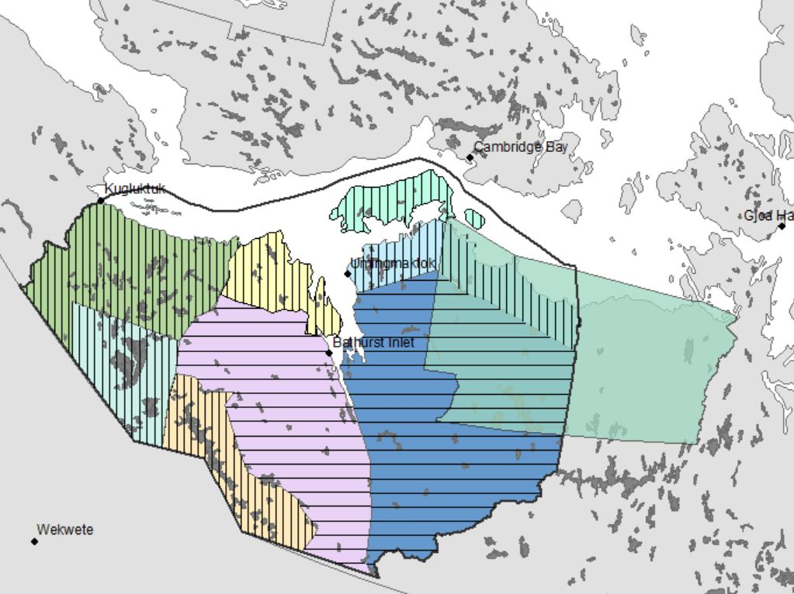
Figure 1: Map of the Muskox management unit MX-11 (black line), in relation to the Queen Maud Gulf Bird Sanctuary (light green).

Project duration:
From July 1, 2021 to September 15, 2021. We are looking to be 2-5 days in the QMGS.

Method of transportation:
This is an aerial survey with no landing in the QMGS.

Summary of the activity and rational:
In 2015, new muskox management units were established in Nunavut to represent muskox population boundaries. The management unit MX-11 represents now three old harvest zones; MX-13, MX-14, MX-15, and part of MX-16 and MX-19. Current harvesting rate for the muskox management unit MX-11 is based on muskox numbers estimated in 2013 from the west partand old surveys results, which result to 7,500 adult muskoxen. Although this number is the best available information, it does not accurately represent the current muskox distribution and abundance in the western part of MX-11. To obtain these numbers, we are planning to conduct an aerial survey of MX-11 in summer 2021. The area will be flown with up to 25% coverage, with transect lines spaced 8 to 12 km apart. The transect line will be surveyed at a speed of 160 km/h and an altitude of 150 m. Observers will record the number of muskox and GPS location. This project will aim to provide new scientific information on the abundance and distribution of muskox in MX-11 to be able to review the Total Allowable Harvest.

Waste disposal:
N/A

Potential environment impact and mitigation measure:
The muskox survey will commence in mid-July, with the survey area occuring within the QMGS in early August. We will be flying at approximately 150m above the ground with an airspeed of approximately 160kms/hour. This could have a small impact on local wildlife as the aircraft flies overhead, but the wildlife will not be disturbed any further once the area has been surveyed. In the sanctuary, the survey there should be completed between 2 and 5 full days (depending on weather). The percentage of coverage will be adjusted to known muskox distribution, keeping the number of km flown low and the spacing between transect lines wider, where possible, to limit disturbance. In this case, most of the area to be survey in the QMGS will overlap with the dark blue strata shown in Figure 1, which is at a low coverage density of 10%. In addition, the timing of the survey has been selected to minimize overlap with the peak of the breeding bird season in June and July.

Measures to avoid dangerous wildlife encounters:
No planned landing will occur in the QMGS area, which will limit conflict with or major disturbance to wildlife.

Community consultation and involvement:
Since this is a Government of Nunavut, Department of Environment -led project, extensive consultation with the community and co-management partners occurred in the preparation of this project. Direction and community support was given at the 2017 September muskox workshop and at the 2017 and 2018 KRWB AGM that this surveyed was desired. HTOs have been involved in the review of the permit application, as well as in the survey design in 2019, 2020, 2021, as well as during a conference call in the summer of 2019 to plan the survey design. In addition, community members will be employed as observers during the survey.

Future Plans:
This is a short-term duration research project, until there is a need to reassess the Muskox population MX11. Research results will be provided to co-management partners at the Kitikmeot Regional Wildlife Board Annual Meeting, as well as in part of the consultation process with the Hunter and Trapper Organisations and the Public.

