Tree River Geoscience Project: Plain Language Summary
• Who: A scientific collaboration between Professor D. Graham Pearson of the University of Alberta and Dr. Jesse Reimink of Penn State University in the United States. Additional personnel involved include a PhD student from Penn State, and possibly regional geoscience experts from: the University of Alberta, Laurentian University, or the Nunavut Geoscience Office, as well as a float plane pilot.
• What: We will conduct field sampling of ancient basement rocks exposed on the surface. We will be residing at the Plummer’s Tree River Lodge and Kugluktuk for the duration of our project and will be flying a Bush Hawk float plane up to 80 km from this location during the day. We will land the Bush Hawk on small lakes, and hike to outcrops near the lakes. Once at outcrops of scientific interest, we will use small hand hammers to take geological samples for research (~1 kg samples) of the rocks of scientific interest.
We will be sampling for 8-10 days and expect to collect ~100 samples of rocks in this time period. The sampling will be spread out and will largely be focused on going back to sample locations that have been described by previous Geological Survey of Canada bedrock mappers, projects that took place in the 1980’s. Our crew will consist of three to five geologists and a float plane pilot.
• Why: Sedimentary rocks exposed in this region contain mineral grains that are extremely old. With the advanced scientific laboratories currently in use at the University of Alberta, we are able to learn a lot about how the very ancient Earth operated by analyzing tiny mineral grains that are found in these sediments. We will be collecting rock samples that contain these tiny mineral grains, extracting the grains, and analyzing their chemical signatures. Our results will be published in peer-reviewed scientific journals. Hopefully, we will learn a lot about how the ancient Earth operated by analyzing these ancient mineral grains.
• Where: We will be working within 100 km of the Tree River Lodge owned and operated by Plummer’s (67°38'10.47"N; 111°54'7.00"W). We will be landing on small lakes within this radius and collecting samples near those lakes.
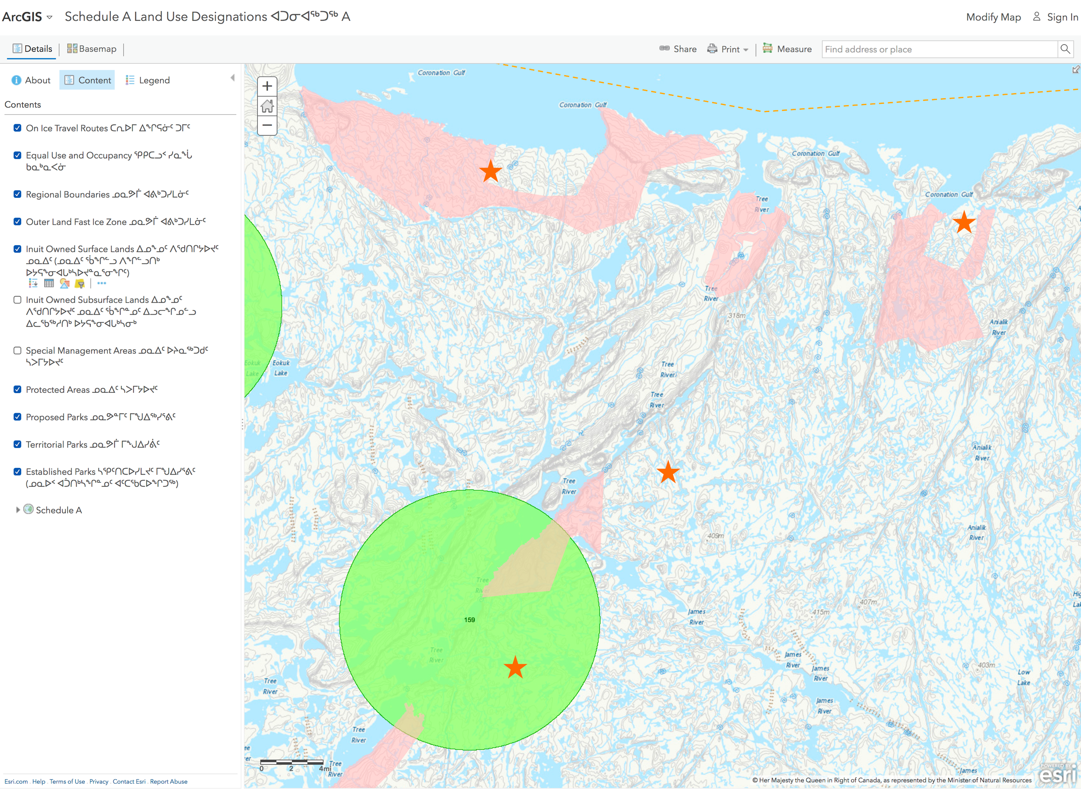Screenshot of the location of our proposed activities, with prospective locations shown in Orange dots.
• When: This activity will take place in late July 2022, likely from July 15-25. We have no plans for any work outside of this window in 2022, or any plans to continue fielwwork in following years.

