Quqluaqtualukmi Nunamiutanik Naunaiyaunmik Havaaq: Naunaitumik Uqauhiqmik Naitumik
• Kina: Naunaiyaut havaqatiriigunmi uumanga D. Graham Pearson-mit Ilihaqvikyuamit Alberta-mi, Dr. Jesse Reimink-milu Penn State-mi Ilihaqvikyuamit Amialigat Nunagiyaanit. Ilagiarutit havaktuni ilauyuni ilaqaqtuq PhD-nigiamini ilihaqtuq Penn State-mit, nunamilu nunamiutaliqiyit ayugitut uvanga, Ilihaqvikyuamit Alberta-mit, Laurentian-mit Ilihaqvikyuamit, uvaluniit Nunavumi Nunamiutanik Naunaiyainit Titiraqvianik, unalu qayalikmik.
• Hunauk: Maniqami naunaiyainiaqtugut igilraat tungaviuyunik uyaqaik takuukhauliqtunik qaagani nunap. Hiniktaqviqaqniaqtugut Plummer-p Qugluaqtualukmi Aguniaqtitiviani Kugluktumilu atuqhimaaqtilugu havaariyaqut tikminiaqtugulu Bush Hawk-mi qayalikmi tikmiaqmi 80-kilaamitanik umanga inigiyauyumit ubluani. Miniaqtugut mikiyuni tahiqni, pihuklutalu uyaraqtuniqnut haniani tattit. Uyaraktuniqmugarupta naunaiyaivikhamut, atuqniaqtugut mikiyunik kautauyanik nunami naunaiyagakhanik ilituqhaqtakhanik (~1-kilogram-guyut naunaiyagakhat) uyaqanik naunaiyagakhanik.
Naunaiyainiaqtugut 8-mit qulinut ubluni nahuriyugulu katitiriami ~100-nik naunaiyagakhanik uyaqanik talvuuna. Naunaiyainiq hiamayaktauniaqtuq ihumagiyauluaqniaqtulu utiriami naunaiyariagani inigiyauyut uqautauyut kiguliqmi Nunaliqijutinik Naunaiyautimi Kanatami qaiqtunik nunauyiuqtinit, havaat atuqhimayut 1980 ukiut atuqtilugit. Havaktivut pigahunit talimanut nunamiutaliqiyit ilauniaqtut qayalikmiklu tikmialikmik.
• Huuq: Qaliriiktuuyaaqtut uyaqat hatqiqtut uvani nunami piqaqtut uyaraktaakhanik utuqaqyuaguyunik. Ihuaqhivaaliqtuni naunaiyautimi ilituqhautit taja atuqtauyuq Ilihaqvikyuami Alberta-mi, ilitpaliahimayugut amihunik qanuq igilraat Hilaqyuaq aulaniganik ilituqhaqhugit mikanuit uyaraktaakhani ilagiyait naniyauhimayut ukunai hiuraliani. Katitiriniaqtugut uyaqanik naunaiyagakhanik piqaqtunik mikanuanik uyaraktaakhanik avugiinik, ahivaqtiqlugit avugiiknigit, ilituqhaqlugilu hunavaluqaqniginik nalunairutinik. Naluhuiqtavut takuupkaqtitauniqtut havaqatinit ihivriuqniginik naunaiyautinik uqauhiini. Ihumami, iliniaqtugut amihunik qanuq taimaniraaluk Nunaqyuaq aulaniqaqmagaa ilituqhaqniginik ukua igilraat uyaraktaakhani ilaliutihimayut.
• Humi: Havakniaqtugut iluani 1-hanat kilaamitami Quqluaqtualukmi Aguniaqtitiviuyumit nanminigiyauyuq aulapkaqtauvlunilu Plummer’kunit (67°38'10.47"N; 111°54'7.00"W-mi nunauyami). Mitpakniaqtugut mikiyuni tahiqni iluani uuma kaimaluriktumi kikliqaqnigani katitirilutalu naunaiyagakhanik hanianit ukua tattit.
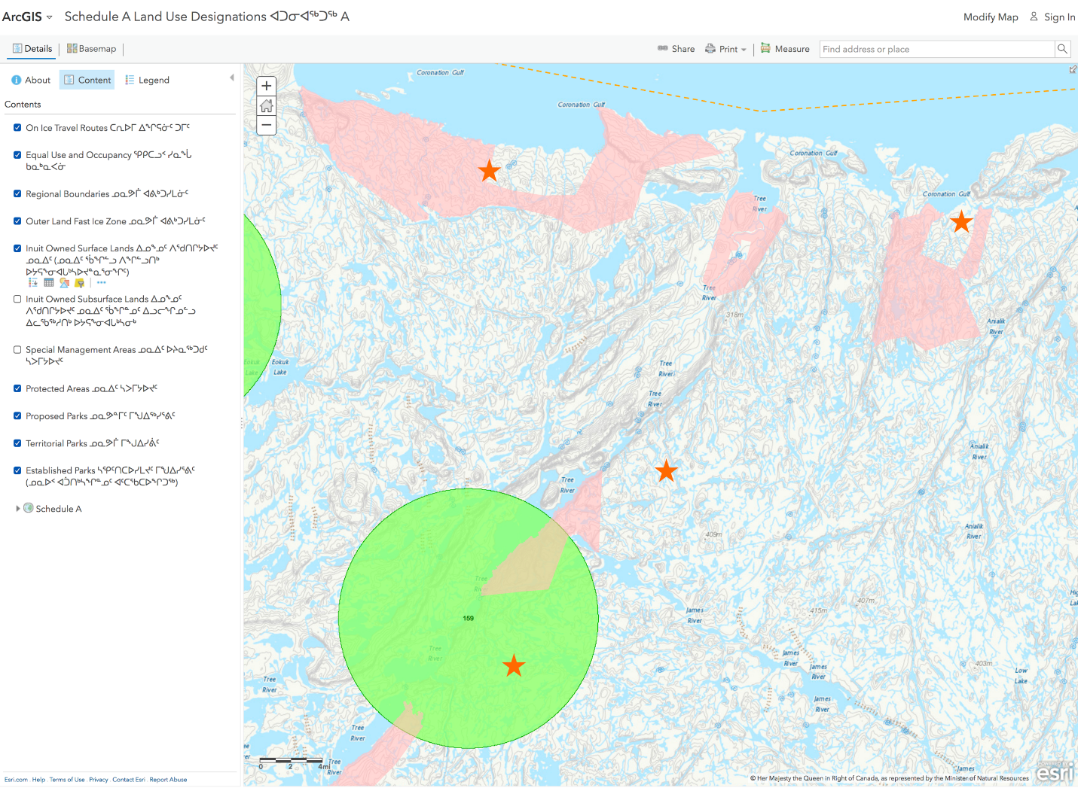Piksaliuqhiayut inigiyauyukhat atulirumayaptikni hulivikhaptiknik, inikhauyuniklu tuyakhani Orange-mi nalunaiyaqvikni.
• Qakugu: Una hulijut atuqniaquuqtuq nuguliqat Taaqhivaliavia 2022-mi, ahu Taaqhivaliavia 15-mit 25-mut. Upalugaiyaihimagitugut havaakhanik ahianik uuma pivikhaqaqniup 2022-mi, upalugaiyautinikluniit havaarihimaaqniganik maniqami atuqtukhani ukiuni.

