Measuring Glacier and Snow Changes in Grise Fiord
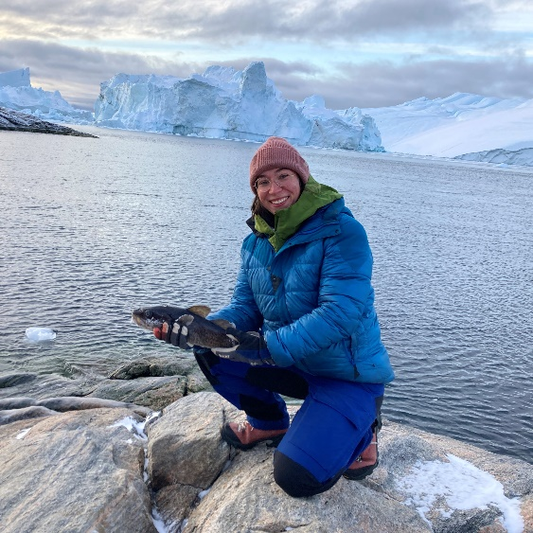
Contact:
Please send any questions or comments to me at the following options:
Danielle Hallé, dhalle@uwaterloo.ca (email), 343-463-4637 (Cell Phone).
About me: I am a student from the Uni. Of Waterloo with a big passion for glaciers, snow, and climate change. I am interested in the impacts of a warming climate on communities and how research can benefit society. I have previously spent time living and working in Western Greenland studying glacier melt. I am hoping to work together with people from Grise Fiord to include objectives and research goals that would be of interest to members of community.
Please note I am open to any feedback or changes that would be of interest to the community, for instance if the proposed sites should be changed to other areas of interest. I will incorporate any changes to the proposal that are requested.
Project Description:
[Introduction] Motivation for this work comes from the inherent connection of glaciers and local nearby communities that will be affected by fluctuations of future warmings and associated glacier meltwater flowing through them. Previous studies of impacts on increasing glacier meltwater in a high Arctic community have been undertaken in the town of Qaanaaq in Greenland, where landslides have been triggered from increasing precipitation and runoff from Qaanaaq Ice Cap, which has results in blocked access to the local airport for an extended period. Qaanaaq is located at a similar latitude to Grise Fiord yet does not have any studies on the impacts of a warming climate on the local communities’ glaciers and snowpack, this demonstrates the need for local studies of community impacts from a warming climate and increased glacial meltwater.
Currently, the community of Grise Fiord does not rely on the glacier for a source of potable water, rather it is from the snowpack that accumulates in the nearby gullies and the meltwater from the annual snowpack that is stored in water tanks for use throughout the year. However, in low snow years or when infrastructure breaks down then a shortage in potable water occurs. Therefore, assessing the quantity and variations of the runoff from the partially glaciated watershed would help to inform the community of whether it is reasonable to install infrastructure to extract drinking water infrastructure for the glacier and snow meltwater.
The Grise Fiord watershed is 39km² in area and consists of four different glaciers ranging from 0.12km² to 5.69 km² in total area. The glaciers are the ideal size for smaller uncrewed aerial vehicle (UAV) surveys, as larger remote sensing imagery are often too low resolution and low temporal coverage for time series analysis at finer scales. The UAV will be used for creating snow depth products for monitoring snow cover. Some challenges for mapping snow depth with a UAV includes time constraints, inaccessible steep field sites, image correlation issues due to large spectral differences of snow surface and weather conditions. These challenges are considerations that are integrated into the method of conducting fieldwork and can be overcome through spending longer periods in the field to ensure weather windows for conducting UAV fieldwork and repeat visits. The products developed from drone photography, snow depth measurements, AWS measurements will be essential for accurately modelling the watershed for current and future melt processes.

[Data and Methods]

Snow Measurements
Snow depth will be measured each year in the late spring season across the river basin shown in Fig. 1 to understand the spatial variation in snow depth. In addition, snow depth measurements will assist in providing measurements of the snow water equivalent (SWE) within the snowpack. Therefore, density measurements of the snow will be required to determine SWE measurements and will require a snow tube and scale to measure changes in density across the watershed. Snow depth measurements will be important for validating UAV images, glacier melt model inputs/validation and for understanding melt intensity through quantifying the amount of snow to be melted.

Time lapse photo
Three timelapse cameras will be installed in summer at site 1 to 3, to overlook the river basin (Site 1), the upper glacier (Site 2) and the Grise Fiord Glacier (Site 3). Timelapse photography will be able to provide a visual insight into how the glacier surface evolves throughout the year, specifically the date of melt onset and freeze up which defines the duration of the melt season. Timelapse photography gives the ability to capture a specific moment in time when satellite data may not have passed over the area of interest during a key time of the study. Furthermore, timelapse photos will also be used as validation for the glacier melt model and satellite images.

Weather Station Data
Automatic weather station data will be required to determine relations between climate and melt onset/intensity. A series of air temperature loggers will be set up at various elevations along the Grise Fiord Glacier and in the river basin to determine local lapse rates (how temperature changes with elevation) and measure changes in air temperature. Air temperature and lapse rates will be used as inputs into a glacier melt model will also used for validation of remote sensing data.

UAV Photogrammetry (SfM)
Structure from motion (SfM) will be used to create a high-resolution digital elevation model that can determine glacier surface elevation changes, snowpack thickness variability and surface albedo for inputs into a glacier melt model and analysis of melt progression. Processing of UAV imagery can be done in Agisoft Photoscan, with the following steps: (1) photo acquisition (2) ground control points with a GPS survey (3) generate the digital elevation model (4) perform an accuracy assessment. This process will be repeated in late spring and summer of each year in the study period.
Community Capacity Building
Communication and collaboration with the community of Grise Fiord is the highest priority for this project, each step of the project will involve inputs from the community and incorporate any changes or additions to the project as requested. Collaboration with the community will manifest in the form of community meetings at the local school with demonstrations of the work that is taking place. Training of locals in glacier sampling techniques, for instance flying and mapping an area with an uncrewed aerial vehicle.
Community Communication Plan
January/February 2022 – Send project proposal over email, follow-up with phone call after two weeks. Adjust proposal with any feedback from community members.
May 2022 – Visit community and host community meeting to discuss any changes or feedback requested for the project.
August 2022 – Set up training and understand the interest from community to participate in field work activities.
December 2022 – communicate any initial results with community (virtually).
May 2023 – Host community meeting to discuss any updates with the project and plans for the next year.
August 2023 – Continue training, host community meetings for updates on the project and to provide opportunity to share results and receive feedback/input from community meetings.
May 2024 – Continue fieldwork, working to collect field samples with community member inputs and assistance.
August 2024 – Present findings of the project and discuss next steps.
[Expected Outcomes] The outcomes of this research project will be a comprehensive assessment of the past and future changes within the watershed of Grise Fiord. This is significant for quantifying impacts of climate change at the watershed scale and for determining feasibility of the glacier and snow melt to provide a secondary source of potable water for the Inuit community of Grise Fiord.
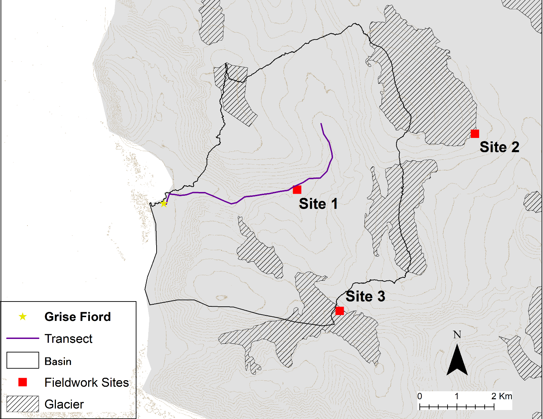
Map:
Figure 1: Map of study area, with the community of Grise Fiord indicated by the yellow star. The watershed is delineated in the black line and the elevation contour lines are light brown and separated by 50 m spacing.

[Tentative Fieldwork Plan] The fieldwork is planned for Spring – May 2022-2024 and Summer - August 2022-2024. With the following schedules and field plan.
SPRING 2022
Day | Site (See Map Below) | Description
1 | 1 | Measure snow depths  Set up area for Drone flights
2 | 1 | Drone Flights  Install air temperature instruments
3 | 1 | Finish work outlined above

SUMMER 2022
Day | Site (See Map Below) | Description
1 | 1 | -Repeat snow survey area from Spring work (see transect on map below)
2 | 1 | Drone Flights
3 | Moving Day | Set up camp at Site 2
4 | 2 | Set up area for drone flights
5 | 2 | Fly Drone
6 | 2 | Set up Timelapse Camera
7 | Moving Day | Set up camp at Site 3
8 | 3 | Set up are for drone flights
9 | 3 | Fly Drone
10 | Moving Day | Back to Hamlet
11+ | Hamlet | Organize and attend community meetings to discuss project.

