Part 1 - Activity Information

Title of Proposed Activity
Op NANOOK-TUUGAALIK 2022 and Op NANOOK-NUNAKPUT 2022

Originating Directorate, Base, or Unit
Maritime Forces Atlantic (MARLANT), Canadian Forces Base (CFB) Halifax

Location of Proposed Activity
Op NA-TU and Op NA-NA will take place in the Maritime Atlantic Operating Areas (MARLOAs), off the coast of Newfoundland, and in the eastern Canadian Arctic, between 2 August and 29 September 2022.

Maritime participants will operate in the following general areas:

- MARLOAs;
- Labrador Sea;
- Davis Strait;
- Hudson Strait;
- Frobisher Bay;
- Baffin Bay;
- Lancaster Sound; and
- Sagleck Bay.

Ship and supporting personnel are expected to visit the following locations:

- Pond Inlet, Nunavut (NU) (community);
- Nanisivik, NU (future DND fuelling facility);
- Arctic Bay, NU (community);
- Cambridge Bay, NU (community);
- Griffin Inlet, NU (uninhabited);
- Lowther Island, NU (uninhabited);
- Gascoyne, NU (DND camp);
- Dundas Harbour, NU (community);
- Qikiqtarquaq, NU (community);
- Iqaluit, NU (community):
- Nain, Newfoundland and Labrador (NL) (community);
- Hopedale, NL (community);
- Goose Bay, NL (community); and
- St. John’s, NL (community).

The Port of Nuuk, Greenland (GL) will also be visited for fuelling purposes.

Activity Summary

1.4.1 Mission and Objectives
The mission of Op NANOOK 2022 is to conduct operations in Canada’s North with Allies and other partners to ensure the Canadian Armed Forces’ (CAF) readiness to operate in the North and improve interoperability with mission partners. The Operational Objectives are:

- Increase interoperability in the North with Joint Task Force North (JTFN);
- Overcome logistical challenges of the Northern operational area;
- Increased interoperability with allies (dealing with a common threat); and
- Support whole of government effort by supporting other governmental departments (OGD) and research and development (R & D).

This EED focuses on the following two lines of effort, designed to meet the following specific Operational Objectives:

Op NA-TU
Increase and reinforce CAF maritime capabilities in Arctic surveillance and mobility;
Demonstrate capability to project joint force effects anywhere in the Arctic; and
Demonstrate the ability to operate with maritime allied and partner nations.

Op NA-NK
Increase Canadian Armed Forces (CAF) joint capabilities in Arctic surveillance and mobility along Canada’s Northwest Passage (NWP).

1.4.2 Exercise Participants
Ships participating in the exercise are:

Royal Canadian Navy (RCN):
- Her Majesty’s Canadian Ship (HMCS) HARRY DEWOLF (HDW) (Harry Dewolf Class)
- HMCS MARGARET BROOKE (MAR) (Harry Dewolf Class)
- HMCS GOOSE BAY (GBY) (Kingston Class)

Danish Navy
- His Danish Majesty’s Ship (HDMS) TRITON (TRI) (Thetis Class) and helicopter

United States Coast Guard (USCG)
- USCG BEAR (BEA) (medium endurance cutter)

French Navy
- French Ship (FS) RHONE (RHO) (Loire Class)

Royal Navy
- Her Majesty’s Ship (HMS) PROTECTOR (PRO) (Research Ship and Ice Breaker)

Participants in the exercise include:
- Royal Canadian Mounted Police
- CCG Ice Breaker with helicopter
- Department of Fisheries and Oceans (DFO) Ice Observers and Marine Mammal Lookouts
- United States Navy CF2
- CG LANTAREA (Atlantic Area)
- Observers: 2 x Japan Joint Staff; 1 x Belgium Officer
- CAF: Joint Task Force Atlantic (JTFA)/JTFN/Defence Research and Development Canada (DRDC)/CP-140 Aurora maritime patrol aircraft

It should be noted that HDW Class vessels have an increased crane safety hazard to the crew from falling loads or equipment. Safety limits have failed and various valves and safety switches are not working properly, or could fail. The equipment manufacturer is no longer in business and parts are not easily available. Mitigation is in place but relies on people to inform the crane operator when they are approaching limits.

1.4.3 Overall Exercise Schedule
The overall exercise schedule is as follows:

Phase 1 (Deployment):
- August: HDW, MAR,GBY/Allies depart Halifax

Phase 2 (Employment):
- 2-12 August: Op NA-TU Fleet Integration Training and LIVEX
- 12-15 August: HDW, GBY Port Visit/Fuel Nuuk, GL
- 15-18 August: MAR Port Visit/Fuel Nuuk, GL
- 15 August – 22 September: Op NA-NK, HDW, MAR, GBY, DRDC and OGD Support

Phase 3 (Re-Deployment):
- 12 September: HDW, MAR depart Lancaster Sound (NWP)
- 12 September: GBY depart Nuuk
- 24-28 September: HDW, MAR and GBY St. John’s
- 29 September: HDW, MAR and GBY return to Halifax

1.4.4 OP NANOOK-TUUGAALIK
The Command Task Group (CTG) will conduct a serialized program focusing on maritime security while transiting from Halifax, Nova Scotia (NS) to Nuuk, Greenland (GL). This will include HDW, MAR, GBY, TRI, BEA, RHO and PRO, and will run from 2 to 12 August. Op NA-TU will take place south of 60ºN.

The schedule of major serials/events are shown in Table 1, and associated locations are shown on Figure 1:

Table 1 - Op NA-TU Schedule of Major Serials/Events

No. on Figure 1 | Date | Serial/Event | Description | Location | Applicable Activities
1 | 2 Aug | HDW, MAR, GBY, TRI, BEA, RHO, PRO depart Halifax |  | Halifax | 1.Vessel Movements and General Operations
2 | 2 Aug | Gunnery | Surface firing of main guns and machine guns against a towed or remotely operated target. | Within MARLOAs | 1.Vessel Movements and General Operations  2.Aircraft and Helicopter Movements  5.Single/Multiple Tow  7.Radar Use (Fire Control only) and Laser  10.Surface Fire
3 | 4 Aug | Maritime Interdiction Operation (MIO)/BOARDEX AREA ELK | Searching for, stopping and boarding a ship to search for weapons and fugitives. One “vessel of interest” (VOI) may take the route on the west side of NL through the Cabot Strait. | Off NL east coast | 1.Vessel Movements and General Operations  2.Aircraft and Helicopter Movements
4 | 5 Aug | Manoeuvres | Ships sailing as a group in relation to a guide ship, and changing formations. | Off NL east coast | 1.Vessel Movements and General Operations
5 | 6 Aug | CROSSPOL | Exchange of personnel from one ship to another. | Off NL east coast | 1.Vessel Movements and General Operations
6 | 7 Aug | ENCOUNTEREX | Multi-ship exercise to detect other ships and avoid detection. | Off NL east coast | 1.Vessel Movements and General Operations  2.Aircraft and Helicopter Movements
7 | 8 Aug | SAREX | Location and recovery of at least one ship or aircraft in distress; dropping smoke markers and conducting a search pattern.  CCG icebreaker will join for 2 days. | Labrador Sea | 1.Vessel Movements and General Operations  2.Aircraft and Helicopter Movements
8 | 9 Aug | PHOTOEX | Taking photographs from a helicopter or drone. | Labrador Sea | 1.Vessel Movements and General Operations  2.Aircraft and Helicopter Movements
Star | 10 Aug | MAR to Iqaluit | Re-supply | Iqaluit | 1.Vessel Movements and General Operations  4. Bottom Interaction
9 | 11 Aug | Fjord NAV | Navigating the fjord into and out of Nuuk. | Nuuk, GL | 1.Vessel Movements and General Operations
10 | 12 Aug | HDW – JTF(N) Key Leadership Engagement (KLE) | This involves briefs to the ships’ Command Teams. | Nuuk, GL

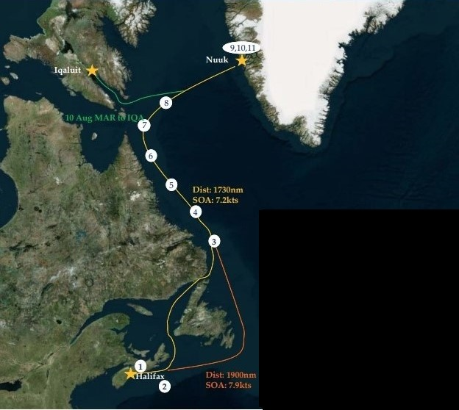

Figure 1 – Overview of Op NA-TU (Source: ref. A)

1.4.5 OP NANOOK-NUNAKPUT
OP NA-NU includes community engagement (COMREL), reconnaissance shore landings (RECCE) and four scientific trials. HDW, MAR and GBY each have a different program, which are described in the following sections.

JTFN activities involving Army and Air Force will also be taking place in the Arctic at this time, and the RCN supports JTFN by providing maritime surveillance, presence and sometimes interaction with Army personnel. The RCN is prepared to respond to any emergency situation in the North West Passage all the way to the border with Alaska. This could include a search and rescue, escort duties or a medical emergency. HDW and MAR plan to travel to Cambridge Bay as the point furthest west.

The planned routes of HDW, MAR and GBY are shown in Figures 2 and 3.

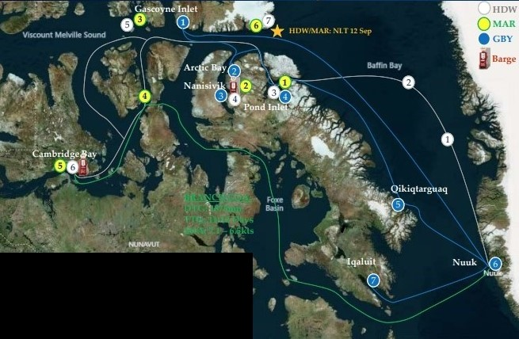

Figure 2 - Overview of Phase 1 of Op NA-NK (Source: ref. A)

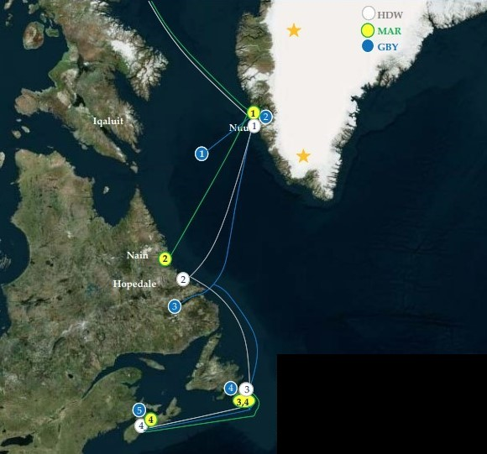

Figure 3 – Overview of Phase 2 of Op NA-NK (Source: ref. A)

The schedule of events for HDW, MAR and GBY are shown on Tables 2, 3 and 4, respectively. Table 5 summarizes the activities at each community/port to show the dates where they will be affected.

Table 2 - Op NA-NK Schedule of Events for HDW

No. on Figure | Date | Serial/Event | Description | Location | Applicable Activities
Phase 1 – see Figure 2
White 1 | 15-18 Aug | Towed Reelable Active Passive Sonar (TRAPS)/Expendable Mobile Anti-submarine Warfare Training Target (EMATT)Trials | DRDC Trial – see 1.4.6.1 | Baffin Bay | 1.Vessel Movements and General Operations  4.Bottom Interaction  5.Single/Multiple Tow  6.Active Sonar
White 2 | 19-21 Aug | TRAPS/Behavioural Response Study (BRS) Trials | DRDC Trial – see 1.4.6.1 | Baffin Bay | 1.Vessel Movements and General Operations  4.Bottom Interaction  5.Single/Multiple Tow  6.Active Sonar
White 3 | 24 Aug | Disembark TRAPS personnel |  | Pond Inlet, NU | 1.Vessel Movements and General Operations
White 4 | 26 Aug | Fuelling | Fuelling by commercial barge. | Nanisivik, NU | 3.Fuelling Alongside and at Anchor  4.Bottom Interaction
White 5 | 28 or 29 Aug | RECCE | Shore Landing of personnel – reconnaissance; day only (no overnight camping); may include landing of all-terrain vehicle (ATV) | Griffith Island, NU / Lowther Island, NU | 1.Vessel Movements and General Operations
White 6 | 3-5 Sep | Re-supply, fuelling, COMREL | Fuelling by commercial barge or CCG at anchor; re-supply using small boats; community relations | Cambridge Bay, NU | 3.Fuelling Alongside and at Anchor  4.Bottom Interaction
White 7 | 11 Sep | COMREL | Community relations | Dundas Harbour, NU | 1.Vessel Movements and General Operations
Phase 2 – see Figure 3
White 1 | 16 Sep | Fuelling | Fuelling at commercial port | Nuuk, GL | 3.Fuelling Alongside and at Anchor
White 2 | 19-20 Sep | COMREL | Community Relations | Hopedale, NL | 1.Vessel Movements and General Operations
White 3 | 24-27 Sep | Port Visit | Rest and recreation for sailors (no Op NA-NK activities) | St. John’s | 1.Vessel Movements and General Operations
White 4 | 29 or 30 Sep | Return |  | Halifax | 1.Vessel Movements and General Operations

Table 3 - Op NA-NK Schedule of Events for MAR

No. on Figure | Date | Serial/Event | Description | Location | Applicable Activities
Phase 1 – see Figure 2
Yellow 1 | 22-23 Aug | Maritime Autonomous and Remotely Piloted Systems (MARPS) Trial | DRDC Trial – see 1.4.6.2 | Pond Inlet, NU | 1.Vessel Movements and General Operations  4.Bottom Interaction  6.Active Sonar
Yellow 2 | 26 Aug | Fuelling | Fuelling by commercial barge | Nanisivik, NU | 3.Fuelling Alongside and at Anchor
Yellow 3 | 29 Aug | RECCE | Shore Landing of personnel – reconnaissance; day only (no overnight camping); may include landing of all-terrain vehicle (ATV) | Griffith Island, NU/ Lowther Island, NU | 1.Vessel Movements and General Operations
Yellow 4 | 24 Aug – 7 Sep | JTFN support, COMREL | No details provided. Community relations. | To be decided | 1.Vessel Movements and General Operations
Yellow 5 | 3-5 Sep | Re-supply, fuelling, COMREL | Fuelling by commercial barge or CCG at anchor; re-supply using small boats; community relations | Cambridge Bay, NU | 3.Fuelling Alongside and at Anchor  4.Bottom Interaction
Yellow 6 | 11 Sep | COMREL | Community relations | Dundas Harbour, NU | 1.Vessel Movements and General Operations
Phase 2 – see Figure 3
Yellow 1 | 16 Sep | Brief Fuel Stop | Fuelling at commercial port. | Nuuk, GL | 3.Fuelling Alongside and at Anchor
Yellow 2 | 19-20 Sep | COMREL | Community relations | Nain, NL | 1.Vessel Movements and General Operations  4.Bottom Interaction
Yellow 3 | 24-26 Sep | Port Visit | Rest and recreation for sailors (no Op NA-NK activities) | St. John’s | 1.Vessel Movements and General Operations
Yellow 3 – Yellow 4 | 27 Sep | Lieutenant Governor Sail | Visit onboard by Lt. Gov | St. John’s - Halifax | 1.Vessel Movements and General Operations
Yellow 4 | 29 or 30 Sep | Return |  | Halifax | 1.Vessel Movements and General Operations

Table 4 - Op NA-NK Schedule of Events for GBY

No. on Figure | Date | Serial/Event | Description | Location | Applicable Activities
Phase 1 – see Figure 1
Blue 1 | 20-23 Aug | Embark Long-Range Underwater Acoustic Communication Experiment  (LRUACE) staff in Gascoyne, conduct trial, disembark | DRDC Trial – see 1.4.6.3 | Lancaster Sound | 1.Vessel Movements and General Operations  4.Bottom Interaction  6.Active Sonar
Blue 2 | 24 Aug | Integrated Surveillance via Layered Arctic Networked Defence Sensors (ISLANDS) Trial: Arctic Acoustic Recorder (AAR) 1 | DRDC Trial – see 1.4.6.4 | Arctic Bay, NU | 1.Vessel Movements and General Operations  4.Bottom Interaction
Blue 3 | 25 Aug | Fuelling | Fuelling from commercial barge or from MAR | Nanisivik, NU | 3.Fuelling Alongside or at Anchor
Blue 4 | 27 Aug | ISLANDS: AAR 2 | DRDC Trial – see 1.4.6.4 | Pond Inlet, NU | 1.Vessel Movements and General Operations  4.Bottom Interaction
Blue 5 | 31 Aug | ISLANDS: AAR 3 | DRDC Trial – see 1.4.6.4 | Qikiqtarquaq, NU | 1.Vessel Movements and General Operations  4.Bottom Interaction
Blue 6 | 3 Sep | Brief Fuel Stop | Fuelling at commercial port | Nuuk, GL | 3.Fuelling Alongside and at Anchor
Blue 7 | 5 Sep | Embark DFO |  | Iqaluit, NU | 1.Vessel Movements and General Operations  4. Bottom Interaction
Phase 2 – see Figure 2
Blue 1 | 5-18 Sep | FISHPAT | Fisheries Patrol – monitoring of fishing vessels and enforcement of fishing regulations through inspections | Davis Strait | 1.Vessel Movements  2.Aircraft and Helicopter Movements
Blue 2 | 12 Sep | Brief Fuel Stop | Fuelling at commercial port | Nuuk, GL | 3.Fuelling Alongside and at Anchor
Blue 3 | 18-20 | COMREL (Namesake visit), disembark DFO | Community relations | Goose Bay, NL | 1.Vessel Movements
Blue 4 | 24-27 Sep | Port Visit | Rest and recreation for sailors (no Op NA-NK activities) | St. John’s | 1.Vessel Movements
Blue 4 | 29 or 30 Sep | Return |  | Halifax, NS | 1.Vessel Movements

Table 5 – Activities by Community/Port

Community/Port | Date | Activity
Halifax, NS | 2 August | HDW, MAR, GBY, TRI, BEA, RHO, PRO Depart
Halifax, NS | 29-30 September | HDW, MAR, GBY return
Nuuk, GL | 12 August | Command Team briefs (HDW)
 | 3 September | Fuelling GBY
 | 12 September | Fuelling GBY
 | 16 September | Fuelling HDW and MAR  Embark MARPS personnel (MAR)
Iqaluit, NU | 10 August | MAR to re-supply
Iqaluit, NU | 5 September | Embark DFO on GBY for FISHPAT
Gascoyne, NU | 20-23 August | LRUACE Trial – embark, conduct trial, disembark
Pond Inlet, NU | 20-24 August | Possible Army exercise in the area (P11 Eclipse Sound) – insertion/extraction by RCN vessel may be possible
Pond Inlet, NU | 22-23 August | MARPS Trial (MAR)
Pond Inlet, NU | 24 August | Disembark MARPS personnel from MAR
Pond Inlet, NU | 24 August | Disembark TRAPS personnel from HDW
Pond Inlet, NU | 27 August | ISLANDS Trial: placement of AAR No. 2 (GBY)
Arctic Bay, NU | 24 August | ISLANDS Trial: placement of AAR No. 1 (GBY)
Nanisivik, NU | 25 August | Fuelling of GBY by commercial barge or MAR
Nanisivik, NU | 26 August | Fuelling of HDW by commercial barge  Fuelling of MAR by commercial barge
Griffith IslandNU/  Lowther Island, NU | 28 or 29 August | RECCE (HDW and MAR)
Qikiqtarquaq, NU | 31 August | ISLANDS Trial: placement of AAR No. 3 (GBY)
Cambridge Bay, NU | 3-5 September | Fuelling by commercial barge or CCG (HDW and MAR); re-supply; community relations
Dundas Harbour, NU | 11 September | Community Relations (HDW and MAR)
Goose Bay, NL | 18-20 September | Disembark DFO (FISHPAT); community relations (GBY)
Hopedale, NL | 19-20 September | Community Relations (HDW)
Nain, NL | 19-20 September | Community Relations (MAR)
St. John’s, NL | 24-27 September | Port Visit (no Op-NK activities) (HDW, MAR,GBY)  Embark Lt. Gov (MAR)

1.4.6 Research and Development
During OP NA-NK, four scientific trials will be conducted.

1.4.6.1 Maritime Evaluation (MAREVAL) with Towed Reelable Active Passive Sonar Trial combined with a Behavioural Response Study

TRAPS and EMATT Trial

TRAPS is a portable, containerized system with active and passive sonar capability for detection, classification, tracking and localization of underwater targets. A crane is required to deploy and tow the 12 m long sonar array. The TRAPS will be located on the HDW, and will be involved in a 2-part trial taking place in Baffin Bay (ref. B).

The TRAPS/EMATT trial will take place 15-18 August (see White 1 and White 2 on Figure 2). The TRAPS will likely be operated using the trial plan from 2021, that is, active sonar pings every 10 km along the route between 10:00 – 15:00 local time. Each ping will be 11 seconds long, with a 1 second 1800 Hz continuous tone, followed by a linear frequency sweep from 2000-2600 Hz lasting 10 seconds. For 2022, it is possible that the trial will be done within a smaller area, and if so, the pings will occur every 45 minutes assuming a tow speed of 8 kt. If the ping is modified, it will be shorter, but within the same frequency range. In any case, the ping source level will be 210 dB re 1 µPa²·m².

In conjunction with the TRAPS trial, Expendable Mobile ASW Training Targets (EMATTS) will be tracked with TRAPS in a passive mode in order to obtain some baseline bathymetric data. During this activity 4 EMATTS will be used.

A modelling report for the TRAPS was carried out in 2021 for a trial within Lancaster Sound (Ref. C). The active sonar portion of the trial for which the modelling was conducted was not carried out in 2021, and will be carried out in Baffin Bay/Davis Strait for Op NA-NK 2022. Modelling was carried out at 8 locations, from the east end of Lancaster Sound to Herschel Island in the western Arctic. Propagation model results from Site 1 in reference C (see Figure 4) can be extended to the 2022 trial, since the sound speed profiles and bottom type from Site 1 were chosen to be representative of Baffin Bay and Davis Strait.

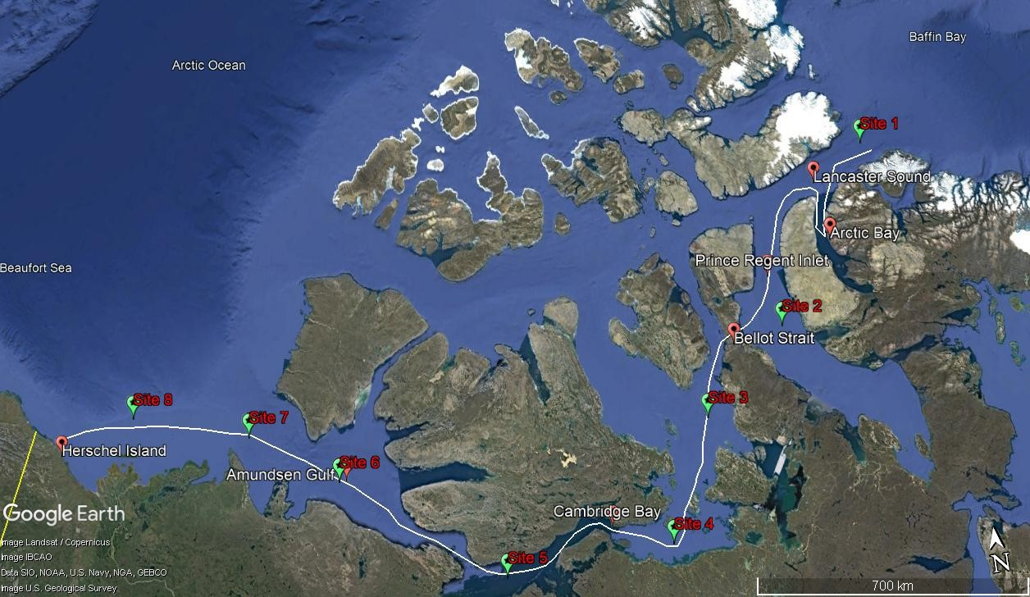

Figure 4 – Route used for JASCO 2021 Modelling of TRAPS (Source: ref. C)

Injury

Injury from underwater noise can be permanent (Permanent Threshold Shift [PTS]) or
temporary (Temporary Threshold Shift [TTS]). For injury to marine mammals, JASCO applied
the specific methods and thresholds for assessing PTS and TTS summarized by the National
Marine Fisheries Service (NMFS) of the United States (US) National Oceanic and Atmospheric
Administration (Ref. D).

Table 6 presents the distances in meters to the PTS and TTS thresholds calculated by JASCO using different auditory frequency weighting functions at Site 1.
Table 6 - Range to Weighted Thresholds (Source: ref. C)

Hearing Groups and Impact Threshold |  | Weighted sound exposure level (SEL) thresholds  (dB re 1 µPa²s) | Range to Threshold  Site 1  (m)
Low-frequency cetaceans (e.g. Bowhead Whale) | PTS | 199 | -
Low-frequency cetaceans (e.g. Bowhead Whale) | TTS | 179 | 262
Mid-frequency cetaceans (e.g. Sperm Whale, Northern Bottlenose Whale, Beluga, Narwahl) | PTS | 198 | -
 | TTS | 178 | -
High-frequency cetaceans (e.g. porpoise) | PTS | 173 | -
High-frequency cetaceans (e.g. porpoise) | TTS | 153 | 290
Phocid pinnipeds (e.g. Ringed Seal) | PTS | 201 | -
Phocid pinnipeds (e.g. Ringed Seal) | TTS | 181 | 83
Otariid pinnipeds (e.g. Atlantic Walrus) | PTS | 219 | -
Otariid pinnipeds (e.g. Atlantic Walrus) | TTS | 199 | -
A dash indicates that the threshold distance was never exceeded.
Based on the modelling, the PTS threshold was not exceeded at Site 1. The maximum TTS distance modelled was 290 m, for high-frequency mammals (porpoises). The maximum TTS distance for the species that are expected to occur in the Op NA-NK trial area is 260 m for low-frequency cetaceans (e.g., bowhead whales).

Behaviour

The distances to marine mammal disturbance radii in the JASCO report are shown in Table 7. The frequencies considered correspond to the single frequency 1 second continuous wave at 1800 Hz and four representative frequencies of the 10 second LFM that ranges from 2000–2600 Hz. Three isopleth distances were considered: 160, 140, and 120 dB re 1 µPa. The 160 and 120 dB re 1 µPa isopleths are the sound levels for behavioural disturbance in marine mammals for impulsive and continuous sound sources, respectively, as recommended by reference E. The 140 dB re 1 µPa isopleth was included to provide scale/context for the 160 and 120 dB re 1 µPa distances.
Table 7 – Distances to Marine Mammal Disturbance at Site 1 (Source: ref. C)

Modelled frequency (Hz) | Unweighted SPL isopleth  (dB re 1 µPa) | R_{Max} (km) | R₉₅ (km)
1800 | 160 | 0.7 | 0.7
1800 | 140 | 23.6 | 23.1
1800 | 120 | 121.6 | 112.9
2000 | 160 | 0.8 | 0.7
2000 | 140 | 23.6 | 23.0
2000 | 120 | 110.9 | 106.1
2200 | 160 | 0.8 | 0.7
2200 | 140 | 23.3 | 22.8
2200 | 120 | 103.3 | 99.0
2400 | 160 | 0.8 | 0.8
2400 | 140 | 23.1 | 21.4
2400 | 120 | 97.0 | 93.1
2600 | 160 | 0.8 | 0.7
2600 | 140 | 23.1 | 21.2
2600 | 120 | 91.9 | 88.3

If the threshold SPL of 160 dB re 1 µPa² (non-impulsive) is considered, marine mammals would not be disturbed beyond 800 m, based on the modelling. However, the modelling shows that marine mammals can be disturbed at long distances, when a threshold SPL of 120 dB re 1 µPa² (continuous) is considered.

TRAPS and Arctic BRS Trial

TRAPS will be used as an active sonar source to conduct a Marine Mammal Arctic Behavioural Response Study (BRS) in Davis Strait/Baffin Bay 19-21 Aug. The trial will take place 250 km from the east shore of Baffin Island, at latitudes south of Clyde River and north of Pangnirtung. The BRS will involve a Controlled Exposure Experiment (CEE) which will provide information critical for supporting future use of active sonar in the Arctic, and ultimately contribute to improved marine mammal mitigations for the RCN as required by the Species at Risk Act.

This trial will be undertaken in collaboration with Dalhousie University Large Whale Chair. The BRS will look solely at northern bottlenose and sperm whales, and will involve the activities in Table 8. A fishing vessel, KIVIUQ, will be used by DRDC for the tagging and biopsy collection activities. According to the ref. B, approval has been received from the Nunavut Wildlife Management Board to tag and biopsy the northern bottlenose and sperm whales.

Table 8 – Activities during TRAPS/ABR Trial (Source: ref. F)

Activity | Details
Tagging of Vertebrate Wildlife | Target species: sperm whale (Physeteridae macrocephalus) and northern bottlenose whales (Hyperoodon ampullatus)  Type of manipulation: Equipping individuals with 1) long-term dermally attached satellite-transmitters with time-depth recorders (Wildlife Computers Fast-loc “SPLASH” tags) and 2) short-term suction-cup attached archival tags (Customizable Animal Tracking Solutions tags) with 3-D kinematic sensors and passive acoustic recorders.  Number of specimens affected: 20-43 satellite tags and 10-30 archival tags.  Tagging is expected to cause minor, short-term disturbance to whale behaviour.
Biopsy collection of vertebrate wildlife | Target species: sperm whale (Physeteridae macrocephalus) and northern bottlenose whales (Hyperoodon ampullatus)  Type of manipulation: skin and blubber samples will be obtained using a crossbow and biopsy dart.  Number of specimens affected: 40-60 biopsy samples.  Biopsy collection is expected to cause slight to no disturbance to whale behaviour.
Behavioural response study of vertebrate wildlife | Target species: sperm whale (Physeteridae macrocephalus) and northern bottlenose whales (Hyperoodon ampullatus)  Type of manipulation: tagged whales will be exposed to low to mid amplitude sonar using 1) a calibrated, submersible speaker; and 2) ship-based sonar. For all playbacks, whales will be exposed to one of three noise treatments: 1) control sound (ambient noise/naturally occurring sound): 2) vessel noise: 3) vessel noise and military sonar. Playbacks will be at realistic source levels but at sufficient distance so received levels would not cause hearing damage.  Number of specimens affected: 30-73 short and long-term tagged whales are expected to be involved in the behavioural response study.

Ensuring whale safety is a critical component of the study design (ref. G). Being a CCE trial, the sonar level will begin at a level below which any behavioural reaction would be expected, and should not cause any physical harm to the whales. The level will be slowly stepped up over time, with careful observation for any behavioural changes in the whales, always remaining well below the threshold for causing physical harm. This trial follows a similar study design to what has been previously reported in the literature. These previous studies were conducted by USN-funded researches, as well as Dutch and Norwegian defense researchers. The experiment will be carried out in open water. Many of the past stranding cases have been linked to regions where the shoreline constrains potential escape routes for whales.

Typical marine mammal mitigation procedures will be followed, including ramp-up, the use of a mitigation avoidance zone (MAZ), visual and passive acoustic monitoring, and shut-down procedures in the case that a whale approaches too closely to the vessel. A conservative MAZ of 500 m will be used, based on the results of the JASCO modelling discussed previously.

Marine mammal scientists from Dalhousie University and/or DFO will be on board to assist with the trial. Their expertise will be critical for monitoring the whales' behavioural state to avoid adversely affecting the whales.

It is intended to supplement typical visual observation techniques with electro-optical/infra-red systems and drone usage to maximize the chances of knowing where the whales are at all times.

1.4.6.2 Maritime Autonomous and Remotely Piloted Systems Trial
This DRDC trial is a demonstration of interoperability between mobile and stationary maritime autonomous and remotely piloted systems for the Above Surface Warfare “hold at risk scenario”. A “hold at risk” scenario is the monitoring of a port or transit choke point with the intent of detecting submarines entering or exiting the area. This 2-day trial will be undertaken in shallow water near Pond Inlet, NU on 22-23 August 2022 with the support of MAR. The trial requires a location with depth of water under 100 meters. One unmanned surface vessel (USV) will be deployed and recovered using a rigid hull inflatable boat (RHIB) from MAR, and one recorder will be deployed prior to the experiment and recovered after completion. The activities are described in Table 9.

The key objectives include:

- Testing the interoperability between mobile and stationary MARPS to demonstrate an ASW concept of employment in the Arctic environment;
- Evaluation of alignment performance and quality of a new inertial navigation system (INS), on board an autonomous underwater vehicle (AUV), following stationary and moving calibration at high arctic latitudes;
- Collection of high-frequency (450 kHz) sonar data from an USV to evaluate the performance characteristics of this sonar in the arctic ocean where the presence of freshwater layers affect the sound velocity profile;
- Development of safe and efficient procedures for arctic MARPS operation, including deployment and recovery from an RCN platform; and
- Provide DRDC personnel with Arctic training and experience for MARPS, onboard an RCN platform.

Table 9 – Activities during MARPS Trial (Source: ref. H)

Day | Activity Details
15-17 August  2022 | DRDC personnel (1 scientist and 3 technicians) embark on MAR at Nuuk, Greenland (all equipment already onboard from Halifax)
17-21 August 2022 | - MAR transits from Nuuk, Greenland, to Pond Inlet, Nunavut.  ii. DRDC personnel perform pre-deployment testing of all instruments  iii. DRDC personnel train crew of MAR for instrument deployment  iv. Calibration of the INS onboard the AUV is performed while the ship transits (AUV remains onboard Margaret Brook for duration of calibration).
22 August 2022 | Deploy one Distributed Underwater Sensor Network  (DUSN) node and RF float at location 72.54094°N, 78.58181°W; perform modem localization; run USV pre-dive sequence and deploy USV; run USV in-water tests  ii. Test communications between DUSN node and USV  iii. Begin running the USV in a “box-pattern” survey path centered on the DUSN node with side lengths of 1000 m each.  iv. Deploy the rigid-hulled inflatable boat (RHIB) with automatic identification system transmitter and run a transect through the USV survey box (acting as a target).  v. The RHIB target should trigger a request for automatic identification system traffic from USV, which will subsequently communicate this information to the DUSN node.  vi. Recover USV at end of operation day  vii. Recover the RF float (the DUSN node remains on sea bottom to be recovered the next day pending favorable weather)  10 hour day.
23 August 2022 | i. Run USV pre-dive sequence and deploy USV  ii. Perform the same set of steps as day before (ii – iv)  iii. Perform a shallow water survey with USV and the PingDSP sonar with a simple lawnmower line pattern moving from shallow to increasingly deeper water (approx. 5 m to 50 m water depths).  iv. Collect CTD at locations of PingDSP survey  v. Recover all instruments and secure for transit  10 hour day.
24 August 2022 | DRDC personnel disembark from Margaret Brooke at Pond Inlet, Nunavut.

The technical details of the USV sonar are:

- located approximately 1 m below the water surface and transmits sound at approximately 45 degrees on wither side of the USV;
- frequency: 450 kHz;
- sound pressure (source) level: 200dB re 1 μPa @ 1 m typically;
- pulse length: 0.1ms;
- repetition rate: 33 ms; and
- operation duration: 8 hours per day (at most) for 2 days.

At the very high frequencies of this sonar transmitter, there is very strong absorption and attenuation of sound in seawater (ref. I). Due to the rapid absorption of sound above 100 kHz by water, a short mitigation avoidance zone of 100 m has been recommended in the past for similar side-scan sonars above 100 kHz, and no ramp up has been required (ref. J).

The location of the trial is within the soon-to-be-established Tallurutiup Imanga NMCA. The Government of Canada and the Qikiqtani Inuit Association signed an Inuit Impact and Benefit Agreement (IIBA) required for the establishment of the Tallurutiup Imanga NMCA on 1 August 2019 (ref. K). The IIBA acknowledges that DND conducts military related research in the Arctic, including Tallurutiup Imanga NMCA. In the agreement, DND commits to providing information to assess the environmental impact of its research programs on Tallurutiup Imanga NMCA, commits to providing unclassified summaries of the planned research within Tallurutiup Imanga NMCA and, where possible, will provide the information requested in the IIBA for research proposals. Upon completion of DND research, an unclassified summary of the results will be provided. The information is to be provided to the Aulattiqatigiit Board which is a joint Inuit and Canada management board.

According to the IIBA, DND will be involved as appropriate for input to the proposed Tallurutiup Imanga NMCA Research and Monitoring Strategy before it is finalized.

1.4.6.3 Long-Range Underwater Acoustic Communication Experiment
This trial will take place with the participation of the GBY that will deploy both transmitter and recorders. The trial will take place 20 – 23 August in the area of Gascoyne Inlet Camp (GIC), which is located within the soon-to-be-established Tallurutiup Imanga National Marine Conservation Area (NMCA) in the Parry Channel (Barrow Strait and Lancaster Sound). More information on this protected area can be found in Annex A.

The key objectives include (ref. L):

  - collection of acoustic and non-acoustic data;
  - experiment new buoyancy and fairings; and
  - achieve 50-to-100 km communication range by testing different communication schemes at relatively low active sonar frequencies.

The trial activities are shown in Table 10:

Table 10 – LRUACE Activities (Source: ref. L)

Day
20 August 2022 | 1. Pick up personnel at GIC using GBY RHIB.  2. Deploy 2 DUSN receivers, deploy, deploy Conductivity-Temperature-Depth Array and Acoustic Doppler Current Profiler, localization  3. GBY to 1st waypoint and deploy source (DACS acoustic projector), run signal sequence for ~ 1hr, recover source and reposition.
21 August 2022 | Repeat above step 3 up to 100 km away from receivers
22 August 2022 | Repeat above step 3 by getting closer to receivers
23 August 2022 | Recover all gear and drop personnel at GIC. GBY RHIB will be used to recover DUSN nodes and transport personnel.

The equipment will be located per Table 11 and Figure 5:

Table 11 – Asset Locations for LRUACE (Source: ref. L)

Asset | Latitude | Longitude | Depth (m) | Note
DUSN #1 | 74º30.125’ N | 91º18’ W | 151 | Straight south of GIC
DUSN #2 | 74º 29.0451’N | 91º18’ W | 145 | 2-km south of DUSN #1
CTD Array | Between DUSN #1 & #2 | Between DUSN #1 & #2 | ~147
ADCP | Between DUSN #1 & #2 | Between DUSN #1 & #2 | ~147
GBY 100-km Waypoint | 74º 28.0579’N | 94º39.7474’ | N/A
N/A: Not available.

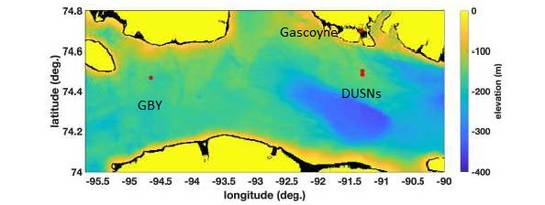

Figure 5 – Asset Locations for LRUACE (Source: ref. L)

Source characteristics are provided in Table 12:

Table 12 – Source Characteristics (Source: ref. L)

Source Level | Not to exceed 170 dB rel. 1 micro-pascal @ 1 m. for a tone centered in signal band
Source Depth | Approximately 50 meters
Source Speed | Drifting, therefore low speed
Source Bandwidth | A 10-to-50 Hz band between 150 Hz and 360 Hz
Source Duty Cycle in 24 hours | About 30% (assuming 1-hr transmit, 2-hr for commute and deployment/recovery)

The active sonar in this case can be considered to be non-impulsive, and therefore the sound exposure thresholds for marine mammals in Table 13 can be applied here. The source level will not exceed 170 re 1 µPa², which is below the identified thresholds, except for the TTS threshold for high-frequency cetaceans (e.g. porpoise), which would not be expected this far north. Behavioural effects are expected at distances far from the source area. A MAZ should be determined for this trial.

Table 13 - Thresholds for TTS and PTS in Hearing Groups (Source: ref. D)

Hearing Group | Weighted SEL_{24h}  (dB re 1 μPa2·s)
Hearing Group | TTS | PTS
Low-frequency cetaceans | 179 | 199
Mid-frequency cetaceans | 178 | 198
High-frequency cetaceans | 153 | 173
Phocid pinnipeds (underwater) | 181 | 201
Otariid pinnipeds (underwater) | 199 | 219

The generalized hearing groups are provided in Table 14.

Table 14 - Generalized Hearing Range of Hearing Groups (Source: ref. D)

Hearing Group | Generalized Hearing Range
Low-frequency cetaceans  (baleen whales) | 7 Hz to 35 kHz
Mid-frequency cetaceans  (dolphins, toothed whales, beaked whales, bottlenose whales, narwahl) | 150 Hz to 160 kHz
High-frequency cetaceans  (true porpoises, Kogia, river dolpins, cephalorhynchid, Lagenorthynchus cruciger & Lagenorthynchus australis) | 275 Hz to 160 kHz
Phocid pinnipeds (underwater)  (true seals) | 50 Hz to 86 kHz
Otariid pinnipeds (underwater)  (sea lions and fur seals; Atlantic Walrus) | 60 Hz to 39 kHz

The trial will be located within the Tallurutiup Imanga NMCA, and therefore DND must meet their commitments in the IIBA as discussed in section 1.4.6.2.

1.4.6.4 Integrated Surveillance via Layered Arctic Networked Defence Sensors Trial
In this activity three (3) acoustic hydrophone recorders (1 on the bottom, 2 in the water column) will be deployed for period of one year. These are passive recorders, with no surface expression or noise emissions. The recorders are expected to be recovered in summer of 2023 (summer 2024 as backup). The recorders will each leave behind about 50 kg of iron anchor weight due to their moorings. These recorders will be located as shown in Table 15 and Figure 6:

Table 15 – Planned AAR Locations (Source: ref. M)

Recorder | Date of Deployment | Approximate Location | Longitude/ Latitude | Water Depth | Recorder Depth
AAR 1 | 24 August 2022 | Near Arctic Bay | 73°49'30.00"N, 84°16'45.00"W | ~ 300m | Bottom lander
AAR 2 | 26 August 2022 | Near Pond Inlet | 73° 6'00.00"N, 74° 9'22.00"W | ~ 900m | Within sound duct
AAR 3 | 30 August 2022 | Near Qikiqtarjuaq | 68° 7'52.00"N, 63°20'56.00"W | ~ 900m | Within sound duct

Arctic Bay and Pond Inlet are both located within the Tallurutiup Imanga NMCA, and therefore DND must meet their commitments in the IIBA as discussed in section 1.4.6.2.

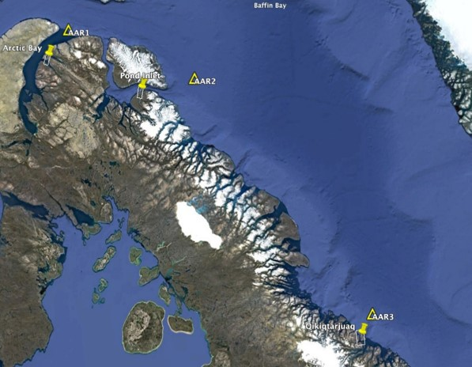

Figure 6 – Proposed locations of AAR (Source: ref. M)

Applicability of DND EIA Directive
This activity does not meet the definition of a project in section 81 of the Impact Assessment Act (IAA) and therefore sections 82 and 83 of the IAA do not apply. However, according to the DND Environmental Impact Assessment Directive, a determination on the likelihood of adverse environmental effects is required as an exercise of due diligence.
This DDEED report assesses activities carried out during Op NA-TU 2022 and Op NA-NK 2022. Operational controls are included in the Environmental Support Instructions in Annex B.
1.6 EED Start Date
- May 2022

1.7 EIA number
The MARLANT MARL SE number is: 1267-0100-2242.

1.8 Territorial, Provincial and Municipal Government Involvement
- Qikiqtani Inuit Association (QIA)
- Kitikmeot Inuit Association (KIA)
- Nunavut Tuungavit, Inc.

1.9 Other Federal Departments or Third Party Groups
- JTFN
- DFO

1.10 Contacts
1.101.1 Establishment Point of Contact:

MARLANT Safety and Environment (SE)

E-mail Address: +N48FormationSafetyandEnvironment@forces.gc.ca

Telephone number: 902-427-1423

1.10.2 Activity OPI:

MARLANT SE

E-mail Address: +N48FormationSafetyandEnvironment@forces.gc.ca

Telephone number: 902-427-1423

1.11 Interviews
No interviews were carried out for this DDEED, however information for this report was received from the following:

- Deanna Brewster, MARLANT SE
- Lieutenant Commander (LCdr) Sylvain Bernier, Maritime Component Commander/ Future Operations SSE Continental
- LCdr Mitchell Lane, SSO Future Operations Continental, Maritime Component Command
Canadian Armed Forces
- Reza Mir, DRDC
- Carolyn Binder, DRDC
- Stephane Blouin, DRDC
- Sean Pecknold, DRDC
- Sarah Rahmer, Defence Construction Canada (DCC)

