Spills Contingency Planning and Reporting
Introduction
The Geological Survey of Canada is undertaking a mapping and assessment project of Canada’s north under the GEM-GeoNorth program to increase geologic knowledge for future natural resource exploration, better informed land use, balanced conservation, and responsible resource development. The objective of the proposed activity described in this document is to collect between 1,200 to 1,500 centre-lake bottom sediment and near-surface water samples over an area of approximately 18,000 km² shown in Figure 1 to provide baseline geochemical data for mineral exploration and environmental studies.
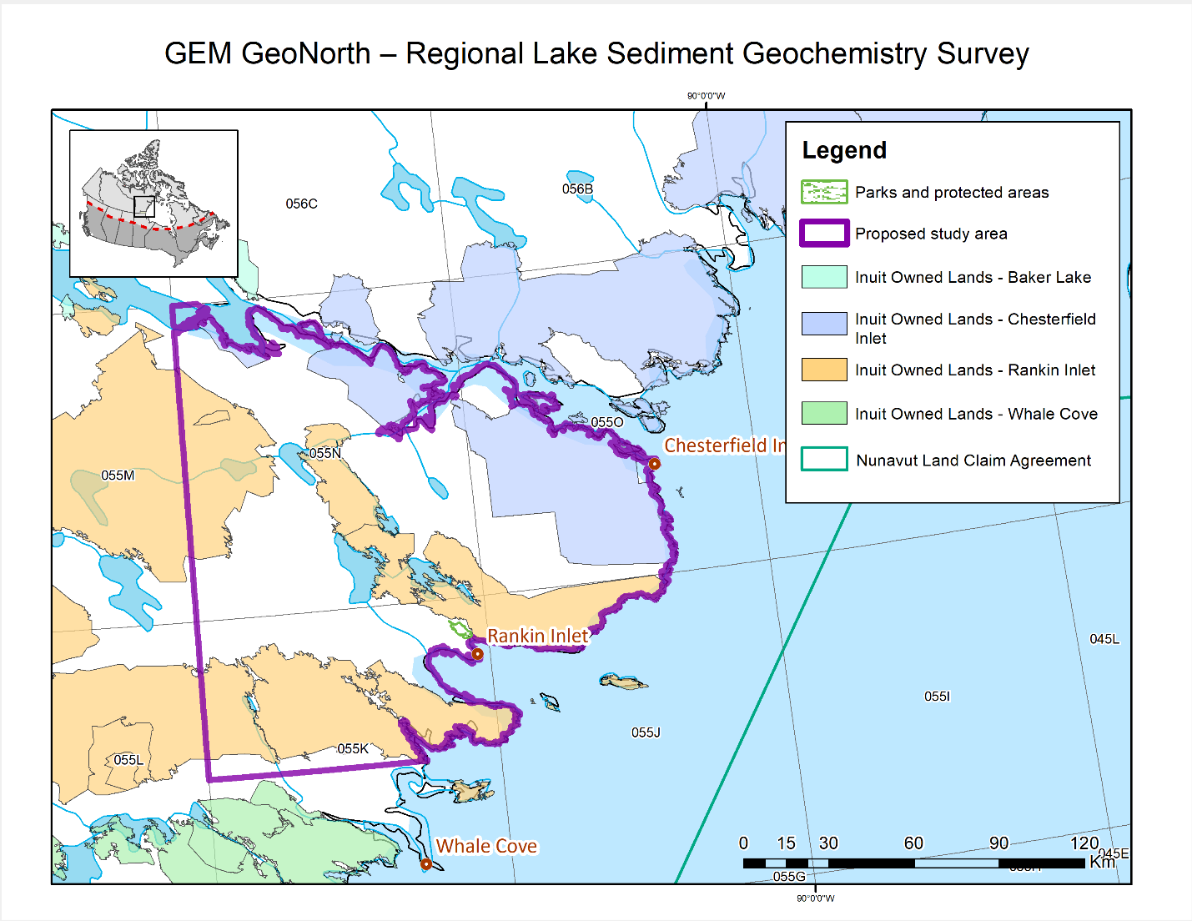
Figure 1. The area of the proposed lake sediment and water survey in the Kivalliq Region is outlined in purple.
Collection Procedures
A two-person crew collects samples of lake sediment and water from a float-equipped helicopter. A Bell LongRanger 206L is typically used for lake sediment surveys in the Arctic. In routine operations, one person navigates from the front of the helicopter cabin while a second crew member in the back of the helicopter collects the samples. The device used to collect samples is a hollow pipe-like device with a butterfly valve in the removable nose section (Fig. 2). The lower 40 cm is the core retaining section.
Figure 2. Lake sediment sampler used at the Geological Survey of Canada. The device weighs 7.1 kg and collects a 30 cm core sample of lake sediment, corresponding to a weight of 1.2 kg of lake sediment.
When the helicopter has landed in the centre of the lake and has become stationary, the sediment sample-collecting member of the crew proceeds to collect the water and sediment samples.
Helicopter Fuel Use
The Bell 206L LongRanger burns about 114 litres (25 Imperial/30 U.S. U.S. gallons) of Jet A aviation fuel per hour. There are currently 96 drums of fuel stored by a local contractor in Rankin Inlet and 40 drums stored by a local contractor in Chesterfield Inlet. A fuel drum holds about 205 litres (44 Imperial/55 U.S.) of Jet A fuel. Currently, it is proposed that fuel drums from Chesterfield Inlet and/or Rankin Inlet be positioned at two caches of 18 drums each approximately 80 km west of the two communities. Depending on the time of year, positioning will take place in 2023 either by over-land hauling by a local contractor or fixed-wing aircraft. Removal of empties and unused fuel will be carried out by over-land hauling during the winter of 2024. Empty fuel drums (Jet-A) will be shipped to a proper disposal site.

Initial Action in the Event of a Fuel Spill
In the event that a fuel spill has occurred, below is a list of procedures and suggested course of action of the first person on the scene who has detected a problem.
- Be alert and consider your safety first. If possible, identify the product spilled;
- Assess the hazards to persons in the vicinity of the spill and alert or take appropriate evacuation measures if needed (e.g., eliminate sources of ignition);
- If possible, control danger to human life;
- Assess whether the spill can be readily stopped or brought under control;
- If safe to do so, and if possible, try to stop the flow of material (e.g., stop fuelling, shut off valve (if present), manoeuvring a leaking drum);
- Gather information on the status of the situation;
- Report the spill without delay to the spill response person/team affiliated with the project and ensure that where applicable the government is notified at the same time according to via the 24 Hour Spill Report Line for Nunavut
Spill Response Person
Stephen J.A. Day
Activity Lead, Lake Sediment and Water Survey
Geological Survey of Canada/Commission géologique du Canada
Land & Minerals Sector/Secteur des terres et minéraux
Natural Resources Canada
275-601 Booth Street, Ottawa, Ontario K1A 0E8
stephen.day@NRCan-RNCan.gc.ca
Phone: (613) 327-0256
Nunavut and NWT 24-hour Spill Report Line
Phone (867) 920-8130
Fax (867) 873- 6924
- Resume any effective action to contain, clean up, or stop the flow of spilled material.
Procedure
The person who first discovers a fuel spill should follow the procedures set out in the ‘Initial Action’ section (above) of this document.
If the spill is not easily contained and/or cleaned up by the person who first discovers it, then that person will immediately report the incident to Stephen Day at Natural Resources Canada (contact information provided above under Initial Action). Together the situation will be reassessed, and effective actions will be carried out in order to contain, clean up, and stop the flow of the spillage.
Procedure for Spills on Snow
By its nature, snow is an absorbent, and fuel spilled on snow is collected with relative ease,
either by shovel, in the case of small-range spills, or other means in the case of more
extensive spills.
- The person who first discovers a fuel spill should follow the procedures set out in
the ‘Initial Action’ section of this document.
- Assess the nature of the spill. Necessary equipment might include shovels, plastic tarp(s), and empty drums.
- Shovel or scrape contaminated snow and deposit in empty refuge drums. If the spill is more extensive, build compacted-snow berms with plastic over top, around the affected area.
4. Either during or immediately after the incident, notify the 24-Hour Spill Line.
5. Receive instructions on the preferred disposal method (e.g., storage in empty drums, incineration, or deposit in an appropriately placed area.
Procedures for Spills on Ice
Spills on ice are handled in a similar fashion as those on snow. However, as ice presents the
added danger of immediate access to water, care must be taken to respond quickly to such
spills. Should fuel seep or flow through cracks or breaks in the ice, despite all precautions,
assistance should be sought immediately.
- The person who first discovers a fuel spill should follow the procedures set out in the ‘Initial Action’ section of this document.
2. Construct a compacted-snow berm around the edge of the spill area.
3. Although hard ice will retard or prevent fuel entry to the receiving waters below, all contaminated snow and ice, as well as objects embedded in the ice (such as gravel) must be scraped from the ice surface and disposed of in an appropriate manner.
4. Contact the 24-Hour Spill Line.
5. Receive instructions on the preferred disposal method (e.g., storage in empty drums,
incineration or deposit in an appropriately placed area.
Preventive Measures
While response plans are necessary in the event a fuel spill occurs, all involved with fuel handling and storage should strive to take all necessary feasible precautions to ensure fuel spills do not occur. To minimize the risk of a fuel spill many preventative measures and standard operating procedures should be implemented. Some key preventive measures include:

- All fuel will be stored and transported in approved sealed containers.
- No fuel storage containers will be placed within 30m of the ordinary high-water mark of any water body.
- No fuelling or servicing of equipment will be done within 30m of a water body, except where it is impractical due to the size or use of the equipment (e.g., refuelling a small boat, ski work on sea ice). Any portable fuel storage not in use will be placed a minimum of 30m from the ordinary high water mark of any water body.
- Precautions will be taken in the transportation and handling of fuels to prevent contamination of soil or water.
- Fuel storage areas and equipment will be inspected regularly to detect leaks and overall condition. Leaks will be repaired immediately.
- Those refuelling will be trained on proper fuelling procedures (e.g., uses of drip pans, proper drum storage) and equipment (e.g., hand and electric transfer pumps, filter units, spill kits).
Drum Storage
When a fuel cache is established, it is assumed that the drums will be stored onsite, with minimal human presence for the majority of the storage time. Therefore, drums should be stored in a manner to minimize possible accidents or leaks. Drums can be stored either upright or on their side.
Upright storage:
Fuel drums should be stored canted or tilted slightly to keep water from covering bungs or stored with a canvas cover on the top tier. This will minimize water infiltrating the drums and altering fuel quality. Where ground subsidence or settling is expected to occur, fuel drums should be stored on wooden pallets, or using other means of stabilizing the base.
Horizontal storage:
Fuel drums should be stored on their side, with bungs at the 3 o’clock and 9 o’clock positions, and with bungs seals immersed in fuel. Proper support may also be required beneath the first tier of drums to ensure the drums do not settle into the soil. Also, where drums are stored on their side, blocks or spikes should be used to prevent them from rolling, displacing drums stored in higher tiers.
Transferring Fuel
Fuel transfers are often the primary causes of fuel contamination, thus all individuals involved with refuelling should undertake reasonable measures to ensure that fuel transfers are done properly to avoid spills and contamination. To minimize the risks of fuel contamination during a fuelling event all persons should be trained and aware of the following:
- Safe operation of the equipment they use;
- Operation of emergency controls;
- Procedures to be followed in the event of a fuel spill or leak and in response to an emergency condition.

Nunavut Telephone Numbers
Nunavut 24 hour Spill Line
(867) 920-8130
Department of the Environment (Nunavut)
(867) 975-5900

12.7 Emergency Contacts
Contractor
Name:
Address
Phone:
Email:

Director
David Mate
Northern Division Director
Geological Survey of Canada/Commission géologique du Canada
Land & Minerals Sector/Secteur des terres et minéraux
Natural Resources Canada
367-601 Booth Street, Ottawa, Ontario K1A 0E8
Telephone: (343) 550-1198
E-mail: david.mate@NRCan-RNCan.gc.ca

Program Manager
Michel Plouffe
GEM-GeoNorth Program Manager
Geological Survey of Canada/Commission géologique du Canada
Land & Minerals Sector/Secteur des terres et minéraux
Natural Resources Canada
239-601 Booth Street, Ottawa, Ontario K1A 0E8
Telephone: (613) 218-4728
E-mail: michel.plouffe@NRCan-RNCan.gc.ca

Project Manager
Natalie Shea
Sub-Division Head
Geological Survey of Canada/Commission géologique du Canada
Land & Minerals Sector/Secteur des terres et minéraux
Natural Resources Canada
1 Challenger Drive, P.O. Box 1006, 5th Floor, Room. M512
Dartmouth, NS B2Y 4A2
Telephone: (902) 426-4289
E-mail: natalie.shea@NRCan-RNCan.gc.ca

Project Officer
Martin W. McCurdy
GEM-GeoNorth Project Officer
Geological Survey of Canada/Commission géologique du Canada
Land & Minerals Sector/Secteur des terres et minéraux
Natural Resources Canada
279-601 Booth Street, Ottawa, Ontario K1A 0E8
Telephone: (613) 859-5835
E-mail: martin.mccurdy@NRCan-RNCan.gc.ca

