Annual Summary Report for Nunavut Research Institute Scientific Research License Holders
Project title: Oceans Protection Plan (OPP) 2.0 Baseline Shoreline Mapping
Project lead/team members: Valerie Wynja (lead); Zhaohua Chen (team member)
Project duration: The OPP 2.0 Baseline Shoreline Mapping project is funded for 9 years from 2022-23-to 2030-31. This project is currently in its second year and the 2023 field season was the first field season for this project. We are still in the early stages of planning, but in Summer 2024, the potential study sites include the southern coast of Bathurst Inlet (July); coastline around Iqaluit (July) and the coast of Rankin Inlet/Chesterfield Inlet and Baker Lake (August).
Project Description: The main purpose of the shoreline mapping and segmentation process is to collect data to provide operational support to the Shoreline Cleanup and Assessment Technique (SCAT) team in case of a marine oil spill. One of the most critical pieces of information when dealing with oil spill preparedness and response is quick access to up-to-date shoreline data. Pre-SCAT shoreline segmentation datasets include baseline coastal information such as the shoreline type and form, the substrate and vegetation type, and are based on coastal overflights. This type of information is to be used prior to an incident for response planning, and at the time of an incident to support spill response operations. The dataset provides valuable information for wildlife and ecosystem management. Having this dataset in advance of a potential spill permits prioritization of areas for cleanup based on susceptibility.
Project’s main objectives and research question: The goal is to collect key shoreline information and establish a shoreline database, through low-altitude helicopter overflights over the study site to capture video and photos of the shoreline characteristics. Overflights are performed during low-tide windows to fully capture the intertidal zone while focusing on the upper intertidal zone. Once the shoreline data is collected, that information is recorded within a geospatial database through a customized data entry form. Shoreline segmentation is performed manually by interpreting the oblique videography and geotagged photos. The final product is a detailed vector geodatabase which describes each shoreline segment and its associated across-shore and alongshore zones.
Planned field methodology: To collect key shoreline information and establish a shoreline database, low-altitude helicopter overflights are conducted at the study site to capture video and photos of the shoreline characteristics. The data-collection team consists of two people: 1) a videographer who operates the video camera and who also provides audio commentary of the shoreline type, and 2) a photographer/navigator who operates the camera, gives directions to the pilot, and ensures the GPS tracklog is recording properly. The pilot of the helicopter will be responsible for keeping the helicopter at a specific speed and distance from the shoreline (approximately 60-70 knots, 200-300 feet elevation above the water, and 300 ft off the shoreline). The video camera is focused primarily on the upper part of the intertidal zone.
Research activities undertaken in the past year: The fieldwork team, consisting of Valerie Wynja and Zhaohua Chen, undertook two fieldwork trips, one each in August and September 2023. In addition to collecting geotagged imagery, the team collected GPS ground survey points to support the development of mapping methods using satellite imagery.

2023 Mapping summary:
Month-Year | Days of Mapping | Shoreline Coverage (km) | Total Flight Time (hours) | Photos Taken
August 2023 | 7 | 2,971 | 39.6 | 43,000
September 2023 | 6 | 2,321 | 17.9 | 31,862
Total | 13 | 5,292 | 57.5 | 74,862

August 2023 Summary:
In August 2023, the mapping team performed helicopter surveys around Cambridge Bay with the support of Natural Resource Canada’s Polar Continental Shelf Program (PCSP), who provided arctic logistical support in the form of fuel caching and helicopter contracting. The team performed shoreline mapping via helicopter and collected ground-based GPS survey points throughout the study area. In total approximately 2,970 km of shoreline was mapped, and 43,000 helicopter-based photographs and 17 hours of videography were collected. In addition, 865 ground points were collected to support the development of remote sensing methodologies. On August 21, 2023, the team invited a member from the Ekaluktutiak Hunters & Trappers Organization to join them for mapping the coastline around Cambridge Bay and were able to provide a demonstration of mapping techniques and equipment.
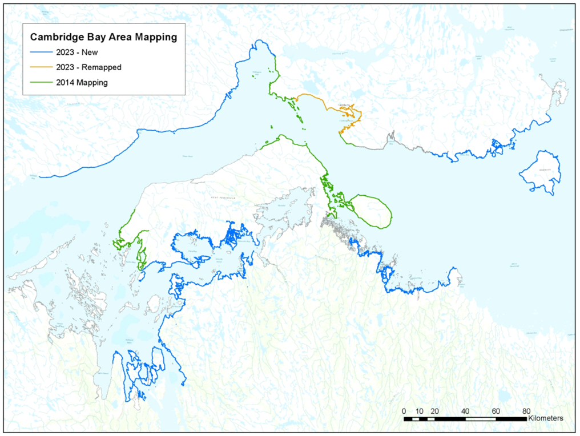

September 2023 Summary:
In September 2023, the mapping team performed helicopter surveys around Lancaster Sound and Parry Channel with the support of the Canadian Coast Guard, who provided accommodations and helicopter flight time. The team performed shoreline mapping via helicopter from the coast guard ship and collected foot, truck and helicopter-based GPS survey points. The team was able to map approximately 2,320 km of shoreline, collect 31,862 helicopter-based photographs, and collect close to 10 hours of videography. In addition, they collected 460 ground points to support the development of remote sensing methodologies. The team started off their fieldwork campaign by spending half a day in Iqaluit collecting ground points and then travelled to Resolute Bay and collected additional ground point sampling before boarding the Coast Guard vessel, the Pierre Radisson for 10 days, disembarking on September 19th.


