Potential Environmental Impacts: Assessment, Minimization and Mitigation of Proposed Activities

While transiting through the arctic as a tourism operator there are numerous Acts and Regulations that must be adhered. The comprehensive list of Acts and Regulations can be found in Appendix to the Guidelines for Passenger Vessels Operating in the Canadian Arctic – TPO13670E:
https://www.tc.gc.ca/eng/marinesafety/guidelines-passenger-vessels-operating-canadian-arctic-tp13670e.html.

Potential environmental impacts include the following:
- Emissions to air
- Emissions to water
- Wastes generated during normal ship operations
- Noise Pollution
- Physical Disturbance
- Introduction of alien species and translocation of disease

1 Emissions to Air
Emissions to air generated from fuel burned during the proposed activity will originate from
- Ship cruising
- Auxiliary equipment
- Incineration of waste onboard
Assessment
The running of the ship and its accompanying machinery is bound to produce emissions that will be released into the atmosphere. These emissions may quickly disperse due to the wind during maritime operations. However, even the slightest atmospheric emissions could have a detrimental impact on the overall air pollution levels in the surrounding area and across the world.

Mitigation
To address the issue of emissions during its operations, HANSEATIC INSPIRATION solely uses low-sulfur diesel, and it is fitted with an exhaust gas purification system that effectively cleanses the exhaust produced by its engines. Moreover, the HANSEATIC INSPIRATION adheres to the pollution prevention measures laid out in the Polar Code and complies with all emission regulations, which enables it to sail through Polar regions while minimizing its environmental impact.

2 Emissions to Water – Fuel and Oil Spills

Emissions to water will originate from:
- Ship cruising
- Auxiliary equipment

Assessment
The operation of the HANSEATIC INSPIRATION and its auxiliary equipment poses a low risk of fuel spills. Although there is a possibility of fuel spills from Zodiac boats and equipment malfunction, it is estimated that any spill would be less than 10 liters. The risk of a large-scale fuel spill is extremely low, and the possibility of a helicopter crash resulting in fuel discharge is highly unlikely.

In the unlikely event of equipment malfunction, there is a possibility of hydraulic oil or coolant fluid leakage. But overall, very unlikely.

Mitigation
The risk of fuel spills can be minimized through proper crew training and following standard operating procedures. Standard operating procedures dictate that all auxiliary equipment and helicopter fueling take place on board the ship, minimizing the risk of fuel spilling into the water.

The HANSEATIC will be fueled in port before entering the Canadian Arctic. All on-board equipment will be maintained and serviced regularly to decrease the likelihood of fuel discharge caused by equipment malfunction.

The vessel will follow the recommended route advised by the ice pilot on board and will not traverse through ice conditions greater than those suggested for its Polar Class rating. No maintenance or repair work on auxiliary equipment will be done anywhere other than on board the vessel, where any spills or leakage can be contained.

3 Wastes Generated During the Expedition

Wastes will or could originate from:
- Ships
- Auxiliary equipment
- On-board activities
- Helicopter
- Submersible or ROV

The nature of the proposed activity will inevitably generate multiple streams of waste.

Please see below table outlining the types of waste that could be generated and their proposed disposal method.

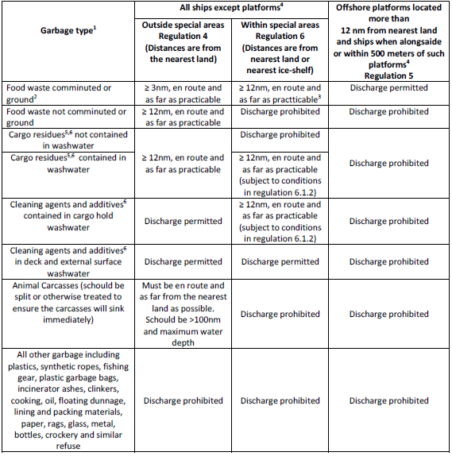

Assessment
All waste materials generated during ship operations will be handled in accordance with Canadian legislation and AECO guidelines, and are unlikely to be illegally discharged.

Mitigation
To minimize the potential for accidental waste discharge, the HANSEATIC INSPIRATION will adhere to standard operating procedures and provide crew members with proper training and supervision. Waste reduction equipment, including an incinerator, glass crusher, shredder, bale compactor, and tin densifier, will be used to minimize the volume of garbage onboard. Sewage and grey water will be stored in tanks and processed as needed. The ship will not take on or discharge ballast water, and will comply with international guidelines to prevent the introduction of non-native organisms. In the event of a marine collision, proper measures will be taken to contain and dispose of any refuse, petroleum fuel, lubricating fluids, oils, unleaded gasoline, or JP5 fuel that may be discharged. Guests will be advised to return any off-ship food or drink packaging for proper disposal. Stranded vessels will contain all generated waste on board and return it to the HANSEATIC INSPIRATION for disposal. Meticulous record-keeping and adherence to best-practice standard operating procedures are among the measures in place to minimize and mitigate waste-related incidents.

4 Noise Pollution

Noises will most likely be generation by
- Ship operations and cruising
- Auxiliary Equipment operations

Assessment
Wildlife can be adversely affected by noise pollution resulting from ship operations, which can disrupt their natural activities such as feeding, breeding, resting, and migration. The introduction of new stimuli can cause changes in behavior, leading to interruptions in their regular activities. Effective management of potential noise pollution from the vessel and its auxiliary vessels can mitigate these effects.

Mitigation
The HANSEATIC INSPIRATION is equipped with an advanced propulsion system that generates the lowest possible levels of noise and vibration to minimize disturbance to marine life. The ship and auxiliary equipment are equipped with state-of-the-art technology to minimize noise emissions, and the number of auxiliary vessels operating nearby is minimized. To prevent noise and disturbance to wildlife, standard operating procedures and AECO guidelines will be strictly followed at all times. Guests will receive a briefing on the relevant guidelines prior to off-ship activities, and adherence will be closely monitored.

5 Physical Disturbance

Physical Disturbance may result from the following activities
- Ship Operations
- Auxiliary equipment operations
- Shore landings

Assessment:
A thorough evaluation of potential impacts indicates that the operations of the HANSEATIC INSPIRATION and auxiliary vessels may result in physical disturbances that can negatively affect the surrounding environment. These disturbances may arise from various factors, such as vessel passage turbulence, breaking of sea ice, pedestrian traffic at historical or cultural sites, and the impact on wilderness or local flora. The operations of the ship and auxiliary equipment may also have adverse effects on marine mammals, including habitat disruption, noise and vibration, water turbulence, pollution, and accidental strikes. Despite these risks, it is expected that the effects of the planned operations will be minor and transient.

Mitigation:
To minimize any negative impact on the environment and wildlife, the HANSEATIC INSPIRATION has established a comprehensive set of procedures designed to prioritize the minimal disturbance of local wildlife. Before conducting landing operations, risk assessments will be conducted, and landing procedures will be planned carefully to reduce potential impacts. Group sizes will be limited, and established walking paths will be used whenever possible. An onboard educational program will ensure that guests understand the importance of appropriate conduct, and staff will supervise guests during all excursions to cultural or wilderness sites to ensure that guidelines are followed.

In addition, the ship will follow all guidelines recommended by AECO and the Canadian Wildlife Service to minimize disturbance to animals and birds in the area. Helicopters will not operate over wildlife colonies and will maintain an acceptable minimum altitude to avoid disruption. The ship will not land ashore unless it is necessary in emergency situations, and the GPS dynamic positioning system will allow it to hold position without anchoring in locations where damage could occur. If there is a risk of negative environmental impact, the ship will avoid breaking ice.

Finally, AECO and its members are committed to treating all land and marine areas as protected, and during landings, nothing will be moved or removed except for clearly identified garbage. No landings will be made near camps or trapper unless previously agreed upon.

6 Introduction of Alien Species and Translocation of Diseases

Increased traffic to the Arctic region through cruise travel can introduce non-native species or communicable diseases. These can be unintentionally transported by guests, crew, or even the ship itself.

Assessment:
Transporting non-native species or diseases can occur unintentionally via seeds, microorganisms, or insects that are carried on clothing, equipment, or footwear. To prevent this from happening, established guidelines must be followed.

Mitigation:
Our cruise will strictly follow the AECO Biosecurity Guidelines as well as our own developed procedures. Mandatory briefings will be conducted for guests, highlighting the importance of complying with biosecurity measures. The Discovery Team members will supervise the cleaning of equipment, and guests and crew will meticulously clean their clothes, footwear, and equipment to remove any organic matter. Before disembarking and upon returning to the ship from every wilderness landing, footwear, walking sticks, or camera tripods will be scrubbed and disinfected with a solution. To ensure all organic matter is removed between landings, a boot washing station will be supervised by the expedition crew and set up at the landing site and the disembarking/embarkation point of the ship.

In addition to the biosecurity measures, Hapag has established enhanced cleaning protocols, improved air filtration and circulation, reduced group sizes, provided socially distanced options for dining, and implemented contact-free options for checking in and out. All policies and training are overseen by our Health & Safety Steering Committee, and we collaborate with CLIA and local and international health agencies to guarantee that our protocols exceed the latest regulatory requirements.

