Project information about ECCC’s Shoreline Mapping for Oil Spill Preparedness in the Arctic

- Proponent information

Sector
Government of Canada, Environment and Climate Change Canada, Science &Technology Branch, Wildlife and Landscape Science Division, Landscape Science & Technology Division, Geomatics Research Section

Originator
Valerie Wynja, Physical Scientist
Valerie.wynja@ec.gc.ca
Cell: 613-296-3540

Proponent Description
The Geomatics Research Section is focused on the use of geospatial data and information to support Environment and Climate Change Canada’s wildlife conservation and protection mandate. The Geomatics Research Section contributes to a number of priority departmental programs, including Species at risk critical habitat delineation and Migratory bird conservation.

- Summary

Non-technical Project Summary
The overall health of Canada’s oceans is strongly influenced by the coastal marine environment. Through the Oceans Protection Plan (OPP), Environment and Climate Change Canada is working to protect, preserve, and restore Canada’s marine environment. Under the OPP, our team has been funded to collect baseline shoreline data for oil spill preparedness.

The main purpose of the shoreline segmentation process is to collect information to help emergency responders plan and prepare for potential marine pollution incidents. A pre-spill shoreline dataset includes baseline coastal information such as the shoreline type and form, the substrate and vegetation type.

- To collect key shoreline information, low-altitude helicopter overflights are conducted at the study sites to capture geotagged video and photos of the shoreline characteristics.
- Once the shoreline data is collected, that information is recorded within a GIS database.
- Shoreline interpretation is performed by reviewing the oblique videography and geotagged photos. The final product is a detailed vector geodatabase which describes each shoreline segment and its associated intertidal zones.
Using shoreline data in environmental response
The vector shoreline characterization database can be used to identify environmentally sensitive shoreline types, support a rapid response to pollution incidents, and aid in effective clean-up efforts. By presenting the data on an interactive map, we are aiming to improve decision-making during oil-spill responses. With the inclusion of information from satellite and drone imagery, we hope to provide broader coverage of Canadian shorelines to support spill response and protect marine ecosystems.

Beyond supporting oil spill response, datasets and imagery have been used by local communities and environmental managers for project planning, marine safety & response preparedness, assessment of areas for marine restoration, marine planning, food security, among others.

Date(s) and Timing
We hope to perform mapping activities during two different time periods in the summer of 2023.

- August 15-23, 2023 (based out of Gjoa Haven, NU)

- September 7-13, 2023 (dates to be confirmed; based from a Canadian Coastguard vessel)

Remediation
NA – This project will not include any sampling or modification of the landscape.

Project Alternatives
The remote and vast Canadian shoreline has made shoreline mapping via helicopter and manual techniques sometimes challenging. As a result, a Canada-wide shoreline classification has never been completed for the entire country. This represents a major information gap, and risk for oil spill risk preparedness.

Newer, high-resolution satellite imagery offers a good opportunity to start exploring options for coast-wide shoreline mapping and classification. As an alternative to helicopter mapping, we will be developing shoreline classification methodologies using a variety of remote sensing technologies. This includes high resolution satellite imagery, as well as very high-resolution drone imagery. We would like to compare remote sensing techniques to helicopter methods to determine if remote sensing methods will prove to be as reliable, and informative as helicopter methods.

In order to validate and develop new methods, we would also like to fly a drone in the Gjoa Haven area to capture coastal images.

- Plans for local hire and training
Gjoa Haven and Taloyoak – During August fieldwork, we are planning to be based out of Gjoa Haven. We would like to invite members of the to join us on a helicopter flight to view the coastline and learn about the mapping process or to participate in the drone mapping.

All communities - After fieldwork is completed, we would like to give the communities all of the photos and videos that we have collected, and once the shoreline database has been completed, provide access to that as well.

After fieldwork (2024-25 or beyond), if there is community interest, we would like to discuss the opportunity to offer a Grant and Contribution, through which we would train someone within the community to help with the shoreline segmentation.

- Wildlife mitigation and monitoring plans

We would like to work with the communities to understand if this mapping activity takes place when wildlife and associated traditional activities are present on the land, in order to:
- Minimize disturbance to wildlife feeding/breeding/migration/etc.
- Minimize disturbance to Inuit activities.
  - We would like to work with the community to avoid and minimize adverse impacts on Inuit rights, traditional harvesting and Inuit land use. For example, are there locations or times we should avoid performing the mapping activities to reduce our impact?

- Spill contingency plans
NA – This project will not include any sampling or modification of the landscape.

- Reclamation plans
NA – This project will not include any sampling or modification of the landscape.

- A map of the project area

The map below shows the priority areas for fieldwork in 2023.

August 15-23, 2023
Mapping the coastline via helicopter along the east coast of King William Island, west coast of Boothia Peninsula, down through Chantrey Inlet. We would also like to fly a drone near Gjoa Haven.

September 7-13, 2023 (dates to be confirmed)
Mapping the coastline via helicopter along Parry Channel (northern Prince of Wales Island, northern Somerset Island, northern Baffin Island and northern Bylot Island) and Peel Sound (eastern Prince of Wales Island, western Somerset Island).

We would like to work with the communities to identify priority areas within these larger study sites.

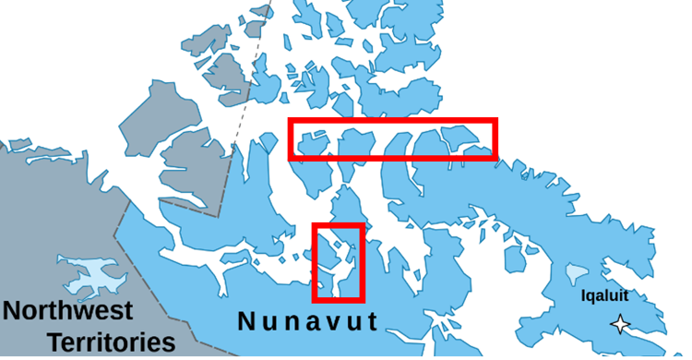

- History of consultation and how it has led to changes in project description
To date, there is no history of consultation on this project, as it was just announced under the Oceans Protection Plan 2.0. We welcome the opportunity to work with communities to identify their priorities, and risks.

- Plans for reporting to the community
We would like to work with the communities to determine how they would like to be communicated to and on what timeframe. We would be very happy to present our program before fieldwork takes place. After fieldwork is completed, we would like to give communities all of the photos and videos that we have collected, and once the shoreline database has been completed, provide access to that as well.

- Funding Sources
This work is funded under the Ocean’s Protection Plan 2.0 (OPP 2.0). On March 22, 2022, Cabinet ratified the Memorandum on the next phase of the Oceans Protection Plan. The Government of Canada has committed to protecting and restoring coastal ecosystems for future generations through the Oceans Protection Plan.

ECCC-STB-WLSD has been funded under OPP 2.0, within the Advancing Evidence Based Decisions initiative. This initiative will develop new programs in the Arctic to collect baseline data for oil spill preparedness. ECCC-STB-WLSD-LSTD will focus on key gaps, and priority and sensitive areas identified by CCG and Indigenous partners.

Identifying sensitive marine ecosystems and wildlife (canada.ca)

- List of required authorizations
- Screening by the Nunavut Planning Commission
- Screening by the Nunavut Impact Review Board permit (if needed as identified by NPC)
- Nunavut Research Institute Scientific Research License

