Project title:
Nirjutiqarvik NWA management
Applicant name and contact information:
Clément Chevallier, ECCC-CWS
301-933 Mivvik Street
clement.chevallier@ec.gc.ca
867-975-4641

Number of personnel and/or visitors that will be covered under the permit:
10 – 12 persons will be covered under the permit

Project objectives:
The overall objective is to achieve a number of required management actions for Nirjutiqarvik NWA as identified by the Nirjutiqarvik Area Co-Management Committee. Activities we are planning to do cover goals of the draft management plan which are maintain the abundance and diversity of wildlife species, and protect the land and the water for all wildlife and Inuit.

Project location:
Nirjutiqarvik NWA, see map below for details.

Proposed date and duration of visit to each protected area
8 days from July 1, 2024 to August 30, 2024
Up to 8 days for camera retrieval from June 1, 2025 to August 31, 2025

Method of transportation(s):
Twin otter to the destination, two flights to get in and two to get out of site.
Small boat and ATV to build the camp and do bird colony monitoring.
Helicopter for bird colony monitoring.

Summary of activities and rationale:
To reach the first goal identified in the management plan by the Nirjutiqarvik ACMC, we will conduct a photo and a drone survey of the seabirds at seabird colonies in the NWA. Atlantic Puffins will be surveyed by boat or helicopter. If possible, we will go on shore by foot, but it is expected that most if not all the survey will need to be conducted from the boat. In addition, we will set up an Automated Information System/remote camera to track vessel activities in and around the NWA.

As part of the second goal, we will conduct maintenance on the Intershelter Dome structure located on the eastern shore of Nirjutiqarvik NWA. This was installed in 2023 to serve as an emergency shelter until a more permanent shelter can be established.

Waste disposal:
The activities will generate an estimated 800L of greywater that we will dispose in small pit, dug and buried, treated with lime. Sewage will also be buried in cat holes (12 persons X 8 days) or removed from the NWA in waste bags using Go Anywhere kits. The waste bags will be brought back to the community for proper disposal.

Potential environmental impacts and mitigation measures:

As we will monitor bird colonies, wildlife disturbance is a potential environmental impact of our activities as well as hydrocarbon spill from transportation and generator. Researchers on site will take all measures to reduce disturbance to a minimum (keeping distances, avoid encounters, reducing time of observation/disturbance). Participants in the work will be briefed to follow the same measures. Spill kits will be onsite. All garbage will be brought back to the community for proper managing.

Community consultation and involvement:
A summary of how and when you have consulted with local communities,
Nirjutiqarvik ACMC has been consulted at many occasions during the development of the management plan for Nirjutiqarvik NWA.

How local community members are participating in your project:
ACMC members from the Nirjutiqarvik ACMC will participate in our project as they will come with us in the NWA. We will also be hiring community members to participate.

How you plan to follow up with the associated communities after project completion.
We will send a permit report to CWS after the end of the year, but also write and publish an annual report about the activities done by the Nirjutiqarvik ACMC.

Map of Project Location:
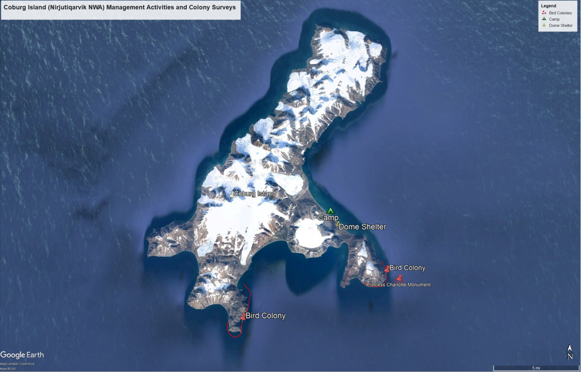
Figure 1. Map of Coburg Island (Nirjutiqarvik NWA) and locations of planned activities (dome shelter maintenance, bird colony surveys, and camp)

