Application to the Nunavut Research Institute - Non-technical project proposal description

Project Title: An Updated View of the Oceanographic Conditions in the northern Canadian Arctic.

Lead: Dr. Dorthe Dahl-Jensen, University of Manitoba
Coordinator: Dr. David Babb, University of Manitoba (David.Babb@umanitoba.ca)

April 2024.

Our group at the University of Manitoba are focused on understanding how climate change has affected the marine environment across the Canadian Arctic. Our group is led by Dr. Dorthe Dahl-Jensen, who holds a Canada Excellence Research Chair in Arctic Ice, Freshwater-Marine Coupling and Climate Change at the University of Manitoba. We are an experienced group of oceanographers and climate scientists who have worked throughout the Arctic and collaborate with several academic, government and indigenous groups to provide a comprehensive understanding of the processes and changes occurring in the Canadian Arctic. For this program we are focused on the oceanography of the northern Canadian Arctic. Our study area includes Eureka Sound, Nansen Sound, Greely Fiord, d’Iberville Fiord and Antoinette Bay, which together form the northernmost oceanographic passageway from the Arctic Ocean into the Canadian Arctic. This area is projected to be home to the last ice and as such is protected under the Tuvaijuittuq Marine Protected Area. However, due to the northern geography and near year-round ice cover the area has been understudied since the original oceanographic surveys in the 1960s and 1970s and as a result the full extent of the changes in the oceanography are not understood.
The primary objective of this program is to provide an updated view of the oceanographic conditions in the northern Canadian Arctic. Our observations will be contrasted against those collected over 50 years ago to understand how this area has responded to climate change. We also wish to examine how the ocean interacts with the surrounding marine terminating glaciers and influences the seasonal landfast ice cover.
To address these objectives, we have proposed a scientific program with four separate legs. Proposed sampling locations are outlined in the map below. The first and fourth legs will take place aboard the Coast Guard vessel Des Groseilliers during its annual re-supply trip to Eureka during summer 2024 and 2025. From the ship we will periodically deploy a CTD to collect a profile of the temperature, salinity and other variables used to characterize the properties of the water. The second and third legs will take place out of Eureka during winter and spring. The winter trip will be brief and focus on deploying sampling equipment on the ice in Eureka Sound to continuously monitor the oceanographic and sea ice conditions in the area throughout winter. During spring we plan to expand the CTD sampling across the study area and complement these profiles with physical samples of water and ice and observations of ice-ocean interactions at the terminus of nearby glaciers.
Access to the Des Groseilliers will be limited to two scientists, but a larger group will conduct the winter and spring surveys from Eureka. We would like to hire someone from one of the surrounding communities with experience on the ice to join us during these two programs and have already been in contact with people in Grise Fiord about this opportunity. Additionally we have spoken to an outfitter in Grise Fiord who is guiding people in the area in 2025, we may provide equipment for him to take additional CTD’s during his travels.

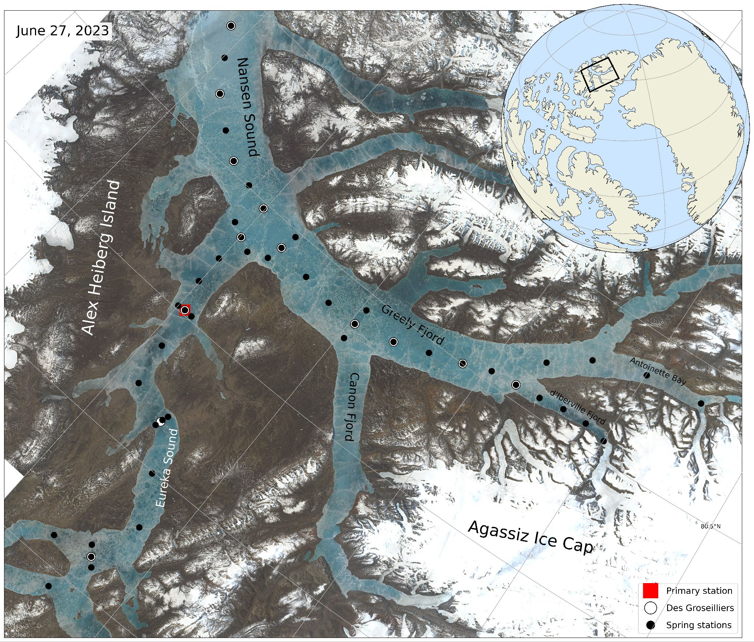
View of the study area during June 2023, when the ice is covered in melt water. Proposed sampling locations during the four legs of the program are identified.

Given the small scale of the program, the non-intrusive sampling techniques, and the fact that it is occurring in a very remote area of the Canadian Arctic the impact on the environment, wildlife and people is expected to be very minimal. Data will be analyzed and stored at the University of Manitoba and communicated through our project report to the NRI, through future meetings with nearby communities and at national conferences (ArcticNet).
This program offers a unique opportunity to provide new insight into the oceanographic conditions of the northern Canadian Arctic, an area that has been understudied but has undergone a notable change since the last oceanographic surveys were conducted over 50 years ago. We have proposed a sampling plan but would be open to adapting the program to address any concerns or interests from the local communities.

