ᐃᑲᔪᖅᑐᐃᓂᕐᒧᑦ ᑎᑎᖅᑲᖅ ᒪᐃ 27, 2024

ᐊᐃᕕᖅ ᐊᖑᓇᓱᒃᑐᓕᕆᔨᒃᑯᑦ
ᑎᑎᖅᑲᒃᑯᕕᐊ 300, ᑭᙵᐃᑦ, ᓄᓇᕗᑦ
XOA OCO
ᐅᖄᓚᐅᑖ 897-8978
ᓱᒃᑲᔪᒃᑯᑦ 897-8214
ᐃᕐᖐᓈᖅᑕᐅᑦ; aivia@baffinhto.ca

ᓄᑖᖅ ᐱᕕᒃᓴᖅ ᓴᖅᑭᓯᒪᓕᖅᑐᖅ ᐊᖏᒡᓕᒋᐊᖅᑎᓪᓗᒍ ᓄᓇᓕᖕᓂ−ᐊᐅᓚᑕᐅᔪᑦ ᐊᐃᕖᑦ ᐱᓕᕆᓂᖏᑦ ᑲᑎᖅᓱᐃᓂᕐᒧᑦ ᑐᓴᖅᑕᐅᑎᑦᑎᔾᔪᑎᓂᒃ ᕿᓚᓗᒐᐅᑉ ᒥᒃᓵᓄᑦ. ᐅᕙᒍᑦ, ᐃᒪᕐᒥᐅᑕᓕᕆᔨᒃᑯᑦ ᑲᓇᑕᒥ (DFO), ᑐᒃᓯᕋᖅᑐᒍᑦ ᓄᓇᓕᖕᓂ-ᐊᐅᓚᑕᐅᔪᓂᒃ ᕿᓚᓗᒐᕐᓂᒃ ᖃᐅᔨᓴᕐᓂᕐᒧᑦ ᐱᓕᕆᐊᒥᒃ ᑭᙵᕐᓂ ᐅᑭᐊᒃᓵᒃᑯᑦ 2024-ᒥ ᐊᑕᐅᑦᑎᒃᑰᖃᑎᖃᖁᓪᓗᒋᑦ ᐊᐃᕖᑦ ᐱᓕᕆᐊᖏᓐᓂᒃ.

ᑐᕌᕆᔭᕗᑦ ᑐᑭᓯᐅᒪᑦᑎᐊᒃᑲᓐᓂᕈᒪᓂᐅᕗᖅ ᐃᒪᕐᒥᐅᑕᓂᒃ ᐆᒪᔪᓂᒃ (ᕿᓚᓗᒐᖅ ᐊᐃᕕᓪᓗ) ᑭᙵᐃᑦ ᖃᓂᒋᔮᓂ ᐊᖏᒡᓕᒋᐊᖅᓯᒪᔪᒥᒃ ᐊᐅᓪᓚᖅᑎᑦᑎᔪᖃᖃᑦᑕᕐᓗᓂ ᓴᓇᔭᐅᑎᓪᓗᒍ ᓄᓘᔮᑦ ᔅᑏᔅᐱ ᑐᓚᒃᑕᕐᕕᒃ ᓯᑯᓯᓛᕐᒥᐅᑦ ᑕᕆᐅᖓᓂ. ᑐᒃᓯᕋᖅᓯᒪᕗᒍᑦ ᐊᔾᔨᑦᑎᐊᖓᓂᒃ ᖃᐅᔨᓴᕈᑎᒥᒃ ᐊᐃᕖᑦ ᐱᓕᕆᐊᖓ ᒪᓕᒡᓗᒍ ᐊᑖᓂ, ᖁᓕᒥᒎᕋᓛᓂᒃ ᐊᔾᔨᓕᐅᕆᒃᑲᓐᓂᖅᖢᑕ.

- ᐊᒥᖏᑦ ᐅᑲᓪᓘᓪᓗ ᑎᒥᖏᓐᓂᑦ ᐲᖅᓯᓂᖅ ᐊᑐᕐᓗᑎᒃ CO₂ ᖁᑭᐅᑎᓂᑦ (ᒥᖅᑯᓖᑦ) ᖃᐅᔨᓴᖅᑎᓂᑦ (4-6 ᓄᓇᓕᖕᓂ ᖃᐅᔨᓴᖅᑎᓄᑦ ᐃᑲᔪᖅᑎᓂᑦ) ᐅᒥᐊᓂᑦ. ᐊᒥᖏᑦ ᖃᐅᔨᓴᒐᒃᓴᑦ ᖃᐅᔨᓴᖅᑕᐅᖃᑦᑕᕐᓂᐊᖅᐳᑦ ᓇᑭᙶᕐᒪᖔᑕ ᖃᐅᔨᓴᖅᑕᐅᓕᖅᐸᑕ ᕿᓚᓗᒐᐃᑦ ᐋᖅᑭᒃᓯᒪᓂᖏᑦ.
- ᐃᖅᑲᓇᐃᔮᓂᒃ ᐃᓕᐅᖅᑲᐃᓂᖅ ᖃᖓᑦᑕᖅᑎᑕᐅᓯᒪᔪᒃᑯᑦ ᓂᕕᙵᑖᓂᒃ ᐊᑐᖅᑐᖃᕐᓗᓂ ᐃᑰᑕᕐᓂᒃ (ᖃᐅᔨᒪᔭᐅᓕ: ᓂᕕᙵᑖᑦ ᐃᓕᔭᐅᓂᐊᖅᐳᑦ ᖁᓛᓃᓐᓂᖅᓴᒧᑦ; ᕿᓚᓗᒐᕐᒧᑦ ᓯᒥᒃᑕᐅᖃᑦᑕᔾᔮᙱᓚᑦ). ᖃᖓᑦᑕᖅᑎᑕᐅᓯᒪᔪᒃᑯᑦ ᓂᕕᖓᑖᓕᖅᓱᐃᖃᑦᑕᕐᓂᐊᖅᑐᑦ ᐅᒥᐊᒃᑯᑦ ᓄᓇᒃᑯᓪᓘᓐᓃᑦ 4-6−ᓂᒃ ᖃᐅᔨᓴᖅᑎᑦ ᐃᑲᔪᖅᑎᖏᓐᓂᒃ. ᓇᒧᙵᐅᕙᖕᓂᖏᓐᓄᑦ ᑎᑎᖅᑲᐃᑦ ᓂᕕᖓᐅᒃᑯᑕᓂᑦ ᐊᑐᕐᑕᐅᓂᐊᖅᐳᑦ ᐊᐱᖅᑯᑎᓂᑦ ᑐᕌᖓᔪᑦ ᕿᓚᓗᒐᑦ ᓯᐊᒻᒪᒃᑕᐅᓂᖏᓐᓂᑦ ᐃᖏᕐᕋᓂᖏᓐᓂᒡᓗ (ᓲᕐᓗ, ᐋᖅᑭᐅᒪᓂᖏᑦ, ᐊᒃᑐᐃᓂᐅᕙᒃᑐᑦ ᐊᐅᓪᓚᖅᑎᑕᐅᓂᖏᓐᓂᑦ).
- ᑕᑯᔭᐅᓗᑎᒃ ᖁᓕᒥᒎᕋᓛᓖᑦ ᕿᓚᓗᒐᐃᑦ. ᖃᖓᑕᑎᑦᑎᕙᓚᐅᖅᑐᒍᑦ ᖁᓕᒥᒎᕋᓛᒥᒃ ᓯᒡᔭᒥᑦ/ᓯᑯᒥᑦ ᐅᒥᐊᒥᓪᓘᓐᓃᑦ 20 ᒦᑕᒥᑦ ᐳᖅᑐᓂᓕᖕᒥᑦ ᐅᓚᕕᓴᖁᓇᒍᑦ ᓂᕐᔪᑎᓂᑦ. ᖁᓕᒥᒎᕋᓛᓕᒃ ᖃᖓᑕᓂᐊᖅᑐᖅ ᑐᕋᐃᓐᓇᖅᑐᒥᒃ ᖃᐅᔨᒪᒋᐊᕐᓗᓂ ᑕᐅᑐᑦᑎᐊᕐᓂᑦᑎᓐᓂᒃ ᕿᓚᓗᒐᕐᓂᒃ, ᑲᑎᖅᓱᐃᓗᑎᒃ ᓇᓗᓇᐃᔭᐅᑎᓂᒃ ᑎᒥᖓᑕ ᖃᓄᐃᓕᖓᓂᖓᓂᒃ.
ᐱᓕᕆᐊᖑᔪᒪᔪᖅ ᐊᖏᒡᓕᒋᐊᖅᑕᐅᓗᓂ ᓄᓇᓕᖕᓂ−ᐊᐅᓚᑕᐅᔪᖅ ᓯᓚᒥ ᐱᓕᕆᓂᐅᔪᖅ ᐊᐃᕖᑦ ᐱᓕᕆᖃᑎᒋᓪᓗᒋᑦ ᐅᑭᐅᒃ ᒪᕐᕉᒃ ᐊᓂᒍᖅᑐᓂᒃ ᒫᓐᓇ ᐃᓚᐅᑎᓪᓗᒍ ᕿᓚᓗᒐᖅ. ᒪᒃᐱᖅᑐᒐᐅᓂᐊᓕᕐᒥᔪᓂ ᐃᓚᓕᐅᔾᔨᓯᒪᕗᒍᑦ ᓇᐃᒡᓕᒋᐊᖅᓯᒪᔪᓂᒃ ᐊᔾᔨᒌᙱᑦᑐᓄᑦ ᐃᓚᖏᓐᓄᑦ ᐱᓕᕆᐊᖑᔪᒥ ᕿᒥᕐᕈᐊᒃᑲᓐᓂᕐᓂᐊᖅᑕᕐᓄᑦ.

ᖃᐅᔨᑎᓐᓂᐊᖅᐸᑦᑎᒍᑦ ᐊᖏᕈᕕᒋᑦ ᑕᒪᕐᒥᒃ ᐱᓕᕆᐊᒃᓴᑦ ᑎᑎᕋᕐᓂᒃᑯᑦ X ᐱᓕᕆᐊᒃᓴᑦ ᐃᑲᔪᖅᑐᐃᔾᔪᑎᕕᑦ ᓴᓂᐊᒍᑦ

_______________________________________ ______________________
ᐊᑎᓕᐅᕈᓯᐊ ᐅᓪᓗᖅ

ᐊᐱᖅᑯᑏᑦ/ᐅᖃᐅᓯᒃᓴᑦ:

ᑲᓐᓇ ᐱᓕᕆᔭᐅᔪᒪᔫᑉ ᐃᓗᓕᖏᑦ ᑐᒃᓯᕌᖓᔪᑦ ᖁᓛᒍᑦ ᖃᖓᑕᔪᒃᑯᓘᓐᓃᑦ ᕿᓚᓗᒐᓕᕆᔾᔪᑎᓄᑦ ᐊᑐᖅᑕᐅᔪᒪᔪᑦ

ᒪᕐᕉᖕᒪᑎᒃ ᐱᓇᓱᐊᕈᑎᒋᔪᒪᔭᕗᑦ:

- ᐊᐅᓚᔪᒥᒃ ᐊᔾᔨᓕᐅᖅᓯᒪᔪᖁᑎᖃᕈᒪᓪᓗᑕ ᕿᓚᓗᒐᖅ ᐳᐃᑎᓪᓗᒍ ᐊᖅᑲᐅᒪᑎᓪᓗᒍᓗ ᑕᑯᒃᓴᐅᓕᕌᖓᑦ, ᒪᓕᒃᑕᐅᔪᓐᓇᕐᕕᓕᒫᖓᓄᑦ ᒪᓕᒃᑕᐅᓗᓂ ᐊᔾᔨᓕᐅᖅᑕᐅᕙᓪᓕᐊᓗᓂ ᐊᖅᑲᖅᑕᕐᓂᖓ ᖃᓄᑎᒋᓗ ᐊᑯᓐᓂᖃᖅᑕᖅᑎᒋᔪᒥᒃ ᐃᑎᑎᒋᔪᒧᓪᓗ ᖃᐅᔨᔪᒪᒐᑦᑎᒍᑦ. ᑲᔪᓯᑦᑎᐊᖅᐸᑦ, ᐊᑑᑎᓂᖃᑦᑎᐊᕐᓂᐊᖅᐳᖅ ᒥᒃᓴᐅᓴᒐᓱᒃᑎᓪᓗᑕ ᕿᓚᓗᒐᑦ ᖃᔅᓯᐅᑎᒋᓕᕐᒪᖔᑕ, ᐋᖅᑭᒋᐊᖃᑦᑕᕐᓗᒍ ᐋᖅᑭᒋᐊᖃᓕᕌᖓᑕ ᑕᑯᔭᐅᔪᑦ ᓈᓴᖅᑕᐅᑎᓪᓗᒋᑦ ᐊᖅᑲᐅᒪᔪᕕᓂᐅᒐᔭᖑᐊᖅᑐᓪᓗ ᐃᓚᓕᐅᑎᔭᐅᓯᒪᑦᑎᐊᖁᓪᓗᒋᑦ.

- ᐊᔾᔨᓕᐅᖅᑕᐅᕙᓪᓕᐊᖁᓪᓗᒋᑦ ᕿᓚᓗᒐᑦ ᑕᖅᓴᖏᑦ ᒪᒃᑖᖓᓗ ᖃᓄᐃᑦᑑᖕᒪᖔᑕ ᓴᓂᓕᕇᓕᓗᒋᑦ ᐊᒃᑎᒋᓂᖓ ᑐᑭᒧᑦ ᓴᓂᒧᓪᓗ.
ᐃᒪᐅᑉ ᓯᓈᓂ (ᓯᒡᔭᒥ) ᐅᒥᐊᒥᓘᓐᓃᑦ ᖃᖓᑦᑕᖅᑎᓪᓗᒍ ᐊᔾᔨᓕᐅᕈᑎᓕᒃ ᐳᖅᑐᓈᑐᐊᖏᓪᓗᓂ ᑕᒫᓂᖃᐃ 20 ᒦᑕᒥᒃ ᐳᖅᑐᑎᒋᔪᒥ ᐸᒡᕕᓴᐃᑦᑕᐃᓕᒪᒧᑦ. ᖁᓕᓪᓗᐊᖓᒍᑦ ᐊᔾᔨᓕᐅᕆᖃᑦᑕᕋᔭᖅᑐᖅ ᕿᓚᓗᒐᕐᓂᒃ, ᒪᓕᒡᓗᒋᓪᓗ ᑕᑯᒃᓴᐅᔪᓐᓇᕐᓂᓕᒫᖏᓐᓂ ᐅᕝᕙᓘᓐᓃᑦ ᕚᑐᐃᕈᑎᓕᖅᐸᑦ ᑭᓯᐊᓂ (ᓄᒃᑭᒃᓴᕆᐊᖃᓕᖅᐸᑦ), ᐊᑯᓂᐅᓛᖑᓲᖅ 20 ᒥᓂᑦ.
ᐆᒃᑑᑎᑐᐃᓐᓇᖅ ᐃᒪᓐᓇᐅᔪᓐᓇᕐᓂᖓᓂᒃ ᕿᓚᓗᒃᑲᑦ ᖁᓛᒍᑦ ᐊᔾᔨᓕᐅᖅᑕᐅᔪᑦ ᐳᖅᑐᓂᓕᖕᒥ 20 ᒦᑕ ᐆᒃᑑᑎᑦ ᖁᓛᒍᑦ ᐳᐃᑲᑕᒃᑎᓪᓗᒋᑦ:

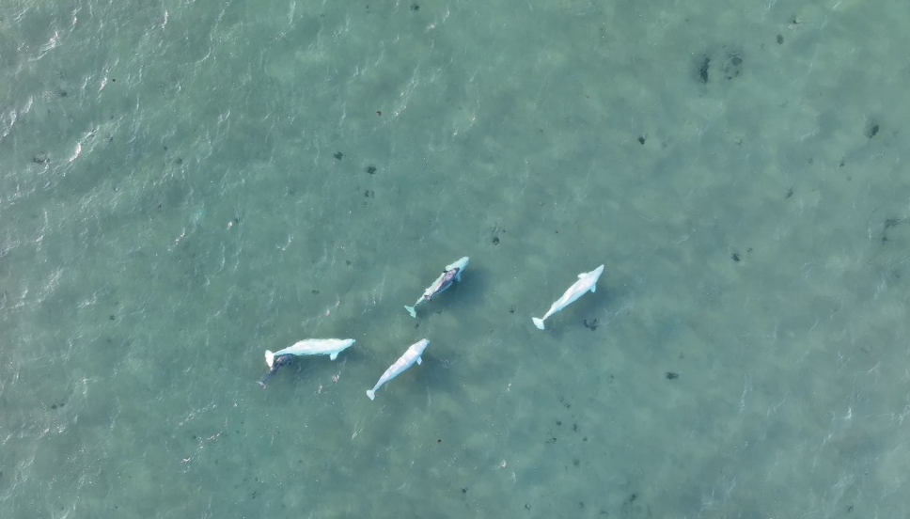

ᐅᓇ ᑕᕝᕙ ᐋᕐᓘᔭᖅ ᐊᖏᔪᐊᓘᓪᓗᓂ ᖃᓪᓗᓈᑎᑐᑦ ᑕᐃᔭᐅᔪᖅ right whale ᖃᓄᕐᓗ ᕿᒥᕐᕈᔭᐅᓂᖓᒍᑦ ᑐᑭᑖᕈᑕᐅᔪᓐᓇᕐᒪᖔᑦ ᒪᒃᑕᖓᑕ ᖃᓄᐃᓐᓂᖓ ᖃᓄᐃᖏᒃᑲᓗᐊᕐᒪᖔᓪᓗ :

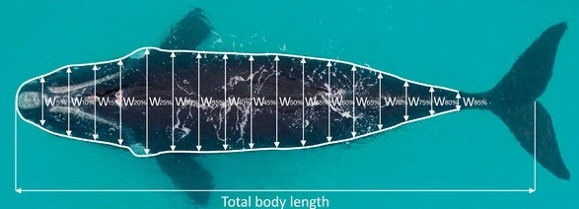

ᑲᓐᓇ ᐱᓕᕆᐊᒃᓴᒧᑦ ᓇᐃᓈᕆᐊᖅᓯᒪᔪᖅ ᑐᒃᓯᕌᖑᔪᖅ ᕿᓚᓗᒐᕐᓂᑦ ᓇᓗᓇᐃᒃᑯᑦᑎᖅᓱᐃᖃᑦᑕᕐᓂᕐᒧᑦ

ᐅᖓᓯᒋᔭᒥ ᓇᓗᓇᐃᒃᑯᑦᑎᖅᓱᐃᖃᑦᑕᕐᓂᖅ ᐊᑐᕈᒥᒋᔭᕗᑦ ᖃᐅᔨᒋᐊᕈᑎᒃᓴᑦᑎᓐᓂᒃ ᐊᖅᑲᖅᑕᕐᓂᕆᕙᒃᑕᖏᓐᓄᑦ ᕿᓚᓗᒐᐃᑦ. ᑐᕌᒐᖃᖅᑐᒍᑦ ᓇᓗᓇᐃᒃᑯᑦᑎᖅᓱᐃᖄᕈᒪᓪᓗᑕ ᖁᓛᒍᑦ ᐊᔾᔨᓕᐅᕈᑎᓕᖕᓂᒃ ᓈᓴᐃᒋᐊᓚᐅᖅᑎᓐᓇᑕ ᖃᐅᔨᒪᕙᒌᕈᑎᒋᓂᐊᕋᑦᑎᒍᑦ ᓇᒦᕈᔪᖕᒪᖔᑕ ᕿᓚᓗᒃᑲᑦ. ᓇᓗᓇᐃᒃᑯᑕᑦ ᑕᒪᒃᑯᐊ ᐱᓇᓱᐊᕈᓯᓂᒃ ᖃᔅᓰᓐᓇᑯᓗᖕᓄᑦ ᐊᑕᕙᖕᒪᑕ ᑭᓯᐊᓂ ᖃᑯᑎᒃᑯᑦ ᐊᑯᓂᐅᒐᓛᐱᒍᓐᓇᓲᖑᓪᓗᑎᒃ ᑕᖅᑭᓄᑦ ᖃᔅᓯᒐᓚᖕᓄᑦ. ᓇᓗᓇᐃᒃᑯᑦᑎᖅᓯᒪᔪᑦ ᖃᐅᔨᒪᔾᔪᑕᐅᔪᓐᓇᕐᒪᑕ ᓇᒦᒻᒪᖔᑕ ᕿᓚᓗᒐᖅ ᖃᑭᓪᓗᓂ ᐊᓂᖅᓵᕆᐊᕌᖓᒥ, ᐊᖅᑲᖅᑕᕐᓂᖏᑦᑕᓗ ᖃᓄᖅ ᐃᑎᑎᒋᔪᒧᑦ ᐊᑯᓂᐅᑎᒋᓂᖓᓄᓪᓗ.

ᕿᓚᓗᒐᐃᑦ ᐳᐃᕋᑖᕐᓂᖏᓐᓂ ᑐᓄᐊᒍᑦ ᓇᓗᓇᐃᒃᑯᑦᑎᖅᑕᐅᖃᑦᑕᕋᔭᖅᑐᑦ ᐊᖅᑲᓚᐅᖏᓐᓂᖏᓐᓂ, ᖁᑭᐊᑦᑕᐅᔭᒧᑦ, ᓯᒡᔭᒦᓪᓗᑎᒃ, ᐅᒥᐊᒥ, ᖃᔭᕐᒥᓘᓐᓃᑦ. ᑕᐃᒪᐃᑦᑐᓂ ᐊᑐᓪᓚᕆᓚᐅᖅᓯᒪᖏᒃᑲᓗᐊᖅᑐᒍᑦ ᕿᓚᓗᒐᕐᓄᑦ ᑑᒑᓕᖕᓄᑦ, ᑭᓯᐊᓂᓕ ᑕᐃᒪᐃᑦᑐᓂᒃ ᐊᑐᖅᖢᑕ ᓇᓗᓇᐃᒃᑯᑦᑎᖅᓱᐃᖃᖅᑕᖅᓯᒪᒐᑦᑕ ᖃᐅᓪᓗᖅᑖᓂ ᕿᓚᓗᒐᕐᓂᑦ, ᐋᕐᓗᓂᒃ, ᐊᕐᕕᕐᓂᒡᓗ. ᑕᐃᒪᓐᓇᑦᑕᐅᖅ ᐆᒃᑐᕈᒪᔭᕗᑦ ᓇᓗᓇᐃᒃᑯᑦᑎᖅᓱᐃᓂᖅ ᐸᒡᕕᓴᐃᖏᓐᓂᖅᓴᐅᓂᖓᓄᑦ ᐊᒃᓱᕈᕐᓇᓗᐊᖏᓐᓂᖓᓄᓪᓗ ᕿᓚᓗᒐᕐᓄᑦ ᓲᖃᐃᒪᓖ ᒪᑦᑎᑦᑕᐅᑎᓄᑦ ᐱᔭᐅᖅᑳᕆᐊᖃᕋᔭᖏᒻᒪᑕ ᓇᓗᓇᐃᒃᑯᑦᑎᖅᑕᐅᖁᓪᓗᒋᑦ. ᐊᒡᓛᑦ ᐊᒡᒐᑦᑎᓐᓄᑦ ᐊᒃᑐᕆᐊᖃᕋᔭᖏᒻᒪᕆᒃᑐᖅ ᐃᓗᐊᕐᓂᖅᓴᐅᒐᔭᖅᑐᖅ.

ᑕᕝᕙ ᑎᑎᖅᑐᒐᖅᓯᒪᔪᑦ ᐃᒪᐃᑦᑐᒥᒃ ᓇᓗᓇᐃᒃᑯᑦᑎᖅᑕᐅᖓᔭᕐᓂᖏᑦ ᖃᖓᑦᑕᖅᑎᑕᐅᓯᒪᔪᑎᒍᑦ ᐳᐃᔭᕌᖓᑦ
ᖃᐅᔨᒪᔾᔪᑎᒃᓴᑦᑎᓐᓂᒃ ᓇᒃᓯᐅᔾᔨᖃᑦᑕᕋᔭᖅᑐᖅ ᐊᒻᒪᓗ ᖁᑭᐅᑦᑕᐅᔭᖅ ᐃᒪᐃᑦᑑᓪᓗᓂ:
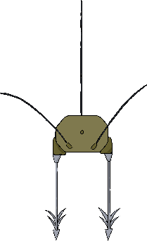
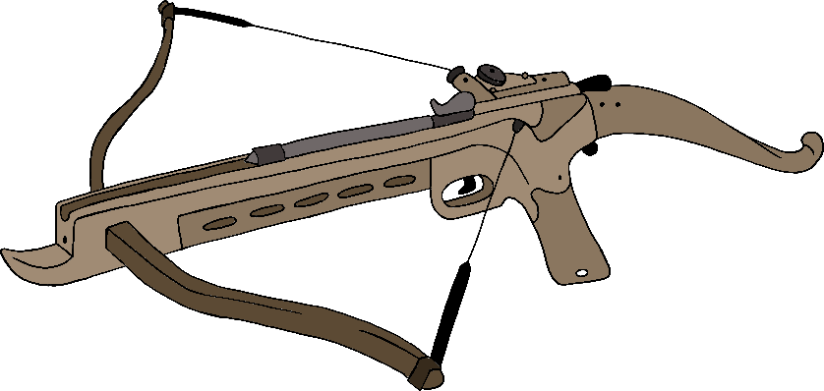

ᐊᐅᐸᖅᑐᒥᒃ ᑎᑎᖅᓯᒪᔪᖅ ᑕᒪᐅᓇ ᓇᓗᓇᐃᒃᑯᑦᑎᖅᓯᕕᒋᓇᓱᖃᑦᑕᕋᔭᖅᑕᖅ ᐳᐃᔭᕌᖓᑕ:
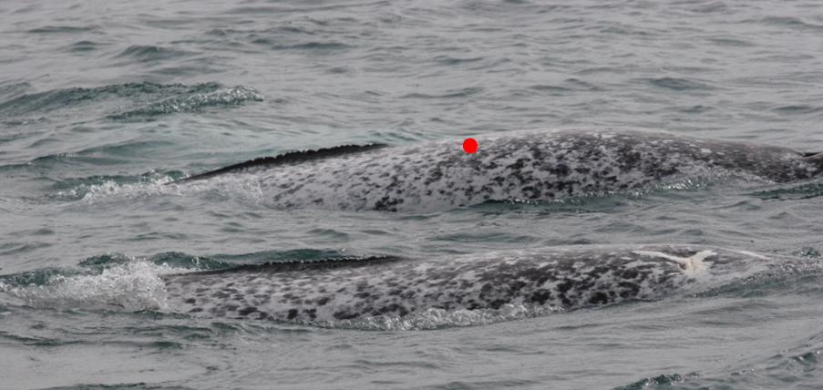
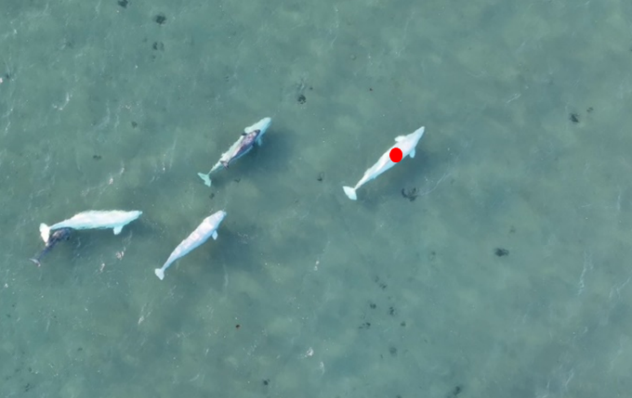

ᐊᑖᓂ ᐱᓕᕆᐊᒃᓴᐅ ᑎᑎᖃᖏ ᐱᔭᐅᔪᒪᓂᖅ ᑑᒑᓕᐅᑉ ᑎᒥᖓᓂᖔᖅᑐᒥᒃ

ᐊᑐᕋᔭᖅᑐᒍᑦ ᖁᑭᐅᑦᑕᐅᔭᒥᑦ ᐅᕝᕙᓘᓐᓃᑦ ᐳᓪᓚᒨᖅᑐᒥᑦ ᖁᑭᐅᒻᒥᑦ ᖃᕐᔪᖓ ᓴᕕᕋᔭᒻᒥᑦ ᓄᕗᖃᕐᓗᓂ ᐲᖅᓯᓗᓂ ᒪᑦᑕᖓᓂᑦ ᐊᒻᒪ ᐅᖅᓱᖓᓂ ᑑᒑᓖᑦ. ᒪᑦᑕᖓ ᐊᒻᒪ ᐅᖅᓱᖓ ᐃᓚᒋᔭᐅᒐᔭᖅᑐᑦ ᐅᕙᒍᑦ ᓄᐊᑕᖏᓐᓄᑦ ᖃᐅᔨᓴᕋᔅᓴᓂᑦ ᑑᒑᓕᓐᓃᖔᖅᑐᓂᑦ ᑐᑭᓯᓗᒋᑦ ᓂᕆᖃᑦᑕᖅᑕᖏᑦ, ᑲᑎᓐᖓᔪᑦ ᓴᓇᓯᒪᓂᖏᑦ ᐊᒻᒪᓗ ᐊᕐᕌᒍᒋᒍᓐᓇᖅᑕᖏᑦ.



