Letter of support May 27, 2024

Aiviq HTO
Box 300, Cape Dorset, NU
XOA OCO
Tel. 897-8978
Fax. 897-8214
Email; aivia@baffinhto.ca

A new opportunity has arisen to expand the community-led walrus work to gather information on beluga. We, Fisheries and Oceans Canada (DFO), are proposing the following community-led beluga research program in Kinngait during fall 2024 to coincide with the walrus work.

Our objective is to better understand marine mammals (beluga and walrus) surrounding Kinngait with increased shipping with the construction of Baffinland’s Steensby Port in Foxe Basin. We have proposed the same sampling methods as the walrus project listed below, with the addition of drone imagery.

- Collection of skin and blubber biopsies using CO₂ guns (airguns) by a research team (4-6 local research assistants) in boats. Skin samples will be analysed for genetics in an assessment of beluga stock structure.
- Remote deployment of satellite tags using crossbows (NOTE: tags will be placed onto the upper back; beluga will not be anaesthetized). Satellite tagging will be done from boats or land by 4-6 local research assistants. Movement data from the tags will be used to address questions related to beluga distribution and movements (e.g. stock structure, impacts of shipping).
- To collect drone footage of beluga. We would fly the drone from the shore/ice or boat at a minimum height of 20 meters to ensure we do not disturb the animals. The drone will fly directly overhead to ensure we get a straight down view of the whales, to gather information on body condition.
The proposed work is an expansion of community-led field work on walrus in collaboration with DFO over the past couple of years to now include beluga. In the following pages we have included summaries about the different parts of the project for your review.

Please let us know if you approve each aspect of the work by writing an X next to the projects you support above

_______________________________________ ______________________
Signature Date

Questions/comments:

Below is the project summary for the proposed drone work on beluga:

We have two goals for the drone work:
- To collect footage of beluga swimming at and near the surface of the water, to follow them for as long as possible and get information on their dive behaviour and how long they stay underwater.

- To collect footage of beluga to look at their body condition by comparing their length to width at different points along the body.
We would fly the drone from the shore/ice or boat at a minimum height of 20 meters to ensure we do not disturb the animals. The drone will fly directly overhead to ensure we get a straight down view of the whales, and will follow the whales until they cannot be seen or the drone battery runs out, usually a maximum of 20 minutes.

Here is an example of a drone image taken from 20 meters above the water’s surface:

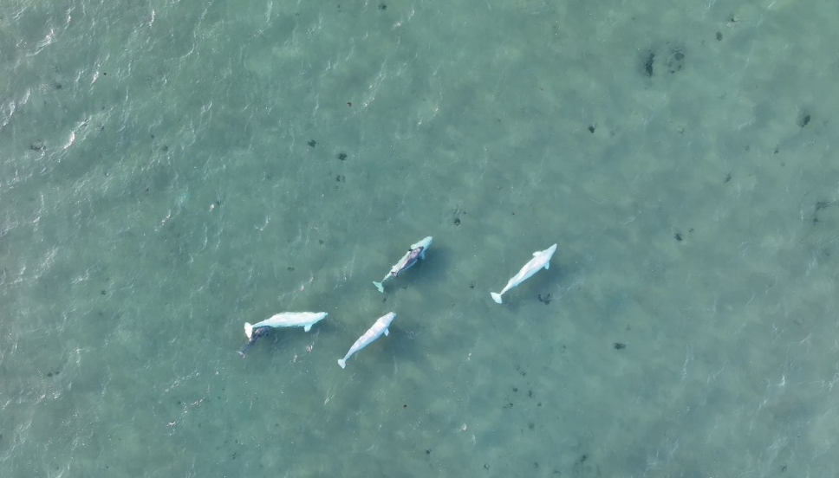

Here is an example of a right whale and how the body condition images can be analyzed:

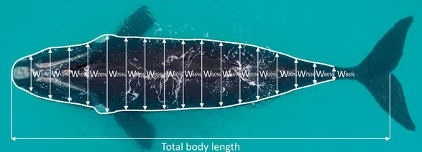

Below is the project summary for the proposed remote tagging of beluga

We would like to use remote tags to gather information about the dive behaviour of beluga. Tags usually last a few weeks but have lasted for many months in the past. The tags provide information on location when the whale surfaces, as well as information on the depth and time of their dives.

Our team would attempt to deploy tags on the belugas backs using a crossbow, from either shore/ice or boat. We have had success with this method on killer whales and bowhead whales. We would like to try this method because it is less invasive and less stressful for the animals than capturing them in a net to put a tag on their back. In this way there would be no direct contact between the human and the whale.

These are drawings of what the satellite tag and crossbow look like:

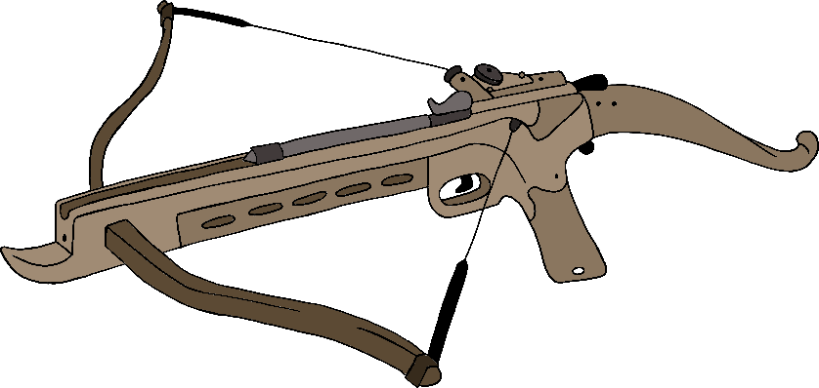
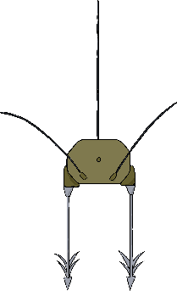

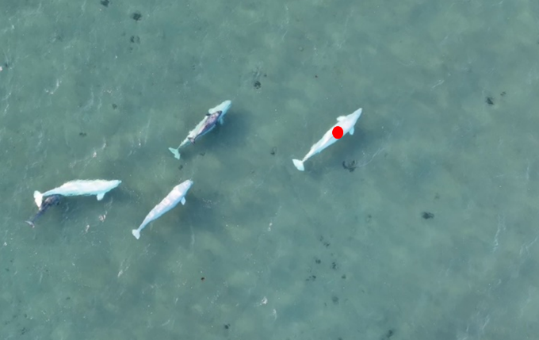
The location of the red dot is approximately where we would aim to put the tag on the whale:
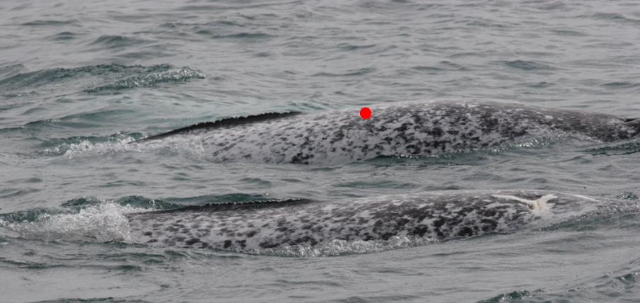

Below is the project summary for the proposed beluga biopsies

We would use a crossbow or a CO₂ gun to project an arrow with a small metal tip to get a small piece of skin and blubber from narwhals. The skin and blubber would be part of our general collection of samples from narwhals to understand their diet, group structure and potentially their age.



