Government of Canada / Gouvernement du Canada
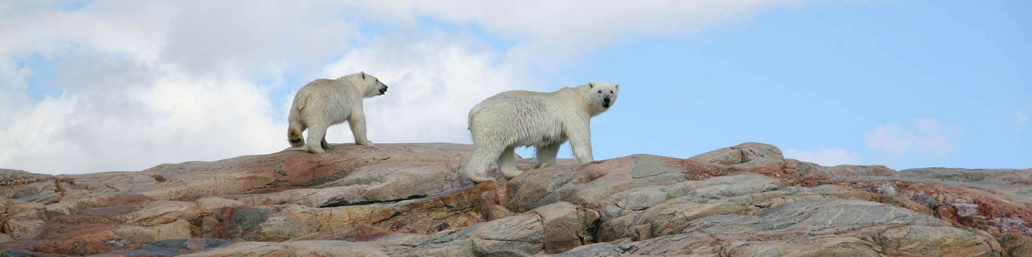
Handling an encounter
Ukkusiksalik National Park
Polar bears are the largest land carnivore in North America. An adult male typically weighs 300–450 kg, stretching three metres from nose to tail. They are strong, fast, and agile on land or ice, and are expert swimmers and divers. Their sense of smell is exceptional, their eyesight comparable to a human’s. Polar bears are naturally curious, not fearless as they have been labelled. They are shy and prefer to avoid confrontations with humans and other polar bears. Their primary prey is the ringed seal but they will also prey on birds, eggs, small mammals, and even humans. They also scavenge anything from beached whales to human garbage. In the heat of summer, polar bears may appear slow and docile, but they are capable of moving swiftly and with purpose.
Before your trip, discuss possible plans of action for dealing with bears in a variety of circumstances and be sure everyone understands. The actions of each individual either contribute to or detract from the safety of everyone else. Stay calm and assess the situation. What is the bear doing? What is the bear's behaviour?
- IF a bear does not know you are there:
- IF a bear knows you are there and shows signs of being curious, such as:
- IF the bear has been surprised at close range or shows signs of being agitated or threatened, such as:
- IF the bear shows signs of stalking or hunting you, such as:
- IF a bear charges:
Never get between a bear and her cubs. If a female with cubs is surprised at close range or separated from her cubs she will likely attack to defend her cubs.
- Leave the area immediately.
- Stay in a group.
- Fight back if she attacks.
- Always leave an escape route for the bear.
- Carry deterrents and know how to use them.
In case of an attack
Please follow this emergency check list:
- STAY CALM and call for help by radio or satellite phone. (Get contact numbers during your orientation to the park).
- Report location and time of incident.
- Report number of people involved.
- Report extent of injuries and property damage.
- Check that all people in the group are accounted for.
- Report numbers and last locations of all polar bears involved in the incident.
- Report reason for the attack if known (Female protecting cubs, surprise, defending food source, etc.).
- Report description of bears (male or female, size, markings, etc.).
- Stand by to provide additional information to rescuers.
Please report all polar bear sightings and signs to park staff, as soon as possible.

