The complete guide to visiting Parks Canada
How to have a safe and enjoyable Parks Canada experience: be prepared and know what’s expected of you when you visit.

Before you go

Plan ahead
Be sure to check what locations are open, what to expect, how to prepare, and what services are available before you travel.

During your visit

10 golden visitor rules
Parks Canada protected areas are unique places and require unique rules to protect them and keep you safe.
Take the 'Golden rule challenge' - what's your score?
Give yourself 2 points for each "Do" and subtract 1 point for each "Don't" that you are in the habit of regularly doing. Tally up your score and then challenge your friends and family to compare scores - and see if you can improve it on your next trip!
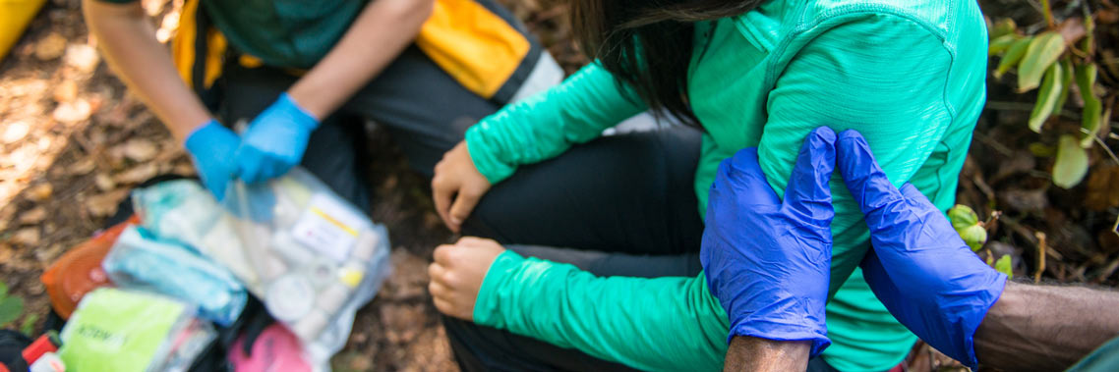

1. Know your limits
- Do: make safe choices. Choose activities that match your level of skill and experience to avoid injury and/or getting lost. This reduces the risks and demands placed on emergency response, search and rescue teams, and the health care system. Get inspired by ourbest hikes , where length, time and level of difficulty are clearly indicated.
- Don’t: overestimate your abilities. Whether you’re planning a leisurely hike or a longer backcountry adventure, don’t forget to check the latest trail conditions before you go. Make sure you have the proper equipment for the activity you’re going to undertake and you know how to use it, such as compass, maps and mapping apps, avalanche safety equipment, personal floatation device and water safety equipment.
- Did you know?
Between 700-800 people require assistance from search and rescue services in Canada’s national parks each year. Don’t be part of the statistics! Make sure you are well prepared with a trip plan in place, the training and fitness needed, and the appropriate equipment.
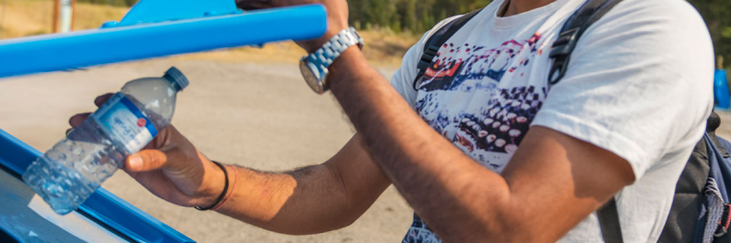

2. Dispose of garbage properly
- Do: put all of your garbage (including disposable masks) and recyclables into designated bins. Good times in the great outdoors are safer and more rewarding when you Leave No Trace of your visit.
- Don’t: discard your garbage anywhere other than a designated bin. Any littering is against the law, no matter how recyclable or compostable they may be. Remember wildlife is attracted to the smell of food but also to other items that retain odours, for example garbage, dishes, pots, stoves, coolers and toiletries.
- Did you know?
When exploring nature, if you pack it in, pack it out. It’s the law!
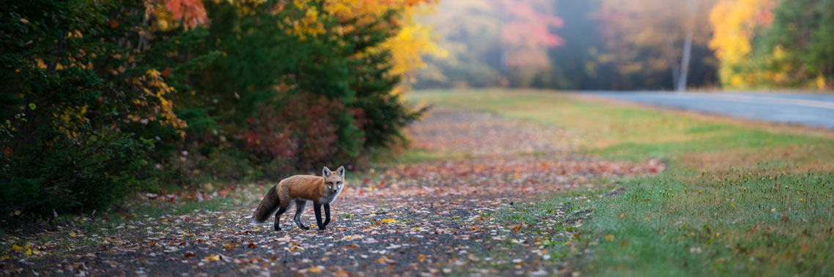

3. Never feed wildlife
- Do: enjoy wildlife from a distance. Let them graze on nature’s bounty, not human food. Remember, your food and garbage kills wildness.
- Don’t: feed wildlife, no matter how ‘hungry’ they look. Feeding wildlife creates a safety risk for both people and wildlife. This is why it’s illegal. Don’t assume coolers, boxes, food and beverage cans, tents and soft-sided campers are bear-proof (they’re not!)
- Did you know?
Parks Canada offers many tips to have a safe and enjoyable experience when recreating in areas that wildlife calls home.


4. Keep your pet on a leash at all times
- Do: bring your pet or service animal, but keep them on a leash or in suitable confinement at all times (it’s the law). Check out pet-friendly places to stay overnight. Pets are not recommended in backcountry. Learn more about dogs in Parks Canada places.
- Don’t: assume that because your pet is well behaved off-leash that it’s okay. Pets can disturb or injure wildlife, and they often attract predators to you. Keeping them on-leash is important not just for the safety of you and your dog but also for the safety of the wildlife whose home you visit. If you’re unwilling to keep your pet on a leash, please leave it at home.
- Did you know?
Your sweet pet can be a predator and destroy nests in the blink of an eye. Pets can also look like prey and can lead predators to you. Better safe than sorry!
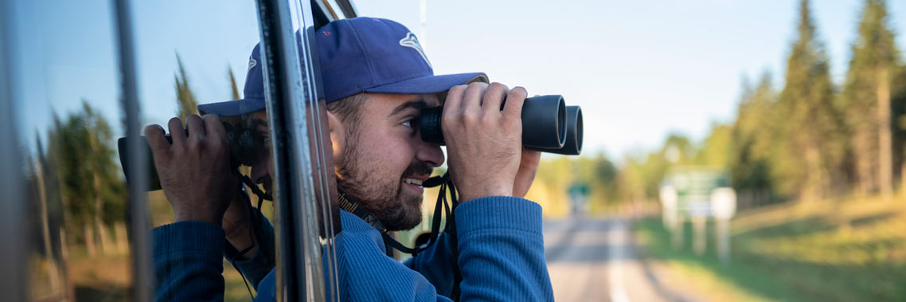

5. Give wildlife the space they need
- Do: keep the wild in wildlife! The chance of seeing wildlife in the wild is one of the most exciting things about national parks. Treat wild animals with the respect they deserve. Stay at least 100 metres (10 buses) away from bears, bison, cougars and wolves, and at least 30 metres (3 buses) from other large animals such as moose, elk, deer, sheep, and goats. Familiarize yourself with our top tips to respect wildlife and stay safe.
- Don’t: approach wildlife. They may react defensively and they also gradually lose their natural fear of people. This creates a dangerous situation for you, the animal, and other visitors that it encounters.
- Did you know?
If you can tell that your presence or actions affect an animal’s behaviour, such as making them move away, become alert, stare at you, or try to approach, then you are disrupting their natural activities and you are too close.
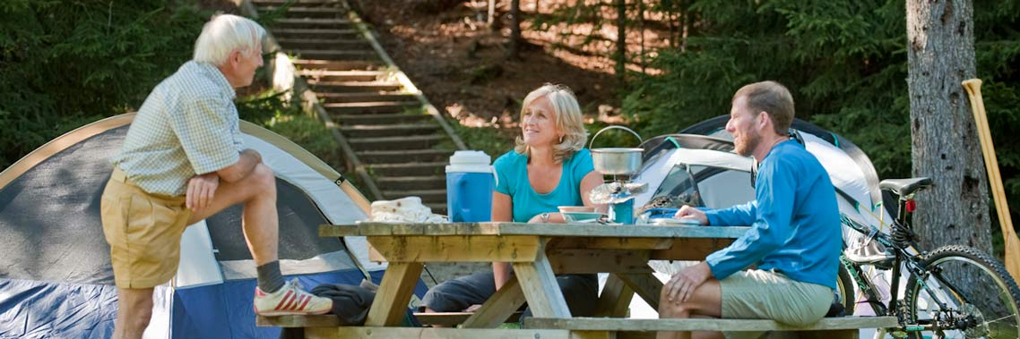

6. Avoid excessive noise
- Do: keep noise to a reasonable volume in campgrounds. Encourage kids to be respectful of others. Make peace of mind your main goal and respect other campers’ experience by respecting designated quiet hours.
- Don’t: speak at full volume, yell or play loud music. Excessive noise in campgrounds is prohibited at any time of day.
- Did you know?
We receive hundreds of noise complaints in our parks and sites across the country each year.
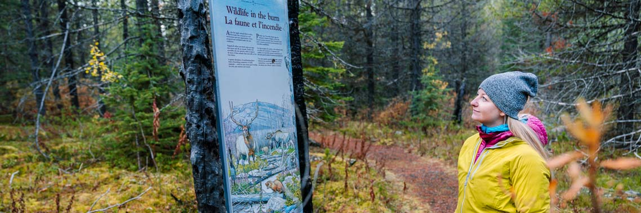

7. Use designated paths
- Do: stay on marked trails. Only camp in designated areas. Use roadways and pathways to travel to and from campground facilities (cook shelters, bathrooms, etc.).
- Don’t: cut through neighbouring campsites. Not only can it disturb other campers, it can also cause damage to fragile vegetation. Avoid camping outside of designated areas, especially near running water, thick brush or berry patches where encounters with bears or other wildlife are more likely.
- Did you know?
Going off trail can cause soil erosion or the trampling of fragile flora and fauna. Plus, you could accidentally stumble upon poison ivy or stinging nettles!
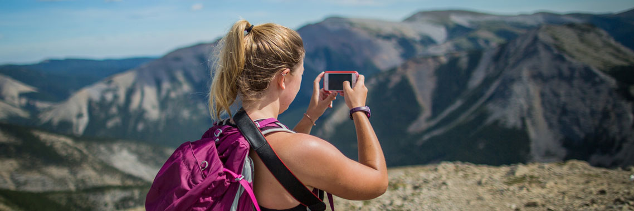

8. Take nothing but photographs
- Do: take photos and videos of amazing places and landscapes, but only from the safety of solid ground. No photo is worth your life! Also give wildlife the space they need when taking pictures of them—use a camera with a zoom or telephoto lens. Never attempt selfie pictures with wildlife.
- Don’t: collect rocks, shells, flowers, etc. to keep as souvenirs. It is important to leave these natural objects where they are so that others can enjoy them. All Parks Canada places are also no drone zones without a permit or special permission. Leave them at home!
- Did you know?
It is actually illegal to collect plants, mushrooms, berries, animals, animal parts (including antlers), fossils, driftwood, rocks, and other historical or natural objects. Leave with nothing but memories.
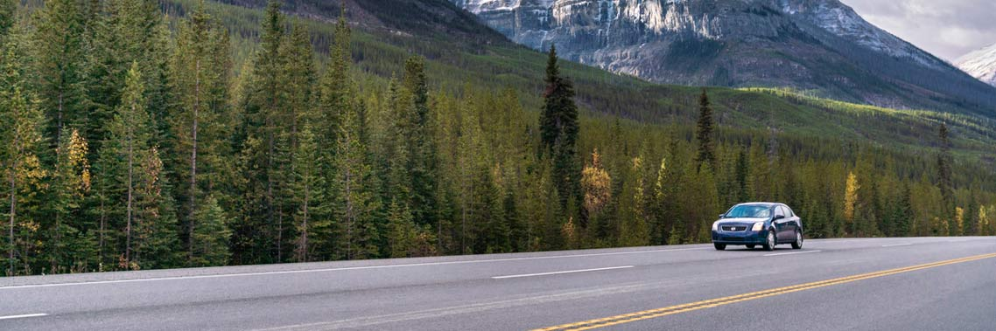

9. Respect speed limits and drive with caution
- Do: slow down to save lives. Respect the posted speed limits, follow directional signage and remain alert while driving.
- Don’t: speed around roadways or rev engines needlessly. Little kids and animals can run out unexpectedly onto roadways very easily.
- Did you know?
Parks Canada boasts some of the most scenic drives in the country. Slow down and enjoy them.
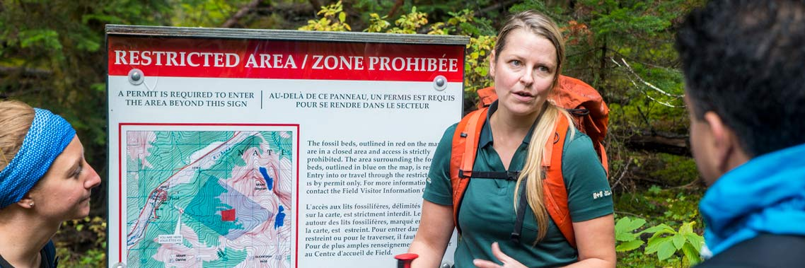

10. Stay out of restricted areas
- Do: know what’s open and closed before you go to avoid disappointment.
- Don’t: ignore posted notices. When posted, area closures, warnings and restrictions are necessary to enhance public safety, to protect sensitive species and to help maintain natural processes.
- Did you know?
Areas can be temporarily closed to reduce human activity in important wildlife corridors, to conduct research or protect sensitive habitats, or for fire danger, construction, maintenance, avalanche risks and more.

