https://www.canada.ca/en/environment-climate-change/services/migratory-bird-sanctuaries/locations/bylot-island.html

Bylot Island Migratory Bird Sanctuary
- Inuktitut
The Bylot Island Migratory Bird Sanctuary is located north-west of Baffin Island, in Nunavut. It offers a great amount of food and an ideal habitat to nest for many seabirds.
On this page
- Importance of the sanctuary: migratory birds and other wildlife
- Landscape
- Map of the area
- Access to the sanctuary
- Key facts about Bylot Island Migratory Bird Sanctuary
- Contact us
- Related links
Importance of the sanctuary: migratory birds and other wildlife
Located off the coast of northeastern Baffin Island, Nunavut, Bylot Island Migratory Bird Sanctuary encompasses an abundance of wildlife, a great variety of habitats and spectacular scenery. Birdlife on Bylot Island is particularly diverse; 71 species have been identified within the sanctuary, including at least 35 breeding species and six that are permanent residents. This is an impressive assortment for such a northern location. This sizable array is attributed mainly to the open water that occurs each year at the junction of Lancaster Sound and Baffin Bay; an area that provides important foraging grounds for tens of thousands of seabirds. The high quality of the nesting grounds in this area is also a factor. Seabirds gather and build their nests along both the northwestern tip of the island at Cape Hay, and along the southeastern corner of the island at Cape Graham Moore. Seabirds account for 37% of the birdlife population on the island, while shorebirds, waterfowl and songbirds (passerines) make up most of the remaining population.
This sanctuary was created with the express purpose of protecting the nesting grounds of thick-billed murres, black-legged kittiwakes and greater snow geese. These birds all use the sanctuary in outstanding concentrations and it is estimated that more than 10% of the Canadian population of thick-billed murres and 25% of black-legged kittiwakes share the island’s cliffs. This represents a gathering of more than 300,000 murres and 50,000 kittiwakes in one location each spring during breeding season (they spend the rest of the year at sea). In addition, approximately 100,000 greater snow geese, an estimated 15% of the Canadian population and the largest known colony, can be found on Bylot Island’s southwestern lowland tundra at the end of each summer. These same geese rest and feed in southern Quebec for a few weeks during their migration each spring and fall.
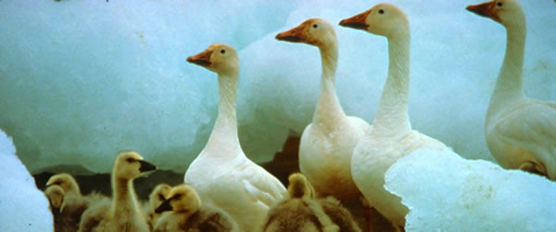Snow geese. Photo: P. Dupuis
Bylot Island is occupied by species of both high-Arctic and low-Arctic affinity as both groups congregate on the island to breed. ”High-Arctic” birds include the black-bellied plover, ruddy turnstone and white-rumped sandpiper, whereas the “low-Arctic” group includes the horned lark, Sabine's gull and American golden plover. These birds are scattered across the island so that it is possible to see sandhill cranes and pectoral sandpipers, of low-arctic affinity, nesting near ruddy turnstones and white-rumped sandpipers, typically high-Arctic birds. At least three Old World species (those generally found in Europe, Africa and Asia) are also known to visit or nest on Bylot Island; namely the red knot, the common ringed plover and the northern wheatear. These birds fly to northern Canada via Greenland and Iceland from their Old World wintering grounds.
Landscape
As Bylot Island lies adjacent to Lancaster Sound, a major migration route and summering area for marine mammals, twenty-one species of marine and terrestrial mammals have been recorded in and around the sanctuary. These include five species of seals, four species of whales and numerous polar bears, which use the island as a retreat in the summer. Other species commonly spotted in the sanctuary include arctic fox, collared lemming and arctic hare.
The Bylot Island Migratory Bird Sanctuary, established in 1965, encompasses the entirety of Bylot Island as well as the adjacent marine waters within 3.2 kilometres from shore. Due to the richness of the wildlife and the great beauty and diversity of the landscapes in the area, a large portion of the island was also included in the Sirmilik National Park established in 2001.
The shores of Bylot Island are bounded by Lancaster Sound to the north, Baffin Bay to the east, Navy Board Inlet to the west and both Pond Inlet and Eclipse Sound to the south. The island itself is composed of mountains, snowfields, ice fields, a glacier, pingos, and hoodoo rock formations.
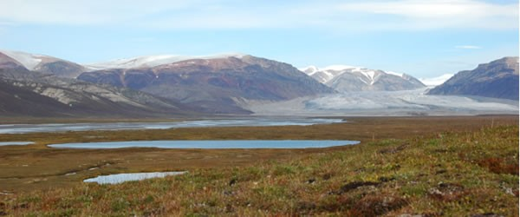Landscape of Qarlikturvik Valley, Bylot Island Migratory Bird Sanctuary. Photo: Josée Lefebvre
The diversity of species that visit this sanctuary is mainly due to the juxtaposition of marine and terrestrial habitats, where the polynya and lead system develops yearly at the junction of Lancaster Sound and Baffin Bay.
Did you know?
A hoodoo is a rock formation that resembles a tall, column-like protrusion from the ground upward. Hoodoos can range in size from the height of an average person up to the height of a 10-storey building (1.5 to 45 metres). The unique shapes and colours of hoodoos are a result of the erosion of the various types of minerals that make up the hard and softer layers of the rock types in the area that it is located. The hoodoos on Bylot Island are the inspiration for the name of the Asungasungaat Area Co-management Committee, who is responsible for the day-to-day management of the Bylot Island Migratory Bird Sanctuary. “Asungasungaat” is the Inuktitut word for hoodoos.
Map of the area
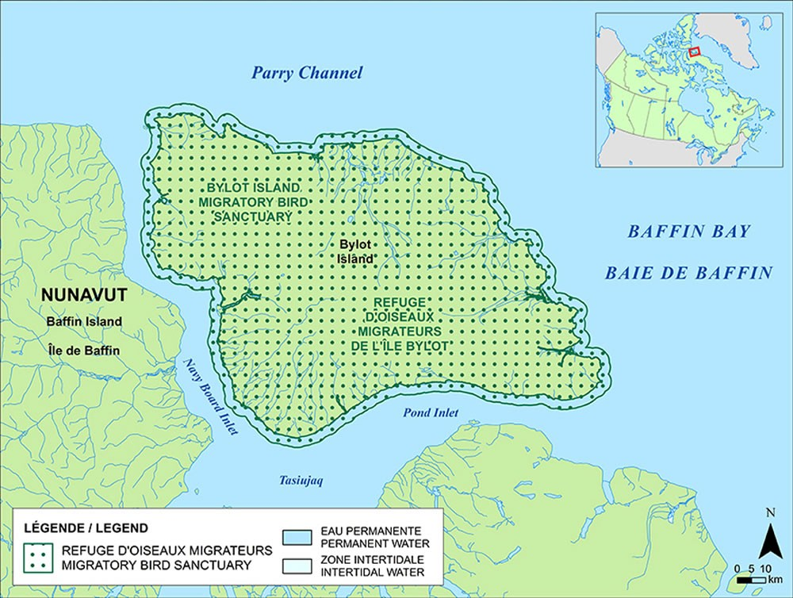Map of Bylot Island MBS
Long description
Access to the sanctuary
Migratory Bird Sanctuaries, such as Bylot Island, are established across the country to protect migratory birds during critical periods of their life cycle. Whether these areas are used for feeding, resting or nesting, they play an important role in the survival of many species. Entry and access to most Migratory Bird Sanctuaries is not restricted, however the Migratory Bird Sanctuary Regulations set out the activities that are prohibited. The Minister of Environment has the authority to authorize or permit activities in Migratory Bird Sanctuaries that are otherwise prohibited.
Bylot Island MBS is managed by the Canadian Wildlife Service (CWS) of Environment and Climate Change Canada (ECCC) and Inuit from Pond Inlet, NU as part of a co-management agreement established through the Inuit Impact and Benefit Agreement for National Wildlife Areas and Migratory Bird Sanctuaries in the Nunavut Settlement Area (IIBA). The Asungasungaat Area Co-Management Committee (ACMC) was formed through the IIBA and provides advice on all aspects of the MBS, permit applications, research conducted within the MBS, visitor use of the area, and management and protection of migratory birds and bird habitat. In Nunavut, Nunavut Inuit, as per the Nunavut Agreement (NA), can hunt wildlife, including the collection of migratory bird eggs and feathers for their economic, social and cultural needs (Section 5 of the NA). Access to Bylot Island MBS by anyone other than Inuit enrolled under the NA is restricted; therefore, any non-Inuit must obtain a permit to access or conduct any activity within the MBS. Activities that may be permitted will be in accordance with the conservation objectives of the MBS management plan.
If you would like further information on what is permitted in Migratory Bird Sanctuaries, please visit the Management and Activities section of the website. More information on access and permitting for Bylot Island MBS can be obtained by contacting the Environment and Climate Change Canada regional office.
Key facts about Bylot Island Migratory Bird Sanctuary
Summary table of Bylot Island Migratory Bird Sanctuary
Category | Information
Protected Area designation | Migratory Bird Sanctuary
Province or territory | Nunavut
Latitude/longitude | 73°13' N, 78°34' W
Size | 1,282,730 hectares (includes a marine portion of 176,515 hectares around the island)
Reason for creation of protected area | To protect nesting sites of thick-billed murres, black-legged kittiwakes, and greater snow geese
Date created (Gazetted) | 1965
International Union for Conservation of Nature (IUCN) Management Category | National Park (II)
Additional designations | - Part of Cape Hay Important Bird Area  - Part of Southwest Bylot Important Bird Area  - Part of Cape Graham Moore Important Bird Area  - Sirmilik National Park
Main habitat type | - Open water (14%)  - Mountains (69%, including a large portion covered by the ice cap)  - Limestone cliffs (1%)  - Moist tundra lowland (16%)
Keystone or flagship species | - Thick-billed murre  - black-legged kittiwake  - greater snow goose
Listed species under the Species at Risk Act (SARA) | - Peregrine falcon  - red knot  - bowhead whale (eastern arctic population)  - polar bear
Invasive Species | - None confirmed
Other species | Birds:  - Black guillemot  - glaucous gull  - northern fulmar  - Sabine’s gull  - American golden plover  - arctic tern  - black-bellied plover  - common raven  - common ringed plover  - horned lark  - long-tailed jaeger  - northern wheatear  - pectoral sandpiper  - peregrine falcon  - red knot  - rock ptarmigan  - ruddy turnstone  - snow bunting  - snowy owl  - white-rumped sandpiper  - king eider  - long-tailed duck  - red-throated loon  - sandhill crane  Marine:  - Bearded seal  - ringed seal  - harp seal  - hooded seal  - harbour seal  - beluga  - orca  - narwhal  - bowhead whale  Terrestrial:  - Caribou  - collared lemming  - arctic fox  - arctic hare  - polar bear
Management agency | Canadian Wildlife Service, Prairie and Northern Region in collaboration with the Asungasungaaq Co-Management Committee of Pond Inlet Area
Public access and usage | Nunavut Inuit have a free and unrestricted right of access for the purpose of harvesting to all lands, waters, and marine areas within the MBS, as per Article 5 of the IIBA and subject to s.5.7.18 of the Nunavut Agreement.  For all non-Nunavut Inuit, a permit may be required to access or conduct activities in the MBS, particularly if firearms will be carried and/or migratory birds may be disturbed.
Contact us
Environment and Climate Change Canada – Northern Region
Canadian Wildlife Service
Protected Areas and Stewardship
Eastern Arctic Unit
P.O. Box 1870
Iqaluit NU X0A 0H0
Telephone: 867-975-4642
Toll Free: 1-800-668-6767 (in Canada only)
Email: enviroinfo@ec.gc.ca
Related links
- Bylot Island Migratory Bird Sanctuary on Google Maps (Please note that the Google map is a complementary source of information that can help locate the migratory bird sanctuary and does not represent the official map or site name)
- Nunavut Land Claims Agreement Act
- Migratory Bird Sanctuary Regulations
- Cape Hay Important Bird Area
- Southwest Bylot Important Bird Area
- Cape Graham Moore Important Bird Area
- Sirmilik National Park
- International Union for Conservation of Nature (IUCN)
- Learn more about pingos in Canada (Parks Canada)

