Government of Canada / Gouvernement du Canada
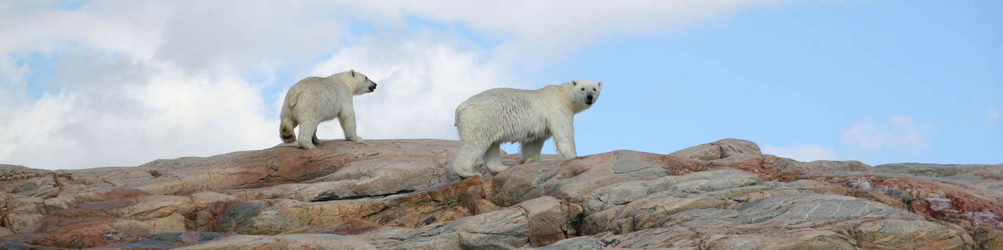
Deterrents and warning systems
Ukkusiksalik National Park
Reducing the threat posed by a polar bear during an interaction may be difficult. Non-lethal deterrents cannot be depended on to ensure safety. The best way to live safely with bears is to avoid contact with them. Any potential weapon must be considered, such as skis, poles, rocks, blocks of ice or even knives. Stay together as a group. This can be a deterrent and actions, such as making noise, jumping, waving arms, throwing things, may help to drive a polar bear away.
- Commercial deterrents
- Warning systems
In Canada’s national parks it is unlawful to possess a firearm unless you are a licensed guide or bear monitor with a permit. Consider hiring a guide or a bear monitor for increased safety. If you operate a guiding or outfitting business and wish your guides to be considered for a firearms permit, please contact the National Park or Site or Field Unit Office. The exception to this regulation is for beneficiaries of the Inuvialuit Final Agreement, the Nunavut Land Claim Agreement, the Labrador Inuit Land Claims Agreement, the Nunavik Inuit Land Claim Agreement and any future land claim agreements, who can carry firearms when engaged in traditional activities within national parks within their land claim area.

