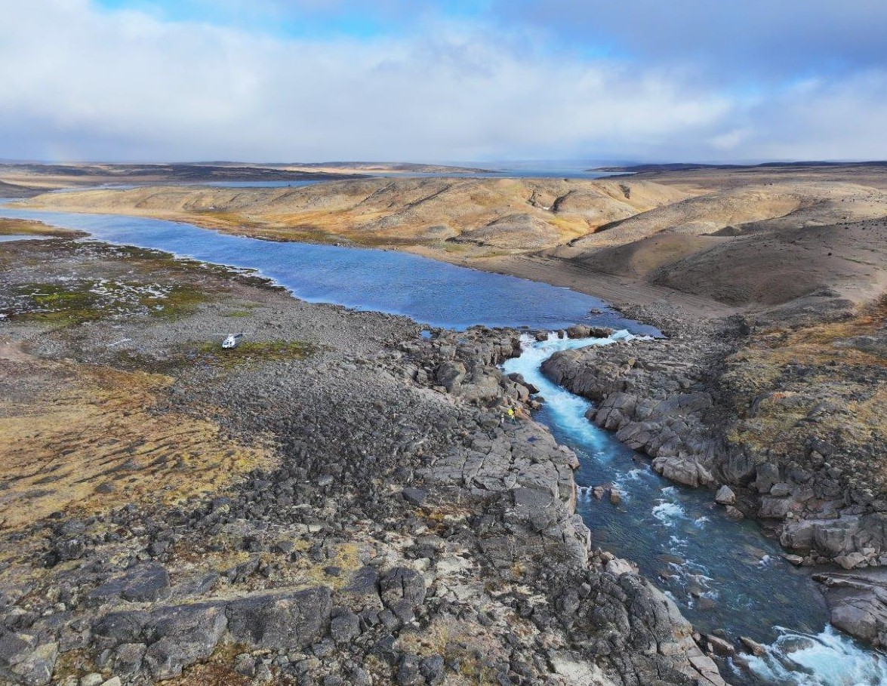

ᐃᖃᓗᐃᑦ ᓄᑭᒃᓴᐅᑏᑦ ᓴᓇᔭᐅᓂᖓ
IQALUIT NUKKIKSAUTIIT PROJECT

ᐅᖃᓪᓚᖃᑎᒌᒃᑕ ᐃᒪᕐᒥᑦ ᐆᒻᒪᖁᑎᖃᐅᑎᖃᕐᓂᖅ
LET’S TALK WATER POWER
ᔮᓄᐊᕆ 2025
JANUARY 2025

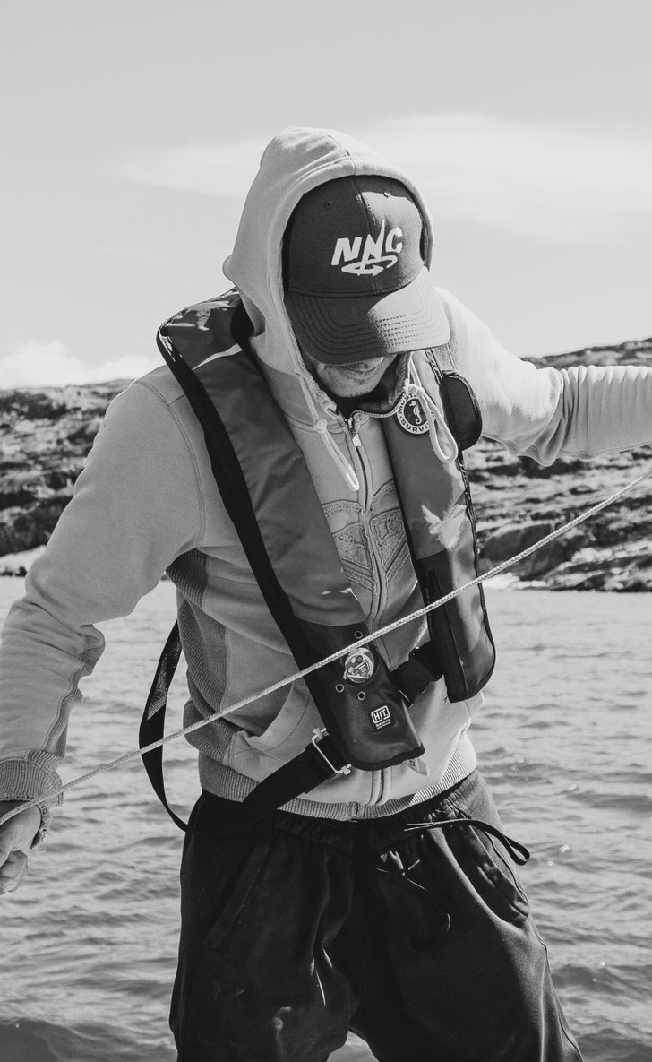
ᐃᖃᓗᐃᑦ ᓄᑭᒃᓴᐅᑏᑦ ᓴᓇᔭᐅᓂᖓ
2

ᐅᑯᐊ ᓄᓇᕗᑦ ᓄᒃᑭᒃᓴᐅᑏᑦ ᑯᐊᐳᕆᓴᓐ

ABOUT NNC

ᓄᓇᕗᑦ ᓄᒃᑭᒃᓴᐅᑏᑦ ᑯᐊᐳᕆᓴᓐ ᐅᑯᐊ 100% ᐃᓄᖕᓂᑦ- ᓇᖕᒥᓂᖁᑎᒋᔭᐅᔪᑦ ᐊᑕᑎᑕᐅᔪᑦ ᕿᑭᖅᑖᓗᒃ ᑯᐊᐳᕆᓴᓐ. ᐅᓇ ᑐᑭᖃᖅᑐᖅ ᓄᓇᕗᑦ ᓄᒃᑭᒃᓴᐅᑏᑦ ᑯᐊᐳᕆᓴᓐ ᓴᓇᓲᖑᕗᑦ ᐃᑲᔫᓯᐊᕐᓂᐊᕐᒪᑕ ᕿᑭᖅᑕᓂ ᐃᓄᖕᓂᒃ.
ᓄᓇᕗᑦ ᓄᒃᑭᒃᓴᐅᑏᑦ ᑯᐊᐳᕆᓴᓐ ᓴᕿᓚᐅᖅᓯᒪᔪᑦ 2017 ᐊᐅᓚᑦᓯᖁᓪᓗᒋᑦ ᕿᑭᖅᑕᓂ ᓄᓇᓕᖕᓂᒃ ᕿᓂᕐᓗᑎᒃ ᓄᓇᒥᑦ ᐆᒻᒪᖁᑎᖃᐅᑎᖃᕐᕕᐅᔪᓐᓇᖅᑐᓂᒃ. ᓴᕿᑕᐅᓚᐅᖅᑐᖅ ᐃᓄᖕᓂᑦ-ᐊᒻᒪᓗ ᓄᓇᓕᖕᓂᑦ-ᐊᐅᓚᑕᐅᓪᓗᓂ ᐱᓕᕆᐊᖑᔪᑦ ᐱᕚᓪᓕᖅᐸᓪᓕᐊᑎᑦᑎᔪᑦ ᐆᒻᒪᖁᑎᖃᐅᑎᖃᕐᕕᒋᔪᓐᓇᖅᑕᒥᖕᓂᒃ ᓇᖕᒥᓂᖅ ᓄᓇᕗᒻᒥ.

Nunavut Nukkiksautiit Corporation (NNC) is a 100% Inuit-owned subsidiary of Qikiqtaaluk Corporation (QC). That means NNC works for the benefit of Qikiqtani Inuit.
NNC was created in 2017 in response to the desire of Qikiqtani communities to explore renewable energy. We develop Inuit- and community-led projects that advance energy sovereignty in Nunavut.

IQALUIT NUKKIKSAUTIIT PROJECT

ᐃᖃᓗᐃᑦ ᓄᑭᒃᓴᐅᑏᑦ ᓴᓇᔭᐅᔪᖅ
ᐅᓇ ᐃᖃᓗᐃᑦ ᓄᑭᒃᓴᐅᑏᑦ ᓴᓇᔭᐅᓂᖓ ᓴᓇᔭᐅᔪᖅ ᓄᓇᒥᑦ ᐆᒻᒪᖁᑎᖃᐅᑎᒃᓴᖅ ᐊᓯᕈᐃᓂᐊᖅᑐᖅ ᐃᖃᓗᐃᑦ ᐆᒻᒪᖁᑎᖃᐅᑎᖃᕈᓯᖓᓂᒃ.
ᐅᓇ ᓴᓇᔭᐅᔪᖅ ᑐᒃᓯᕋᖅᐳᖅ ᐃᒫᒍᑦ ᐊᐅᓚᐅᑎᖃᕐᕕᖃᕐᓗᓂ ᑕᒫᓂ ᑰᒑᓗᒃ, ᖃᓂᒋᔮᓂ 60 ᑭᓚᒦᑕᔅ ᐅᐊᖕᓇᖓᓂᑦ ᑲᓇᖕᓇᖓᓄᑦ ᐃᖃᓗᐃᑦ.
ᐅᓇ ᓴᓇᔭᐅᔪᖅ ᐃᖃᓗᖕᒥᐅᓂᑦ ᐆᒻᒪᖁᑎᖃᐅᑎᖃᕐᕕᓪᓗᐊᑕᐅᓕᕐᑎᒃ ᑕᐃᒪᓐᓇᐅᔪᓐᓇᖅᑐᖅ, ᐃᓇᖐᓗᑎᒃ ᐊᑐᕈᓐᓃᕐᓗᑎᒃ ᑏᓱᒨᖅᑐᖅ-ᐊᐅᓚᐅᑎᑦ ᐆᒻᒪᖁᑎᖃᐅᑎ ᓱᕈᖅᓴᐃᓐᖏᓪᓗᓂ, ᓄᓇᒥᑦ ᓄᒃᑭᒃᓴᐅᑎᖃᕐᓗᓂ. ᐅᓇᖅᑕᐅᖅ ᐊᖏᓂᖅᓴᐅᓕᕈᓐᓇᖅᑐᖅ ᐅᖂᑎᑦᑎᓗᓂ ᐊᖏᕐᕋᓂᒃ ᐊᒻᒪᓗ ᓇᖕᒥᓂᖁᑎᒋᔭᐅᔪᓂᒃ ᐃᖃᓗᖕᓂ, ᐅᕝᕙᓘᓐᓃᑦ ᐆᒻᒪᖁᑎᖃᕐᑎᑦᑎᔨᐅᓗᑎᒃ ᑲᒻᐸᓂᐅᔪᓄᑦ, ᓲᕐᓗ ᓯᕗᓂᒃᓴᑦᑎᓐᓂᒃ ᐅᔭᕋᒃᓯᐅᕐᕕᒃᓴᓄᑦ ᖃᓂᒋᔭᖓᓂ.
ᐅᓇ ᐅᖃᓕᒫᒐᖅ ᑎᑎᕋᖅᓯᒪᔪᖅ ᖃᓄᐃᓕᖓᓕᕐᒪᖔᑕ 2024 ᓄᓇᒥ ᐱᓕᕆᑎᑦᑎᔾᔪᑕᐅᔪᒥᑦ ᓇᓂᔭᐅᓚᐅᖅᑐᑦ, ᖃᓄᐃᓕᖓᓕᖅᑎᑦᑎᓯᒪᓂᖓ ᐊᒃᑐᐃᓂᖓᑕ ᐱᓕᕆᐊᖑᔪᖅ ᑕᖏᒃᓴᖏᓐᓄᑦ, ᐊᒻᒪᓗ ᓇᓗᓇᐃᑦᑎᐊᖅᓯᒪᔪᑦ ᐸᕐᓇᒃᓯᒪᔪᑦ ᖃᓄᐃᓕᐅᕈᑎᒃᓴᓂᒃ ᐊᕐᕌᒍᓂᐊᖅᑐᒧᑦ. ᑐᓂᓯᖕᒥᔪᖅ ᖄᖓᒍᑦ ᐱᓕᕆᐊᒃᓴᓄᑦ ᐱᕕᖃᕐᑎᑦᑎᓂᖅ ᐃᓱᒪᒋᔭᕆᐊᖃᖅᑕᓯ ᐊᒻᒪᓗ ᐅᖃᐅᓯᕆᔭᕆᐊᖃᖅᑕᓯ.

IQALUIT NUKKIKSAUTIIT PROJECT
The Iqaluit Nukkiksautiit Project is a renewable power project that will transform Iqaluit’s energy landscape.
The Project is proposing a water power plant along the Kuugaluk River, about 60 km northeast of Iqaluit.
The Project has the potential to become Iqaluit’s main electricity source, replacing diesel- generated electricity with clean, renewable power. It also has the potential to be made bigger to supply electricity for heating homes and businesses in Iqaluit, or for producing electricity for industrial users, such as future mines nearby.
This booklet provides an update on the 2024 field program findings, the resulting impacts to the Project concept, and outlines the planned activities over the next year. It also presents additional project options for your consideration and input.

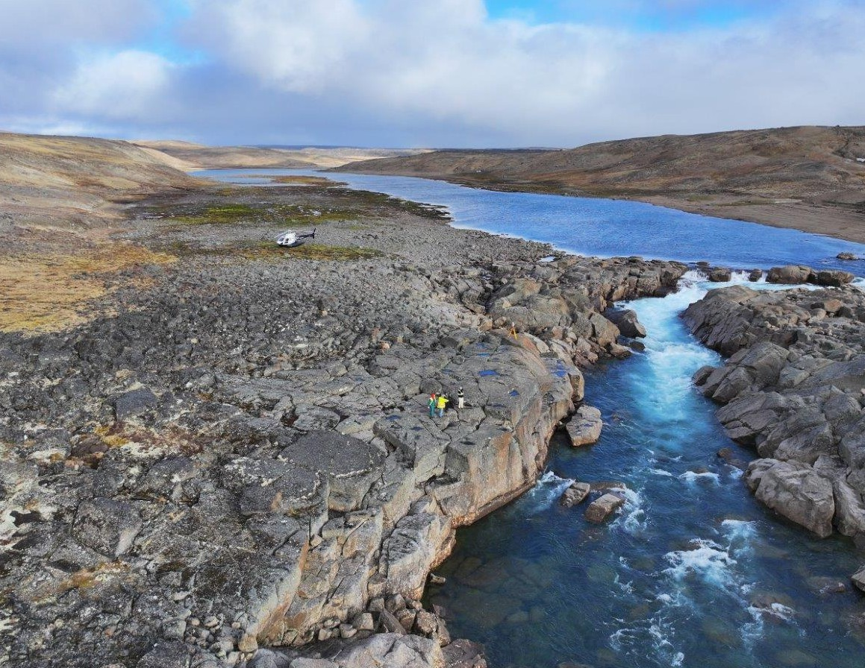


3

ᐃᖃᓗᐃᑦ ᓄᑭᒃᓴᐅᑏᑦ ᓴᓇᔭᐅᓂᖓ
ᐃᒪᓐᓇ ᐃᒫᓂᑦ ᐆᒻᒪᖁᑎᖃᐅᑎᖃᓲᑦ
HOW WATER POWER WORKS

1 2

ᐅᓇ ᑰᖕᒥᒃ ᓯᒥᒃᓯᓯᒪᔪᖅ ᐋᕿᒃᓯᓲᖅ ᐃᒪᖃᐅᑎᖃᕐᕕᖓ ᓯᒥᒃᓯᓯᒪᔪᖅ ᓄᓇᐅᑉ ᑕᓯᐊᓂᒃ.
The dam creates a reservoir by blocking the outlet of a natural lake.
ᐃᓚᖓ ᐃᒪᐃᔭᖅᑐᖅ ᐃᒥᖅᑕᕐᕕᖕᒥᑦ ᑕᒪᐅᓐᓇ ᓯᓕᒃᑐᐋᓗᒃ ᓱᓪᓗᖅ (ᑕᑭᔪᐋᓗᒃ) ᐊᑕᔪᖅ ᐊᐅᓚᐅᑎᖃᕐᕕᖓᓄᑦ.
Some of the water leaves the reservoir through the penstock (a big pipe) to the powerhouse.

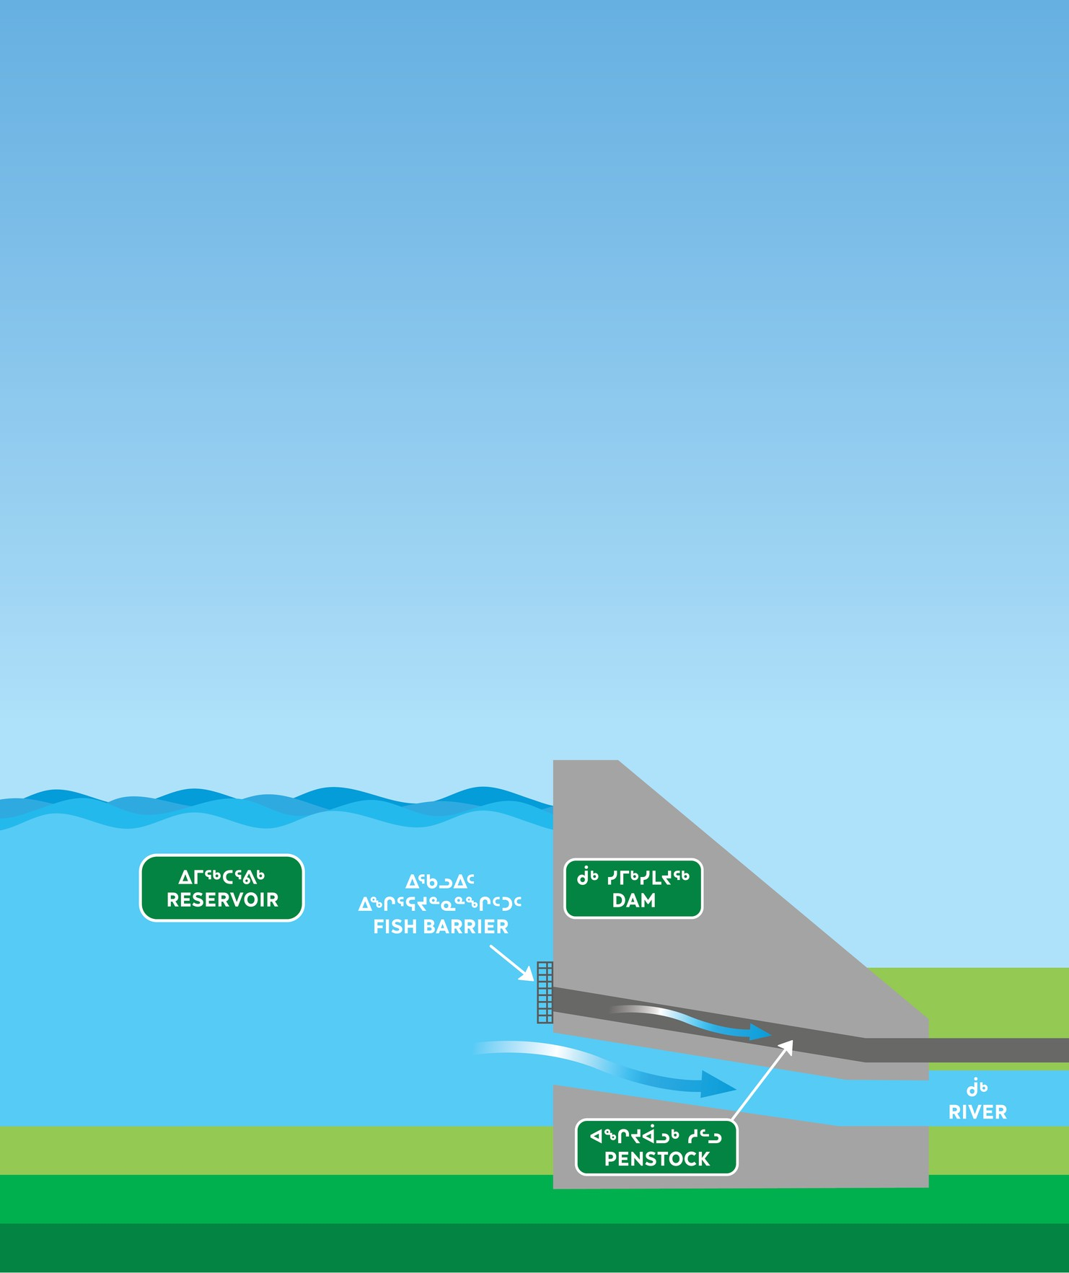


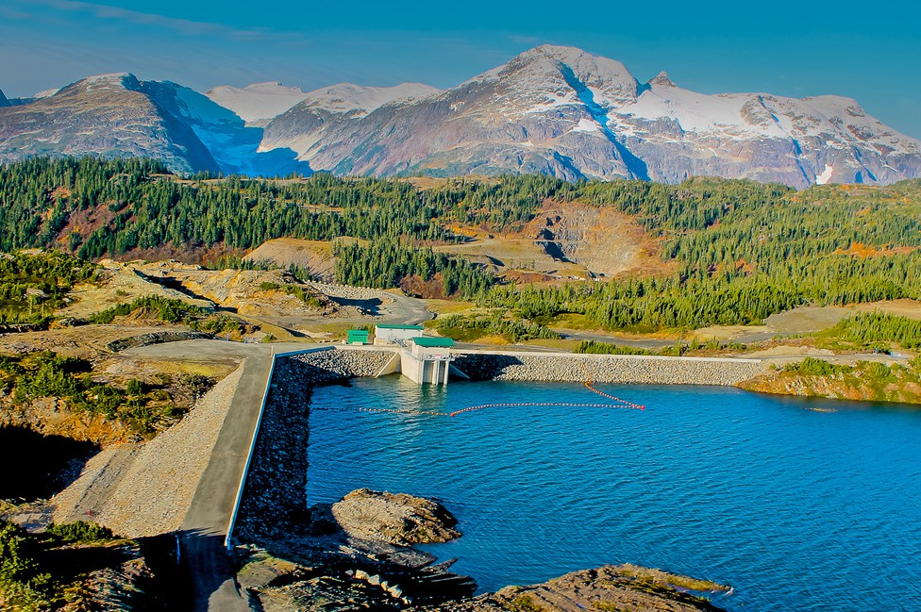

4

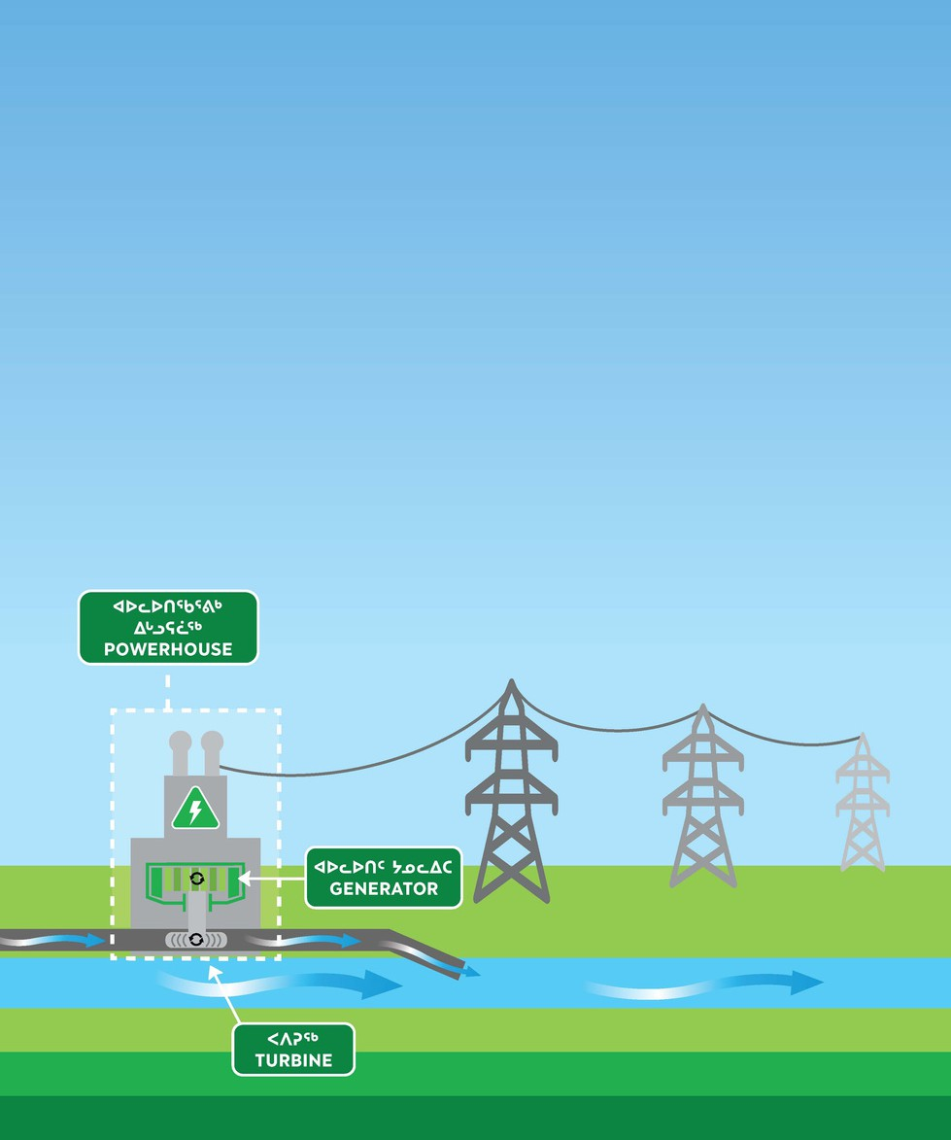

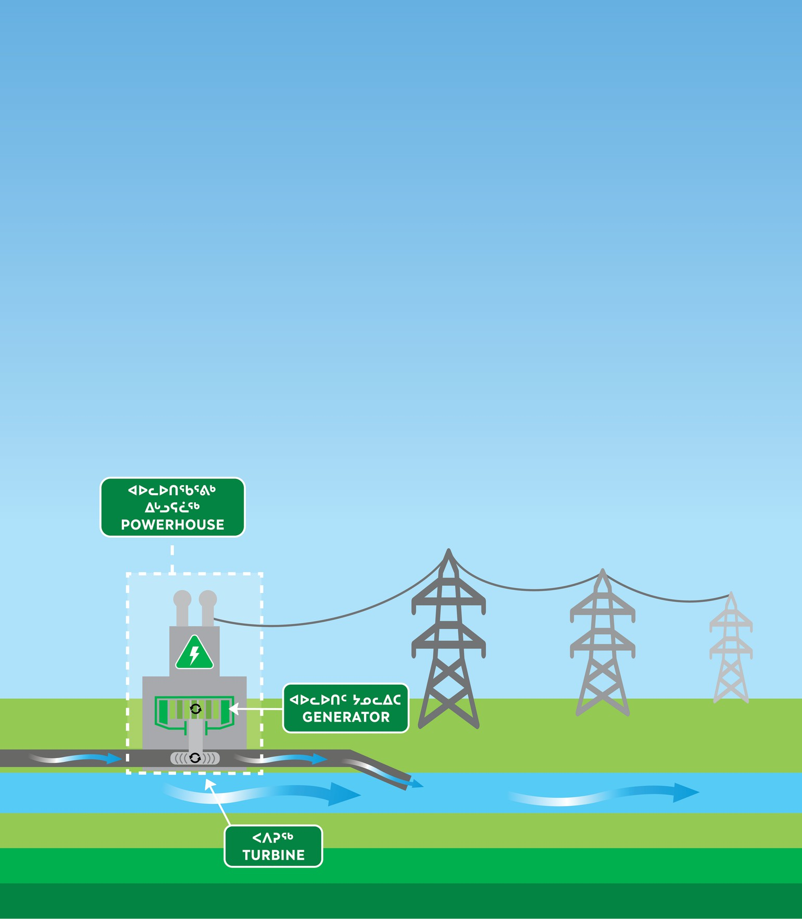
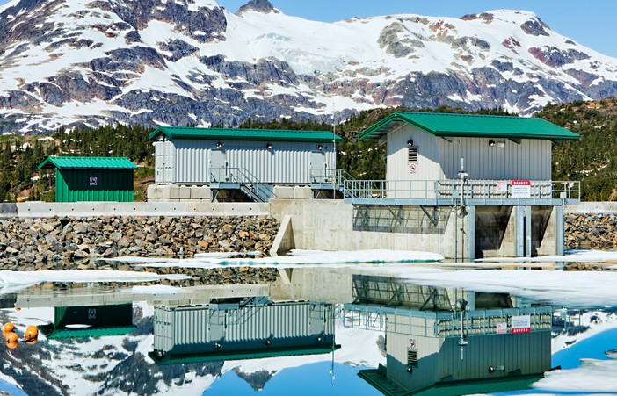

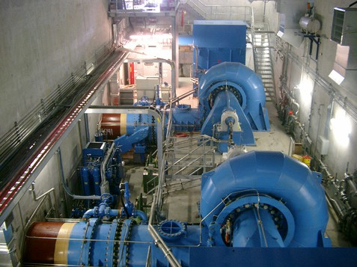
IQALUIT NUKKIKSAUTIIT PROJECT

4 5
ᓄᒃᑕᕋᒥ ᐃᒪᖅ ᑕᒪᐅᓐᓇ ᓯᓕᒃᑐᖅ ᓱᓪᓗᖅ ᐅᐃᔮᖅᑎᑕᖓ ᐸᐱᕈᐊᓂᒃ.
The moving water in the penstock turns the turbine.
3
ᑖᓐᓇ ᓄᒃᑎᒃᓴᐅᑎᖓ ᐊᑐᖅᑕᐅᔪᓐᓇᖅᖢᓂ ᑎᑭᐅᒪᔪᓐᓇᖅᑕᖏᓐᓄᑦ.
The electricity is exported to the grid.
ᑖᓐᓇ ᐸᐱᕈᐊ ᐊᐅᓚᐅᑎᖑᖅᖢᓂ ᐆᒻᒪᖁᑎᖃᕈᓐᓇᖅᓯᑎᑦᑎᓪᓗᓂ.
The turbine turns the generator to produce electricity.

5

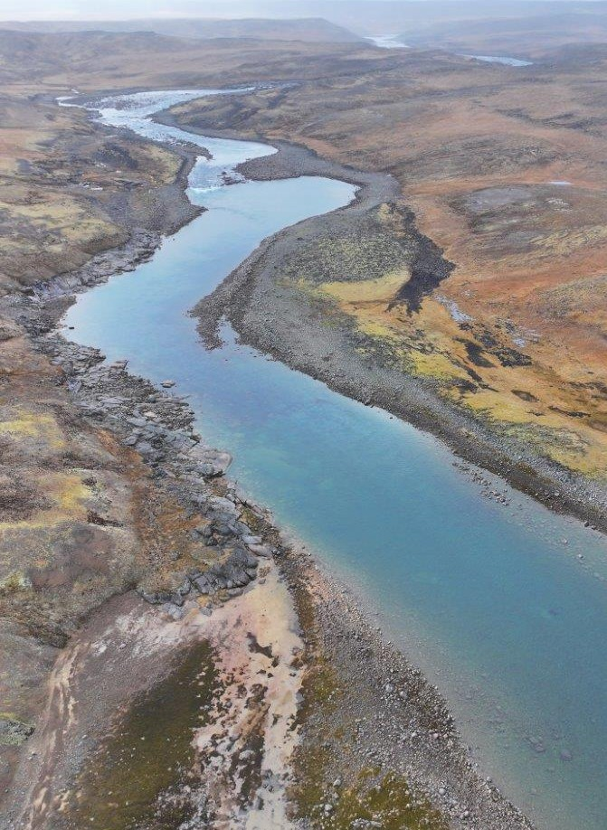
ᐃᖃᓗᐃᑦ ᓄᑭᒃᓴᐅᑏᑦ ᓴᓇᔭᐅᓂᖓ

ᐱᒋᐊᕈᑎᕗᑦ

OUR APPROACH
ᓄᓇᕗᑦ ᓄᒃᑭᒃᓴᐅᑏᑦ ᑯᐊᐳᕆᓴᓐ ᒪᓕᒃᑐᑦ “ᓯᕗᒃᑲᖅᑕᖅᐸᓪᓕᐊᓗᓂ” ᐱᒋᐊᕈᑎᖃᕐᓂᐊᖅᑐᑦ ᑐᓂᓯᕙᓪᓕᐊᓗᑎᒃ ᓴᓇᔭᐅᓂᐊᖅᑐᓂᒃ. ᑲᑎᒪᖃᑎᒋᓗᒋᑦ ᐱᔪᓐᓇᐅᑎᖃᖅᑐᑦ, ᑭᒃᑯᑐᐃᓐᓇᐃᑦ, ᑎᒍᒥᐊᖅᑎᑦ, ᐊᒻᒪᓗ ᐱᓕᕆᖃᑎᒋᓂᐊᖅᑕᕗᑦ ᐃᓚᒋᔭᐅᔪᑦ ᑕᒪᐃᓐᓄᑦ ᓯᕗᒃᑲᖅᑕᖅᐸᓪᓕᐊᓂᐊᕐᓂᖓᒍᑦ, ᑕᐃᒫᒃ ᑐᑭᒧᐊᒃᑎᑕᐅᓂᐊᕋᑦᑕ ᐱᔪᓐᓇᐅᑎᖃᖅᑐᓂᑦ ᓴᓇᔭᐅᔪᒧᑦ ᐃᓱᒪᓕᐅᕆᖃᑦᑕᕐᓗᑎᒃ, ᐊᒻᒪᓗ ᑕᐃᒫᒃ ᑕᒪᕐᒥᒃ ᐱᓕᕆᖃᑕᐅᔪᑦ ᐅᖃᐅᓯᒃᓴᒥᖕᓂᒃ ᑐᓂᓯᖃᑦᑕᕐᓗᑎᒃ. ᐊᕙᑖᓂᑦ ᐊᑐᓂ ᓯᕗᒃᑲᖅᑕᕐᓂᖓᑕ ᐱᑕᖃᕐᒥᔪᖅ ᐃᓱᒪᓕᐅᕆᕙᓪᓕᐊᓂᖅ ᓯᕗᒃᑲᖅᑕᕐᓂᖓ ᐊᖏᖅᑕᐅᖃᑦᑕᕆᐊᖃᖅᑐᓄᑦ ᑭᖑᓪᓕᕐᒧᑦ ᓯᕗᒃᑲᖅᑕᐅᑎᖓᓄᑦ ᑕᒫᖓᑦ ᑲᑎᒪᖃᑎᖃᓚᐅᕐᓗᑎᒃ ᐃᓚᐅᔪᓂᒃ ᐊᒻᒪᓗ ᐃᓄᖕᓂᒃ ᓯᕗᓕᐅᖅᑎᓂᒃ.
NNC follows a “Phase Gate” approach to delivering projects. Engagements with Rightsholders, the public, stakeholders, and partners are part of every Phase, to ensure we are taking direction from Rightsholders in project decision-making, and that all parties have input. Between each Phase there is a Decision Gate which requires approval to move on to the next Phase from engagement participants and Inuit leadership.

6

ᐅᕙᓃᑉᐳᒍᑦ
WE ARE HERE


ᓇᓗᓇᐃᕐᓗᒋᑦ
ᐱᕕᖃᕐᑎᑦᑎᔪᑦ
ᑲᔪᓯᔪᓐᓇᕐᒪᖔᑕ
ᑲᔪᓯᔪᓐᓇᓐᖏᒻᒪᖔ ᑕᓘᓐᓃᑦ
ᑮᓇᐅᔭᒃᓴᖃᑦᑎᑕᐅᓗᑎ
ᒃ ᐸᕐᓇᐃᓗᑎᒃᓗ ᐊᒻᒪᓗ ᖃᓄᖅ ᓴᓇᓯᒪᓂᐊᕐᒪᖔᑦ
ᓇᓗᓇᐃᑦᑎᐊᖅᓯᒪᔪᑦ
ᓴᓇᔭᕆᐊᖃᖅᑐᓂᒃ ᐊᒻᒪᓗ ᐱᔪᓐᓇᐅᑎᒃᓴᖏᓐᓄᑦ
ᓴᓇᓗᑎᒃ
ᐱᖁᑎᑦ
ᐃᖏᕐᕋᓯᑎᑕᐅᓗᑎᒃ
1

Identify Opportunity
2

Feasibility
3

Front-End Engineering and Design (FEED)
4

Detailed Engineering and Permitting
5

Construction
6

Asset Operation
ᓱᒃᑲᖅᑕᕐᓂᖓ
Project Phase
ᓱᕈᖅᓴᐃᓐᖏᑦᑐᓂᒃ ᖃᓄᕆᑦᑐᓂᒃ
ᐆᒻᒪᖁᑎᖃᐅᑎᒃᓴᓂᒃ ᓱᕈᖅᓴᐃᓐᖏᑦᑐᑦ ᕿᓂᖅᑕᐅᒃᑲᓐᓂᕈᓐᓇᖅᐸ? ᐆᒻᒪᖁᑎᖃᐅᑎᑦ ᐊᒻᒪᓗ
ᓇᓂ?
ᐅᓇ ᑕᖏᖓ ᑐᑭᖃᖅᐸ
ᐊᒻᒪᓗ ᓴᓇᔭᐅᓂᖓᓄᑦ ᐱᕚᓪᓕᕈᑎᒋᔪᓐᓇᖅᐸ ᐱᔪᓐᓇᐅᑎᑖᕈᓐᓇᕐᓂᐊᕐᒪᑕ?
ᓴᓇᔭᐅᔪᒪᔪᖅ
ᓴᓇᔭᐅᔭᕆᐊᖃᖅᐸ?
ᐃᓱᒪᓕᐅᕆᔭᕆᐊᓕᑦ
Decision Gate

Should clean energy be further explored?
What type of clean energy and where?
Does the concept make sense and should the Project advance to permitting?
Should the Project be built?

ᓴᓇᔭᐅᔪᖅ ᖃᓄᐃᓕᐅᕈᑎᖏᑦ ᒫᓐᓇᒧᑦ

ᓯᕗᒃᑲᖅᑕᕐᓂᖓ 1: ᓇᓗᓇᐃᕐᓗᒍ ᐱᕕᖃᕐᑎᑦᑎᓂᖅ
ᓄᓇᕗᑦ ᓄᒃᑭᒃᓴᐅᑏᑦ ᑯᐊᐳᕆᓴᓐ ᓇᓗᓇᐃᖅᓯᓯᒪᔪᑦ ᐊᑑᑎᖏᓐᓂᒃ ᐃᖃᓗᖕᒥᐅᑦ ᕿᓂᕈᓐᓇᖅᑐᑦ ᓱᕈᖅᓴᐃᓐᖏᑦᑐᒥᒃ ᐆᒻᒪᖁᑎᖃᐅᑎᓂᒃ ᑕᒪᒃᑭᖅᑕᐅᓂᐊᕐᒪᑕ ᐃᖃᓄᐃᑦ ᐱᔭᕆᐊᖃᖅᑕᖏᑦ. ᓄᓇᕗᑦ ᓄᒃᑭᒃᓴᐅᑏᑦ ᑯᐊᐳᕆᓴᓐ ᐱᔭᕇᖅᓯᓗᑎᒃ ᐱᔭᕐᓂᓐᖏᑦᑑᑎᖏᓐᓂᒃ ᐊᒻᒪᓗ ᒪᑭᒪᔾᔪᑕᐅᔪᓐᓇᕐᒪᖔᑦ ᒪᑭᒪᔾᔪᑕᐅᔪᓐᓇᓐᖏᒻᒪᖔᑦ ᕿᒥᕐᕈᐊᖅᑕᐅᓗᓂ, ᑐᓴᖅᑕᕗᑦ ᐃᓕᑕᐅᓇᓱᒃᓗᑎᕐ ᐃᓄᐃᑦ ᓄᓇᐃᑦ-ᐊᑐᖅᑕᖏᑦ, ᐊᒻᒪᓗ ᐊᕙᑎᖓ ᖃᐅᔨᓴᖅᑕᐅᓗᓂ.
1
2

Phase 1: Identify Opportunity
NNC identified the value to
Iqalungmiut in exploring clean power solutions to meet Iqaluit’s needs. NNC completed a Technical and Economic Feasibility Review, a Tusaqtavut Study on Inuit land-use, and a desktop Environmental Survey.

ᐃᓱᒪᓕᐊᒃᓴᐃᑦ 1: ᓱᕈᖅᓴᐃᓐᖏᑦᑐᒥᒃ ᐆᒻᒪᖁᑎᖃᐅᑎᒃᓴᒥᒃ ᕿᓂᒃᑲᓐᓂᕆᐊᖃᖅᐱᑖ ᐃᖃᓗᖕᓄᑦ?
ᐃᓄᐃᑦ ᓯᕗᓕᐅᖅᑎᑦ ᕿᑭᖅᑖᓗᒃ ᑯᐊᐳᕆᓴᓐ ᐊᒻᒪᓗ ᕿᑭᖅᑕᓂ ᐃᓄᐃᑦ ᑲᑐᔾᔨᖃᑎᒌᑦ ᐃᑲᔪᖅᑐᑦ ᐃᓕᑦᑎᒃᑲᓐᓂᕋᓲᑎᒃᓴᓂᒃ ᐱᐅᓂᖅᐹᒧᑦ ᐊᖁᑎᒃᓴᒥᒃ ᓯᕗᒻᒧᐊᒍᑕᐅᓂᐊᖅᑐᓄᑦ.

Decision Gate 1:
Should clean power be further explored for Iqaluit?
Inuit leadership from
Qikiqtaaluk Corporation and Qikiqtani Inuit Association supported doing more studies to find the best path forward.

ᓯᕗᒃᑲᖅᑕᕐᓂᖓ 2: ᑲᔪᓯᔪᓐᓇᕐᒪᖔᑕ ᑲᔪᓯᔪᓐᓇᓐᖏᒻᒪᖔᑕᓘᓐᓃᑦ
17 ᐊᔾᔨᒌᓐᖏᑦᑐᑦ ᐆᒻᒪᖁᑎᖃᐅᑎᑦ ᓂᕈᐊᖑᔪᓐᓇᖅᑐᑦ ᓇᓗᓇᐃᖅᑕᐅᓯᒪᕗᑦ
ᐃᓂᒋᔭᐅᔪᓐᓇᖅᑐᑦ ᖃᓂᒋᔭᖓᓂ ᐃᖃᓗᐃᑦ, ᐃᓚᒋᔭᐅᕗᑦ ᐊᔾᔨᒌᓐᖏᑦᑐᑦ ᐃᒫᒍᑦ, ᐊᓄᕆᒃᑯᑦ, ᑲᑎᖓᓗᒋᑦ ᐃᒫᒍᑦ ᐊᒻᒪᓗ ᐊᓄᕆᒃᑯᑦ, ᐊᒻᒪᓗ ᑲᔪᓯᓂᖅ ᑏᓱᒥᒃ ᐅᖅᓱᒃᓴᖃᕐᓗᑎᒃ.

Phase 2 : Feasibility
17 different power system
options were identified at sites near Iqaluit, including different types of water power, wind power, a combination of water and wind, and continuing with diesel.

PROJECT ACTIVITIES TO DATE

ᐃᓱᒪᓕᐊᒃᓴᐃᑦ 2: ᖃᓄᕆᑦᑑᕙ ᓱᕈᖅᓴᐃᓐᖏᑦᑐᖅ ᐆᒻᒪᖁᑎᖃᐅᑎ ᐊᒻᒪᓗ ᓇᓂ?
ᑕᒪᐅᓐᓇ ᓂᕈᐊᓚᐅᖅᑐᑦ, ᐱᔪᓐᓇᐅᑎᖃᖅᑐᑦ, ᑎᒍᒥᐊᖅᑎᑦ, ᐃᖃᓗᖕᒥᐅᑦ, ᐊᒻᒪᓗ ᐱᓕᕆᖃᑎᒋᔭᕗᑦ ᐊᖏᖅᓯᓪᓗᑎᒃ ᐃᒫᒍᑦ ᐆᒻᒪᖁᑎᖃᐅᑎᒃᓴᖅ ᑰᒐᓗᖕᒥᑦ ᓂᕈᐊᖑᓯᒪᕗᖅ ᐃᓂᒃᓴᖓ.

ᓯᕗᒃᑲᖅᑕᕐᓂᖓ 3: ᑮᓇᐅᔭᒃᓴᖃᑦᑎᑕᐅᓗᑎᒃ ᐸᕐᓇᐃᓗᑎᒃᓗ ᐊᒻᒪᓗ ᖃᓄᖅ
ᓴᓇᓯᒪᓂᐊᕐᒪᖔᑦ
ᑕᕝᕙᓃᓕᖅᐳᒍᑦ: ᓇᓗᐃᑦᑎᐊᕐᓗᒋᑦ ᓄᓇᖓᓂᒃ ᐃᓕᑦᑎᓇᓱᒍᑕᐅᔪᑦ ᐊᒻᒪᓗ ᑭᒃᑯᑐᐃᓐᓇᓂᒃ ᑲᑎᒪᖃᑎᖃᕐᓗᑕ. ᐅᑯᐊ ᐊᐅᓚᐅᓯᕆᔨᖏᑦ ᐱᓕᕆᖃᑎᒌᑦ ᓴᕿᑦᑎᓂᐊᖅᑐᑦ ᑕᖏᒃᓴᖓᓂᒃ ᓴᓇᔭᐅᔪᖅ, ᒪᓕᒃᓗᓂ ᑕᐃᒪᐃᓕᖓᓪᓚᕆᒃᑐᓂᒃ ᐃᓂᖓᓂᑦ. ᐅᓇ ᐱᓕᕆᐊᖑᔪᖅ ᐱᔭᕇᕈᓂ ᖃᓄᐃᓕᖓᓂᒃᓴᖓ, ᐱᒋᐊᕈᑎᒃᓴᑦ, ᐊᒻᒪᓗ ᑮᓇᐅᔭᒃᓴᖏᓐᓄᑦ ᐸᒃᓇᐅᑎᑦ ᕿᒥᕐᕈᐊᖅᑕᐅᓗᑎᒃ ᐊᒻᒪᓗ ᐋᕿᒋᐊᖅᑕᐅᓗᑎᒃ ᐊᒥᓱᐃᕐᓗᑎᒃ ᒪᓕᑦᑎᐊᓕᕐᓂᐊᕐᒪᑕ ᐃᓅᓯᓕᕆᓂᕐᒧᑦ, ᐊᕙᑎᓕᕆᓂᕐᒧᑦ ᐊᒻᒪᓗ ᒪᑭᒪᔾᔪᑕᐅᔪᓐᓇᕐᓂᖓᓄᑦ ᐊᑑᑎᖏᑦ.

Decision Gate 2:
What type of clean power and where?
Through a ranked ballot vote,
Rightsholders, stakeholders, Iqalungmiut, and partners approved conventional water power at the Kuugaluk River site as their preferred option.

Phase 3:
Front-End Engineering and Design We are here: Detailed field studies and public engagements will be conducted.
The engineering team will create Project concepts, based on real data from the site. The Project scope, approach, and financing strategy will be reviewed and revised several times to balance social, environmental and economic values.

ᓯᕗᒃᑲᖅᑕᕐᓂᖓ 3 - ᓇᓗᓇᐃᔭᖅᓯᒪᔪᑦ ᐱᓕᕆᓚᐅᖅᑕᑦᑎᓐᓂᒃ

PHASE 3 - OVERVIEW OF WHAT WE HAVE DONE


ᓴᕿᑦᑎᓚᐅᖅᑐᒍᑦ ᓴᓇᔭᐅᔪᑉ ᑕᖏᒃᓴᖓᓂᒃ ᒪᓕᒃᖢᒍ ᐃᓱᒪᒋᔭᑦᑎᓐᓂᒃ ᐃᓂᖓᑕ ᖃᓄᕆᑑᓂᖓ ᒪᓕᒃᖢᒍ, ᐊᑐᖅᓯᓚᐅᖅᑐᒍᑦ
ᖃᕆᓴᐅᔭᒃᑯᑦ ᐃᓕᑦᑎᔾᔪᑕᐅᔪᓐᓇᖅᑐᓂᒃ.
studies.
ᐱᒋᐊᓕᓵᖅᖢᑕ ᐃᓂᖓᓂᒃ
We did an initial site investigation.
We developed a Project concept based on what we thought the site conditions were, using desktop

ᖃᐅᔨᓴᑦᑎᐊᓚᐅᖅᐳᒍᑦ. ᓇᓂᔭᕗᑦ ᖃᐅᔨᓴᕈᑎᓂᑦ ᑕᑯᑎᑦᑎᓚᐅᖅᑐᑦ ᖃᓄᖅ ᐊᔾᔨᒌᓐᖏᑎᒋᓂᖏᓐᓂᒃ ᖃᕆᓴᐅᔭᒃᑯᑦ ᐃᓕᑕᐅᓇᓱᒃᑐᑦ ᐅᑯᐊᓗ ᐊᒃᑐᐃᔪᑦ ᓴᓇᔭᐅᔪᖅ
ᑕᖏᒃᓴᖓᓂᒃ.
What we discovered showed differences from the desktop studies that would impact the Project

concept.


ᐋᕿᒋᐊᑦᑎᐊᓚᐅᖅᑐᑦ ᓴᓇᔭᐅᔪᖅ ᑕᖏᒃᓴᖓ ᒪᓕᒃᖢᒍ ᓇᓂᔭᑦᑎᓐᓂᒃ ᑕᐃᑲᓂ ᐱᒋᐊᓕᓵᖅᖢᑕ ᐃᓂᖓᓂᒃ ᖃᐅᔨᓇᓱᑦᑎᐊᕐᓂᕆᓚᐅᖅᑕᑦᑎᓐᓂᑦ.
We adjusted the Project concept based on what we found during the initial site investigations.

ᓯᕗᒃᑲᖅᑕᕐᓂᖓ 3 - ᓇᓗᓇᐃᔭᖅᓯᒪᔪᑦ ᒫᓐᓇ ᖃᓄᐃᓕᐅᓕᕐᒪᖔᑦᑕ

PHASE 3 - OVERVIEW OF WHAT WE ARE CURRENTLY DOING



ᐱᓕᕆᕗᒍᑦ ᖄᒃᑲᓐᓂᐊᒍᑦ ᓄᓇᖓᓂᒃ ᐃᓕᑦᑎᓇᓱᒃᖢᑕ (ᓄᓇᖏᑦ ᐱᔭᕐᓂᓐᖏᑦᑑᑕᐅᓂᖏᑦ, ᓯᓚᖓ, ᐃᑦᑕᕐᓂᑕᐃᑦ) ᐊᒻᒪᓗ ᐱᓕᕆᖃᑎᖃᖅᐳᒍᑦ ᖃᐅᔨᓂᐊᕋᑦᑕ ᖃᐅᔨᒪᓇᓐᖏᑦᑐᓂᒃ ᐊᒻᒪᓗ
ᑐᑭᓯᔪᓐᓇᓐᖏᑕᑦᑎᓐᓂᒃ ᐊᒻᒪᓗ ᐱᔭᕇᕈᑎᒃᓴᓂᒃ
ᓴᓇᔭᐅᔪᖅ ᐱᔭᕇᕈᓂ ᖃᓄᐃᓕᖓᓂᒃᓴᖓ.
and to finalize the Project scope.
We are doing additional field studies (geotechnical, environmental, archaeological) and engagements to determine the unknowns and uncertainties

ᕿᓂᖅᑐᒍᑦ ᓄᓇᓕᖕᓂᑦ ᑭᐅᔭᐅᔪᒪᓪᓗᑕ ᐋᕿᒃᓱᖅᓯᒪᓂᖓᓂ ᓱᕈᖅᓴᐃᓐᖏᑦᑐᒥᒃ ᐆᒻᒪᖁᑎᖃᐅᑎᒃᓴᓄᑦ ᑐᕌᖅᑕᓂᒃ ᑐᑭᓯᓂᐊᕋᑦᑕ
ᖃᓄᖅ ᐊᖏᑎᒋᓂᐊᕐᒪᖔᑦ ᐃᒫᓂ ᐆᒻᒪᖁᑎᐅᖃᐅᑎᒃᓴᖅ ᐊᐅᓚᐅᑎᖃᕐᕕᒃᓴᖓ.
We are seeking community feedback on clean electricity goals to understand what size the water power plant should be.

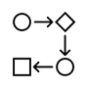
ᒪᓕᒃᖢᒋᑦ ᑭᐅᓯᐅᔾᔪᑎᑦᑎᓐᓂᑦ ᐃᖃᓗᖕᒥᐅᓂᑦ ᐊᒻᒪᓗ ᑐᑭᓯᓇᖅᓯᔪᑦ ᓄᓇᖓᓂ ᐃᓕᑕᐅᓇᓱᒃᑐᓂᑦ, ᐸᕐᓇᐃᓂᐊᕋᑦᑕ ᐱᒋᐋᕈᑎᒃᓴᖏᓐᓄᑦ ᖃᓄᖅ ᓴᓇᓯᒪᓂᐊᕐᒪᖔ.
Based on the response from Iqalungmiut and the results of field studies, we will prepare a preliminary design.


ᐃᒪᓐᓇ ᐃᓱᒪᖃᓚᐅᖅᑐᒍᑦ
ᐃᒪᓐᓇ ᐃᓱᒪᖃᓚᐅᖅᑐᒍᑦ

WHAT WE THOUGHT

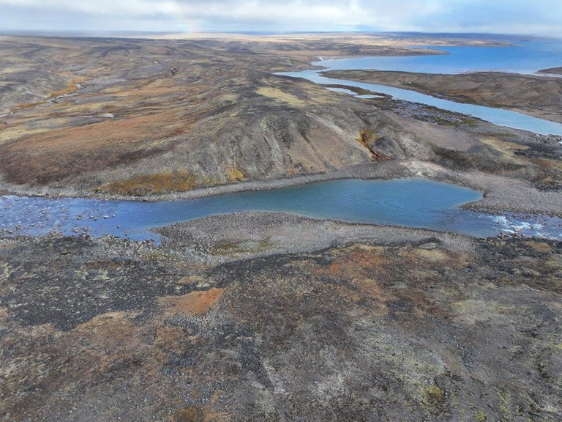
ᖃᕆᓴᐅᔭᒃᑯᑦ ᐃᓕᑦᑎᓇᓱᒍᑎᒋᔭᕗᑦ ᐃᓱᒪᖃᓚᐅᕐᒪᑕ ᑕᒪᕐᒥᒃ ᐅᔭᕋᓱᒃᔫᓇᓱᒋᓪᓗᒍ ᓄᓇᖓ.

ᐱᒋᐊᓕᓵᖅᖢᑕ ᓴᓇᔭᐅᔪᖅ ᑕᖏᒃᓴᖓ ᐊᖏᔪᒥᒃ ᐃᒪᖃᐅᑎᖃᕐᕕᒃᓴᖓᑕ ᐊᒻᒪᓗ ᐃᒫᓂ ᐆᒻᒪᖁᑎᖃᐅᑎᒃᓴᓄᑦ ᐊᐅᓚᐅᑎᖃᕐᕕᖓ ᓴᓇᔭᐅᓗᓂ ᐃᓱᒪᖃᖅᖢᑎᒃ ᐅᔭᕋᓱᒃᔪᐃᓐᓇᐅᓇᓱᒋᓪᓗᒍ.

Our desktop study of the Project site predicted mostly bedrock in the area.
An initial Project concept for a large reservoir and water power plant was developed assuming bedrock conditions.


ᐃᒪᐃᑦᑐᓂᒃ ᓇᓂᓯᓚᐅᖅᑐᒍᑦ

WHAT WE DISCOVERED

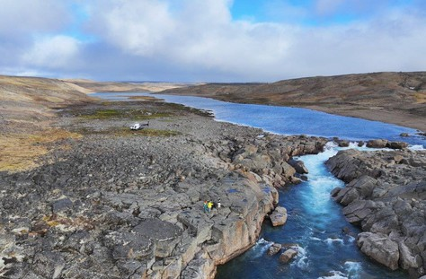
ᓄᓇᕗᑦ ᓄᒃᑭᒃᓴᐅᑏᑦ ᑯᐊᐳᕆᓴᓐ ᐊᒻᒪᓗ ᐊᐅᓚᐅᓯᕆᔨᒃᑯᑦ ᐱᓕᕆᓚᐅᕐᒪᑕ ᐃᓂᖓ ᖃᐅᔨᓇᓱᒃᑕᐅᑦᑎᐊᖅᖢᓂ ᓯᑎᐱᕆ 2024.

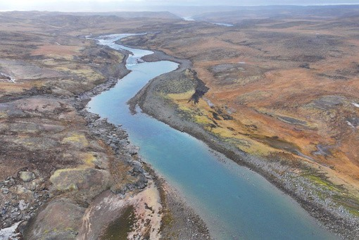
ᐃᓂᖓᓂ ᖃᓄᐃᓕᐅᕈᑕᐅᔪᑦ: ᐊᔾᔨᐅᖅᑕᐅᔪᖅ ᐊᒻᒪᓗ ᖁᓕᒥᒎᓕᖑᐊᖅᑎᒍᑦ ᐊᔾᔨᓕᐅᕈᑎᓕᖕᓄᑦ ᕿᒥᕐᕈᐊᖅᑕᐅᑦᐊᖅᐳᖅ (LiDAR) ᖃᓄᖅ ᓄᓇᖓ ᐋᕿᒃᓯᒪᖕᒪᖔᑦ ᓄᐊᑦᑎᕗᒍᑦ ᒪᓂᕋᖓᓂᑦ ᖃᐅᔨᓴᕈᑎᑖᖅᖢᑕ
ᐃᓂᖓᓂᑦ ᓇᓂᔭᐅᔪᑦ:
ᒪᓂᕋᖓᑕ ᖃᓄᕆᑑᓂᖓ ᐊᕙᓗᐊᓂ ᑐᒃᓯᕋᖅᑕᐅᔪᖅ ᑰᑉ ᓯᒥᒃᓴᖓ ᐊᒻᒪᓗ ᐃᒥᖃᐅᑎᖃᕐᕕᒃᓴᖓ ᑐᐊᑉᐸᒋᐊᖃᕐᓂᖅᓴᐅᔪᖅ ᓯᕗᓪᓕᕐᒥᒃ ᓂᕆᐅᒋᓚᐅᖅᑕᑦᑎᓐᓂᑦ ᖃᕆᓴᐅᔭᒃᑯᑦ ᐃᓕᑦᑎᓇᓱᒃᑎᓪᓗᑕ.

NNC and the engineering team conducted a site investigation in September 2024.
WHAT WE HAVE DONE

Site Activities:
camera and drone photos
LiDAR (laser) scan of topography
collected ground samples

Site Findings:
The ground conditions around the proposed dam area and reservoir have more gravel than originally predicted in the desktop studies.

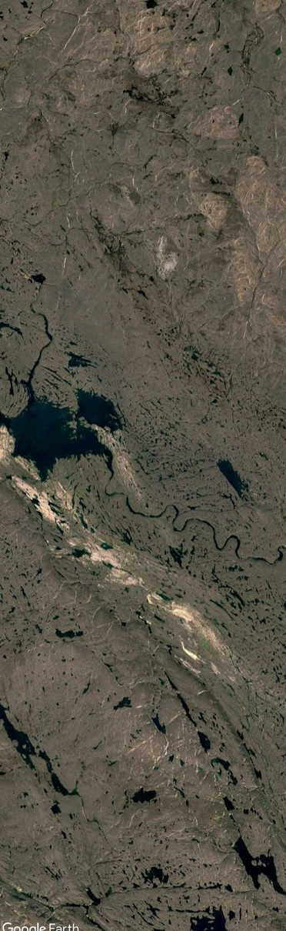

ᓴᓇᔭᐅᔪᖅ ᐋᕿᒋᐊᖃᑦᑕᕐᓗᓂ ᐊᒻᒪᓗ ᓄᑖᖑᕆᐊᖅᑕᐅᕙᒡᓗᑎᒃ ᐃᓚᖏᑦ ᐊᐅᓚᐅᓯᕆᔭᐅᕙᓪᓕᐊᓂᖓ. ᓴᓇᓯᒪᓂᐊᕐᓂᖓ ᐋᕿᒃᓱᖅᓯᒪᔪᖅ ᖃᕆᓴᐅᔭᒃᑯᑦ ᐊᒻᒪᓗ ᓈᓴᐅᓯᕆᓂᒃᑯᑦ ᒪᓕᒃᖢᓂ ᑲᔪᓯᔪᒥᒃ ᑐᓴᒐᒃᓴᖅᑖᖅᐸᓪᓕᐊᓂᖅ ᓄᐊᑕᐅᕙᓪᓕᐊᔪᓂᒃ.
Project adjustments and revisions are a normal part of the engineering process.
Design is an iterative process based on continued information that is gathered.
ᐃᖃᓗᐃᑦ ᓄᑭᒃᓴᐅᑏᑦ ᓴᓇᔭᐅᓂᖓ
ᐃᒪᓐᓇ ᐃᓱᒪᖃᓚᐅᖅᑐᒍᑦ


ᐃᒪᓐᓇ ᐋᕿᒋᐊᖅᓯᓚᐅᖅᐳᒍᑦ

HOW WE ADJUSTED

ᐅᓇ ᐃᓂᖓᓂᒃ ᖃᐅᔨᓇᓱᑦᑎᐊᕐᓂᖅ ᓇᓂᓯᓚᐅᖅᑐᑦ ᑐᐊᑉᐱᒃᑲᓐᓂᕆᐊᓕᒃ ᑕᐃᒪᓐᓇ ᓂᕆᐅᒋᓚᐅᓐᖏᑕᕗᑦ, ᐊᒻᒪᓗ ᐃᑎᓂᖓ ᐅᔭᕋᓱᒃᔪᑦ ᒫᓐᓇ ᖃᐅᔨᒪᔭᐅᓂᓐᖏᑦᑐᖅ.

ᐅᓇ ᑐᑭᖃᖅᑐᖅ ᐃᒥᖃᐅᑎᖃᕐᕕᒃᓴᖓ ᐊᖏᓗᐊᕆᐊᖃᓐᖏᑦᑐᖅ ᐃᓱᒪᒋᔭᐅᖄᓚᐅᖅᑐᒥᑦ.

ᐊᑐᖅᓯᓂᐊᕋᑦᑕ ᐃᖃᓗᐃᑦ ᐆᒻᒪᖁᑎᖃᐅᑎᑭᒃᓴᕐᓂᖏᓐᓄᑦ, ᐊᔪᕐᓇᖏᑦᑐᖅ (ᑭᓯᐊᓂ ᐃᓱᒪᓕᐅᕆᓯᒪᓐᖏᑦᑐᑦ) ᑖᓐᓇ ᐱᖃᑖ ᐃᑲᔫᑎᒐᔭᖅᑐᖅ ᐃᒪᖃᐅᑎᖃᕐᕕᒃᓴᖓ ᖁᓛᓃᑦᑐᒥᒃ ᑕᒫᖓᑦ ᐃᒪᖃᐅᑎᖃᕐᕕᓪᓚᕆᖓᓂᑦ ᐱᑕᖃᕆᐊᖃᕐᓂᐊᑰᖅᑐᖅ. ᐅᕝᕙᓘᓐᓃᑦ, ᐊᓄᕆᒧᑦ ᐆᒻᒪᖁᑎᖃᐅᑎ ᐃᓚᓕᐅᑎᓗᓂ ᓈᒻᒪᒃᓯᓂᐊᕐᒪᑕ ᐱᓕᕆᐊᖑᔪᖅ ᐆᒻᒪᖁᑎᖃᐅᑎᒃᓴᓄᑦ ᑐᕌᖅᑕᑎᒃ.

The site investigations found more gravel than we originally anticipated, and the depth to bedrock is currently unknown.
This means the reservoir cannot be as large as we first thought.
To meet Iqaluit’s electricity demand, it is possible (but not yet determined) that a second supporting reservoir upstream from the main reservoir may be needed. Or, supplemental wind power could be added to meet the Project’s electricity generation target.

IQALUIT NUKKIKSAUTIIT PROJECT

ᐃᖃᓗᐃᑦ
IQALUIT
ᐃᒪᖓᓂ ᐊᐅᓚᐅᑎᖃᕐᕕᒃ ᐊᒻᒪᓗ ᓯᒥᖓ ᑰᒃ Water Power Plant and Dam ᑕᒪᐃᓐᓄᑦ ᐃᒥᖃᐅᑎᖃᕐᕕᖓ

Main Reservoir
ᐃᓯᕐᕕᐊᓄᑦ ᐊᖁᑎ ᓂᕈᐊᖅᓯᒪᔪᓐᓇᖅᑐᑦ

Access Road Options
ᐱᑕᖃᕋᔭᖅᐸᑦ ᐃᑲᔫᑎᔪᒥᒃ ᐃᒥᖃᕐᕕᖓᓄᑦ

Potential Supporting Reservoir
ᐊᓄᕆᒃᑯᑦ ᐆᒻᒪᖁᑎᖃᐅᑎᖃᕆᐊᖃᕈᓂ ᐃᓂᒃᓴᖓ

Potential Wind Power Site

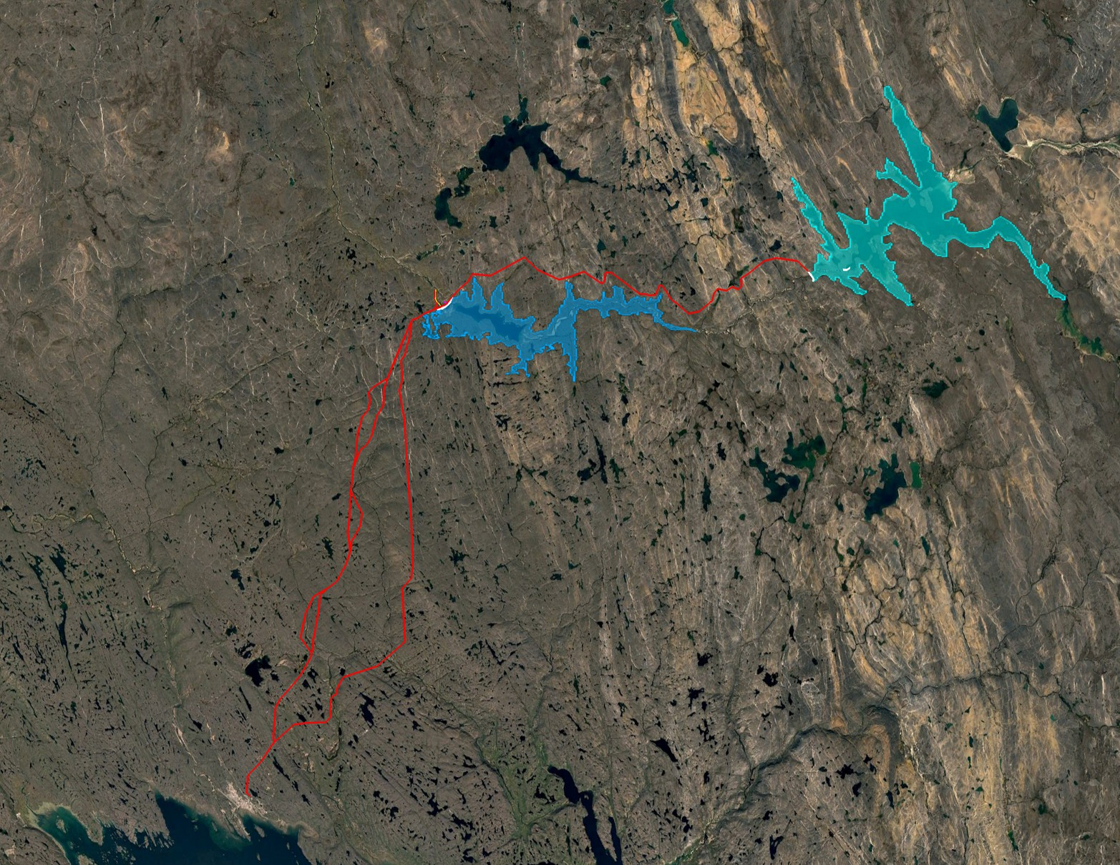


15
WHAT WE HAVE DONE

ᒫᓐᓇ ᐱᓕᕆᐊᖑᔪᖅ ᑕᖏᒃᓴᖓ
ᐃᒪᓐᓇ ᐃᓱᒪᖃᓚᐅᖅᑐᒍᑦ

CURRENT PROJECT CONCEPT

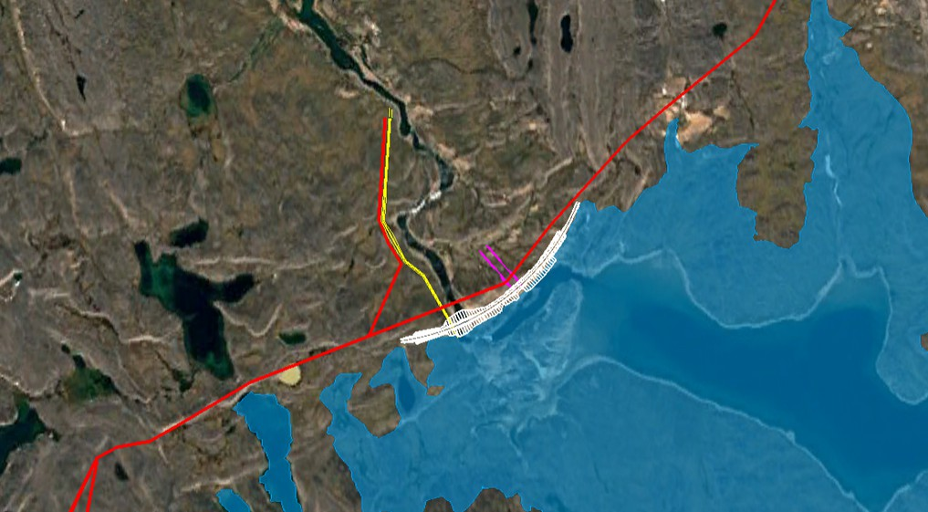
ᐊᐅᓚᐅᑎᖃᕐᕕᒃ
ᐃᒡᓗᕋᓛᖅ
Powerhouse

ᐊᖏᔪᐋᓗᒃ ᓱᓪᓗ
Penstock

ᑕᑕᓗᐊᕈᓂ ᑯᕕᔭᕆᐊᓕᒃ Spillway

ᑰᒃ ᓯᒥᒃᓯᒪᔪᖅ
Dam

ᐃᓯᕐᕕᐊᓄᑦ ᐊᖁᑎᑦ
Access Road
ᑕᒪᐃᓐᓄᑦ ᐃᒥᖃᐅᑎᖃᕐᕕᖓ
Main Reservoir

IQALUIT NUKKIKSAUTIIT PROJECT
WHAT WE HAVE DONE


ᐃᒪᕐᒥ ᐊᐅᓚᐅᑎᖃᕐᕕᖕᒧᑦ ᐊᑕᔪᑦ

WATER POWER PLANT COMPONENTS

ᑰᒃ ᓯᒥᒃᓯᒪᔪᖅ: ᓯᒥᒃᓴᖓ ᓴᓇᔭᐅᓗᓂ, ᐅᓇ ᑯᕕᕕᒃ ᑕᓯᕐᒧᑦ, ᓄᖃᖓᑎᑦᑎᓲᖅ ᐃᒪᕐᒥᒃ ᐊᒻᒪᓗ ᐃᒪᖁᑐᓯᑎᑦᑎᓲᖅ ᑕᓯᕐᒥᒃ, ᐃᒥᖃᕐᕕᐅᓕᖅᖢᓂ.

ᐊᐅᓚᐅᑎᖃᕐᕕᒃ ᐃᒡᓗᕋᓛᖅ: ᓴᓇᓯᒪᓂᖓ ᑖᓐᓇ ᐃᒡᓗ ᐸᐱᕈᓕᒃ, ᐊᐅᓚᐅᑎᓕᒃ ᐊᒻᒪᓗ ᐊᓯᖏᓐᓂᒃ ᐅᐊᔭᒨᖅᑐᑦ ᐊᑕᔪᑦ.

ᑕᑕᓗᐊᕈᓂ ᑯᕕᔭᕆᐊᓕᒃ: ᑕᐃᑲᓂ ᐃᒪᖃᓗᐊᓕᕈᓂ ᐃᒪᖃᕐᕕᖓ, ᑕᑕᓗᐊᓕᕐᓗᓂ ᓯᒥᒃᓯᓯᒪᔪᖅᑕᒪᐅᓐᓇ ᑕᑕᓗᐊᕈᓂ ᖁᕕᑎᓪᓗᒍ ᐊᑦᑕᕐᓇᓐᖏᑦᑐᒥᒃ ᐊᒻᒪᓗ ᓄᖃᖅᑎᑦᑎᕕᖃᖅᑐᖅ. ᐅᓇ ᐃᒪᖓ ᑰᓲᖅ ᑰᖕᒧᑦ.

ᐊᖏᔪᐋᓗᒃ ᓱᓪᓗ: ᐅᓇ ᓱᓪᓗᖅ ᐃᒻᒥᖅᓱᐃᔪᖅ ᐃᒥᖃᐅᑎᖃᕐᕕᖓᓂᒃ ᑕᕝᕗᖓ ᐊᐅᓚᐅᑎᖃᕐᕕᖓᓄᑦ. ᓴᐅᓯᒪᔪᓐᓇᖅᑐᖅ ᐅᕝᕙᓘᓐᓃᑦ ᖄᖓᒍᑦ ᑐᐊᐸᐅᒃ.
DAM: A barrier constructed, typically at the outlet of a lake, to hold back water and raise the water level of the lake, forming a reservoir.

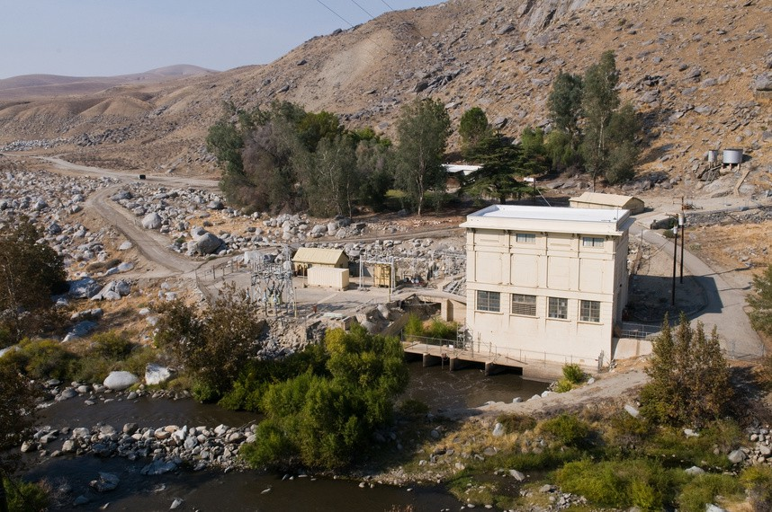
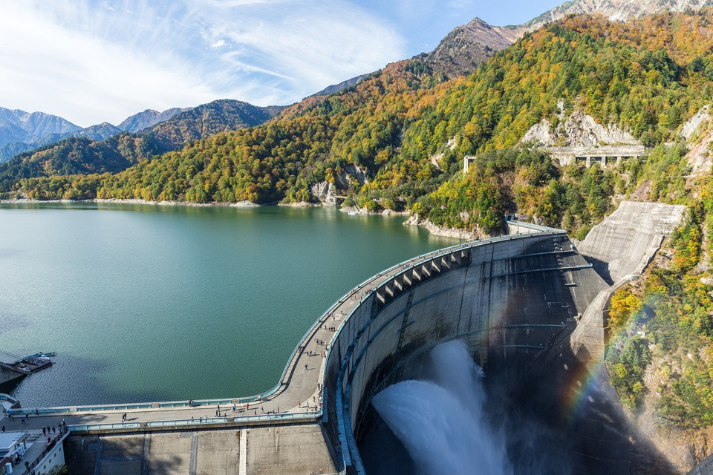
POWERHOUSE: A building that houses the turbine, generator and other electrical components.

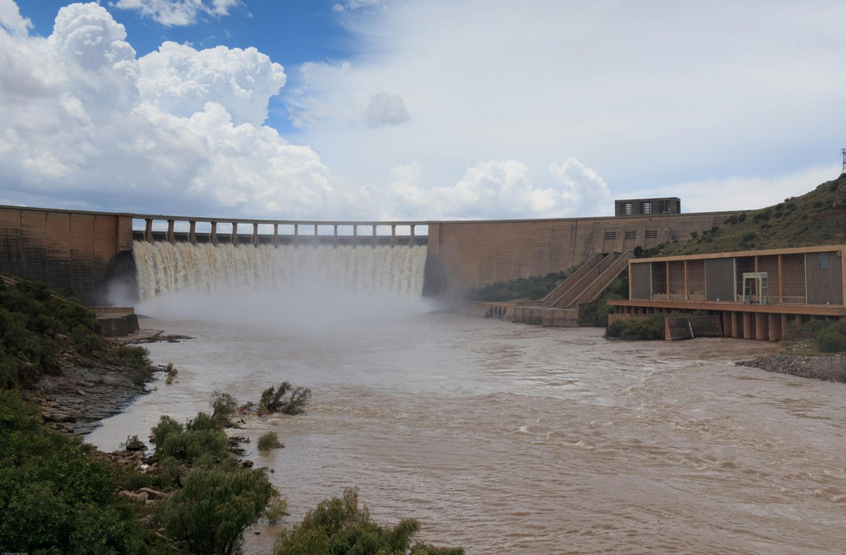
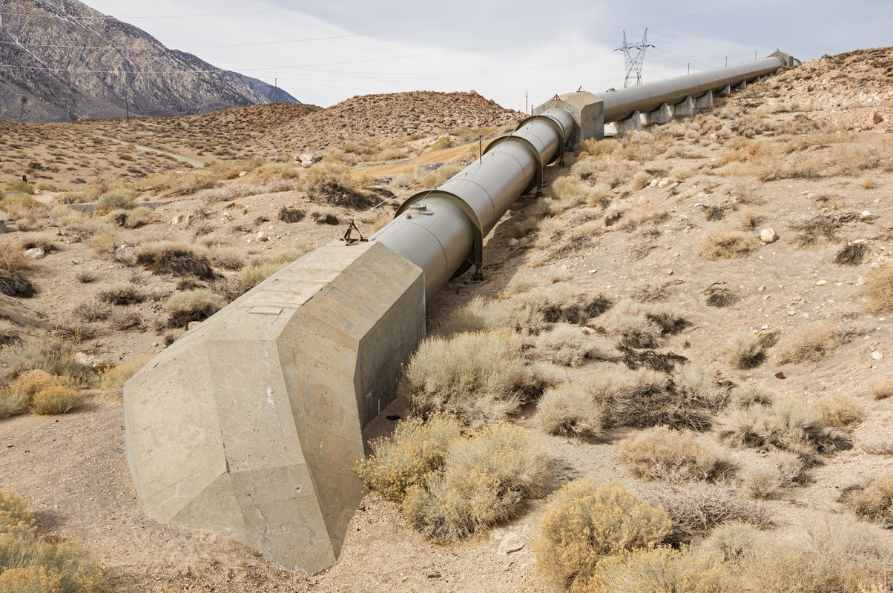
SPILLWAY: When there is too much water in the reservoir, it passes over the dam through the spillway in a safe and controlled way. This water flows into the river.

PENSTOCK: A pipe that brings water from the reservoir to the powerhouse. It can be buried or above ground.


ᓴᓇᔭᐅᔪᒥ ᖃᐅᔨᒪᓇᓐᖏᑦᑐᑦ

PROJECT UNKNOWNS

ᐱᕚᓪᓕᖅᐸᓪᓕᐊᓗᓂ ᓱᒃᑲᒃᑕᕐᓂᖓ 3 ᓴᓇᔭᐅᔪᖅ, ᑲᔪᓯᓂᐊᕋᑦᑕ ᐊᑐᕐᓗᑕ “ᑕᑯᔭᐅᔪᒪᔪᖅ, ᐊᑭᖓ ᐊᒻᒪᓗ ᖃᓄᖅ ᐊᑯᓂᐅᑎᒋᓂᐊᕐᓂᖓ” ᐱᓕᕆᐊᖑᔪᒧᑦ ᐱᒋᐊᕈᑎᒋᓗᒍ.
ᒫᓐᓇᐅᔪᖅ ᐱᓕᕆᐊᕆᔭᕗᑦ

ᑖᔅᓱᑐᓇᖅᑕᐅᖅ ᐱᒻᒪᕆᐅᑎᒋᔪᖅ ᐃᓕᔭᐅᓯᒪᓂᐊᖅᑐᖅ ᒪᑭᒪᓇᓱᐊᕈᑎᓄᑦ, ᐊᕙᑎᒧᑦ ᐊᒻᒪᓗ ᐃᓅᓯᖕᒥ ᐊᑑᑎᖃᖅᑐᓄᑦ ᓴᓇᔭᐅᓂᖓᒍᑦ. ᐱᑕᖃᖅᑐᖅ ᖃᐅᔨᒪᓇᓐᖏᑦᑐᓂᒃ ᐊᒻᒪᓗ ᑐᑭᓯᓇᓐᖏᑦᑐᓂᒃ ᐊᑐᓂ ᑖᒃᑯᓄᖓ ᐱᖓᓱᓄᑦ ᐅᑯᐊᓗ ᖃᐅᔨᒋᐊᖃᖅᑕᕗᑦ ᐊᒻᒪᓗ ᑲᔪᓯᓂᐊᕋᑦᑕ ᐋᕿᑦᑎᐊᖅᐸᓪᓕᐊᓗᒍ ᓴᓇᔭᐅᔪᖅ ᐱᔭᕇᕈᓂ ᖃᓄᐃᓕᖓᓂᒃᓴᖓᓄᑦ.
ᓄᐊᑦᑎᕗᒍᑦ ᑐᓴᒐᒃᓴᓂᒃ ᑖᒃᑯᓂᖓ ᖃᐅᔨᒪᔭᐅᓐᖏᑦᑐᓂᒃ ᑕᐃᒪᓗ ᐊᐅᓚᐅᓯᕆᔨᕗᑦ ᓴᕿᑦᑎᔪᓐᓇᕐᓂᐊᕐᒪᑕ ᐱᒋᐊᕈᑎᒃᓴᑦ ᖃᓄᖅ ᓴᓇᓯᒪᓂᐊᕐᓂᖓᓂᒃ.

ᐅᓇ ᓴᓇᓯᒪᓂᖓ ᓈᓴᐅᓯᕆᔭᕆᐊᓕᑦ ᖃᕆᓴᐅᔭᒃᑯᑦ ᐋᕿᒃᓱᕆᐊᓕᑦ ᐱᕙᓪᓕᐊᓂᖓ ᒪᓕᒃᖢᓂ ᑲᔪᓯᔪᓂᑦ ᑐᓴᒐᒃᓴᖅᑖᕆᔭᐅᕙᓪᓕᐊᔪᓂᑦ ᐅᑯᐊᓗ ᓄᐊᑕᐅᔪᑦ ᐊᑐᓂ ᐱᓕᕆᐊᖑᔪᒧᑦ ᐊᑑᑎᖃᕐᓂᖏᑦ.
As we advance with Phase 3 of the Project, we will continue to apply the “three-legged stool” approach.
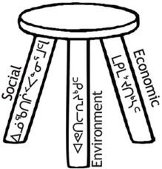

Equal importance will be placed on the economic, environmental and social values of the Project. There are unknowns and uncertainties about each of these ‘legs’ that need to be determined and will continue to shape the Project scope.
As we gather information on these unknowns our engineers will be able to develop a preliminary design.

The design will be an iterative process based on continued information that is gathered about each of the Project values.

ᐱᑕᖃᖅᑐᖅ ᐃᓚᖏᓐᓂᒃ ᐃᕐᖐᓐᓇᖅ ᖃᐅᔨᒪᓇᓐᖏᑦᑐᓂᒃ ᑖᒃᑯᐊ ᓄᓇᕗᑦ ᓄᒃᑭᒃᓴᐅᑏᑦ ᑯᐊᐳᕆᓴᓐ ᖃᐅᔨᓴᕆᐊᖃᖅᑕᖏᑦ.

ᐅᓂᒃᑳᕐᓂᐊᖅᐳᒍᑦ ᓄᓇᓕᖕᓄᑦ ᖃᐅᔨᓴᖅᑕᐅᔪᑦ ᑐᑭᓯᓇᖅᓯᑦᑎᐊᖅᐸᑕ. ᐆᒃᑑᑎᒋᓪᓗᒋᑦ ᖃᐅᔨᒪᓇᓐᖏᑦᑐᑦ ᖃᐅᔨᓴᖅᑕᐅᓂᐊᖅᑐᑦ ᐅᑯᐊ ᐃᓚᒋᔭᐅᕗᑦ:
ᐱᑕᖃᖅᐸ ᐃᑦᑕᕐᓂᑕᖃᕐᕕᖕᓂᒃ ᑐᒃᓯᕋᖅᑕᐅᔪᑦ ᐊᑐᖅᑕᐅᓂᐊᖅᑐᒥ ᐊᖁᑎᒥ ᐊᒻᒪᓗ ᖃᓂᒋᔭᖓᓂ ᓴᓇᔭᐅᔪᑉ ᐃᓂᖓᑕ?
ᖁᓛᓂ ᐊᒻᒪᓗ ᐊᑖᓂ ᖃᓄᕆᑑᕙᑦ ᑐᐊᐸᖏᑦ ᓴᓇᕕᐅᔪᖅ ᐃᓂᖓᓂ?
ᓂᕐᔪᑎᑦ ᐊᒃᑐᖅᑕᐅᓂᐊᖅᐸᑦ, ᑕᒪᒃᑯᐊᓗ ᐃᖃᓗᐃᑦ ᐊᒻᒪᓗ ᐃᖃᓗᐃᑦ ᓇᔪᖅᐸᒃᑕᖏᑦ, ᑎᖕᒥᐊᑦ, ᐊᒻᒪᓗ ᓄᓇᐅᑉ ᓂᕐᔪᑎᖏᑦ?
ᖃᓄᖅ ᑎᑭᐅᒪᑎᒋᕙᑦ ᐊᖁᑎᑦ ᐃᓂᒋᔭᐅᓲᑦ ᖃᓂᒋᔭᖓᓂ ᐃᓂᖓᑕ?
ᖃᓄᖅ ᐊᑕᕕᖃᕐᓂᐊᖅᑐᖅ ᖁᓪᓕᒃᑯᓄᑦ ᒫᓐᓇᐅᔪᖅ ᐅᐊᔭᐃᑦ ᐊᑐᖅᑕᐅᔪᓄᑦ?
ᖃᓄᖅ ᐆᒻᒪᖁᑎᖃᐅᑎᓄᑦ ᐊᑭᓕᐅᑎᒃᓴᐃᑦ ᐊᕿᒃᓯᒪᓂᐊᑦᐸᒃ, ᐅᕝᕙᓘᓐᓃᑦ ᐊᓯᖏᓐᓄᑦ ᓴᓇᕕᖃᖅᑐᓄᑦ ᐊᑭᓕᐅᑎᒃᓴᑦ, ᖁᓪᓕᒃᑯᓄᑦ ᖃᓄᖅ ᑕᐅᑦᑐᖃᕐᓂᐊᖅᐸᑦ, ᓴᓇᔭᐅᔪᖅ ᑮᓇᐅᔭᓕᐅᕈᑕᐅᔪᓐᓇᕐᓂᐊᕐᒪᑦ?
There are some immediate unknowns that NNC will begin investigating. We will report back to the community on the investigation findings.
Examples of unknowns that we are investigating include:
WHAT WE ARE CURRENTlY DOING
Are there archaeological sites along the proposed access road and nearby the Project site?
What are the above and below ground conditions at the Project site?
Will wildlife be impacted, including fish and fish habitat, birds, and land animals?
What is the extent of trail systems near the site?
How will the Project connect with Qulliq Energy Corporation’s (QEC) existing electricity grid?
Can a power purchase agreement, or another commercial agreement, with QEC be achieved to make the Project economically feasible?


ᖃᓄᐃᓕᐅᕐᓂᐊᓕᖅᐱᑕ 2025-ᒧᑦ WHAT’S NEXT FOR 2025
ᐊᐅᔭᖅ/ᐅᐱᕐᖔᖅ
2025
ᐃᖅᑲᓇᐃᔭᖅᑎᑖᕐᓗᑕ ᐃᑲᔪᖅᑎᐅᓂᐊᖅᑐᓂᒃ 2025 ᓄᓇᒥ ᐱᓕᕆᑎᑦᑎᔾᔪᑕᐅᔪᓄᑦ ᑲᑎᒪᖃᑎᒋᓗᒋ ᓄᓇᓖᑦ ᐊᒻᒪᓗ ᓄᓇᕗᒻᒥ ᐊᕙᑎᓕᕆᔨᒃᑯᑦ ᑲᑎᒪᔨᖏᑦ 2025 ᓄᓇᒥ ᐱᓕᕆᑎᑦᑎᔾᔪᑕᐅᔪᓄᑦ ᐸᕐᓇᐃᓗᑎᒃ ᐱᓂᕆᖃᑎᒋᓗᒋᑦ ᓄᓇᓕᒃ ᓴᓇᔨᑦ ᐃᒃᓗᒃᓴᖏᓐᓂᑦ
ᐃᑦᑕᕐᓂᑕᖃᕐᕕᒃᑕᖃᕐᒪᖔᑦ ᖃᐅᔨᓇᓱᒃᓗᑎᒃ ᓴᓇᔭᐅᔪᖅ ᐃᓂᖓᓂ ᐊᒻᒪᓗ ᐊᖁᑖᓂ ᐱᓕᕆᖃᑎᒋᓗᒋᑦ ᖁᓪᓕᒃᑯᑦ ᖃᓄᐃᓕᐅᕆᐊᖃᖅᑐᓄᑦ ᐊᒻᒪᓗ ᐱᔭᕐᓂᓐᖏᑦᑐᓕᕆᓗᑎᒃ ᓂᕆᐅᒋᔭᐅᔪᓄᑦ
Conduct archaeological surveys of the Project site and access road
Hire supporting roles for 2025 field programs
Engage community and NIRB on 2025 field program plans Engage community on Project worker housing
Engage QEC on logistical and technical expectations
ᒫᓐᓇᐅᔪᖅ ᐱᓕᕆᐊᕆᔭᕗᑦ


2025  ᐅᑭᐅᖅ/ᐅᐱᕐᖔᖅ WINTER/SPRING
ᑲᔪᓯᓗᓂ ᐋᕿᒋᐊᖃᑦᑕᕐᓂᖓ ᓴᓇᔭᐅᔪᑉ ᑕᖏᒃᓴᖓ ᖃᐅᔨᒍᑦᑕ ᖃᓅᑎᒋᔪᖅ ᐆᒻᒪᖁᑎᖃᐅᑎᒃᓴᖅ ᓂᕆᐅᒋᔭᐅᕙ ᓴᓇᔭᐅᔪᒥᑦ, ᐊᒻᒪᓗ ᐊᑭᖏᑦ ᓇᓚᐅᑖᖅᓯᒪᔪᑦ ᐃᖅᑲᓇᐃᔭᖅᑎᑖᕐᓗᑕ ᐃᑦᑕᕐᓂᑕᓕᕆᔨᒥᒃ ᐊᒻᒪᓗ ᐊᕙᑎᒥᒃ ᖃᐅᔨᒪᔨᒻᒪᕆᑦ ᐱᓕᕆᖃᑕᐅᑎᑦᑎᓗᑕ ᐅᑯᓂᖓ:
ᐊᐅᓪᓚᕆᐊᖅᑐᖅᑐᑦ ᐃᓂᖏᑦ ᖃᓂᒋᔭᖓᓂ ᐃᓂᖓᑕ
2024 ᓴᓇᔭᐅᔪᒥᑦ ᖃᓄᐃᓕᖓᓕᓚᐅᖅᑐᑦ ᐊᒻᒪᓗ ᓴᓇᔭᐅᔪᖅ ᖄᒃᑲᓐᓂᐊᒍᑦ ᓂᕈᐊᖅᑕᐅᓯᒪᔪᑦ
2025 ᓄᓇᒥ ᐱᓕᕆᑎᑦᑎᔾᔪᑕᐅᔪᑦ ᕿᒥᕐᕈᐊᖅᑕᐅᓗᑎᒃ ᑕᒪᐅᓐᓇ ᐃᓄᐃᑦ ᖃᐅᔨᒪᔭᑐᖃᖏᑦᑎᒍᑦ ᐊᒻᒪᓗ ᐊᐅᓪᓚᖃᑦᑕᖅᑐᑦ ᐃᓂᖃᖅᑐᑦ ᑕᒪᐅᓐᓇ ᓄᓇᓕᖕᑎᒍᑦ ᐱᔪᓐᓇᐅᑎᖃᖅᑐᓄᑦ ᐊᐅᓚᑦᓯᔨᑦ
ᐅᖃᐅᓯᕆᓗᒋᑦ ᖁᓪᓕᒃᑯᓄᑦ ᐱᒋᐊᓕᓵᖅᖢᑕ ᑐᑭᖏᑦ ᐆᒻᒪᖁᑎᖃᐅᑎᒥᒃ ᐊᑐᖅᑐᑦ ᐊᑭᒃᓴᖏᑦ, ᐅᕝᕙᓘᓐᓃᑦ ᓴᓇᕕᖃᖅᑐᑦ ᐊᑭᒃᓴᖏᑦ
Continue to revise the Project concept to determine how much electricity we can expect the Project to produce, and to determine cost estimations
Hire archaeological and environmental consultants Engage on:
Trail systems near the site
2024 Project outcomes and Project additional options
2025 field program review through IQ lens and transport routes through town with Rightsholding organizations
Engage with QEC on preliminary terms of a power purchase agreement, or other commercial agreement
20


SPRING/SUMMER
ᐅᑭᐊᒃᓵᖅ FALL
2025
ᐱᓕᕆᐊᕆᓗᒋᑦ ᓄᓇᒥ ᐃᓕᑕᐅᓇᓱᒋᐊᓕᑦ ᐅᑯᐊᓗ:
ᓄᓇᖓᓂ ᐱᔭᕐᓂᓐᖏᑦᑐᑦ ᖃᐅᔨᓴᖅᑕᐅᓗᑎᒃ ᑐᑭᓯᓇᖅᓯᑦᑎᐊᕐᓂᐊᕐᒪᑕ ᑐᐊᐸᖓ
LiDAR ᓄᓇᓐᖑᐅᕐᓗᑎᒃ ᑕᒪᒃᑭᖅᓯᒪᑦᑎᐊᖅᑐᒥᒃ ᓄᓇᐅᑉ ᖄᖓᓂᒃ ᐊᔾᔨᖑᐊᓂᒃ
ᑲᔪᓯᓗᓂ ᐃᒪᖓᑕ ᐃᖏᕐᕋᓂᖓ ᑰᖕᓂᖓ ᒥᐊᓂᕆᔭᐅᓗᓂ ᑐᑭᓯᑦᑎᐊᕐᓂᐊᕋᑦᑕ ᐃᒪᖓ ᖃᓄᕆᑑᓂᖓᓂᒃ
ᐱᓕᕆᐊᕆᓗᒋᑦ ᐊᕙᑎᑦᑎᒍᑦ ᐃᓕᑦᑎᓇᓱᖕᓂᖅ ᐅᑯᐊᓗ: ᐃᖃᓗᐃᑦ ᐊᒻᒪᓗ ᐃᖃᓗᐃᑦ ᓇᔪᕐᕕᖏᑦ ᐃᓕᑕᐅᓇᓱᒃᓗᑎᒃ ᓄᓇᒥ ᓂᕐᔪᑎᑦ ᐃᓕᑕᐅᓇᓱᒃᓗᑎᒃ (ᑖᒃᑯᐊᓗ ᑐᒃᑐᐃᑦ) ᑎᖕᒥᐊᑦ ᐊᒻᒪᓗ ᓂᕐᔪᑎᑦ ᐃᓕᑕᐅᓇᓱᒃᓗᑎᒃ
ᐱᕚᓪᓕᖅᑎᓪᓗᒋᑦ ᑕᖏᒃᓴᖏᑦ ᐱᒋᐊᓕᓵᖅᖢᑕ ᖃᓄᖅ ᓴᓇᓯᒪᓂᐊᕐᒪᖔᑦ ᐱᓯᒪᔪᑦ ᐋᕿᑦᑎᐊᒃᑲᓐᓂᕐᓗᒋᑦ ᐆᒻᒪᖁᑎᖃᐅᑎ ᓄᒃᑭᒃᓴᐅᑎᒃᓴᖏᑦ ᐊᒻᒪᓗ ᐊᑭᓕᐅᑎᒃᓴᑦ ᕿᒥᕐᕈᐊᕐᓗᒋᑦ 2025 ᓄᓇᒥ ᐱᓕᕆᑎᑦᑎᔾᔪᑕᐅᔪᑦ ᓈᓴᐅᓯᕆᓯᒪᔭᖏᑦ ᑖᒃᑯᓄᖓ ᐃᓄᐃᑦ ᖃᐅᔨᒪᔭᑐᖃᖏᓐᓄᑦ ᐱᔪᓐᓇᐅᑎᖃᖅᑐᑦ ᐊᐅᓚᑦᓯᔨᓪᓗ ᐱᓕᕆᖃᑎᒋᓗᒋᑦ ᓄᓇᓖᑦ 2025 ᓄᓇᒥ ᐱᓕᕆᑎᑦᑎᔾᔪᑕᐅᔪᑦ ᖃᓄᖅ ᐋᕿᒃᓯᒪᓕᖅᐸᑕ ᐱᓕᕆᖃᑎᒋᓗᒋᑦ ᓄᓇᓖᑦ ᓴᓇᔭᐅᔪᖅ ᐊᑎᒃᓴᖓᓂᒃ
Conduct field studies including:
Geotechnical investigation to better understand ground conditions
Advance concept to a preliminary design
Refine electricity generation and cost estimates
Review 2025 field program data through IQ lens with Rightsholding organizations Engage community on the 2025 field program outcomes Engage community on Project name
WHAT WE ARE CURRENTlY DOING
LiDAR mapping to get more accurate topographic imagery
Continued water flow monitoring to better understand water conditions
Conduct environmental studies including: Fish and fish habitat studies
Terrestrial wildlife studies (including caribou) Bird and wildlife studies


ᓇᒧᖓᐅᕕᑕ

WHERE WE ARE GOING

ᒫᓐᓇᐅᔪᖅ ᐱᓕᕆᐊᖑᔪᖅ ᑕᖏᒃᓴᖓ ᐃᓱᒪᓇᖅᑐᖅ ᐅᓇ ᓴᓇᔭᐅᔪᖅ ᓱᕈᖅᓴᐃᓐᖏᑦᑐᒥᒃ ᐆᒻᒪᖁᑎᖃᐅᑎᖃᕐᑎᑦᑎᓂᐊᖅᑐᖅ ᐃᖃᓗᖕᒥᐅᑦ ᒫᓐᓴᐅᔪᖅ ᐊᒻᒪᓗ ᓯᕗᓂᒃᓴᑦᑎᓐᓂ ᐊᒥᒐᖅᓯᓕᒑᔪᒃ. ᐃᓱᒪᔪᒍᑦ ᐅᓇ ᐊᑐᕐᓗᒍ ᐋᕿᒃᓯᒪᕕᒃᓴᖓᑕ ᑕᐅᑦᑐᒃᓴᖓ.
ᒫᓐᓇᐅᔪᖅ ᐱᓕᕆᐊᕆᔭᕗᑦ

ᖄᖓᒍᑦ ᐋᕿᒃᓯᒪᕕᒃᓴᖓᑕ ᑕᐅᑦᑐᒃᓴᖓ, ᓄᓇᕗᑦ ᓄᒃᑭᒃᓴᐅᑏᑦ ᑯᐊᐳᕆᓴᓐ ᐃᓱᒪᖃᖅᑐᑦ
ᖃᐅᔨᓴᒃᑲᓐᓂᕐᓗᑎ ᒪᕐᕉᓃᒃ ᓂᕈᐊᖅᑕᐅᓯᒪᔪᓐᓇᖅᑐᓂᒃ:

ᓂᕈᐊᖅᑕᐅᓯᒪᔪᓐᓇᖅᑐᖅ 1: ᐊᖏᓂᖅᓴᒥᒃ ᐆᒻᒪᖁᑎᖃᐅᑎᑦ ᐃᖃᓗᖕᓄᑦ ᐅᖂᓴᐅᑎᒃᓴᖏᓐᓄᑦ ᑭᓐᖒᒪᒋᓂᐊᖅᑕᖏᓐᓄᑦ. ᐅᓇ ᐃᒡᓗᖕᓂᒃ ᐊᒻᒪᓗ ᐃᒡᓗᓂᒃ ᐊᑐᖅᑎᑦᑎᖔᕆᐊᖃᖅᑐᖅ ᐅᐊᔭᒨᖅᑐᓂᒃ ᐆᒻᒪᖁᑎᖃᐅᑎᖃᕈᓯᑦ.

ᓂᕈᐊᖅᑕᐅᓯᒪᔪᓐᓇᖅᑐᖅ 2: ᓱᕈᖅᓴᐃᓐᖏᑦᑐᒥᒃ ᐆᒻᒪᖁᑎᖃᐅᑎᖃᕐᓗᑎᒃ ᓯᓚᑖᒍᑦ ᑲᒻᐸᓂᐅᔪᑦ ᐆᒻᒪᖁᑎᖃᐅᑎᒋᔭᕆᐊᖃᖅᑕᖏᓐᓂᑦ, ᓲᕐᓗ ᓯᕗᓂᒃᓴᑦᑎᓐᓂ ᐅᔭᕋᒃᓯᐅᕐᕕᒃ ᖃᓂᒋᔭᖓᓂ ᐃᖃᓗᐃᑦ.

ᐅᓇ ᓴᓇᐅᔪᖅ ᐃᑲᔪᕈᓐᓇᖅᑐᖅ ᓇᓕᐊᖕᓂᑐᐃᓐᓇᖅ ᖄᖓᒍᑦ ᓂᕈᐊᖅᑕᐅᓯᒪᔪᓐᓇᖅᑐᖅ 1 ᐅᕝᕙᓘᓐᓃ ᓂᕈᐊᖅᑕᐅᓯᒪᔪᓐᓇᖅᑐᖅ 2, ᑭᓯᐊᓂ ᑕᒪᒃᑭᕈᓐᓇᓐᖏᑦᑐᑦ ᑖᒃᑯᐊᒃ ᖄᒃᑲᓐᓂᐊᒍᑦ ᓂᕈᐊᖅᑕᐅᓯᒪᔪᓐᓇᖅᑐᑦ.
The current Project concept assumes the Project will produce clean power to meet Iqaluit’s current and future electricity demand. We consider this the base scenario.
In addition to the base scenario, NNC is considering investigating two additional options:

Additional Option 1: produce more clean power for Iqaluit's heating needs. This would require homes and buildings to switch to electric heating methods.

Additional Option 2: produce more clean power for off-site industrial electricity demand, such as a future mine near Iqaluit.
The Project may be able to support either Additional Option 1 or Additional Option 2, but not both additional options.

ᓄᓇᕗᑦ ᓄᒃᑭᒃᓴᐅᑏᑦ ᑯᐊᐳᕆᓴᓐ ᖃᐅᔨᓇᓱᑦᑎᐊᖁᕕᐅᒃ ᓂᕈᐊᖅᑕᐅᓯᒪᔪᓐᓇᖅᑐᒥᒃ 1?
ᓄᓇᕗᑦ ᓄᒃᑭᒃᓴᐅᑏᑦ ᑯᐊᐳᕆᓴᓐ ᖃᐅᔨᓇᓱᒃᑲᓐᓂᕈᓐᓇᖅᑕᖓ ᓂᕈᐊᖅᑕᐅᓯᒪᔪᓐᓇᖅᑐᒥᒃ 1 ᐃᓚᖃᖅᐳᑦ ᑭᐅᓗᒋᑦ ᐊᐱᖁᑎᑦ ᐃᒪᐃᓕᖓᔪᑦ:
ᖃᓄᖅ ᐊᖏᕐᕋᕗᑦ ᐊᒻᒪᓗ ᐃᒡᓗᑦ ᓴᖑᔪᓐᓇᕐᒪᑕ ᐅᐊᔭᒨᖅᑐᒧᑦ ᐅᖂᓴᐅᑎᖃᓕᕐᓗᑎᒃ?
ᑭᒃᑯᑦ ᐊᑭᓖᓂᐊᖅᐸᑦ ᑕᒪᑐᓱᖓ?
ᐅᑯᐊ ᐅᐊᔭᒨᖅᑐᑦ ᐅᖂᓴᐅᑎᑦ ᐊᑭᑭᓐᓂᖅᓴᐅᒐᔭᖅᐸᑦ?
ᖃᓄᖅ ᐅᓇ ᐊᒃᑐᐃᒐᔭᖅᑐᖅ ᐱᔭᕇᕈᓂ ᖃᓄᐃᓕᖓᓂᒃᓴᖓᓄᑦ, ᐊᒻᒪᓗ ᐊᑭᖓᓄᑦ ᓴᓇᔭᐅᔪᖅ?
ᐅᓇ ᐊᒃᑐᐃᒐᔭᖅᐸ ᐊᕙᑎᒥᒃ ᐊᒻᒪᓗ ᓄᓇᓕᖕᓂᒃ ᐊᔾᔨᒋᓐᖏᑕᖓᓂᒃ ᐋᕿᒃᓯᒪᕕᒃᓴᖓᑕ ᑕᐅᑦᑐᒃᓴᓂᒃ?
ᓄᓇᕗᑦ ᓄᒃᑭᒃᓴᐅᑏᑦ ᑯᐊᐳᕆᓴᓐ ᖃᐅᔨᓇᓱᑦᑎᐊᖁᕕᐅᒃ ᓂᕈᐊᖅᑕᐅᓯᒪᔪᓐᓇᖅᑐᒥᒃ 2?
ᓄᓇᕗᑦ ᓄᒃᑭᒃᓴᐅᑏᑦ ᑯᐊᐳᕆᓴᓐ ᖃᐅᔨᓇᓱᒃᑲᓐᓂᕈᓐᓇᖅᑕᖓ ᓂᕈᐊᖅᑕᐅᓯᒪᔪᓐᓇᖅᑐᒥᒃ 2 ᐃᓚᖃᖅᐳᑦ ᑭᐅᓗᒋᑦ ᐊᐱᖁᑎᑦ ᐃᒪᐃᓕᖓᔪᑦ:
ᖃᓄᖅ ᓯᕗᓂᒃᓴᑦᑎᓐᓂ ᑲᒻᐸᓂᐅᔪᑦ ᐱᔪᒪᓂᖃᖅᑎᒋᓂᐊᖅᐸᑦ?
ᖃᓄᖅ ᐅᓇ ᐊᒃᑐᐃᒐᔭᖅᑐᖅ ᐱᔭᕇᕈᓂ ᖃᓄᐃᓕᖓᓂᒃᓴᖓᓄᑦ, ᐊᒻᒪᓗ ᐊᑭᖓᓄᑦ ᓴᓇᔭᐅᔪᖅ?
ᐅᓇ ᐊᒃᑐᐃᒐᔭᖅᐸ ᐊᕙᑎᒥᒃ ᐊᒻᒪᓗ ᓄᓇᓕᖕᓂᒃ ᐊᔾᔨᒋᓐᖏᑕᖓᓂᒃ ᐋᕿᒃᓯᒪᕕᒃᓴᖓᑕ ᑕᐅᑦᑐᒃᓴᓂᒃ?

Do you want NNC to explore Additional Option 1?

NNC’s exploration of Additional Option 1 would include answering questions such as:
WHAT WE ARE CURRENTlY DOING
How would homes and buildings be converted to electric heat?
Who would pay for this?
Would electric heat be less expensive?
How would this affect the Project scope and cost?
Would this impact the environment and the community differently from the base case?

Do you want NNC to explore Additional Option 2?

NNC’s exploration of Additional Option 2 would include answering questions such as:
What future industrial demand can we expect?
How would this affect the Project scope and cost?
Would this impact the environment and the community differently from the base case?

ᓴᓇᔭᐅᔪᖅ ᖃᓄᐃᑉᐸᓪᓕᐊᓯᒪᓂᖓ PROJECT ROADMAP

ᐊᐅᓚᐅᓯᕆᔨᑦ

ENGINEERING
ᖃᕆᓴᐅᔭᒃᑯᑦ ᐃᓕᑕᐅᓇᓱᒃᑐᑦ ᐊᒻᒪᓗ ᐱᒋᐊᓕᓵᖅᖢᓂ

Early Study Work
ᐃᓕᑕᐅᓇᓱᒃᑐᑦ ᓴᓇᔭᐅᓂᖏᑦ
2022
Desktop Studies and

ᓴᓇᔭᐅᔪᑉ ᑕᖏᒃᓴᖓ ᐱᕙᓪᓕᐊᑎᑦᑎᓂᕐᒧᑦ ᐊᒻᒪᓗ ᐋᕿᒃᓱᑦᑎᐊᒃᑲᓐᓂᕆᐊᓕᖕᓄᑦ

Project Concept Development and Refinement


ᐃᓂᖃ ᖃᐅᔨᓇᓱᒃᑕᐅᑦᑎᐊᕐᓗᓂ ᐊᒻᒪᓗ ᓄᓇᒥ ᓴᓇᔭᐅᓂᖓ SITE

INVESTIGATIONS &
FIELD WORK

ᐃᒪᖓᑕ ᐃᖏᕐᕋᓂᖓ

Monitoring

ᐊᑯᓚᐃᑦᑐᒥᒃ ᐱᓕᕆᖃᑎᒋᓗᒋᑦ ᐱᔪᓐᓇᐅᑎᖃᖅᑐᑦ ᐊᒻᒪᓗ
ᐱᔭᕇᕈᓂ ᖃᓄᐃᖓᓂᒃᓴᖓ | ᐊᑭᓕᐅᑎᒃᓴᐃᑦ ᐱᓕᕆᖃᑎᒌᒍᑎᒃᓴᕗᑦ
2023
Regular Engagement with Rightsholders and

ᐱᔭᕐᓂᓐᖏᑦᑐᓕᕆᓂᖅ ᓄᓇᒥ ᓴᓇᔭᐅᔪᓄᑦ, ᐃᑦᑕᕐᓂᑕᖃᕐᕕᑦ ᖃᐅᔨᓴᖅᑕᐅᓗᑎᒃ, ᐊᕙᑎᖓ ᓄᓇᒥ

Technical Fieldwork, Archaeological Surveys, Environmental Field Work Year 1
ᒥᐊᓂᕆᔭᐅᓗᓂ | ᓴᓇᔭᐅᓗᓂ ᐊᕐᕌᒍ 1-ᖓᓂ
2024
Water Flow

ᐊᕙᑎᑦᑎᓂᒃ ᐊᒃᑐᐃᒐᔭᖅᑐᑦ ᖃᐅᔨᓇᓱᒃᑕᐅᑦᑎᐊᕐᓗᑎᒃ


ᐱᖁᔭᕋᓛᑦ ᐊᒻᒪᓗ ᓄᓇᓕᖕᓂᑦ ᐊᖏᖅᑕᐅᔭᕆᐊᓕᑦ

REGULATORY & COMMUNITY APPROVALS


ᓴᓇᔭᐅᓂᖓ

CONSTRUCTION
ᑎᒍᒥᐊᖅᑎᑦ, ᐊᕙᑎᑦᑎᓂᒃ ᐊᒃᑐᐃᔭᑦᑐᓂᒃ ᖃᐅᔨᓇᓱᑦᑎᐊᖅᑐᑦ

Stakeholders, Environmental Impact Assessment (EIA) Scoping
ᐱᕙᓪᓕᐊᑎᑦᑎᓂᖅ, ᐆᒻᒪᖁᑎᖃᐅᑎᓄᑦ

EIA Development, Power Purchase and Partnership Agreements

ᓴᓇᓯᒪᓂᕆᓂᐊᖅᑕᖓ,
ᐊᑭᒃᓴᖏᑦ ᐊᒻᒪᓗ ᐱᔭᕐᓂᓐᖏᑦᑐᓕᕆᓂᖅ
Preliminary Design, Costing and Logistics
Detailed Design Engineering
ᐊᕙᑎᒥ ᓄᓇᖓᓂᒃ ᓴᓇᓗᑎᒃ
ᐊᕐᕌᒍ 2-ᖓᓂ
ᑲᔪᓯᓗᓂ ᐃᒪᖓᑕ
ᐃᖏᕐᕋᓂᖓ ᒥᐊᓂᕆᔭᐅᓗᓂ
2030
Environmental Field Work Year 2
Continued Water Flow Monitoring
ᐊᕙᑎᑦᑎᓐᓂᒃ ᐊᒃᑐᐃᒐᔭᖅᑐᑦ
ᖃᐅᔨᓇᓱᒃᑕᐅᑦᑎᐊᖅᓯᒪᓂᖓᑕ ᐅᓂᒃᑳᖓ ᑐᓂᔭᐅᓗᓂ
EIA Report Submission
ᐃᓱᒪᓕᐅᕆᕕᖃᖅᑐᓯ
ᐱᖁᔭᕋᓛᑦ ᐊᖏᖅᑕᐅᓗᑎᒃ, ᑭᖑᓪᓕᖅᐹᖅᓯᐅᑎ ᓴᓇᔭᐅᔪᒧᑦ ᐊᖏᖅᑕᐅᓗᓂ, ᑭᖑᓪᓕᖅᐹᖅᓯᐅᑎ ᖃᑭᔾᔪᑎᒃᓴᓄᑦ ᐃᓱᒪᓂᐊᒃᓴᐃᑦ

DECISION WINDOW
Regulatory Approval, Final Project Approval, Final Investment Decision
2029
2028
2029
ᓇᓗᓇᕈᓐᓃᑦᑎᐊᖅᓯᒪᓗᓂ ᓴᓇᓯᒪᓂᐊᕐᓂᖓ ᐊᐅᓚᐅᓯᕆᓂᖓᑕ

ᐱᒋᐊᓕᓵᖅᖢᑎᒃ
ᐊᒥᓲᖕᒪᑕ ᖃᐅᔨᒪᓇᓐᖏᑦᑐᑦ ᓴᓇᔭᐅᔪᑉ ᐃᓂᓕᐅᖅᓯᒪᓂᖏᑦ, ᐊᒻᒪᓗ ᐊᓯᖑᕋᔭᖅᑐᒃᓴᐅᔪᑦ ᑕᐃᒪᓗ ᓴᓇᔭᐅᔪᖅ ᐱᕙᓪᓕᐊᑎᓪᓗᒍ. ᓇᓪᓕᐊᖕᓄᑦ ᓴᓇᔭᐅᔪᒥ ᖃᓄᐃᓕᐅᕈᑕᐅᔪᑦ, ᓲᕐᓗ ᐱᖁᔭᕋᓛᑦ ᐊᖏᖅᑕᐅᓗᑎᒃ, ᖃᐅᔨᒪᓇᓐᖏᑦᑐᑦ ᖃᖓᑰᖓᓂᐊᖅᑐᑦ ᐅᑯᐊᓗ ᐅᖓᕙᕆᐊᖅᑎᑦᑎᔪᓐᓇᖅᑐᑦ ᓴᓇᔭᐅᔪᑉ ᐃᓂᓕᐅᖅᓯᒪᔭᖏᓐᓄᑦ.
There are many unknowns about the Project schedule, and it will likely change as the Project progresses. Certain activities, such as regulatory approvals, have unknown timeframes which could extend the Project schedule.

ᓂᐅᕐᕈᓯᕆᓂᕐᒧᑦ

Commissioning
ᓴᓇᔭᐅᓂᖓ | ᐊᑭᓕᖅᑕᐅᒍᑏᑦC
2030 | 2033
Construction

ᐃᒫᒍᑦ ᐆᒻᒪᖁᑎᖃᐅᑎᒧᑦ: ᐊᐱᖁᑕᐅᒐᔪᓲᑦ

WATER POWER: FAQs


ᖃᖓ ᐃᒫᓂᑦ ᐆᒻᒪᖁᑎᖃᐅᑎᖃᕐᕕᒃ ᓴᓇᔭᐅᒐᔭᖅᐸ? Why should a water power plant be

built?

ᓄᓇᕗᑦ ᓄᒃᑭᒃᓴᐅᑏᑦ ᑯᐊᐳᕆᓴᒃᑯᑦ ᑕᒪᐃᓐᓄᑦ
ᑐᑭᑖᕈᑎᒋᓇᓱᐊᖅᑐᖅ ᐱᓕᕆᐊᖑᔪᖅ ᐊᑐᕈᓐᓃᕐᓂᐊᕐᒪᑕ ᑏᓱᒥᒃ - ᐊᐅᓚᐅᑎᓕᑦ ᐊᑐᖅᓯᖔᓕᕐᓗᑎᒃ ᐆᒻᒪᖁᑎᖃᐅᑎᑦ ᓱᕈᖅᓴᐃᓐᖏᑦᑐᓂᒃ, ᓄᓇᒥᐅᑕᑎᒍᑦ ᐆᒪᖁᑎᖃᐅᑎᒃᓴᓄᑦ. ᐊᔪᕐᓇᖏᑦᑐᖅᑕᐅᖅ ᐃᒪ ᐆᒻᒪᖁᑎᖃᐅᑎᖃᕐᕕᒋᓗᒍ ᐅᖅᓱᕐᒥᒃ ᐃᑭᐊᒃᓴᐅᑎᖃᕐᓂᐊᓐᖏᓐᓇᑦᓯ ᐅᖂᓴᕐᓗᒋᑦ ᐊᖏᕐᕋᓯ ᐊᒻᒪᓗ ᐃᒡᓗᐃᑦ.
ᓄᓇᓕᖕᓂᑦ-ᐊᐅᓚᑕᐅᓗᓂ ᐃᒫᒍᑦ ᐆᒻᒪᖁᑎᖃᐅᑎᖓ ᓇᖕᒥᓂᖅ ᐊᐅᓚᑦᑐᓐᓇᖅᑕᑎᒃ, ᐆᒻᒪᖁᑎᒃ ᓱᕋᒍᓐᓇᓐᖏᓪᓗᑎᒃ, ᐊᒻᒪᓗ ᑮᓇᐅᔭᑦ ᐱᓯᒪᔭᐅᓗᓂ ᐃᖃᓗᖕᒥᐅᓂᑦ ᐊᑭᓕᐅᑎᑦ ᐆᒻᒪᖁᑎᖃᖅᑐᓄᑦ ᓄᓇᕗᒻᒥ, ᐊᑭᓕᖅᓱᐃᑐᐃᓐᓇᕐᓂᐊᓐᖏᒻᒪᑕ ᖃᓪᓗᓈᑦ ᓄᓇᖓᓄᑦ ᑏᓱᕐᓂᒃ ᐱᑎᑦᑎᓲᓄᑦ. ᓄᖑᑎᑦᑎᔪᓐᓇᕐᒥᔪᑦ ᓯᓚᑦᑎᓐᓂ ᓱᕈᕐᓇᖅᑐᓂᒃ ᐊᒻᒪᓗ ᑎᐱᖓᓂᒃ ᑏᓱ ᑕᒪᓐᓇ ᖁᓛᓃᖏᓐᓇᖅᑐᖅ ᐃᖃᓗᖕᒥᐅᑦ. ᐊᑐᖔᓕᕈᑦᑕ ᐃᒪᕐᒥᑦ ᐆᒻᒪᖁᑎᖃᐅᑎᖃᕐᓗᑕ ᑐᑭᖃᑦᑎᐊᑐᐃᓐᓇᖅᑐᖅ ᐊᑦᑎᒃᓯᑎᑦᑎᔪᓐᓇᖅᑐᒍᑦ ᐸᐅᕿᔪᓂᒃ ᓄᖃᖅᑎᑕᐅᓇᓱᖕᒪᑦᑕᐅᖅ ᑲᓇᑕᐅᑉ ᓯᓚᐅᑉ ᖃᓄᐃᓐᓂᖓ ᐊᓯᖑᖁᓪᓗᒍ ᑐᕌᖅᑕᐅᔪᖅ.
NNC’s main objective of the Project is to replace diesel-generated electricity with clean, renewable electricity. It is also possible that water power could replace oil furnaces used for heating homes and buildings.
Locally-generated water power offers energy sovereignty, energy security, and it keeps money Iqalungmiut spend on electricity in Nunavut, rather than flowing out to southern diesel suppliers. It would also get rid of the air pollution and smell of diesel exhaust that hangs over Iqaluit. Switching to water power is a meaningful way of reducing our carbon footprint in line with Canada’s climate change goals.

ᐅᓇ ᐃᒫᒍᑦ ᐆᒻᒪᖁᑎᖃᐅᑎᖃᕐᕕᒃ ᐊᒃᑐᐃᓂᐊᖅᐸ ᐊᑐᖅᑕᐅᖃᑦᑕᖅᑐᓂᒃ ᓄᓇᓂᒃ?
ᐅᓇ ᑰᒑᓗᒃ ᐃᓂᖓ ᓂᕈᐊᖑᓯᒪᔪᖅ ᐱᔾᔪᑎᒋᓪᓗᒍ ᐅᖃᖅᓯᒪᖕᒪᑕ ᓄᓇᖓ ᐊᑐᖅᑕᐅᓐᖏᑦᑐᖅ, ᐃᓄᐃᑦ ᐊᖁᓵᑐᐃᓐᓇᓲᑦ ᓇᒧᖓᐅᓕᕌᖓᒥᒃ ᐊᓯᖏᓐᓄᑦ.

Will the water power plant affect traditional land-use?
The Kuugaluk site was chosen because it has zero reported land-use activities. Inuit reported they just pass by this area on their way to other places.

ᐅᓇ ᐃᒫᒍᑦ ᐆᒻᒪᖁᑎᖃᐅᑎ ᐊᑭᒡᓕᒋᐊᖅᑎᑦᑎᔪᓐᓇᖅᐸ ᐆᒻᒪᖁᑎᖃᐅᑎᓄᑦ ᐊᑭᓕᐅᑎᒋᓲᓄᑦ?
ᓄᓇᕗᑦ ᓄᒃᑭᒃᓴᐅᑏᑦ ᑯᐊᐳᕆᓴᒃᑯᑦ ᐊᐅᓚᑦᑎᓐᖏᑦᑐᑦ ᐆᒻᒪᖁᑎᖃᐅᑎᑦ ᐊᑭᖏᓂᒃ ᓄᓇᕗᒻᒥ. ᐅᑯᐊ ᖃᐅᔨᑎᑦᑎᔾᔪᑎᒋᔭᕗᑦ ᓇᓗᓇᕈᓐᓃᑦᑎᐊᕐᓗᒍ ᑕᒪᓐᓇ ᐃᒪᕐᒥ ᐆᒻᒪᖁᑎᖃᐅᑎᑦ ᐊᑭᑭᓐᓂᖅᓴᐅᖕᒪᑕ ᑏᓱᒥᑦ, ᑕᐃᒪᓗ ᐊᔪᕐᓇᖏᑦᑐᖅ ᐅᓇ ᐱᓕᕆᐊᖑᔪᖅ ᐊᑦᑎᒃᓯᓯᒪᑎᑦᑎᓗᓂ ᐆᒻᒪᖁᑎᖃᐅᑎᓄᑦ ᐊᑭᓕᐅᑎᒋᖃᑦᑕᖅᑕᑦᓯᓐᓂᒃ ᓄᓇᕗᒻᒥ. ᖃᓄᑐᐃᓐᓇᖅ ᐃᓱᒪᓕᐅᕆᓲᑦ ᐱᔾᔪᑎᒋᓪᓗᒍ ᐊᑭᒡᓕᒋᐊᖅᑎᑦᑎᓂᖅ ᐆᒻᒪᖁᑎᑦᓯᓐᓂᒃ ᐋᕿᒃᓱᖅᑕᐅᓲᖑᓪᓗᑎᒃ ᖁᓪᓕ ᐆᒻᒪᖁᑎᓕᕆᔨᖏᑦᑕ ᑎᒥᖁᑖ, ᐃᒡᓗᒧᑦ ᐊᑕᔪᓄᑦ ᐊᑭᓕᐅᑎᑦ ᕿᒥᕐᕈᐊᖅᑕᐅᓲᑦ ᑲᒥᓴᒃᑯᓂᑦ, ᐊᒻᒪᓗ ᒪᓕᒐᓕᐅᕐᕕᒃᔪᐊᖓᑦ ᓄᓇᕗᑦ ᒐᕙᒪᒃᑯᓂᑦ.

Will water power lower electricity costs?

NNC does not control electricity rates in Nunavut. Our modelling indicates that water power is cheaper than diesel power, so there is a potential this project could lower electricity bills for the Territory. Any decisions about lowering electricity rates for customers are made by Qulliq Energy Corporation, the Utility Rates Review Commission, and the Legislative Assembly of the Government of Nunavut.

ᖃᓅᑎᒋᔪᖅ ᑏᓱ ᐃᓇᖏᖅᑕᐅᓂᐊᖅᐸ ᐃᒪᕐᒥ ᐆᒻᒪᖁᑎᖃᑎᖃᓕᕈᑦᑕ ?
ᐅᓇ ᐃᓱᒪᓕᐊᖑᓂᐊᖅᑐᖅ ᓄᓇᓕᖕᓂᒃ ᑲᑎᒪᖃᑎᖃᕐᓗᑕ, ᑮᓇᐅᔭᒃᓴᖅ, ᐊᒻᒪᓗ ᓄᓇᖓᓂ ᑭᓱᖃᕐᒪᖔᑕ ᖃᐅᔨᓴᕐᓗᑕ ᑕᐃᑲᓂ ᑰᒑᓗᒃ ᐃᓂᖓᓂ ᑐᑭᓯᑦᑎᐊᕐᓂᐊᕋᑦᑕ ᖃᓅᑎᒋᔪᒥᒃ ᐃᒥᖅᑕᐅᑎᖃᕈᓐᓇᕐᒪᖔᑦᑕ. ᑕᐃᑲᓂ ᐊᑦᑎᓛᖓ, ᐅᓇ ᓴᓇᔭᐅᔪᖅ ᐊᑐᕈᓐᓃᑦᑎᐊᒻᒪᕆᒃᑎᑦᑎᓂᐊᖅᑐᖅ ᑏᓱᒥᒃ (ᐊᒻᒪᓗ ᐃᓯᐊᕿᖃᑦᑕᕈᓐᓃᕐᓗᑎᒃ) ᐊᑐᖅᑕᐅᓕᕐᓗᑎᒃ ᐆᒻᒪᖁᑎᖃᐅᑎᒋᓗᒋᑦ ᐃᖃᓗᖕᓂ, ᐅᑯᐊᓗ ᖃᓂᒋᔮᓂ 19% ᓄᓇᕗᑦ ᑲᑎᓪᖢᒍ ᐆᒻᒪᖁᑎᖃᐅᑎᒋᔭᕆᐊᖃᖅᑕᖏᑦ. ᑏᓱᒨᖅᑐᖅ ᐃᑯᒪᓕᕆᔨᒃᑯᑦ ᓱᓕ ᐋᕿᒃᓯᒪᓂᐊᖅᑐᑦ ᑐᐊᕕᕐᓇᖅᑐᖃᓕᕈᓂ ᐊᑐᖅᑕᐅᔪᒫᕐᓗᓂ, ᐊᒻᒪᓗ ᐆᒻᒪᖁᑎᖃᐅᑎᖃᕐᑎᑦᑎᓗᓂ ᐃᖃᓗᖕᓂ ᐃᒫᒍᑦ ᑕᐃᒪᓗ ᐃᑯᒪᓕᕆᔨᒃᑯᑦ ᐊᔪᓕᖅᓯᒪᑎᓪᓗᒍ ᓴᓇᔭᐅᑎᓪᓗᒍ.

How much diesel power will be replaced by water power?
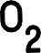
This will be determined through community engagement, funding, and geotechnical field research at the Kuugaluk site to better understand the capacity of the reservoir. At minimum, the project will eliminate diesel (and its emissions) used for generating electricity in Iqaluit, which is almost 19% of Nunavut’s total electrical demand. The diesel power plant will remain in place in case of emergency, and also to provide electricity to Iqaluit when the water power plant is down for maintenance.

ᖃᖓ ᐃᒫᒍᑦ ᐆᒻᒪᖁᑎᖃᐅᑎᒃᓴᖅ ᐃᖏᕐᕋᓯᑎᑕᐅᔪᒫᖅᐸ?
ᖃᓂᓛᖅ ᓂᕆᐅᓇᖅᑐᖅ ᐆᒻᒪᖁᑎᖃᐅᑎᖃᕐᕕᒃᓴᖅ ᐊᐅᓚᔾᔭᒍᒫᖅᑐᖅ 2033. ᑕᐃᒪᓗ ᓱᓕ ᐊᒥᓲᖕᒪᑕ ᐃᓕᓐᓇᓱᒋᐊᖃᖅᑕᕗᑦ, ᐱᖁᔭᐃᑦ ᐱᓕᕆᐊᖑᒋᐊᓕᑦ ᓅᑉᐸᓪᓕᐊᑎᑦᑎᓂᖅᑐᑦ ᑕᒪᐅᓐᓇ, ᐊᒻᒪᓗ ᑮᓇᐅᔭᓂᒃ ᐊᑐᖅᑎᑕᐅᓂᖅ ᑮᓇᐅᔭᒃᑯᕕᖕᓂᑦ ᐋᕿᒋᐊᓕᒃ ᓱᓕ. ᑕᐃᒪᓐᓇᐅᒐᔪᒃᑐᑦ ᐊᑯᓂᐅᓂᖓ ᓄᑖᒥᒃ ᐃᒫᒍᑦ ᐆᒻᒪᖁᑎᖃᐅᑎᓕᖅᑐᑦ ᑲᓇᑕᒥ.

When will the water power plant be operational?

The earliest we could expect the plant to be operational is 2033. There are still many studies needed, regulatory processes to move through, and financing is yet to be secured. This is a very typical timeline for a new water power project in Canada.

ᖃᓄᖅ ᐊᑯᓂᐅᑎᒋᔪᖅ ᐃᒫᒍᑦ ᐆᒻᒪᖁᑎᖃᐅᑎᖃᕐᕕᒃ ᐃᖏᕐᕋᓇᔭᖅᐸ?
ᓴᓇᔭᐅᑦᑎᐊᖃᑦᑕᕈᓂ, ᐃᒫᓂ ᐆᒻᒪᖁᑎᖃᐅᑎᖃᕐᕕᒃ ᐊᑦᑎᓛᖅ ᐃᖏᕐᕋᑎᑕᐅᔪᓐᓇᖅᑐᖅ ᐃᖏᕐᕋᑦᑎᐊᖏᓐᓇᕐᓗᓂ
100 ᐊᕐᕌᒍᓄᑦ.

How long will the water power plant operate?

With proper maintenance, the water power plant will have a minimum useful life of 100 years.

ᖃᓅᓇᔭᖅᐸᓕ ᑕᓯᖅ ᐊᒻᒪᓗ ᑰᒃ ᖁᐊᖅᐸᑦ?
ᒪᓕᒃᖢᒋᑦ ᒫᓐᓇ ᑐᓴᐅᒪᔭᕗᑦ, ᐃᒪᖓ ᖁᐊᓲᖑᓐᖏᑦᑐᖅ ᑕᒪᕐᒥᒃ ᑕᓯᖅ ᐊᒻᒪᓗ ᑰᒃ, ᑕᐃᒪᓗ ᐃᒪᖓ ᐃᖏᕐᕋᐃᓐᓇᓲᑦ ᐅᑭᐅᒃᑯᑦ. ᐃᒪᖓᑕ ᑰᖕᓂᖓ ᖃᐅᔨᓴᖅᓯᒪᔪᖅ ᖃᐅᔨᓴᖅᑕᒥᖕᓂ ᓄᐊᑦᑎᓂᐊᖅᑐᑦ ᐃᓂᖓᓂ ᓴᓇᔭᐅᓚᐅᖅᑎᓪᓗᒍ ᐃᓂᒃᓴᖓ ᒫᓐᓇᐅᔪᖅ, ᑐᑭᓯᑎᑦᑎᓂᐊᕐᒪᑦ ᐅᕙᑦᑎᓐᓂᒃ ᐊᕐᕌᒍᓕᒫᖅ ᖃᓅᑎᒋᔪᖅ ᐃᖏᕐᕋᑎᒋᖕᒪᖔᑦ. ᑖᒃᑯᐊ ᐊᐅᓚᐅᓯᕆᔩᑦ ᓴᓇᓂᐊᖅᑐᑦ ᐃᒫᓂ ᐆᒻᒪᖁᑎᖃᐅᑎᒥᒃ ᖁᐊᕐᓇᖅᓯᔭᕌᖓᑦ ᐊᒻᒪᓗ ᐊᕐᕌᒍᒥ ᓯᓚᖓ ᐊᓯᖑᕌᖓᑦ ᐊᒻᒪᓗ ᐃᖏᕐᕋᐃᓐᓇᕈᓐᓇᕐᓂᐊᕐᒪᑦ ᐃᒪᖓ ᐃᒥᖅᑕᕐᕕᖕᒥᑦ ᑕᐃᑯᖓ ᐃᒫᓂ ᐆᒻᒪᖁᑎᖃᐅᑎᖃᕐᕕᖓᓄᑦ.

What happens when the lake and river freeze?
Based on our current information, the water does not freeze to the full depth of the lake and river, so water still flows in the winter. We have water flow data collection stations installed at the site right now, to give us a year-round set of flow data. The engineering team will design the water power plant for
freezing conditions and seasonal changes and will ensure water will always flow from the reservoir to the water power plant.

ᐅᓇ ᐃᒫᒍᑦ ᐆᒻᒪᖁᑎᖃᐅᑎᖃᕐᕕᒃ ᐊᒃᑐᐃᓂᐊᖅᐸ ᐃᖃᓗᖕᓂᒃ ᐊᒻᒪᓗ ᐃᖃᓗᐃᑦ ᓇᔪᖅᐸᒃᑕᖏᓐᓂᒃ?
ᓴᕿᑦᑎᓂᐊᖅᑐᒍᑦ ᐃᒥᖅᑕᕐᕕᒃ ᐅᕝᕙᓘᓐᓃᑦ ᐊᓯᖑᖅᑎᓪᓗᒍ ᑰᒃ ᑰᒍᓯᖓ ᐃᒻᒪᖄ ᐊᒃᑐᐃᓂᐊᖅᑐᖅ ᐃᖃᓗᖕᓂ ᐊᒻᒪᓗ ᐃᖃᓗᐃᑦ ᓇᔪᖅᐸᒃᑕᖏᓐᓂᒃ. ᑕᐃᒪᓐᓇᐅᒍᓂ ᖃᓄᑐᐃᓐᓇᖅ ᐱᐅᓐᖏᑦᑐᒥᒃ ᐊᒃᑐᐃᓂᒃᓴᖓ ᖃᐅᔨᒪᓇᓐᖏᑦᑐᖅ, ᓴᓇᔪᓐᓇᖅᑐᒍᑦ ᓴᐳᒻᒥᔾᔪᑎᒃᓴᓂᒃ ᐃᖃᓗᖕᓄᑦ ᐅᑯᐊᓗ ᒪᔪᖃᑦᑕᕈᓐᓇᕐᓂᐊᕐᒪᑕ ᑰᒃᑯᑦ, ᐱᓗᐊᖅᑐᒥᒃ ᓱᕙᐃᔭᓕᕌᖓᑕ ᐊᒻᒪᓗ ᓂᕿᒃᓴᖏᓐᓄᑦ. ᑕᐃᑲᓂ ᐃᓄᒃᔪᐊᖅ ᐃᒫᒍᑦ ᐆᒻᒪᖁᑎᖃᐅᑎᖓ ᓄᓇᕕᒻᒥ, ᐆᒃᑑᑎᒋᓪᓗᒍ, ᐱᐅᔪᒥᒃ ᐃᖃᓗᖕᓄᑦ ᐋᕿᒃᓯᓯᒪᔪᑦ ᓄᑖᑦ ᐊᒻᒪᓗ ᐊᖏᓂᖅᓴᐃᑦ ᓱᕙᐃᔭᕐᕕᑦ ᓴᓇᔭᐅᓯᒪᕗᑦ.
ᐃᖃᓗᖕᓄᑦ ᐃᒫᓂ ᐆᒻᒪᖁᑎᖃᐅᑎᖃᕐᕕᒃ, ᐃᓚᖓ ᐃᒪᖓ ᓴᖑᑎᑦᑐᓐᓇᖅᑐᖅ ᐆᒻᒪᖁᑎᖃᐅᑎᒃᓴᒧᑦ ᑕᐃᒪᓗ ᐃᖃᓗᐃᑦ ᒪᔪᖃᑦᑕᕈᓐᓇᕐᓂᐊᕐᒪᑕ ᑰᓪᓚᕆᐊᒍᑦ ᑖᔅᓱᒪᖓᑦ ᐃᒥᑕᕐᕕᖕᒥᑦ.

ᓄᓇᕗᑦ ᓄᒃᑭᒃᓴᐅᑏᑦ ᑯᐊᐳᕆᓴᒃᑯᑦ ᖃᐅᔨᓇᓱᑦᑎᐊᕐᓂᐊᖅᑐᑦ ᓇᓗᓇᐃᑦᑎᐊᖅᓯᒪᓗᒋᑦ ᐊᒃᑐᐃᒐᔭᖅᑐᑦ ᐃᖃᓗᖕᓄᑦ ᐊᒻᒪᓗ ᐃᖃᓗᐃᑦ ᓇᔪᖅᐸᒃᑕᖏᓐᓄᑦ ᐊᒻᒪᓗ ᑕᒪᓐᓇ ᑐᓴᒐᒃᓴᖅ ᑐᓴᕐᑎᑦᑎᔾᔪᑕᐅᓗᓂ ᑭᒃᑯᓕᒫᓄᑦ. ᓄᓇᒥᒃ ᖃᐅᔨᓴᖅᑐᑦ ᐋᕿᒃᓯᒪᕗᖅ ᐱᒋᐊᕈᒫᖅᖢᑎᒃ ᐊᐅᔭᖓᓂ 2025.

Will the water power plant affect fish and fish habitat?

Creating a reservoir or changing river systems has the potential to have an impact on fish and fish habitat. In the case that any potential negative impacts are foreseen, there are ways to build in protections for fish that make sure they have safe ways to navigate the river system, especially for spawning and feeding. In the Inukjuak Hydro Power Project in Nunavik, for example, there was actually a positive impact of new and larger spawning beds created.
For the Iqaluit water power plant, only some of the water will be diverted for power generation so fish can still enter the natural river from the reservoir.
NNC will assess in detail the potential impacts on fish and fish habitat and this information will be shared with the public. Field studies are set to begin during the summer of 2025.



ᐅᖃᓪᓚᖃᑎᒌᒃᑕ ᐃᒪᕐᒥᑦ ᐆᒻᒪᖁᑎᖃᐅᑎᖃᕐᓂᖅ

LET’S TALK WATER POWER

ᐅᓇ ᓴᓇᔭᕗᑦ ᐋᕿᒃᑕᐅᓯᒪᔪᖅ ᐃᓕᑦᓯ ᑭᐅᓯᔾᔪᑎᖏᑦᑎᒍᑦ. ᐊᑏ ᐱᔭᕇᕐᓗᒍ ᐊᑕᔪᑦ ᐊᐱᖁᑎᑦ ᖃᐅᔨᓴᕈᑎᕗᑦ ᓂᐲᑦ ᑐᓴᖅᑕᐅᓂᐊᕐᒪᑦ.

Our Project is shaped by your feedback. Please complete the enclosed survey to make your voice heard.

ᐊᐱᕆᔪᒪᒍᕕᑦ ᖄᖓᒍᑦ ᐊᐱᖁᑎᒃᓴᕐᓂᒃ, ᓂᐲᑦ ᑐᓴᖅᑕᐅᑎᓪᓗᒍ ᐃᓱᒫᓘᑎᒋᔭᕐᓂᒃ, ᐊᒻᒪᓗ ᑐᓂᓯᓗᑎᑦ ᐃᓱᒪᒋᔭᕐᓂᒃ ᑕᒪᑐᒧᖓ ᐃᖃᓗᖕᓂ ᐆᒻᒪᖁᑎᖃᐅᑎᒃᓴᖅ ᓯᕗᓂᒃᓴᑦᑎᓐᓂ ᐅᓇ ᒪᑐᐃᕐᓗᒍ:
To ask questions, voice your concerns, and provide your thoughts on Iqaluit’s energy future go to:
www.nunavutcleanenergy.ca

30

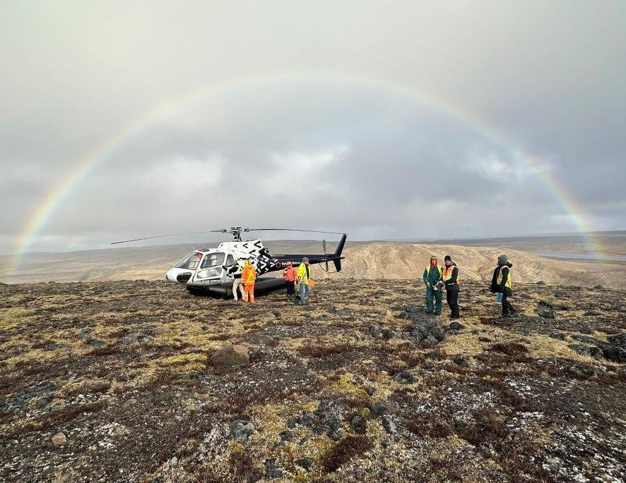
IQALUIT NUKKIKSAUTIIT PROJECT

31



WWW.NUNAVUTCLEANENERGY.CA NNC@QCORP.CA (867) 979-8400

