Community Consultation Correspondence (Panniqtuuq):

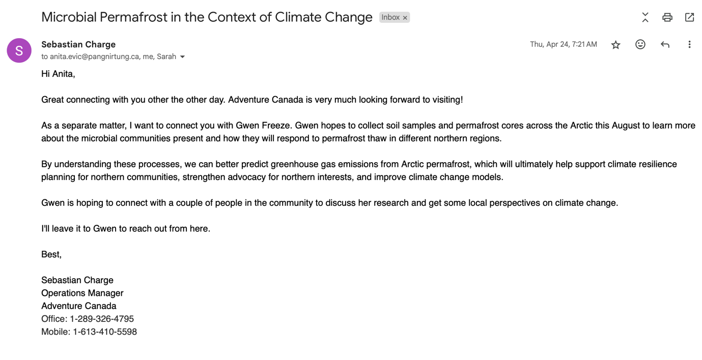
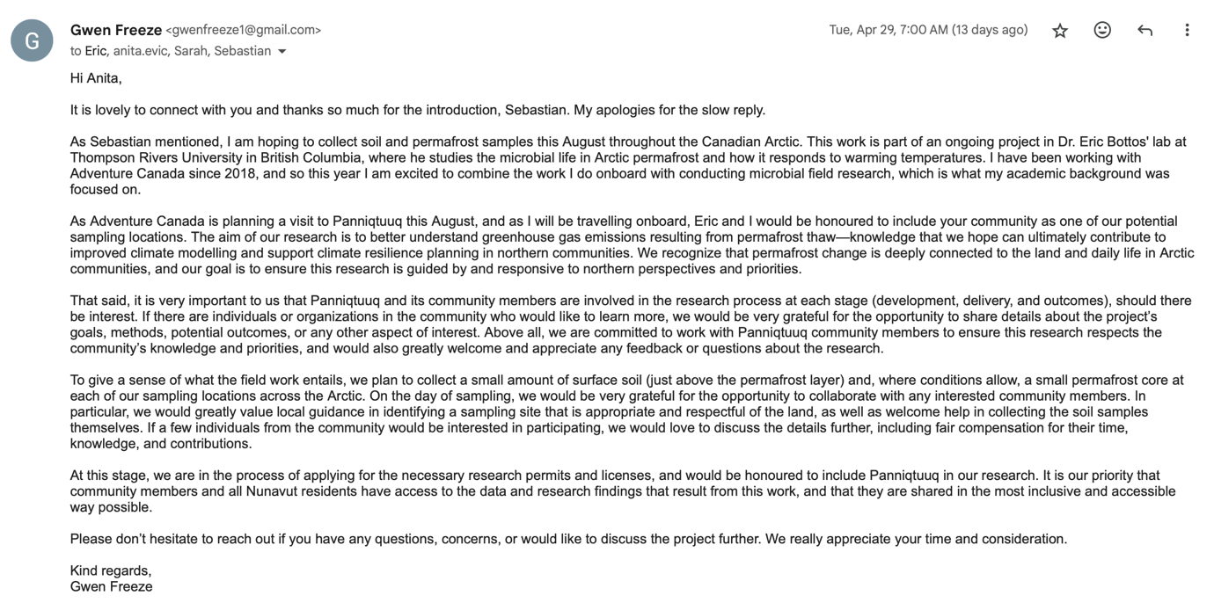

We are currently waiting to hear back from Anita Evic, and will follow up soon.

