OTN arctic survey 2025 – Proposed logistical plan

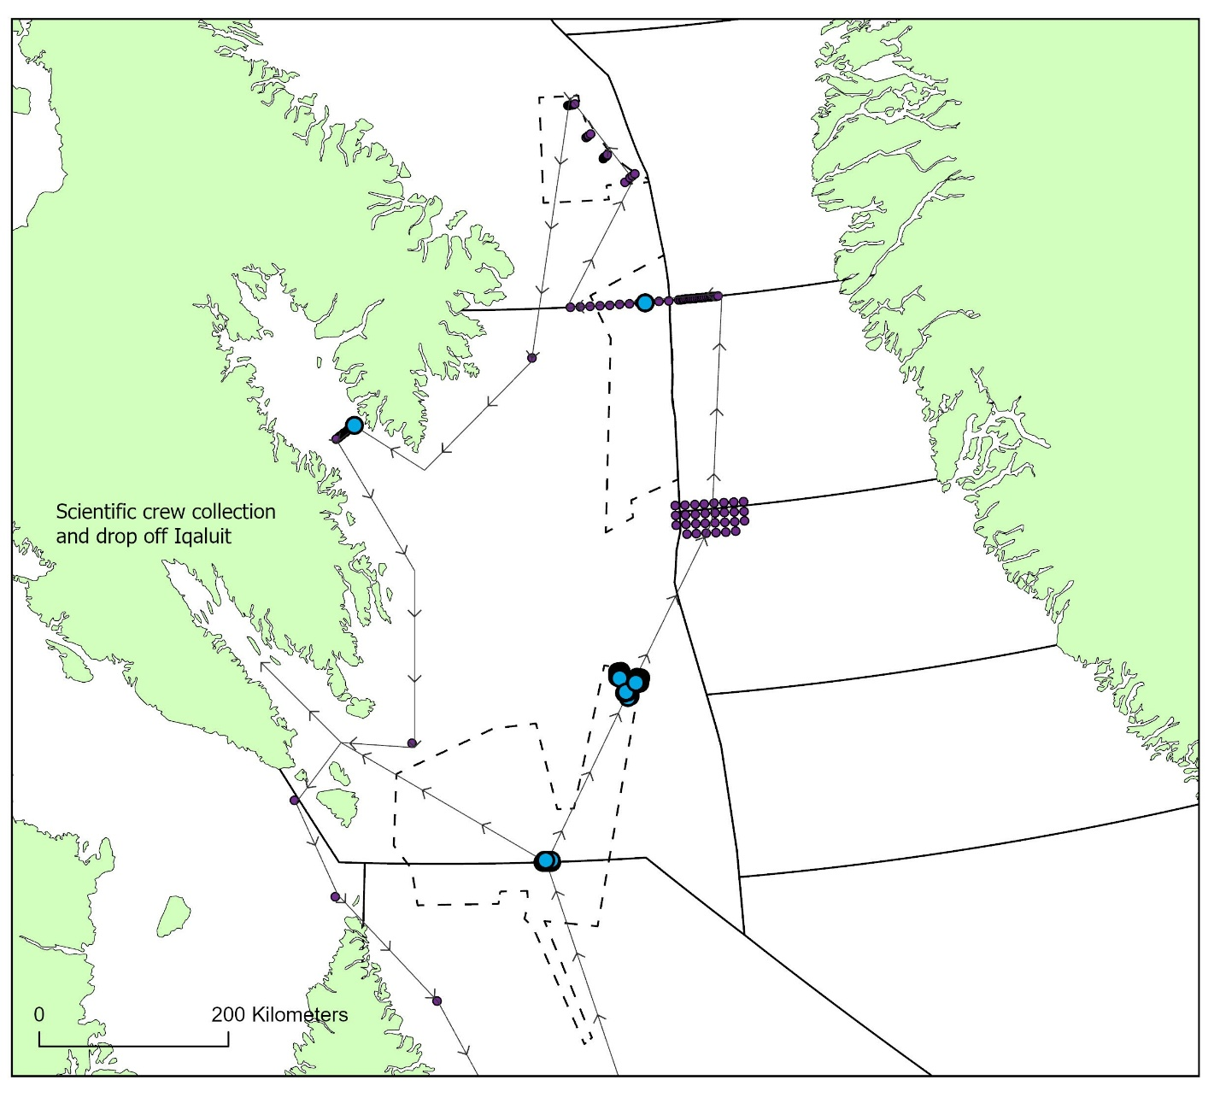
Figure 1: proposed survey route for OTN arctic survey 2025 (dashed line).

Table 1: proposed timeline for 2025 OTN arctic survey
Date | est start time | Project Day | Location | Activity | Duration (hours) | Assumed travel speed (knotts)
2025-08-10 |  |  | 0B-2G | Kiviak crew deploy fishing set at 0B-2G line
2025-08-10 | 9:00 |  | 0B-2G | Transit to Iqaluit to pickup scientific crew | 36 | 8
2025-08-11 | 21:00 | 1 | Iqaluit | Arrive Iqaluit, NU. Kiviak pickup scientific crew
2025-08-11 | 22:00 | 1 | Iqaluit | Transit to 0B-2G line. Scientific crew assemble 0b-2G mooring array | 36 | 8
2025-08-13 | 10:00 | 3 | 0B-2G | Deploy 0B-2G receiver array | 2 | 5
2025-08-13 | 11:00 | 3 | 0B-2G | Pickup fishing line tag fish 0B-2G line. Tag subset of 30 fish | 3
2025-08-13 | 14:00 | 3 | 0B-2G | Transit to Hatton Basin
2025-08-14 | 7:00 | 4 | Hatton Basin | Deploy HB array one (10 moorings) & set fishing line in the middle of array | 3 | 5
2025-08-14 | 10:00 | 4 | Hatton Basin | Transit to HB two array | 1.5 | 5
2025-08-14 | 11:30 | 4 | Hatton Basin | Deploy HB array two (10 moorings) & set fishing line in the middle of array | 3 | 5
2025-08-14 | 14:30 | 4 | Hatton Basin | Transit to HB three array | 1.5 | 5
2025-08-14 | 16:00 | 4 | Hatton Basin | Deploy HB array three (10 moorings) & set fishing line in the middle of array | 3 | 5
2025-08-15 | 8:00 | 5 | Hatton Basin | Return to HB array one. Pickup fishing line (24 hr soak)  Acoustic tag (n=30). MrPAT all available (n=19). Floy tag remaining fish | 5 | 5
2025-08-16 | 13:00 | 5 | Hatton Basin | Transit to HB two array | 1.5 | 5
2025-08-16 | 14:30 | 5 | Hatton Basin | Return to HB array two. Pickup fishing line (24 hr soak)  Acoustic tag (n=30). Floy tag remaining fish | 3 | 5
2025-08-16 | 17:30 | 5 | Hatton Basin | Transit to HB two array | 1.5 | 5
2025-08-16 | 19:00 | 5 | Hatton Basin | Return to HB array three. Pickup fishing line (24 hr soak)  Acoustic tag (n=30). Floy tag remaining fish (3 hours) | 3 | 5
2025-08-16 | 22:00 | 5 | Hatton Basin | Transit to spawning ground | 12 | 8
2025-08-17 | 10:00 | 6 | SPG | Turnover spawning ground | 4 days | 5
2025-08-21 | 17:00 | 10 | SPG | Transit to 0A-0B line (greenland side) | 16 | 8
2025-08-22 | 19:00 | 11 | 0A-OB line | Turnover 0A-0B line (greenland side) | 1 | 5
2025-08-23 | 8:00 | 12 | 0A-OB line | Turnover 0A-0B line (greenland side) | 7 | 5
2025-08-23 | 15:00 | 12 | 0A-OB line | Transit to 0A-0B line (canada side) | 1 | 5
2025-08-23 | 16:00 | 12 | 0A-OB line | Turnover 0A-0B line (canada side) | 4 | 5
2025-08-24 | 8:00 | 13 | 0A-OB line | Turnover 0A-0B line (canada side) | 7 | 5
2025-08-24 | 15:00 | 13 | 0A-OB line | Transit to Diskofan | 11 | 8
2025-08-25 | 14:00 | 14 | Diskofan | Set fishing line. Turnover Diskofan south. | 5 | 5
2025-08-26 | 8:00 | 15 | Diskofan | Whale biologging attachement, biopsy collection | 24 | 5
2025-08-27 | 8:00 | 15 | Diskofan | pickup fishing line. Tag fish. Turn over remaining moorings diskofan south. | 5 | 5
2025-08-27 | 13:00 | 15 | Diskofan | Transit to Diskofan North | 5 | 8
2025-08-27 | 18:00 | 15 | Diskofan | Turn over moorings. Set fishing line | 5 | 5
2025-08-28 | 8:00 | 16 | Diskofan | Whale biologging attachement, biopsy collection | 24 | 5
2025-08-29 | 8:00 | 17 | Diskofan | Pickup fishing line. Tag fish | 3 | 5
2025-08-29 | 11:00 | 17 | Diskofan | Transit to SFA2 North | 20 | 8
2025-08-30 | 19:00 | 18 | SFA2 North | Deploy SFA2 North (check if old mooring is responsive) | 1
2025-08-30 | 20:00 | 18 | SFA2 North | Transit to cumberland sound | 17 | 8
2025-08-31 | 13:00 | 19 | Cumberland sound | Turnover cumberland sound moorings | 6 | 5
2025-09-01 | 8:00 | 20 | Cumberland sound | Turnover cumberland sound moorings | 12 | 5
2025-09-01 | 20:00 | 20 | Cumberland sound | Transit to SFA2-South | 24 | 8
2025-09-02 | 20:00 | 21 | SFA_2 | Turnover SFA2 South | 1
2025-09-02 | 21:00 | 21 | SFA_2 | Transit to Iqaluit (scientific crew drop off) | 22
2025-09-03 | 19:00 | 22 | Iqaluit | Scientific crew drop off | 20
2025-09-04 |  |  |  | Kiviak crew service WA2_north, WA2_south, SFA4. Travel home

