WHALE COVE GOLD CORP. (“WCGC”) SPILL CONTINGENCY PLAN

FOR EXPLORATION CAMP AND DRILL SITES

PISTOL BAY AREA, KIVALLIQ REGION NUNAVUT
Prepared by: Dwayne Car May 2015

Revision 1: Stanley Robinson | March 2017
Revision 2: Stanley Robinson | January 2018
Revision 3: Stanley Robinson | December 2018
Revision 4: David Smith | June 2019
Revision 5: Stanley Robinson | March 2020
Revision 6: Denise Lockett | October 2021
Revision 7: Stanley Robinson | November 2021
Revision 8: Stanley Robinson | March 2023
Revision 9: Stanley Robinson | May 2023
Revision 10: Stanley Robinson | September 2023
Revision 11: Stanley Robinson | February 2024
Revision 12: Brian May | May 2025
Revision 13: Brian May  Revision 14: Brian May | Oct 2025  December 2025
Whale Cove Gold Corp
Suite 3200, Bay Adelaide Centre - North Tower 40
Temperance St
Toronto, Ontario
Canada M5H 0B4

Table of Contents
Page
1.0 INTRODUCTION 3
2.0 SITE INFORMATION 3
2.1 Campsite 3
2.2 Campsite and Drill Sites 5
2.3 Effective Date of Plan 5
2.4 Background Information on the Camp Site 5
3.0 PETROLEUM AND CHEMICAL STORAGE 5
3.1 Petroleum Transfer Method 6
4.0 RISK ASSESSMENT AND MITIGATION OF RISKS 6
4.1 Responsibilities 6
5.0 RESPONDING TO FAILURES AND SPILLS 7
5.1 Basic Steps 7
5.2 Reporting Procedure 7
5.3 Emergency Contact List 7
6.0 ACTION PLANS 9
6.1 Spills on Land (gravel, rock, soil and vegetation) 9
6.2 Spills on Snow 9
6.3 Spills on Ice 10
6.4 Spills on Water 10
6.5 Spills Due to Accidental Load Release 11
7.0 RESOURCE INVENTORY 11
8.0 TRAINING/EXERCISE 12
Appendix A: PROPERTY CONFIGURATION MAP 13
Appendix B: LIST OF MATERIAL SAFETY DATA SHEETS (MSDS) 14

PREAMBLE
This Spill Contingency Plan is effective so long as Whale Cove Gold Corp. holds surface rights on its Whale Cove Property located near Whale Cove, Nunavut.
The Spill Contingency Plan was prepared in May 2015 for internal company use and distributed to regulators for approval as part of Whale Cove Gold Corp’s Land Use and Water Licence permits.
This version dated December 2025 reflects project updates since May 2015.
- INTRODUCTION
The purpose of Whale Cove Gold Corp’s (“WCGC’s”) Spill Contingency Plan is to provide a plan of action for any spill event whilst the Company is executing an exploration program or otherwise conducting work in the Pistol Bay area of Nunavut. This Plan provides the protocol for responding to spills (or potential spills) that will minimize health and safety hazards, environmental damage and clean-up costs as well as defining responsibilities of response personnel. This Spill Contingency Plan details the sites that operations may be conducted upon, describes the response organizations, action plans, reporting procedures and training exercises in place.
The Spill Contingency Plan will:
  - Promote the safe and careful use of potentially hazardous materials.
  - Promote the safe and effective recovery of spilled potentially hazardous materials.
  - Minimize the environmental impacts of spills to water or land.
  - Identify roles, responsibilities and reporting procedures for spill events.
  - Provide readily accessible emergency information to clean-up crews, management and government agencies.
  - Comply with federal and territorial regulations and guidelines pertaining to the preparation of contingency plans and notification requirements in the event of an emergency or spill.
- SITE INFORMATION
  - Campsite
The Pistol Bay camp has been in place since 2011 at Latitude: 62° 21’ 05” N Longitude: 92° 45’ 20” W. A move to a new location, closer to the Vickers Deposit and the Hamlet of Whale Cove, at Latitude: 62o 20’ 30” Longitude: 92o 49’ 48” W with a water source that does not freeze to the bottom in winter has been approved.
Capacity: 35 people

Structures (October 2025):
- Thirteen 14’ x 16’ Weatherhaven sleep tents heated with propane
- One 14’ x 48’ plywood kitchen heated with propane
- One 14’ x 16’ plywood shack heated with propane and used for sample shipment preparation and sample drying. Previously, this building was the core shed.
- One 16’ x 24’ plywood core shack, heated with fuel oil.
- One 16’ x 8’ extension to plywood core logging shack
- One 14’ x 16’ Weatherhaven shower/laundry facility, heated with propane, with an 8’ x 16’ extension which houses the laundry facilities, water storage tanks, water heater and water treatment system
- One 14’ x 16’ Weatherhaven core cutting tent
- One 14’ x 16’ Weatherhaven storage tent
- One 14’ x 20’ Weatherhaven office tent heated with propane
- One 8’ x 8’ plywood equipment shack
- Three plywood outhouses
- One heli-pad made of plywood framed with wooden pallets
- Two fuel caches stored in four “Insta berms” equipped with water drains
- Spill response equipment located beside fuel berms and heli-pad
- Two plywood generator shacks 8’ x 16’
- One 8’ x 8’ shed to contain electrical panels
- One 16’ x 16’ plywood dry (heated by fuel oil)
- One plywood emergency shelter (used at drill rig)
- One 12’ x 10’ plywood drill core sampling shack heated with propane
Whale Cove Gold Corp Machinery (October 2025):
- One 2013 Ford F250 ³/4 ton pick-up truck
- One 2021 Dodge 2500 ³/4 ton pick-up truck
    - One 2025 Ford F250 ¾ ton pick-up truck
- Two Honda 6500 generators
- One gas portable rock saw
- Two 33.1Kva generators (main power plant and spare for camp).
- Two 50 cc Honda water pumps
- One Smart Ash portable, multipurpose batch load incinerator
- One gas-powered hydraulic barrel crusher
- One Kubota M6060 tractor
- One Sure-track trailer model ST8214TLDD
- Two Vancon Core Saws, 3hp, electric
- Two Honda 420 quads

Logan Drilling machinery on site (October 2025):
- Two Duralite DL 1000 drills
- 1x Honda 6500W generator
- 2x bench 2500W suitcase generators
- 1x Miller stick welder
- 6x420 bean supply pumps
- 1x3” Honda trash pump
- 1x2” Honda trash pump
- HQ Drill rods, casing and waterlines
- 2x Survival tents

  - Campsite and Drill Sites
See attached Property Configuration Map – ATTACHMENT A.
  - Effective Date of Plan
June 25, 2015, was the date of the original plan for the project with the most recent revision date being October 2025. The Plan is effectively concurrent with all licences and permits for the Project.
  - Background Information on the Camp Site
The new camp site location is approximately 4.2km west of the old site. The approved new site is 300-400m northwest of and downslope from an old, abandoned trailer near the main road, approximately 22km from town. Water can be drawn from the fish-bearing lake approximately 550m northwest from the old, abandoned trailer.
The new camp site was selected because it is considerably closer to the Vickers Gold Deposit, and it will allow the company to operate year-round. Moving the camp is also more cost effective than building a new camp.
Whale Cove Gold Corp personnel and contractors can travel by pick-up to Whale Cove, the Whale Cove airport and to the Vickers drill target. However, a helicopter is still the primary mode of transport for the project.
The old camp site will be cleaned up and restored to its original condition, if any when the move takes place.
- PETROLEUM AND CHEMICAL STORAGE
Fuels required for use in the exploration program and at the campsite are stored in the project base camp. They are all clearly labelled as the property of WCGC (formerly Northquest Ltd.), are stored in a safe and secure manner with insta-berms and are secured for the Winter.

Fuel type | Purpose | Size
Jet A1 | Helicopter use | 205 litre drums
propane |  | 100 lb tanks

All fuels for exploration purposes, i.e., Jet A, gasoline and diesel are stored in 205 litre (45 gal) metal drums. Propane is stored in standard 100lb propane tanks. Material Safety Data Sheets (MSDS) for these and other petroleum-based products used during the drilling programs are in Appendix B.
Temporary remote fuel caches are located in proximity of the area of drilling and will be located at each drill site and will be in accordance with CSA approved methods of storage of drummed product. Spill kits will be located at each temporary remote fuel cache and fuel will be stored in Insta-berms.
After drilling at each site, empty drums will be crushed and backhauled to Whale Cove for shipping and disposal offsite. Fuel cache inspections will occur on a regular basis for leaks, damaged or punctured drums.
  - Petroleum Transfer Method
Manual, electric engine powered pumps, along with the appropriate filtration devices, may be used for the transfer of petroleum products from their storage drums to their end use fuel tanks. Spill kits will be at all petroleum transfer stations.
- RISK ASSESSMENT AND MITIGATION OF RISKS
The following is a list of sources:
  - Drummed Products: Leaks or ruptures may occur; bung caps may be loose. This includes Jet fuel, diesel, waste fuel and waste oil.
  - Fuel cylinders: Propane leaks may occur at the valves.
  - Vehicles and Equipment: Helicopter and fixed wing aircraft, snowmobiles, generators, pumps, diamond drill, ATVs.
Incidents involving leaking or dripping fuels and oils may occur due to malfunctions, impact damage, and lack of regular maintenance, improper storage, and careless or faulty operation. Regular inspection and maintenance in accordance with recognized and accepted standard practices at all fuel caches, reduces the risks associated with the categories listed above. Spill kits will be located at all drill sites.
  - Responsibilities
Camp Manager – responsible for checking that all fuel and oil drums or containers stored at the camp, or the laydown are in good condition with no evidence of leakage, assuring drip trays and berms are in place and not overflowing, keeping spill kits and absorbent mats in good repair and accessible. If spill or likelihood of a spill occurs the Camp Manager will immediately report to the Project Supervisor.
Drill Foreman and drillers: responsible for checking that all fuel and oil drums or containers and drill muds stored at the drill sites are in good condition with no evidence of leakage, assuring drip trays and berms are in place and not overflowing; keeping spill kits and absorbent mats in good repair and accessible. If spill or likelihood of a spill occurs the Driller or Drill Foreman will immediately report to the Project Supervisor.
Pilots: responsible for checking helicopter fuel storage berms as often as practicable, and at least every time refuelling is completed. All spills or issues with fuel storage will be reported immediately to the Project Supervisor.
Project Supervisor will report any spill to the NWT/NU 24-Hour Spill Report Line and initiate clean-up. Project Supervisor will request additional aid from external sources if deemed necessary. If one or more of these key personnel are absent from the site an alternative person will be named either Camp Manager or Project Supervisor for the interim. The Project Supervisor for the time being is:
Brian May, VP Exploration.
- RESPONDING TO FAILURES AND SPILLS
In the case of any spill or environmental emergency, it is necessary to react in the most immediate, safe and environmentally responsible manner. No spill or incident is so minor that it can be ignored, and every spill must be reported.
  - Basic Steps
The basic steps of the response plan are as follows:
    - Ensure the safety of all persons at all times.
    - Identify and find the spill substance and its source, and, if possible, stop the process or shut off the source.
    - Inform the immediate supervisor or their or her designate at once, so that they may take appropriate action. Appropriate action includes the notification of a government official, if required; Spill Report forms are included at the back of this plan.
    - Contain the spill or environmental hazard, as per its nature, and as per the advice of INAC Water Resources Inspector as required.
    - Implement any necessary cleanup or remedial action.
  - Reporting Procedure
Communication in the way of two-way radios will be set-up in the event that if a spill occurs outside of camp at either the drill rig or external fuel cache so that it can be immediately reported to the Project Supervisor.
All spill kits located at all sources of fuel will have contact information for the NWT Spill Report Line prominently displayed.
A listing of the NWT 24 Hour Spill Report Line as well as other government contacts and company officials will be displayed adjacent to the satellite phone in camp. (See Reporting Procedure and Contacts below).
    - Immediately notify the WCGC office T: (647) 527-8755 and report to the 24-Hour Spill Line at (867) 920-8130 (Fax: 867-873-6924), INAC Land Use Resource Management Officer (867) 645-2840 and KIA Land Use Inspector (867) 645-5735.
    - A Spill Report Form (Appendix 1) is filled out as completely as possible before or after contacting the 24-Hour Spill Line.
    - Notify Brian May, VP Exploration, Cell: (647) 549 0954 or (236) 970-2089.
  - Emergency Contact List

Table 2: Emergency Contact List – Spill Reporting and Response
CONTACT | CONTACT NUMBER (Tel / Cell)
Brian May, VP Exploration, | C: (647) 549-0954 or (236) 970-2089
Whale Cove Gold Corp Headquarters, Toronto | C: (647) 527-8755
24 Hour Emergency Spill Line phone / fax | (867) 920-8130,  Fax (867) 873-6924
Environment Canada – Iqaluit Emergency Pager
CIRNAC Land Use Resource Management Officer (Rankin Inlet) | (867) 645-2840
KIA Land Use Inspector (Rankin Inlet) | (867) 645-5735
CIRNAC NU Water Resources Manager CIRNAC NU Lands Administration Manager | (867) 975 4550
 | FAX (867) 975-4585
(867) 975-4280
FAX (867) 975-4286
DFO NU Region  Manager, Pollution Control and Air Quality | (867) 979-8000
DFO NU Region  Manager, Pollution Control and Air Quality | FAX (867) 979-8039
DFO NU Region  Manager, Pollution Control and Air Quality | (867) 975-5907
Rankin Inlet Hospital; Office Hours / After 5pm | (867) 645-8300 / (867) 645-6700
Rankin Inlet RCMP; Office Hours / Emergency | (867) 645-0123 / (867) 645-1111
Whale Cove RCMP Detachment | (867) 896-0123 or  (867) 896-1111
Keewatin Air Ambulance | (867) 645-4455

A detailed report on each occurrence must also be filled out with the INAC Water Resources Inspector no later than 30 days after initially reporting the event. The Spill Report Form is attached as Appendix C.

- ACTION PLANS
The following responses are recommended for fuel spills in differing environments. Depending on the location and size of the exploration program some of the equipment mentioned in the responses listed below will obviously not be located on site, but could be transported to the spill if deemed necessary. The most likely scenario for fuel spills in this type of exploration program would include leaking drums, hydraulic line malfunction and re-fueling operations. It is not anticipated that a spill of more than 45 gallons will occur as no fuel container on-site will exceed this capacity.
  - Spills on Land (gravel, rock, soil and vegetation)
    - Trench or ditch to intercept or contain flow of fuel or petroleum products on land where feasible (loose sand, gravel and surface layers of organic materials are amenable to trenching/ditching;-trenching in rocky substrates is typically impractical and impossible).
    - Construct a soil berm downslope of the spill. Use of synthetic, impervious sheeting can also be used to act as a barrier.
    - Where available, recover spills through manual or mechanical means including shovels, heavy equipment, and pumps.
    - Absorb petroleum residue with synthetic sorbent pad materials. Recover spilled and contaminated material, including soil and vegetation.
    - Transport contaminated material to approved disposal or recovery site. Equipment used will depend on the magnitude and location of the spill.
    - Land based disposal is only authorized with the approval of government authorities.
  - Spills on Snow
    - Trench or ditch to intercept or contain flow of fuel or petroleum products on snow, where feasible (ice, snow, loose sand, gravel and surface layers of organic materials are amenable to trench/ditching; trenching in solid, frozen ground or rocky substrates is typically impractical and impossible).
    - Compact snow around the outside perimeter of the spill area.
    - Construct a dike or dam out of snow, either manually with shovels or with heavy equipment such as graders or dozers where available.
    - If feasible, use synthetic lines to provide an impervious barrier at the spill site.
    - Locate the low point of the spill area and clear channels in the snow, directed away from waterways, to allow non-absorbed material to flow into the low point.
    - Once collected in the low area, option include shoveling spilled material into containers, picking up with mobile heavy equipment, pumping liquid into tanker trucks or using vacuum truck to pick up material
    - Where safe, disposal can be done through in-situ combustion with approval from government and safety consultants.
    - Transport contaminated material to approved disposal site. The equipment used will depend on the magnitude and location of the spill.
  - Spills on Ice
    - Contain material spill using methods described above for snow, if feasible and/or mechanical recovery with heavy equipment.
    - Prevent fuel/petroleum products from penetrating ice and entering watercourses. Remove contaminated material, including snow/ice as soon as possible.
    - Containment of fuel/petroleum products under ice surface is difficult given the thickness and winter conditions. However, if the materials get under ice, determine the area where the fuel/petroleum product is located.
    - Drill holes through ice using ice auger to locate fuel/petroleum product. Once detected, cut slits in the ice using chain saws and remove ice blocks.
    - Fuel /petroleum products collected in ice slots or holes can be picked up via suction hoses connected to portable pump, vacuum truck or standby tanker. Care should be taken to prevent the end of the suction hose clogged up by snow, ice or debris.
  - Spills on Water
    - Contain spills on open water immediately to restrict the size and extent of the spill
    - Fuel/petroleum products which float on water may be contained through the use of booms, absorbent materials, skimming and the erection of culverts.
    - Deploy containment booms to minimize spill area, although effectiveness of booms may be limited by wind, waves and other factors.
    - Use sorbent booms to slowly encircle and absorb spilled material. These absorbents are hydrophobic (absorb and repel water).
    - Once booms are secured, use skimmers to draw in hydrocarbons and minimal amounts of water. Skimmed material can be pumped through hoses to empty fuel tanks/drums.
    - Culverts permit water flow while capturing and collecting fuel along the surface with absorbent materials.
    - Chemical methods including dispersants, emulsion – treating agents and shoreline cleaning will be considered.
  - Spills Due to Accidental Load Release
The loss of external loads of fuel, oil or chemicals from the helicopter requires an immediate response.
      - Obtain GPS co-ordinates of the location and contact base camp. Include quantity and type of load loss.
      - Base camp will contact the 24-Hour Spill Line and receive instructions on follow-up procedures.
      - Administer the appropriate procedure for spills on Land, Water, Snow or Ice.

NOTE:
- Material Safety Data Sheets for all hazardous materials involved in this project are listed in Appendix B. These MSDS sheets are for all drilling mud, polymers and greases as well as for calcium chloride, diesel, Jet A-1 with AIA, propane and gasoline.
- Precautions need to be taken to ensure safety of personnel. Also, spilled product should be confined to control burning. These include areas where the spilled material has pooled naturally or been contained via dikes, trenches, depressions or ice slots. Prior to any attempts at in-situ burning, consultation with experts and approval by government authorities are required.
- Chemical response methods are also available and may include the use of dispersants, emulsion-treating agents, visco-elastic agents, herding agents, solidifiers, and shoreline cleaning agents.
- Biological response methods include nutrient enrichment and natural microbe seeding.
- Site remediation will be completed as per the advice of government authorities.
- RESOURCE INVENTORY

Resources available on site:
Trenching/digging equipment in the form of loader tractor with bucket, picks and shovels.
Pumps
Impervious sheeting (tarps)
Plastic bags, buckets, empty drums for collection of contaminated material. 2 Spill Kits containing:
4 – oil sorbent booms (5” x 10’)
100 – oil sorbent sheets (16.5” x 20” x 3/8”) 1 – drain cover (36” x 36” x 1/16”)
1 – 1lb plugging compound
2 – pair Nitrile gloves
2 – pair Safety goggles 10 – disposable bags
- TRAINING/EXERCISE
WCGC is aware that without practice no Contingency Plan has value.
At least one practice drill will be held per season to give all employees and contractors a chance to practice emergency response skills. Each practice will be evaluated and a report prepared with the objective of learning where gaps and deficiencies exist, and in what areas more practice is required. Response criteria, communication and reporting requirements will be discussed to ensure everyone fully understands them.

- PROPERTY CONFIGURATION MAP

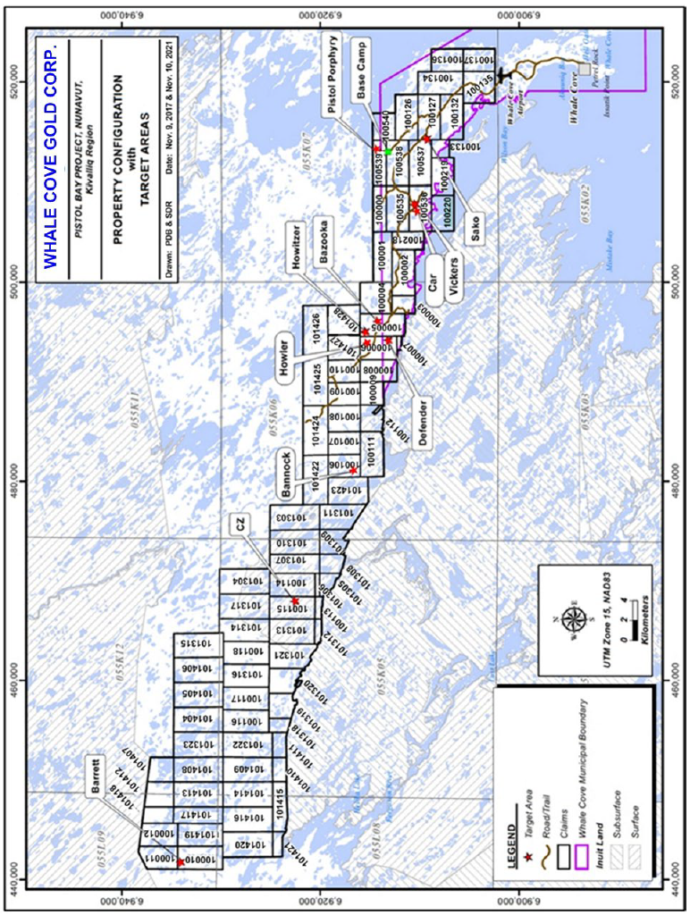

- LIST OF MATERIAL SAFETY DATA SHEETS (MSDS)

(Copies not included herein but retained on-site)
- HESS – Gasoline, All Grades
- HESS – Diesel Fuel (All types)
- AVJET – Jet A-1 with AIA
- BIG BEAR DIAMOND DRILL ROD GREASE
- 550X POLYMER
- G- STOP
- CHEVRON Polyuran EP Grease 2 (Tube Grease)
- Calcium chloride, Anhydrous

