Prospecting Work Plan 2026

Project: Quartzite Lake 2026

Inuit Owned Land Parcel:
WC-08

NTS Sheet Numbers:
Quartzite @ 055L07

KIA License Number:
Requesting Approval from NPC, NIRB, NWB & KIA

Proposed by: John Tugak
Date: January 6, 2026

Quartzite Lake Project 2026

Prospector: John Tugak
KIA License: to update license KVL125B01
NTI MEA: WC08-25-001
Travel to Destination: Travel to location by Float Plane on August 1-7, 2026
NTS Map Sheet: 055L07
Inuit Owned Land Parcel: 055L07
Target to prospect: To engage in magnetic survey over known gold zones using Gradiometer 3D about to detect mineralize zones up to 5-meter depth, target drill sites and engage in shallow diamond drilling over Cache Zone, Kate Zone & Kate South of up to 54 meters using gas powered Backpack Drill by Shaw. Uses 1 gallon of water per hour. Approximately 40 gallons of water will be used for drilling. Water to be retrieved from small lake. Water for drinking will be used from the Quartzite Lake approximately 12 gallons. No footprint shallow drill (motor similar to ice auger). Averages 1 gallon of gasoline per hour and drilling uses an average of 3 meters per hour. All gasoline (one drum) will be stored further then 31 metres away from high water mark. Approximately 54 meters of drilling at Cache Zone property.
NUMIN Website Report: Online report for Cache Zone has information of gold within this parcel. See below…
Zone: | Cache Zone
Reserve Date: | SEP/10, 1990
Comments:
Sample Type: | Drill Core
Sample Weight:
Calculation Method: | Unknown

Reserve Type | Grade | Unit | Commodity | Quantity | Units
Inferred | 9.26 | g/t | Gold | 362,872.00 | t

- Drill indicated reserves of 489,879 tonnes @ 9.26 g/t Au. - The Cache Zone is a shear-hosted gold showing at the contact of intermediate and felsic breccia units with mafic flow units. Mineralization is confined to 4 main zones across a 50 to 75 m width of the shear that has been traced on surface for greater than 5 km. Mineralization is characterized by visible gold in a quartz vein stockwork with coarse euhedral pyrite and minor pyrrhotite, chalcopyrite, sphalerite and galena. Visible gold is found in wide (up to 3 m) E-W trending quartz veins as well as within fine, north-south trending, chlorite filled quartz/carbonate stringers associated with sericite and ankerite alteration of the intermediate tuffs. Some veins are boudinaged and appear to have an alteration haloe of intense ankerite, sericite and coarse grained euhedral pyrite over 3 to 15 cm from the fracture (083569). Helmstaedt (Internal Report for Placer Dome, 1992) suggests that alteration patterns predate deformation of the shear. It is also suggested that the intensity of the potassic (sericite) alteration increases in proximity to the quartz-feldspar porphyry dome immediately to the south of the Cache Zone (083176). Post emplacement deformation has resulted in remobilization of the mineralization and re-deposition of free gold into subhorizontal extension veins (083176). - In summary: Gold bearing quartz-pyrite-carbonate veins in altered and sheared intermediate volcanic rocks in the vicinity of a massive QFP dome. OR: Mineralization is coincides with the contact between felsic and intermediate-mafic volcanics N of and stratigraphically above a massive QFP dome (but nothing to do with the dome).

Prospecting Additional Information: On August 1, 2026 we travel to location by float plane from Arviat, set up camp and prospect the location known as Cache Zone, Kate Zone and Kate South until August 7, 2026.
Note that we do not need any motorized vehicles during the prospection. All garbage and waste to be brought back to the community.
All core will be shipped to Fat Lake Property to be split and then shipped to ALS Lab in Yellowknife for results. A core shack will be available at Fat Lake Property.
All garbage will be sent back to Arviat and into the dumps for proper disposal.
Shaw Backpack Drill: This shallow diamond drill can drill to depth of 20 meters per hole. But will only be used between 3-10 meters per hole. This is gas powered drill of one gallon per hour. Will be used an estimate of 6 hours per day. Water usage for this drill is one gallon per hour. Comes with pressure water bottle of 2 gallon tank of water capable of 2 hours per filled bottle. Will need as estimated 6 gallons of water per day for drill. Nunavut Water Board threshold water uses less than 50 m3 per day (use less then 1 cubic meter of water per day).
Gasoline: Fuel to be stored above and further then 31 metres away from high water mark. One drum of gasoline (205L) will be delivered to location spring of 2026.
Generator: Light generator (2000 watt) will be used only for tent/camp. To supply power for cell phone, star link and gradiometer charging and one light for tent.

Location:
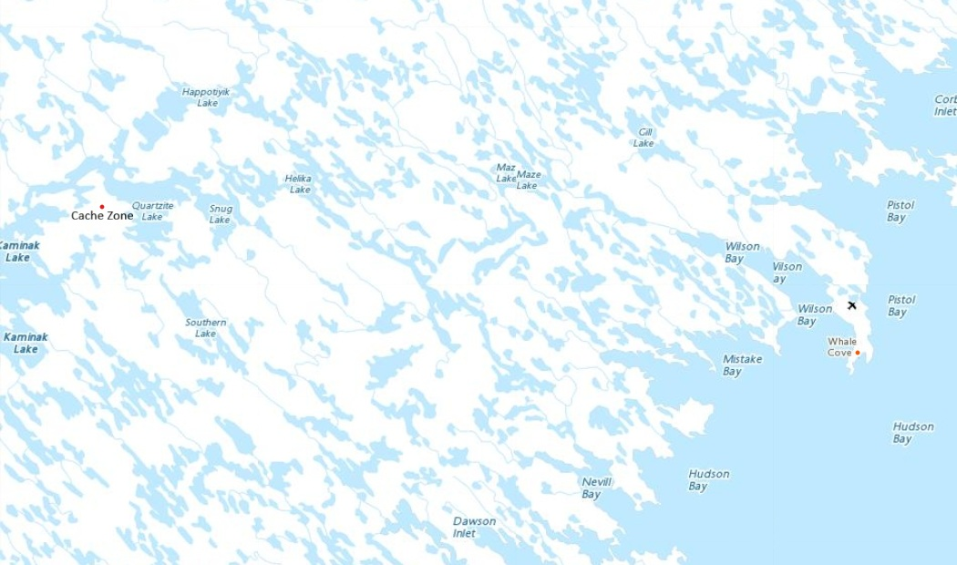
Claim Area Parcel IOL WC-08
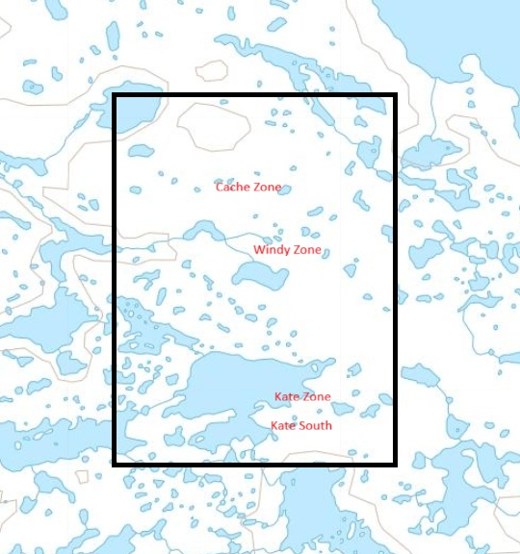
Regards

John William Tugak
Prospector

