Plain Language Summary: Marine Habitat Use of Black Guillemots at Pitsiulaaqsi and Eastern Canada Seabirds at Sea (ECSAS) Surveys

Project Lead/Applicant:
Dr. Julia Baak, Conservation Biologist, Canadian Wildlife Service
Canadian Wildlife Service
301-933 Mivvik Street, Iqaluit, NU, X0A 3H0
Email: julia.baak@ec.gc.ca; Telephone: 867-222-5629

Project Collaborator:
Dr. Kyle Elliott, Associate Professor, McGill University
Dept of Natural Resource Sciences
21111 Rue Lakeshore, Ste Anne-de-Bellevue, QC, H3X 3V9
Email: kyle.elliott@mcgill.ca; Telephone: 514-398-7907

Number of personnel and/or visitors that will be covered under the permit: Maximum of 8

Project objectives and rationale:

Black guillemots (Cepphus grylle) are a widespread Arctic seabird, ranging from the Atlantic to the High Arctic in Canada. Importantly, Canada supports an estimated 440,000 individuals (approximately 58% of the global population), placing a high degree of responsibility on Canada to monitor and conserve this species. As pursuit-diving seabirds that forage in shallow, coastal waters or near ice edges and polynyas, these birds are particularly vulnerable to human activities such as shipping traffic, oil spills, and exposure to contaminants. Despite this, we know little about the movement ecology and threats of black guillemots in Canada, particularly in Nunavut, where there is no available tracking data for this species during the breeding and non-breeding season. As shipping and other human activities continue to increase in the Canadian Arctic, monitoring the movement ecology of black guillemots is important to better understand key habitats for these species, as well as potential threats that these species may be exposed to throughout the year. To address these critical knowledge gaps, we propose to deploy Global Positioning System (GPS) transmitters on 30 adult black guillemots to quantify fine-scale foraging movements during the breeding season. These data will provide the first detailed insights into the movement ecology of black guillemots in this region, which will support the identification of important marine areas and inform marine spatial planning. The resulting data will also establish a baseline for future monitoring and contribute to multi-regional seabird tracking efforts aimed at assessing cumulative impacts and conservation needs in a rapidly changing Arctic.

Additionally, subarctic and arctic waters around Canada support millions of breeding birds. Although tied closer to land during the breeding season when they raise their young, seabirds exist mostly in the marine environment. Since many spend much of their lives out of sight of land, knowledge of their at-sea distribution has been difficult to obtain. Since 2006, the Eastern Canada Seabirds at Sea (ECSAS) program has monitored seabirds at sea using ships-of-opportunity, including Canadian Coast Guard vessels, cruise ships, and more recently, ships in local communities. The information from these surveys is used to identify important marine areas for protection, and understand the potential consequences of climate change and other threats on Arctic marine bird populations. Although the surveys were designed to count birds, observers collect information on all wildlife sightings, including marine mammals and plastic pollution. All data are made publicly available through the Open Government Data Portal. Although several trained observers exist in the Atlantic provinces of Canada, we lack the expertise in Arctic Canada where survey effort is needed most. Thus, our second objective is to train northern community members, including Inuit staff within CWS, to enhance our capacity to monitor seabirds across Arctic Canada.

Project location:
Pitsiulaaqsi (63.4624° N, 67.8421° W) and Frobisher Bay.

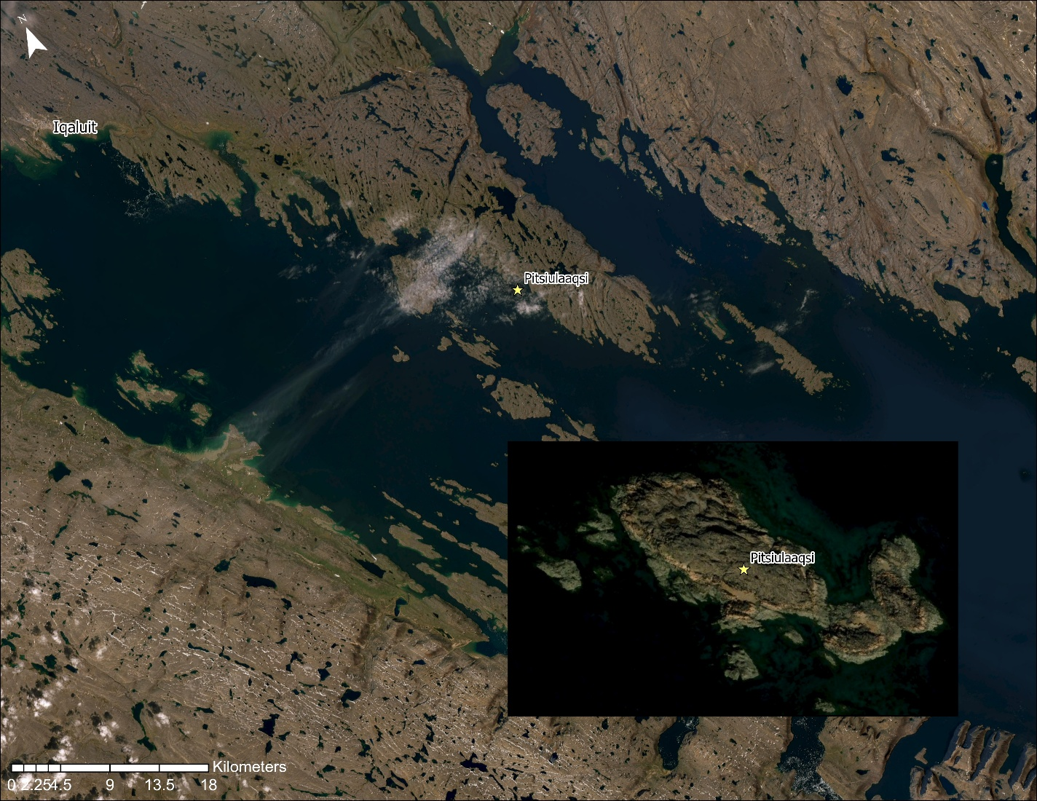

Proposed date and duration of visit:
We propose to take three daytrips to Pitsiulaaqsi (63.4624° N, 67.8421° W) by boat between July 1st to August 31st 2026. Eastern Canada Seabirds at Sea Surveys will be conducted on the boat ride to and from Pitsiulaaqsi.

Project methods:
Black Guillemot Tracking
We will make two daytrips to Pitsiulaaqsi to capture, band, and deploy 30 GPS transmitters (Ecotone Alle, 6 g, < 2% of black guillemot body mass) on adult male and female black guillemots during the incubation and chick-rearing stages (between July 1st to August 31st, 2026). Birds will be caught by hand at their burrow, using a noose pole, and/or by using a noose carpet placed outside of their burrow. Upon capture, a small blood sample will be collected from the tarsus vein to obtain the sex of each individual. Birds will then be measured (mass, tarsus, wing length, head-bill, and culmen), and feather samples (breast and head) will be collected to estimate diet from stable isotope analysis. GPS transmitters will be affixed to the back or tail of black guillemots with Tesa tape. After deployment, we will return to Pitsiulaaqsi for another day trip (July 1st to August 31st, 2026) to remove the GPS transmitters. Upon recapture, we will collect a blood sample (1-2 mL) to measure contaminant levels in this species.

Eastern Canada Seabirds at Sea Surveys
For the Eastern Canada Seabirds at Sea surveys, marine bird observers will conduct surveys from the bridge of the vessel while the vessel is in transit in Frobisher Bay, scanning ahead to a 90° angle. Observations are limited to 300 m from the beam of the ship, and all birds observed are counted and identified. Each survey lasts five minutes and as many consecutive surveys as possible are conducted during daylight hours. At the beginning of each 5-minute survey, we record the ship’s position, speed and direction, time of day, and a number of environmental variables (e.g., ice conditions, visibility, wind speed). These methods are standardized with methods used elsewhere in the North Atlantic and will allow us to compare data across survey years and regions.

Program Logistics
Transportation:
Pitsiulaaqsi: Boat (3 landings)

Community consultation and involvement:
We will consult with the Amaruq HTA of Iqaluit requesting support for the project. We plan to hire Polar Outfitters for the day trips to Pitsiulaaqsi and the ECSAS surveys, which will include Alex Flaherty and 1-2 aids/bear monitors from Iqaluit.

