Evaluation of the Geothermal Potential of Iqaluit, Nunavut, Canada

Primary Applicant’s Name and Affiliation:
The primary applicants are Ysaline Bacon and Xavier Leveillee Dallaire. Both are PhD students in Earth Sciences at the Institut National de la Recherche Scientifique (INRS) in Québec, Canada, and hold double master's diplomas in Earth Sciences from INRS and renewable energy from Reykjavik University (Iceland). Ysaline's master's thesis (2023-2026) focused on the deep geothermal potential of the Baker Lake community and Xavier's (2021- 2023) work examinined horizontal geothermal heat pump systems for urban greenhouses in Quebec. Jasmin Raymond, a professor in geothermal energy and director of the Canada Research Chair on Sustainable Geoenergy Systems Analysis at INRS is also part of the applicants. His team contributes to energy transition by conducting in-depth studies of geoenergy systems - including geothermal energy, underground green hydrogen storage, and natural hydrogen exploration - in rural, isolated communities and northern Indigenous lands. Their presence in the field is yet to be confirmed, but two other researchers are also part of the project: and Andrew Wigston, a geologist at CanmetENERGY (Natural Resources Canada), specializing in geothermal energy and with previous experience in projects in northern communities.

a) Objectives: short-term and long-term objectives for the project

Short-Term Objectives (2025-2026)
- Sample collection: Collect representative rock samples from key lithological units (20-30 in crystalline basement rocks, sedimentary sequences, and fractured/surficial formations) to derive site-specific geothermal parameters.
- Fracture network characterization: Conduct scanline surveys on outcrops to systematically map fracture networks, quantifying critical attributes such as orientation, spacing, aperture, and connectivity for fluid flow and permeability assessments.
- Stakeholder engagement and ethical fieldwork: Initiate and sustain early engagement with local stakeholders and Indigenous organizations to ensure transparent communication of project plans and implement culturally appropriate fieldwork protocols.
- Laboratory-based thermal property measurements: Quantify the thermal properties of collected samples (including thermal conductivity, volumetric heat capacity, and density) to provide site-specific input parameters for geothermal modeling.

Long-Term Objectives (2026–2030)
- Increasing knowledge and thermal data in Northern Canada: All data generated by the project will be made available in the Northern Geothermal Database on Borealis, a public dataverse gathering geothermal data for Northern Canada, currently including datasets from Kuujjuaq, Carmacks, Whitehorse, and Baker Lake.
- Regional geothermal gradient determination: Establish the regional geothermal gradient to inform prospective drilling depths and assess the resource potential of the study area.
- Local geothermal resources assessment: Evaluate the potential of two distinct geothermal systems:
  - Ground-Source Heat Pumps (GSHPs) systems: Simulate technical viability of residential and commercial heating applications by integrating measurements of rock thermal into numerical simulations. These simulations will account for permafrost dynamics, phase-change effects, and long-term system performance.
  - Enhanced Geothermal Systems (EGS): Screen deeper reservoir and fracture network potential for heat and electricity generation. Employ numerical reservoir modeling to assess system viability while quantifying associated uncertainties.
- Techno-economic feasibility analysis: Conduct comprehensive techno-economic assessments to estimate the levelized cost of energy, define CAPEX, projected system lifetimes, and trade-offs relative to community energy priorities.
- Policy and community energy planning support : Develop data-driven recommendations to facilitate Nunavut’s energy transition, producing decision-ready deliverables to inform local planners in evaluating the progression to pilot-scale testing (e.g., exploratory drilling or GSHP demonstrators).

b) Background and Rationale:
Geothermal energy is a low‑carbon option that can provide reliable heat and electricity, year‑round. This reliability is particularly relevant for northern communities that currently depend on imported fuels and face high logistics costs. In Nunavut, however, geothermal potential is still largely unexplored and recent territorial efforts have emphasized that additional data collection is required before moving toward development decisions.
The two systems considered :
- GSHPs systems: These systems exploit the relatively stable temperature of the shallow, undisturbed ground to provide both heating and cooling for residential or commercial buildings. They do not require high-temperature geothermal resources; instead, they enhance energy efficiency by exchanging heat with the subsurface. Their performance strongly depends on the thermal properties of subsurface materials, making field investigations and site-specific measurements essential for reliable system design. GSHPs are currently the most widely deployed geothermal technology in Canada, and several pilot projects have already been implemented in northern regions.
- Enhanced Geothermal Systems (EGS): EGS target deeper, hotter rock formations by drilling wells and circulating water through networks of fractures in hard crystalline rock to extract heat for district heating and, where temperatures are sufficient, electricity generation. Their performance strongly depends on the fracture network and the thermal properties of the surrounding rocks, which control fluid flow and heat transfer within the reservoir. EGS have already been assessed in northern Canadian contexts, including Baker Lake and Kuujjuaq, although no operational projects currently exist in the region. However, a deep EGS project has been successfully developed in the Finnish Precambrian Shield at depths of approximately 6 km, demonstrating the feasibility of this technology in similar geological settings.

State of knowledge and remaining gaps
Even where interest and preliminary studies exist, site‑specific subsurface data remain the main limitation for geothermal screening and design in Arctic hard‑rock settings. In practice, two evidence‑based gaps are most important:
- Local thermal information is limited (e.g., geothermal gradient and thermal properties of rock).
- Permeability of the basement: fractures must be characterized to evaluate whether an EGS‑type concept could work.
The proposed field program is proportionate, non‑invasive and targeted: (1) collect representative surface rock samples for laboratory thermal‑property measurements, and (2) map and measure outcrop fractures (orientation, spacing, aperture/connectivity) using scanlines and photogrammetry to constrain fracture‑network behavior. These basic datasets are essential to reduce uncertainty in feasibility questions for both GSHP and EGS concepts and to produce defensible, site‑specific guidance for decision‑makers. This methodology has been successfully applied at other Arctic‑Shield sites (e.g., Kuujjuaq, Baker Lake), validating its relevance and practicality for early‑stage geothermal exploration in northern settings.

c) Progress to Date:
This project is currently in its initial phase. Iqaluit has been selected as the first study site within the broader project aimed at characterizing Arctic geothermal potential. To date, a comprehensive literature review has been completed, focusing on Arctic geothermal resources, thermal properties of permafrost environments, and comparable renewable energy projects in cold regions. Initial capacity-building and communication efforts have included early engagement with local associations to better understand community needs, foster engagement, and receive guidance relevant to field activities, including culturally appropriate practices and areas to avoid out of respect. In parallel, fieldwork activities have been planned and coordinated in preparation for the summer 2026 field campaign.

d) Recruitment:
No participant recruitment is required for this project. The research involves geological fieldwork only and will be conducted exclusively by members of the research team (Ysaline Bacon, Xavier Léveillée Dallaire, and Prof. Jasmin Raymond). No interviews, surveys, or direct participation by community members are planned as part of the research activities.
During the field campaign, the research team will make use of local community services where available, including accommodation at the Nunavut Research Institute (if possible) or a local hotel, vehicle rental, and food services. If cultural activities or community-led cultural offerings are available during the stay, the researchers may choose to attend on a voluntary basis as a means of learning about the local context and fostering respectful engagement with the community.

e) Methodology:
The field component of this project is exploratory and non‑invasive. Its objective is to collect baseline geological information required to evaluate geothermal feasibility in hard‑rock northern environments. Fieldwork will focus exclusively on bedrock outcrops that are naturally exposed, accessible, and require no environmental disturbance.
Two simple and low‑impact field methods will be employed:

Outcrop rock sampling.
Small, representative rock samples will be collected directly from exposed bedrock outcrops. No digging, drilling, vegetation removal, or mechanical equipment will be used. Sampling will be limited in both number and size and will be conducted only in areas where the crystalline basement is clearly visible at the surface. All sampling locations will be accessible by all‑terrain vehicle and selected to avoid environmentally sensitive areas, culturally significant sites, and locations of community importance (e.g., hunting or harvesting areas, burial sites). Rock samples will be shipped to the laboratory for standard analyses of physical and thermal properties.

Fracture observations using scanline surveys.
Fractures visible on exposed bedrock outcrops will be documented using scanline surveys. This method consists of measuring fracture orientation, spacing, and frequency along a measuring tape placed on the rock surface. Only minimal equipment (measuring tape, compass, and field notebook) will be used, and the method does not modify or damage the outcrop.
Proposed sampling areas have been selected based on accessibility, natural exposure of bedrock without vegetation removal, and the need to minimize disturbance and avoid conflict with community land use. Site selection (Figure 1) will be guided by prior discussions with local organizations and knowledge holders to ensure that field activities are conducted respectfully and in accordance with community expectations.
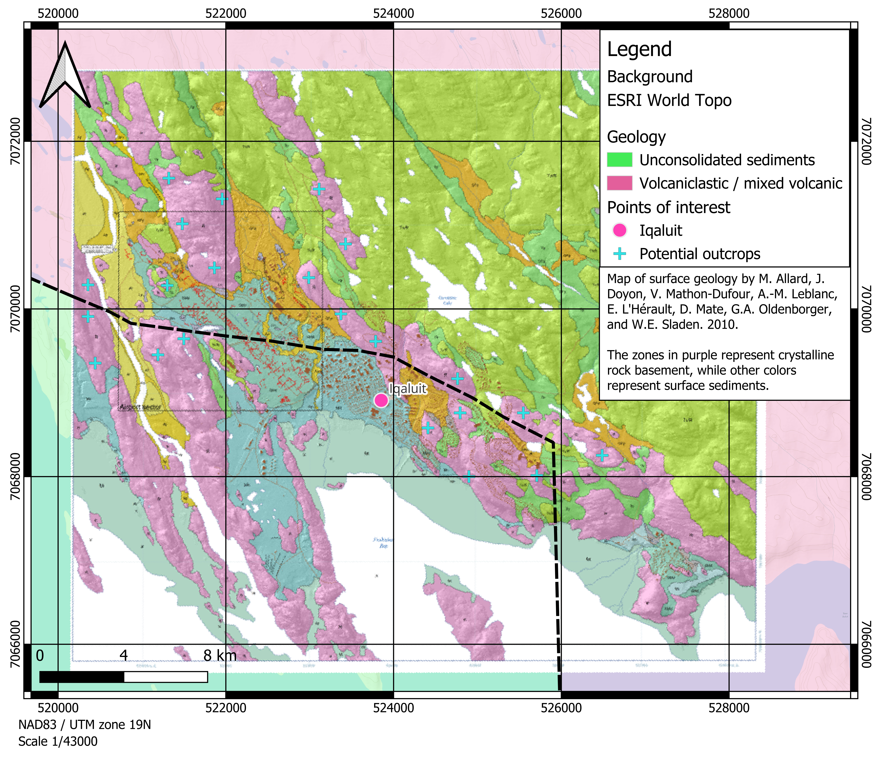
Figure 1. Proposed outcrops for sampling.

Data handling and analysis
Field notes, measurements, and photographs (using a camera and a drone) will be recorded during the survey. Fracture data will be summarized statistically to describe general fracture patterns, and laboratory results will be used to support preliminary geothermal assessments. No personal or sensitive data will be collected.

Location, timing, and justification
Fieldwork will be conducted at selected bedrock outcrops chosen for their accessibility and relevance to regional geology. These locations are appropriate because exposed outcrops provide the only practical way to observe rock and fracture characteristics without subsurface disturbance. The work will take place during a 2-week field campaign in summer 2026;

Ethical considerations and community engagement
The project involves no human subjects. During the stay, the research team will clearly inform local residents and authorities about the purpose of the work, what activities are being carried out, and how the results may be used. Field activities will be conducted respectfully, with minimal environmental impact, and in accordance with local guidelines.

f) Data management:

Data collection and types
This project will generate geological and geophysical data only. Data types will include rock thermal property measurements, fracture characterization datasets (e.g., orientation, spacing, and density), analytical calculations, photographic documentation of outcrops, and numerical modeling outputs derived from laboratory analyses and desktop studies. No personal information, cultural data, or Inuit knowledge will be collected, recorded, or analyzed as part of this project.

Data storage and embargo
All project data will be securely stored at Institut National de la Recherche Scientifique, Quebec. Access to the data will be restricted to members of the research team during an embargo period corresponding to the duration of the project (approximately 2 to 4 years, ending at project completion). This embargo period is necessary to allow for data validation, quality control, peer‑reviewed publication, and incorporation of results into reports and doctoral theses. All reports and theses will be freely available on https://espace.inrs.ca/, the public numerical repository maintained by INRS library.

Data sharing and long‑term access
Following publication, and subject to community awareness and agreement where relevant, datasets will be made publicly accessible. Data will be deposited in Borealis, Canada’s national research data repository, and linked to the Dataverse of Prof. Jasmin Raymond. Shared datasets will include thermal property measurements, fracture datasets, analytical calculations, numerical modeling results, and selected non‑sensitive photographs, all accompanied by appropriate metadata to ensure transparency, traceability, and reusability.

Use of data and ethical principles
All data will be used exclusively for scientific research, knowledge mobilization, and decision‑support related to geothermal energy development in northern and Arctic contexts. Although no Inuit knowledge is collected, the project adheres to principles of respect, transparency, and accountability in research conducted in Nunavut.

Knowledge sharing and community communication
Knowledge mobilization is an integral component of this project. Research results will be communicated to interested communities and organizations in accessible and adapted formats, which may include community presentations, plain‑language summaries, visual materials, or short videos. The level of technical detail will be tailored to community interest and feedback.
Beyond the formal completion of the project, the research team intends to remain available as a resource for communities, organizations, and decision‑makers, supporting informed discussion and guidance on geothermal development initiatives in Nunavut and other northern regions.

g) Research outputs:

Academic and scientific outputs
The primary research outputs of this project will include:
- Doctoral theses, in which all field observations, laboratory measurements, and numerical modeling results will be comprehensively documented, analyzed, and interpreted.
- Peer‑reviewed scientific publications in international journals focusing on geothermal energy, northern and Arctic geology, and subsurface characterization. Publications will be produced progressively throughout the project and finalized by the end of the research period (approximately 2–4 years).
- Conference presentations at national and international scientific meetings to disseminate results to the academic and technical communities.
- Technical datasets, including thermal property measurements, fracture characterization data, analytical calculations, and numerical modeling outputs, which will be made publicly accessible after publication through Borealis (Canada’s national research data repository) and the Northern Geothermal Database.

Validation and communication of results in Nunavut
Research results will be shared with impacted organizations and interested stakeholders in Nunavut at key stages of the project. Preliminary observations may be communicated informally during or shortly after fieldwork to explain field activities, initial observations, and the intended use of the data. Final results will be communicated following completion of analyses and peer‑reviewed publication to ensure scientific rigor and accuracy.
Although the project does not involve research participants, communication will focus on transparency and knowledge sharing with relevant organizations and communities. Communication methods will be adapted to the local context and may include:
- Plain‑language summaries or short reports describing project objectives, methods, and key findings;
- Community meetings or informal discussions, where feasible, to present results and respond to questions;
- Presentations or briefings for local or territorial organizations involved in energy planning, research, or infrastructure development;
- Visual or multimedia materials (e.g., figures, maps, short videos) to support understanding.

