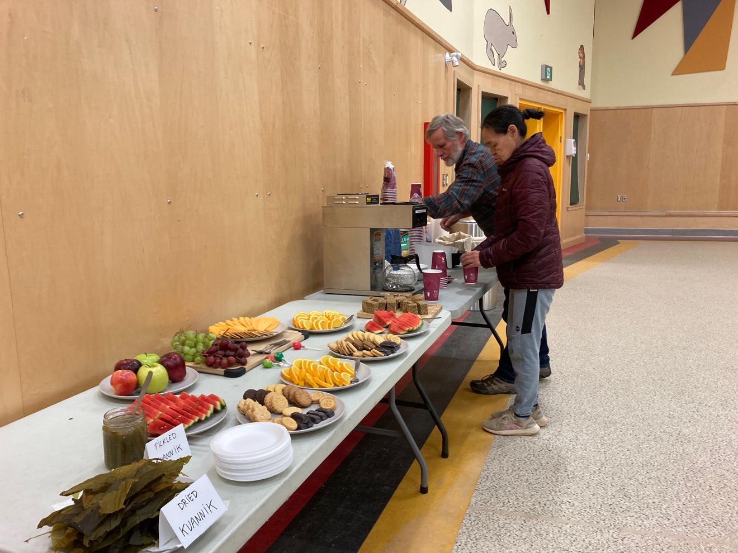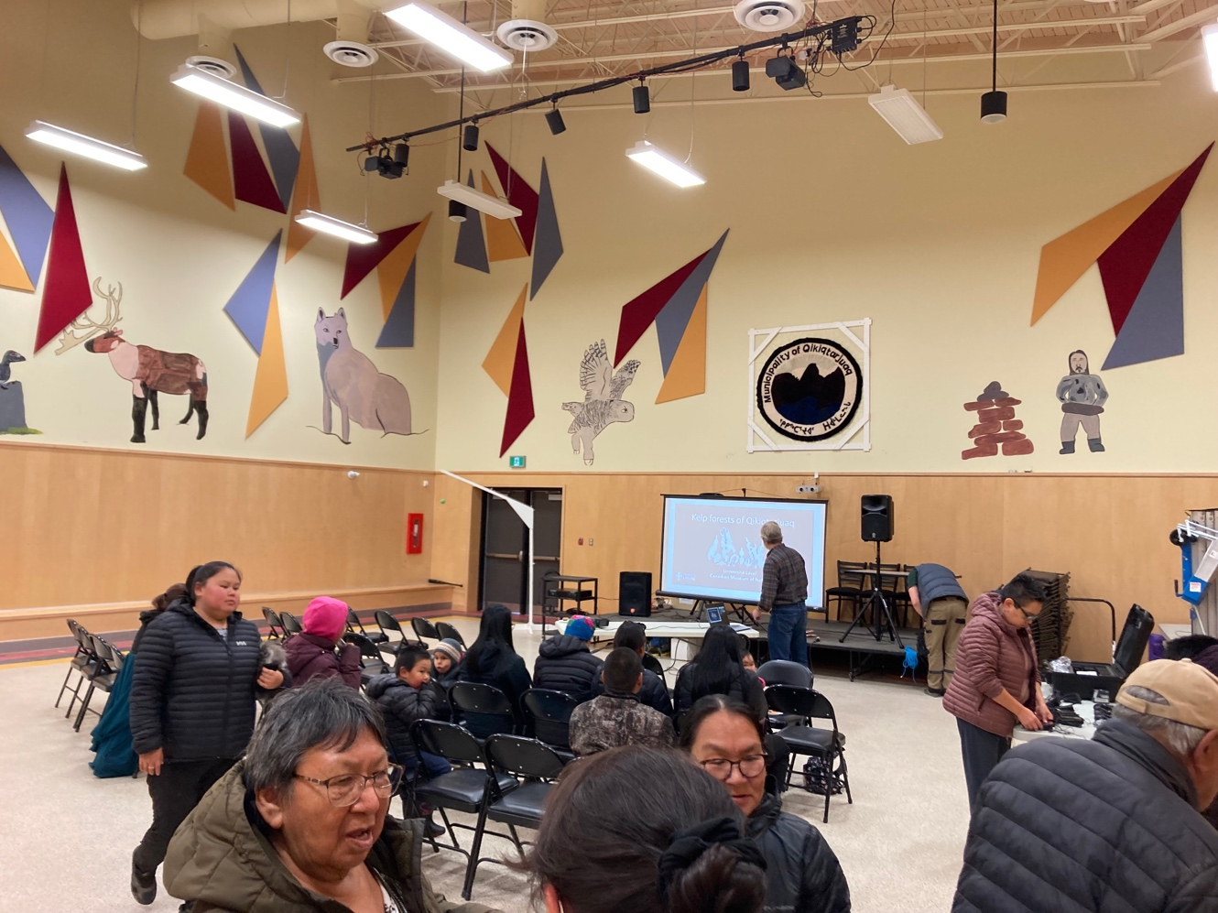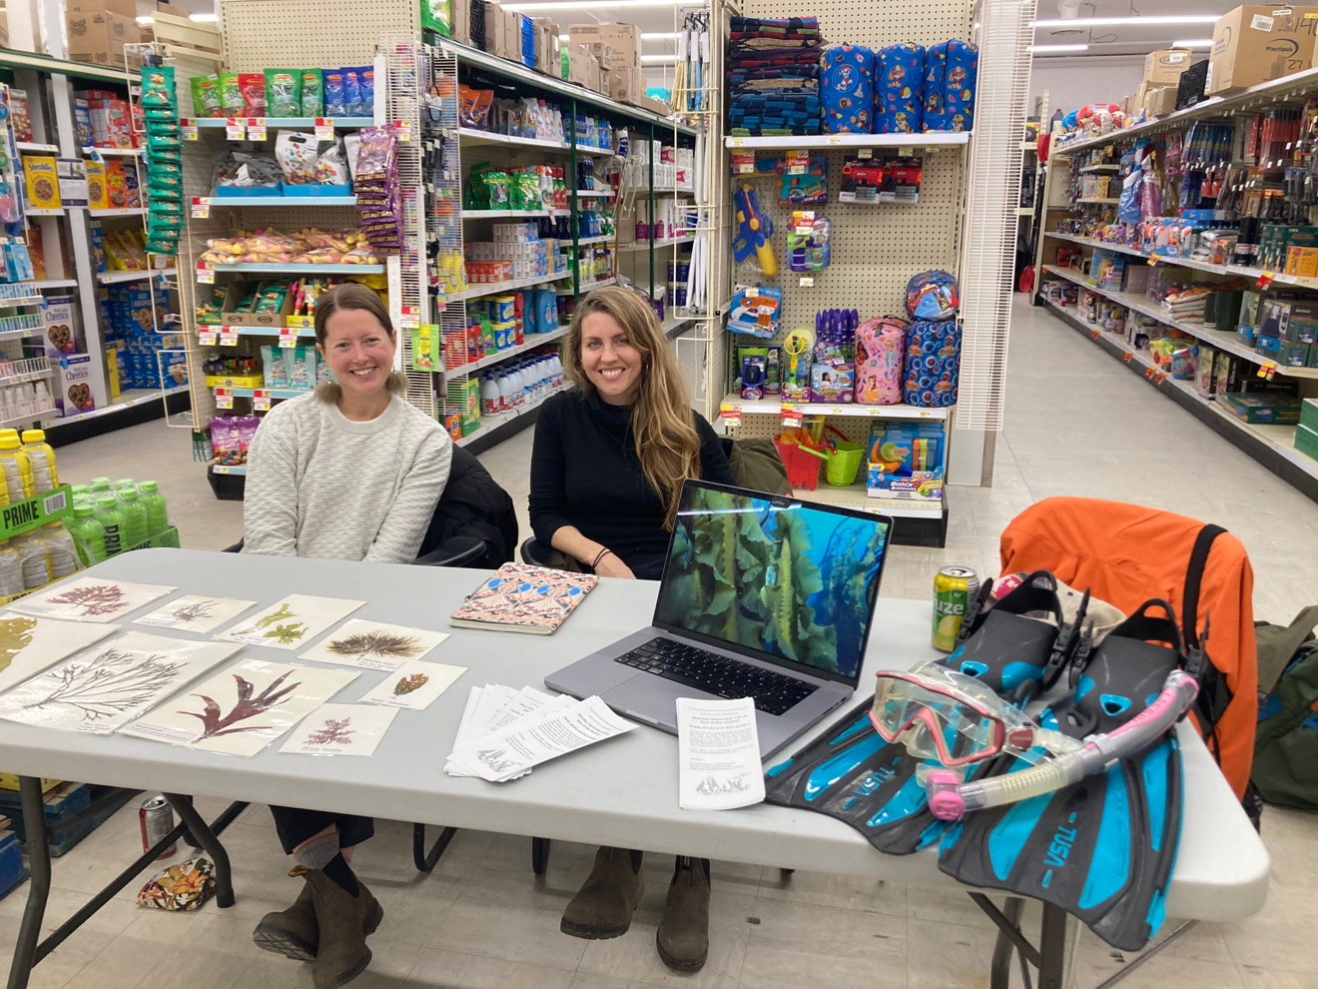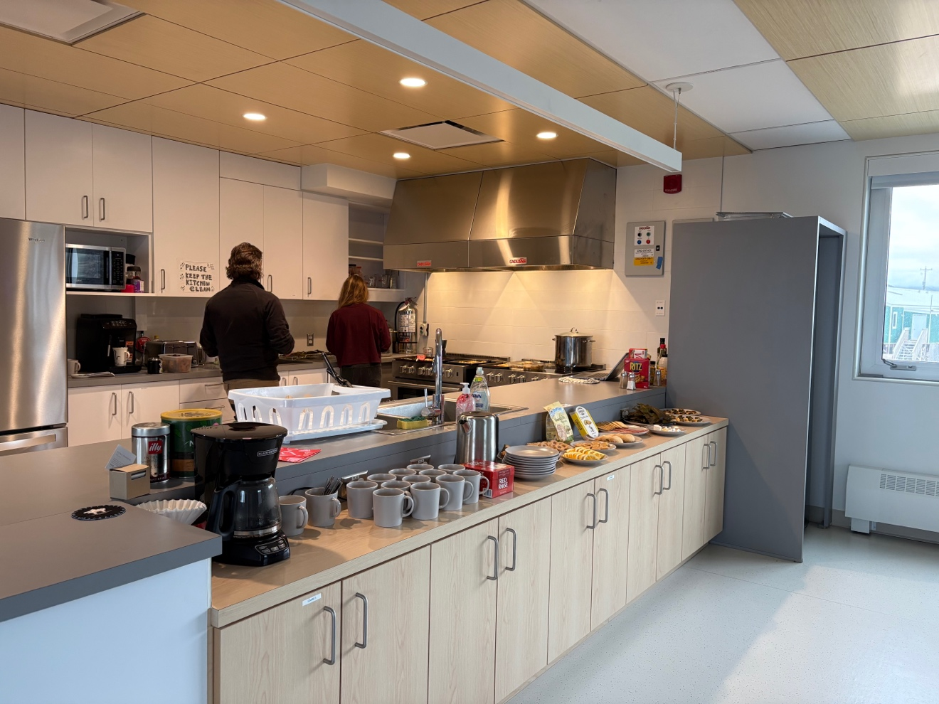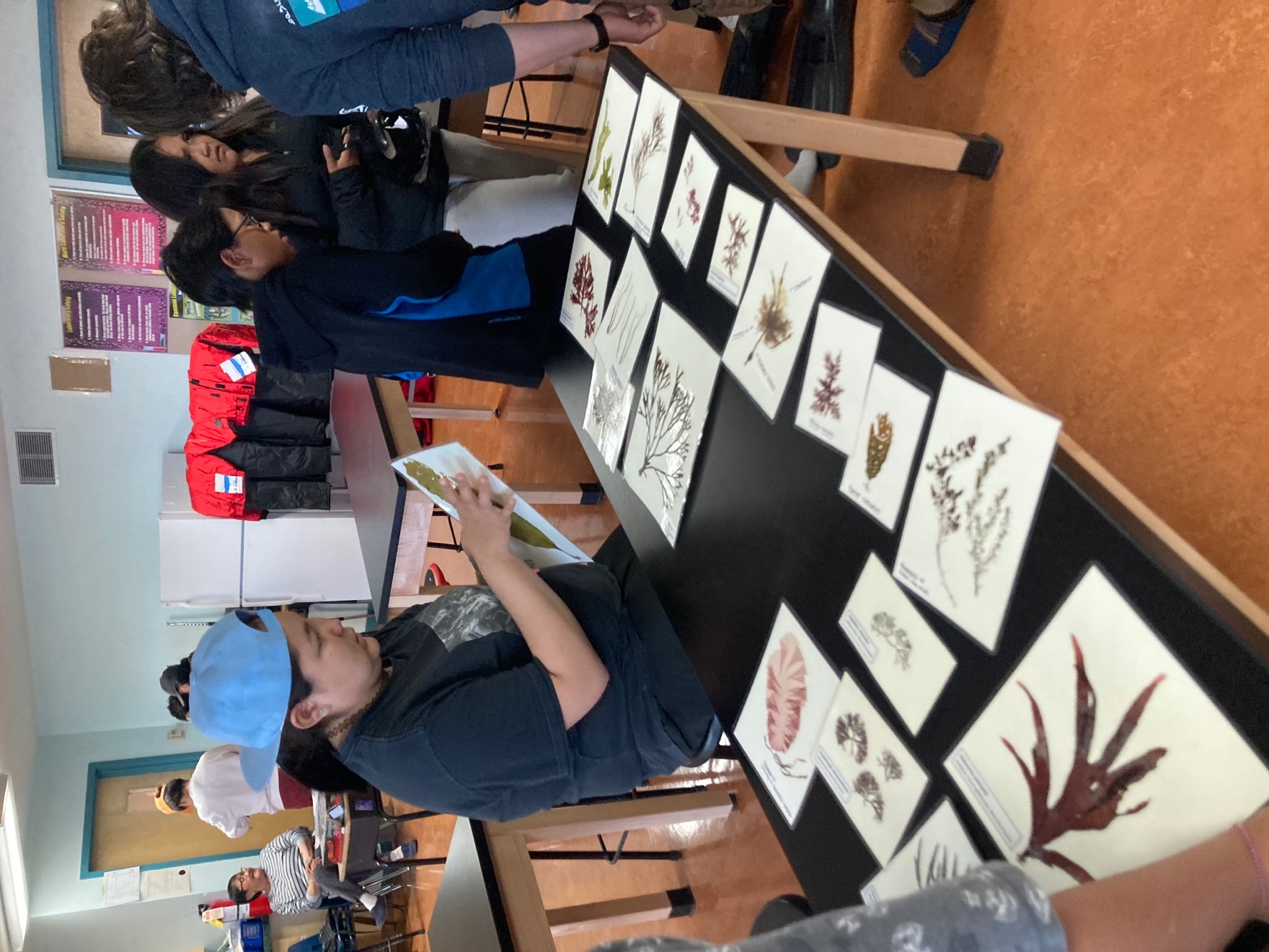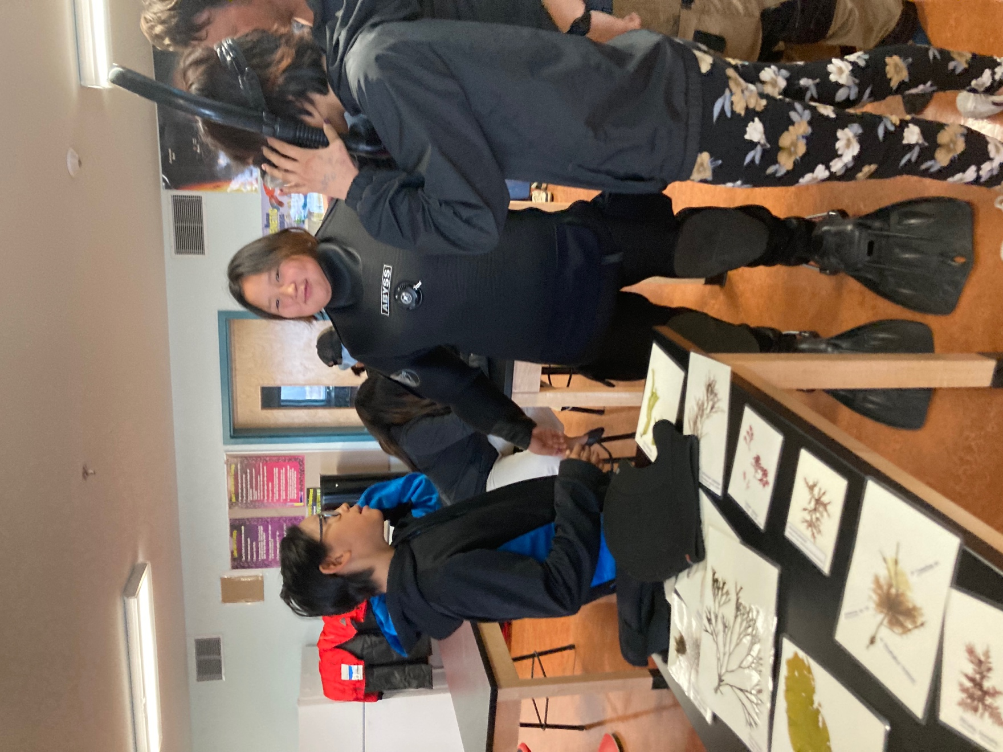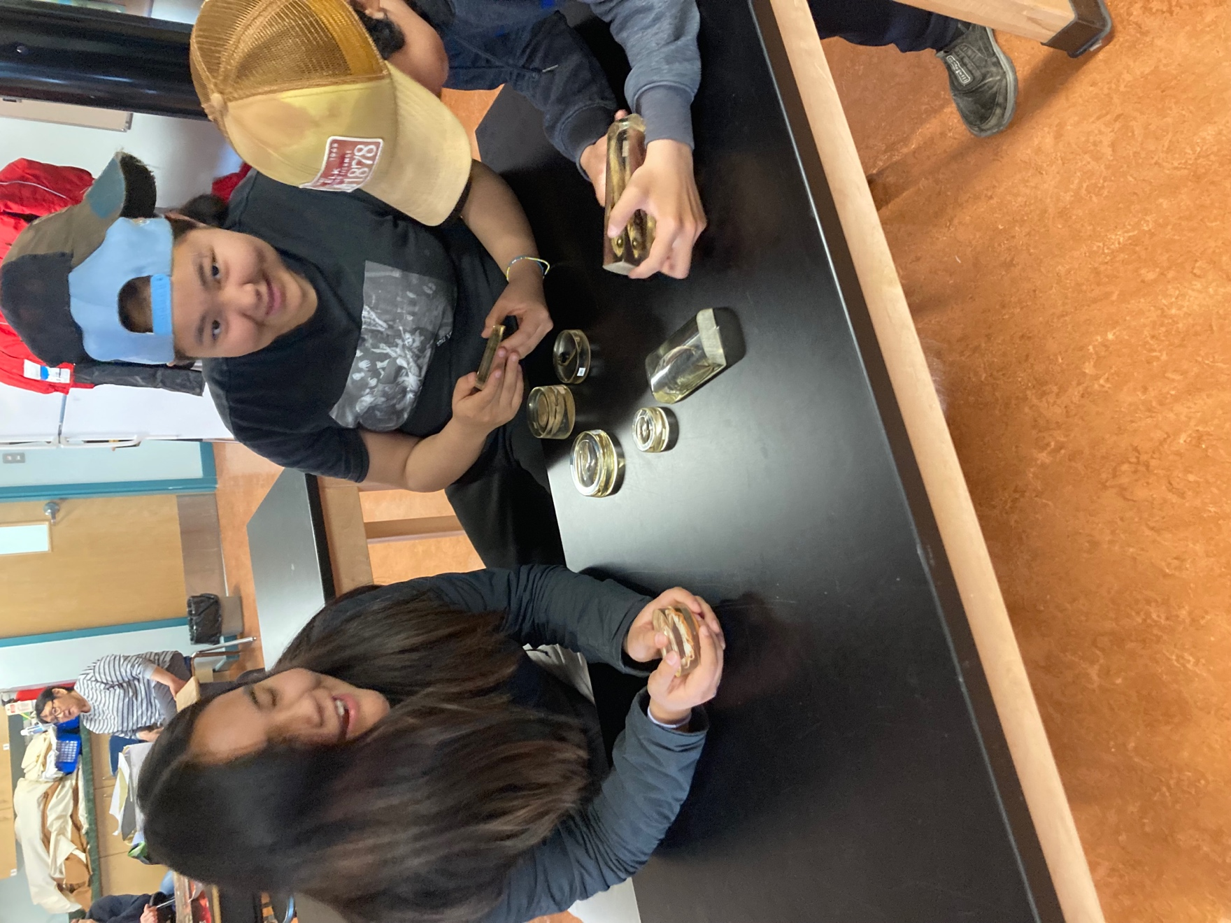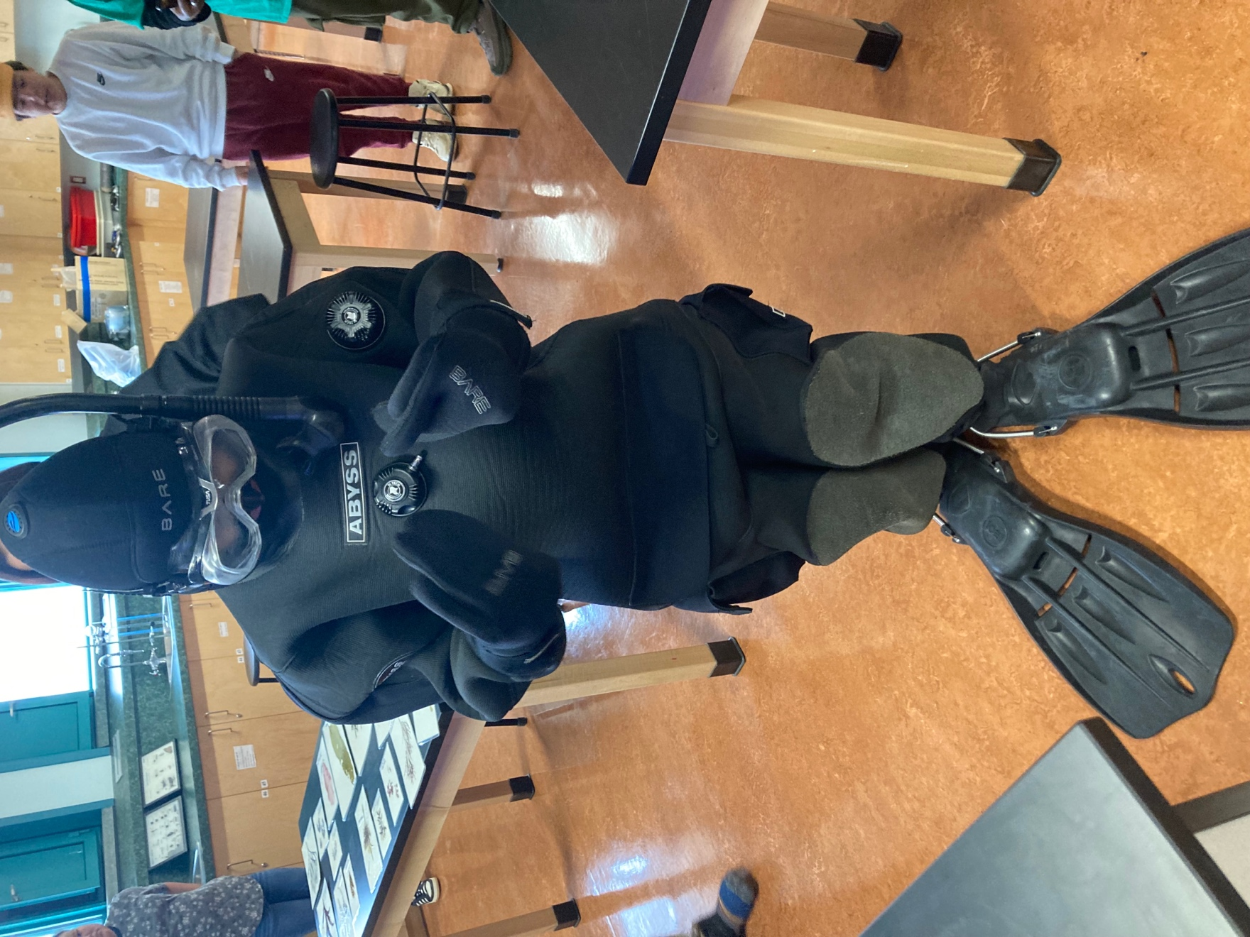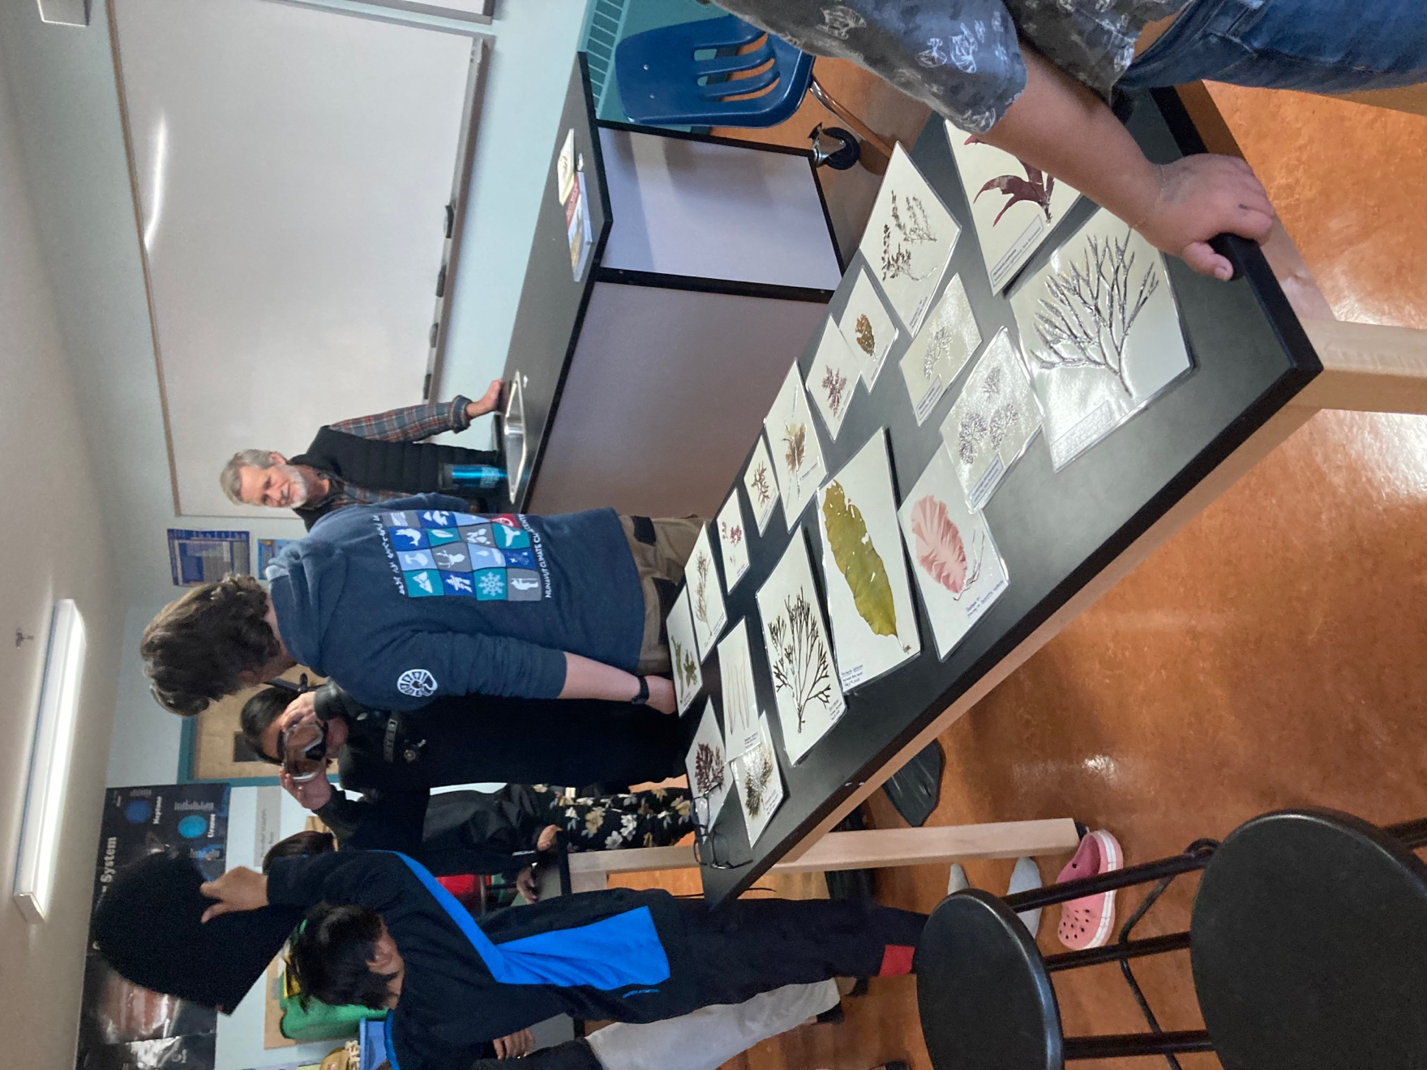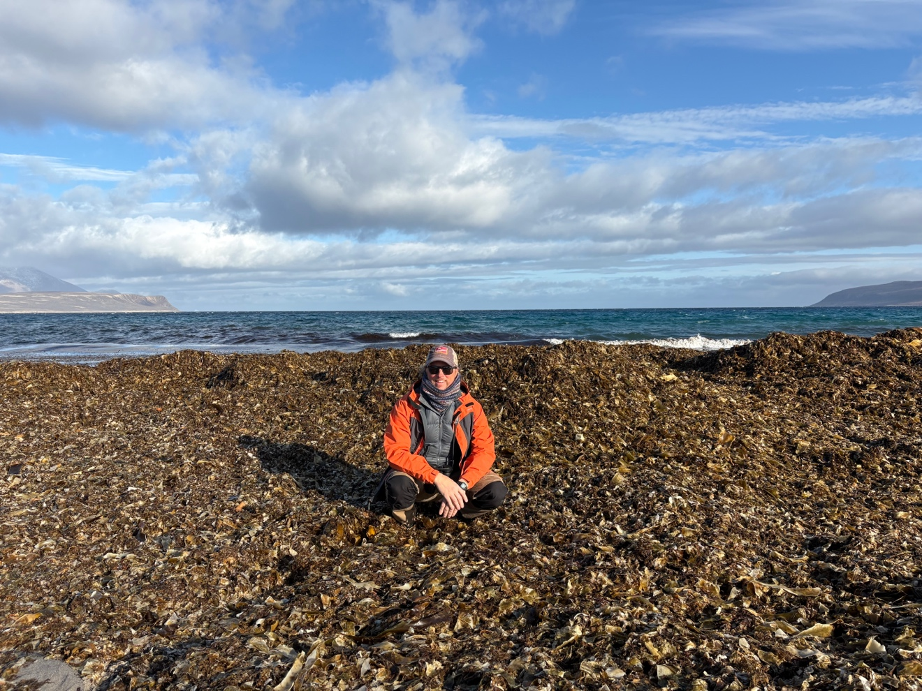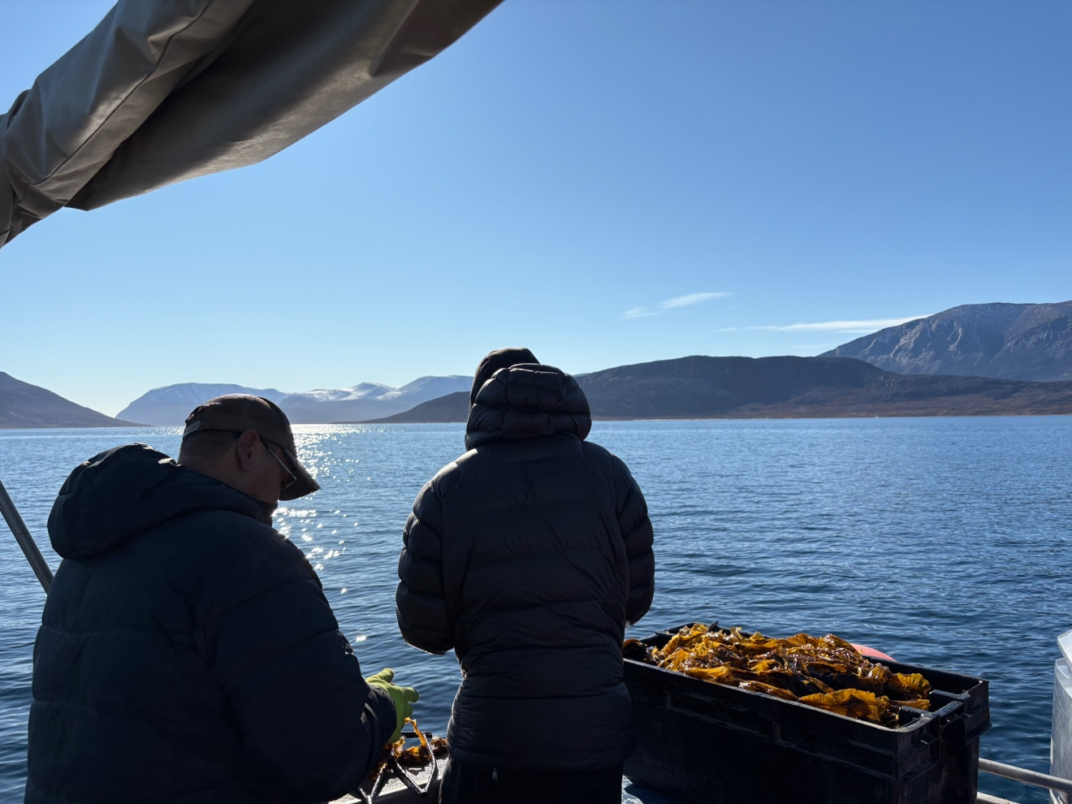
Getting prepared to meet with the community at the hamlet
Our boot at the Northern
Getting prepared for HTA visit at the Research Center
Visiting the Inuksuit school
Visiting the Inuksuit school
Visiting the Inuksuit school
Visiting the Inuksuit school
Visiting the Inuksuit school
There is a lot of Kuannik in Qikiqtarjuaq
Visiting the Inuksuit school
An afternoon with seaweed harvesters
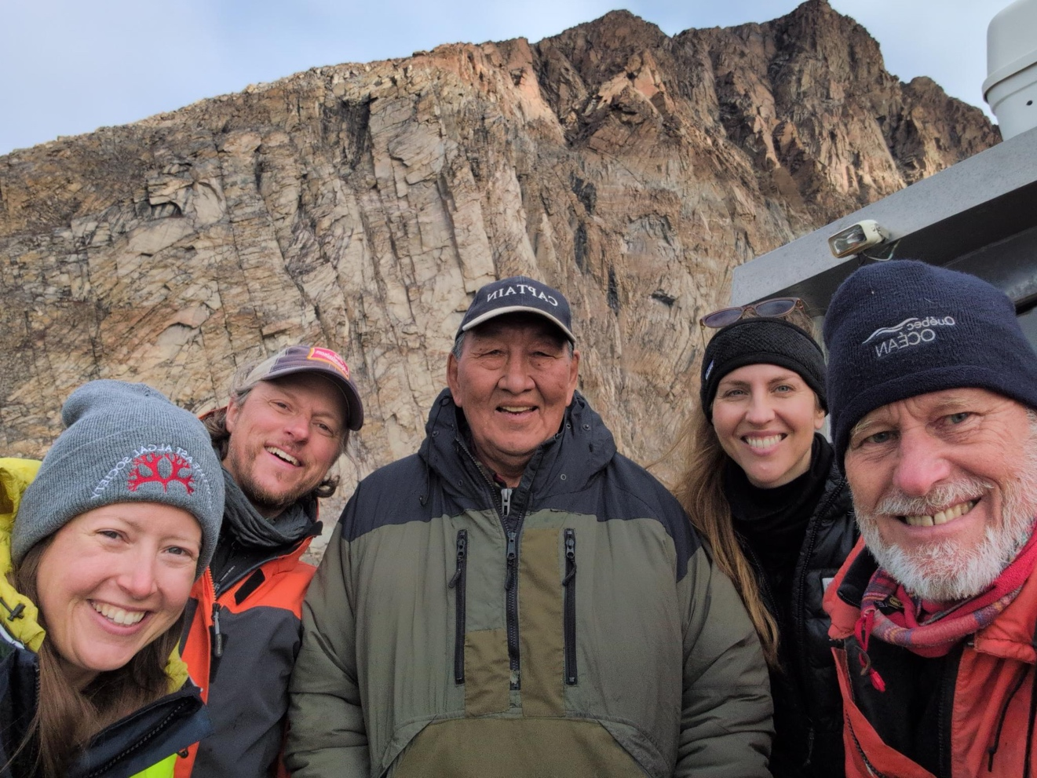
An afternoon with Billy Arnaquq

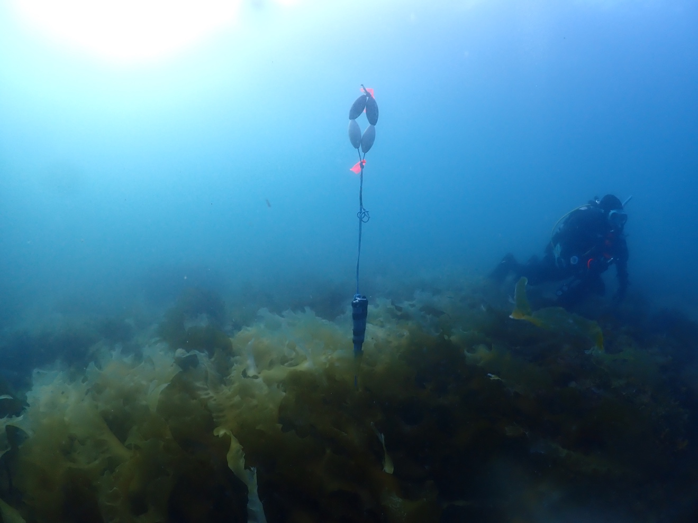
Example of a logger (pH and oxygen) that would be installed in a kelp forest

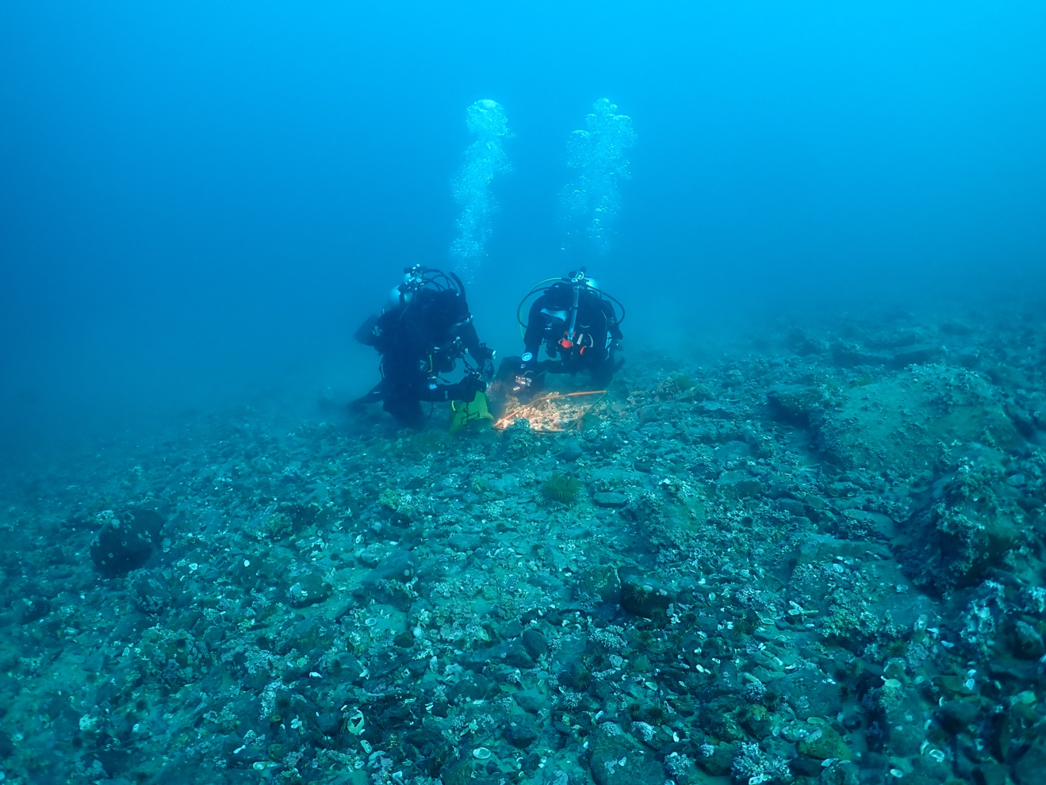
Example of sample collections that would be done by divers.

