CROSSBOW Project Overview
The CROSSBOW project will establish a network of operational defence capabilities across approximately 47 strategic locations in the Canadian Northwest Arctic, from the US-Canadian border in the Yukon to Alert, Nunavut. This Defence capability will operate within self-powered, autonomous, ruggedized power-generating container systems designed for continuous operations in austere environments and extreme Arctic conditions.

Project Inclusions
•Internal component capability acquisition and ISS
•Power generating container system acquisition and ISS
•Data pipeline initiation and management
•Deployment and installation of capability (Internal Capability + Container system)
•Interoperable data pipeline from capability location to intelligence capability

Project Maps/Geographical Footprint

Snapshot of Proposed Site Locations

Container System Prototype
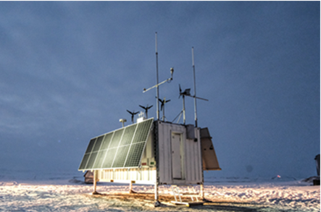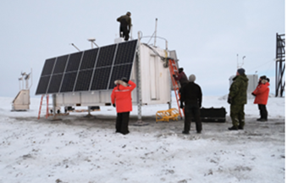

Container System Characteristics
•Modified ISO container (20' long x 8' wide x 8' high)
•Designed to be delivered by Hercules aircraft and heavy lift helicopter
•Estimated assembled weight 20,000 lbs
•Elevated on four 36" adjustable feet with pads
•Battery energy storage that is heated
•Doors at either end
•Powered by renewable and sustainable energy sources for uncrewed year-round operations:
•Solar photovoltaic panels
•Small wind turbines
•Direct methanol fuel cells
•Absorbent Glass Mat (AGM) Batteries
•Ventilated container for cooling purposes
•Requires only yearly (or less frequent) maintenance after installed and operational

Environmental Considerations
Shelter Emissions:
• Heat (used to maintain internal temperature)
• Water vapour (primarily exhausted to environment)
• CO and CO2 (primarily exhausted to environment)
Noise:
• Electromagnetic (low, based on measured testing results)
• Sound (minimal, from small wind turbines)
Impact on wildlife:
• Minimal to none anticipated, given low hub height and small rotor diameter of wind turbines
Ground/Stability:
• Do not disrupt the land / No permanent foundations required
• Mats used to distribute shelter weight pressure and minimize sinking potential

Deployment Logistics
- Study contracted to explore Arctic deployment logistics options. To be confirmed, as the project progresses, however, the project will most likely leverage regional hubs to deploy containers and supplies via airlift. Deployment teams require 3-5 days on site for the install and Initial Operational Testing and Evaluation (IOT&E), to include wildlife monitors/camp security.

Projected Timeline – Current as of June 2026
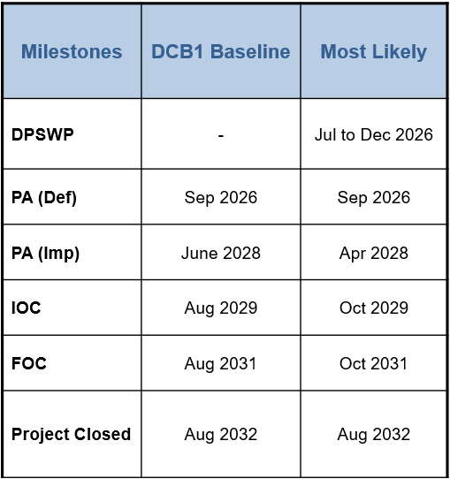

Project Q&A

- What is the physical footprint of development (m2)?
Roughly 14.9 m² per shelter. Each shelter is 20’ long x 8’ wide x 8’ high (with radio antennas and wind turbines extending from the top of the container approx. 6-10’

- Is there a need for site leveling or alternation?
No – the containers rest on 4-6 x 36” adjustable metal “elephant feet” installed at each corner (placed on top of a heavy rubber weight-distributing mat), ensuring minimal ground disruption and built-in container system levelling, which can be adjusted in conjunction with annual maintenance cycles if needed.

- What hazardous materials will be present?
Direct methanol fuel cells and Absorbent Glass Mat (AGM) Batteries – both of which are self-contained, as well as contained within the container system, making it extremely unlikely a spill would occur. Heat, water/vapour, CO, and CO2 are the only emissions from the system. Approximately 42x60L methanol containers will also be on site, however in the unlikely event of a spill, it will be limited to the impacted containers only, and will once again be self-contained within the container, as there is no floor drainage in the container design.

- What is the level of noise generation?
Low noise levels from the shelters, mainly from wind turbines (proportional to wind conditions).
Preliminary Noise Testing Results (conducted by contractor):
WT10 noise level at (6 ± 1) m/s wind speed
Distance | Noise level (dB)
Distance | Wind turbines ON | Wind turbines OFF
0 m at container height | 60 – 70 | 46 – 50
0 m at ground level | 55 – 60 | 46 – 50
10 m at ground level | 49 – 51 | 46 – 50
25 m at ground level | 48 – 50 | 46 – 50

Note: Values are averages over 1 minute.
Note: Due to the experimental limited accuracy and precision, no significant differences were observed between ground level and container height for 10 m and 25 m. No significant differences were found for all sides of the container.
Note: Technically, we only need one measurement for a given wind speed since all noise levels can be derived from the relationship between noise level and distance from the noise source.
Note: for reference:
- 50 dB is equivalent to light rain
- 60 dB is equivalent to a conversation at 1 m distance
- 70 dB is equivalent to a vacuum cleaner.

Electromagnetic noise testing by ADM(Mat) QETE had low results as well. We have requested the results from DRDC and will provide them upon receipt, if needed.

- What is the frequency and timing of access/servicing requirements?
All container systems are uncrewed and self-powered. They require only yearly (or less) maintenance once installed and operational.

- What is the operational need for this development in this location? Can it be located elsewhere?
In terms of site location flexibility, the locations were strategically selected considering several variables (elevation, geo-analysis, etc.) as well as other specific variables based on the Defence capabilities, which are classified. There is some flexibility in site selection, albeit limited, and must be reviewed on a case-by-case basis as a considerable amount of research has identified specific site locations to ensure maximum operational effectiveness of the capability.

In 2022, the Minister of National Defence announced CROSSBOW as part of the Northern Approaches systems to enhance continental Defence capabilities. The project has applied for National Security Exemption (NSE) status (in process).

- What time of year would the installation be expected?
Deployment and installation for all proposed locations will be during summer months (June-Sep), with first deployment tranche anticipated for summer 2029. We will consult with local and regional partners for deployment planning to ensure minimal impact on local harvesting seasons and other environmental and/or wildlife considerations.

- When will the project be decommissioned?
The CROSSBOW project has an Estimated Life Expectancy (ELE) of twenty (20) years. Leading up to the project end of ELE, the RCAF will determine whether the project will be extended, upgraded, repurposed, or decommissioned. Additional Land Use Requests will be submitted in accordance with the determination, if required.

- Will there be any other infrastructure at container site locations, such as a heli-pad or storage sheds? Will all equipment be in the container system?
No, there are no current plans for other infrastructure at site locations, and yes, all equipment will be in the container or attached to it. In summary, there will be no permanent infrastructure, period.

The entire approach of this capability is to choose terrain we can land helicopters on nearby, temporarily, just for the deployment of the systems. By design, we’ve made this as minimal as possible to drop everything in place, install and test component functionality and system operation, then leave it operational and in place. The landing zones will be located on flat land nearby, not too close but offset from the site itself, and will be confirmed at each site location as the geography dictates.

- These sites are in the windiest locations; will the containers tip over?
The project team has no indication they will tip over or be dislodged by the wind. The two container systems currently located in Alert, NU and one in Sachs Harbour, NWT have not moved; they’re quite heavy and stable, weighing approximately 20,000lbs in weight. Also, there are no expectations of tipping, based on 3 years of R&D at CFS Alert and geomatics assessment on site location and ground hardness by DRDC. In the unlikely event of movement/tipping, the capability operation would be interrupted, and the remote monitoring metrics would indicate in real time there is an issue to be investigated. Preventative system monitoring would indicate potential issues in advance as well, so monitoring centers would be able to anticipate potential issues with the systems before they occur.
The geomatics assessment did indicate that in some remote, high-altitude locations that guide wires may be required, however this is only on a site-specific basis and will be determined based on environmental conditions at specific proposed site locations, where needed.

- Are there guidelines used to support the shelters and anchor them in place?
No, guidelines are not required in most locations; however, there will be some exceptions as noted in #10. The rubber weight distributing pads underneath the container’s 4-6 “elephant feet” help to stabilize and distribute the container weight. In most locations, no guidelines are required to anchor it, so there is nothing disrupting or digging into the ground. Each container will “sit” on its 4-6 adjustable “elephant feet” in location.

- Why these two locations (Site 69: Ward hunt Island, and site 150)? Can you please provide a rationale as to why the stations need to be in the locations selected. Ie) need to be at certain intervals to be effective, require X elevation, etc.…Both are in wilderness areas where infrastructure and motorized access is not normally permitted.
See #6. Rationale for site selection is classified SECRET, and the project has requested a National Security Exemption (NSE) to support land use approval requests and equipment procurement.

- Timing of installation: In summer 2029, impact of tundra in summer, is there an option to deploy when snow on ground? Is the use of snowmachines planned?
Deployment details are TBC; however, it will be a common assumption that deployment at the most northern locations will have to be during the least severe weather months. Siting has ensured proposed sites are located on permafrost/hard ground to minimize settling over the estimated life expectancy of the container system. No snow machines are expected to be used to prepare site locations for deployment, however we are open to local knowledge and recommendations to better understand deployment considerations, challenges, special location-specific requirements, and/or risks at these locations.

- Can you please specify for each location if fixed winged (what aircraft) or rotary winged (what aircraft) would be used? Would a sling from rotary be used to place the units or use an ATV/snowmachine to transport out of fixed winged?
Deployment details are TBC, however depending on the location we could potentially assume slung load placement from a Chinook helicopter (or something similar) for the container system deployment.

- Is any fuel caching proposed?
The system does not use petroleum-based fuels, so no. There may be central support hubs established, to more efficiently transport supplies to remote container system locations, however these will not be in National Parks.

- Related to potential wildlife disturbance, the noise (Db) info provided (volume) but what about wavelength?
Preliminary Electromagnetic noise testing by ADM (Materiel) Quality Engineering Test Establishment (QETE) also provides low results as well. We have requested the results from DRDC and will provide them upon receipt, if required for land use permitting approval.

- What will be involved in ongoing maintenance? Small crew referred to, but will it be the same type of aircraft or smaller helicopter?
These details are to be confirmed. The maintenance details will be the responsibility of the selected contractor, so will only be known upon contract award for the container system maintenance services.

- Is there any vegetation removal chemicals planned to be used?
No.

- Is there an Environmental Impact Assessment Mitigation Plan?
Yes, however the Environmental Impact Assessment Mitigation Plan is still in draft form and will be completed as the project progresses leading up to (and including) engagement with regional partners, who can inform select aspects of the mitigation plan. We anticipate support from Defence Construction Canada (DCC) to provide specialized environmental support throughout 2027 which will feed into CROSSBOW environmental mitigation requirements or strategies as part of site assessments, deployment, and ongoing maintenance and life cycling.

Defence Research and Development have already informed items such as:
- Surface installations impact on ground shifting or subsidence, with visual inspections indicating 1” ground settling over a 3-year period.
- Heat loss and long-term presence altering ground conditions, including IR images showing the heat gradient, and indicating no significant heat conduction to the ground.
- Behavior of contaminants in permafrost environments; although no testing has been done as it would require a controlled methanol spill on the ground, however the design of the container assumes leakage is not expected into the environment given the seal of the shelter’s walls and floor (assuming steel container). A design choice was also made not to place a drain hole in the floor to remove any spilled methanol. Methanol safety measures have been implemented, including methanol spillage alarms and MSDS instructions.
- Use of solar PV/wind turbines/DMFCs/batteries was proven to provide a polar night power and energy solution in the Arctic.
- Methanol is contained in discrete 60L cartridges, so meets the transportation requirements for RCAF heavy lift aircraft, and was chosen over diesel for its function at sub-zero temperatures without a direct heating solution, providing longer operation with less (L) fuel on site, as well as methanol’s compatibility with fuel cells to bridge the charging gap when solar/wind resources are not available during polar nights. It also has a lower freezing point and significantly lower GHG emissions.
- Deployment mitigations will be further refined, but will include safety procedures, spill kits, consideration for wildlife migratory paths and an aim to minimally disrupt the environment, including post-deployment site condition reflecting a stable and safe state consistent with pre-deployment site conditions.

- Is the project of national significance to the country and are the proposed sites required for the systems operation?
Yes, the project is of national significance, and the proposed sites are required for overall system network operation. The project has requested a National Security Exemption (NSE) to support land use approval requests, which is currently in progress. CROSSBOW was announced in 2022 by the Minister of National Defence as part of a broader NORAD Modernization Plan.

- Will the container/station be anchored? Are the wind turbines robust enough to withstand high arctic conditions and is there an alternative power source? Extreme high winds are a concern.
See #10. Per the project overview, the system’s primary power sources are wind and solar, with backup battery power also available. Preliminary testing managed by Defence Research and Development Canada (DRDC), who deployed a container system to Alert, NU in 2023 have shown no indication of tipping or movement from the wind. The wind turbines are ruggedized and are part of the system’s routine maintenance plan to be checked/replaced annually. Backup methanol fuel cells are in place for extreme climates where solar and wind power generation are not sufficient for sustained container operation, such as during polar nights and the coldest winter months in the northern-most locations.

