McGill University

Faculty of Agricultural Faculté des sciences de
and Environmental Sciences l'agriculture et de l'environnement

McGill University Université McGill Tel.: (514) 398-7677
Macdonald Campus Campus Macdonald Fax: (514) 398-7990

21,111 Lakeshore Road
Department of Natural Département des sciences Ste-Anne-de-Bellevue
Resource Sciences des ressources naturelles Québec, Canada H9X 3V9

April 12, 2021
Mary Ellen Thomas
Nunavut Research Institute
Iqaluit, NT
X0A 0H0

Re: Nunavut Research License Annual Summary of 2019, 2020 Research Activities

Dear Mary Ellen,

Hope all is well for yourself and the NRI staff. Please find enclosed the Annual Summary of the 2019 Research Activities as required to renew my NRI research license for 2021, as part of my multiyear Nunavut Research License 02 035 19R-M. Please also Our field research season for 2020 was cancelled because of the pandemic and no NRI license was applied for.

Please be advised that I am in the process of having the Inuktitut translation completed and will have it forwarded to your office as soon as it is available.

I have successfully applied to PCSP for a field trip to the McGill Arctic Research Station on Axel Heiberg Island as follows:

a. Summer field trip: ~ 12 days between ~ June 25 to ~ July 30, 2020

Lyle Whyte, Miguel Fernandez, Brady O’Conner, Elisse Magnuson, Louis Jacques Bourdages, Olivia Blenner-Hasset

If further information is required or if you have any questions, please do not hesitate to contact me.

Sincerely,
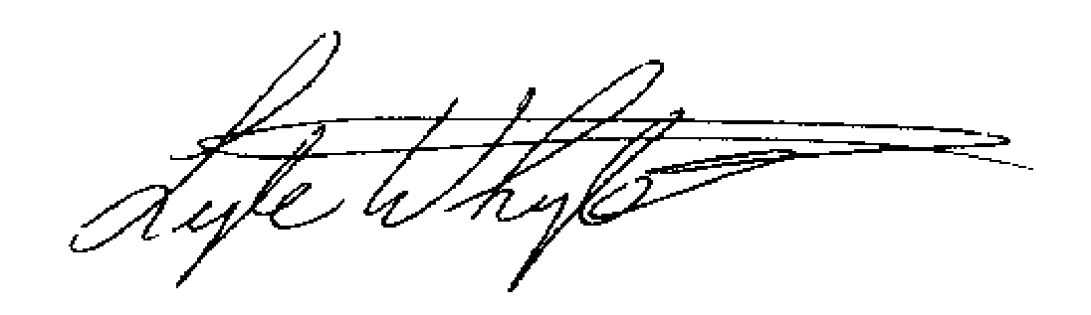

Lyle Whyte
Professor

Tel. 514-398-7889 Fax: 514-398-7990 Email: Lyle.Whyte@mcgill.ca
Nunavut Research License - Dr. Lyle G. Whyte McGill University

Annual Summary of 02 045 19R-M Research Activities

The microbial biodiversity in unique habitats including cold perennial salt springs and permafrost environments have not been fully explored, and molecular traits that enable microorganisms to survive and thrive in the Canadian high Arctic are unknown. My research program examines microbial biodiversity and ecology in unique polar habitats to expand our knowledge of polar microbial communities. We focus on understanding the response of Arctic permafrost microbiology to global warming, and also utilize these environments as Mars analogs. The 2019 field season involved research activities at the cold saline springs on Axel Heiberg Island (AHI) and the permafrost study site near the McGill Arctic Research Station (MARS). Ianina Altshuler (Ph.D), Catherine Maggiori (MSc), David Touchette (MSc), Olivia Blenner (PhD), Elisse Magnuson (PhD), and Lyle Whyte were based at MARS from July 10 to July 22. Altshuler also measured green house gas fluxes at the permafrost site, continuing our long term monitoring of the site. Blenner and Magnuson collected sediment and water samples from the Lost Hammer (LH) and Gypsum Hill (GH) cold saline springs that are hypothesized to contain novel microorganisms. Touchette field tested an updated uMAMA prototype (microbial activity assay) for sensitivity, robustness, and autonomy at the same sites. Maggiori further tested the nanopore MinION, a novel, miniaturized DNA sequencer at MARS to examine capabilities of this new technology for in the field DNA sequencing. Lastly, we field tested (PhD) the microbial detection platform via field testing of 4 major components: drilling and sample acquisition (automated micro-drill), DNA extraction (FastPrep, microfluidic system), sequencing preparation (VolTRAX V2), and DNA sequencing (MinION) required for robotic biosignature detection. These technologies are very promising for field based sequencing in remote locations such as MARS and for future astrobiology missions.

2019 Summary
We are requesting a summer trip for 2021 (June 25 – July 31) with L. Whyte, E. Magnuson, B. O’Connor, M. Fernandez, L. Bourdages, and O. Blenner-Hassett to AHI. Our main objectives are: i) Cold Saline Springs: Magnuson (PhD) will attempt to determine the active microbial components inhabiting the highly unique Lost Hammer (LH) and Gypsum Hill (GH) cold saline springs that are hypothesized to contain novel microorganisms. ii) Biosignature Detection: Fernandez, O’Connor, and Bourdages will field test the microbial detection platform via field testing of 4 major components: drilling and sample acquisition (automated micro-drill), DNA extraction (prototyupe MagLysis), sequencing preparation (VolTRAX V2), and DNA sequencing (MinION) required for robotic biosignature detection. These will be tested with numerous Arctic samples which are considered Mars, Enceladus/Europa analogues. Similarly, O’Connor(MSc) will field test our latest uMAMA prototype developed in collaboration with A. Rico (NASA Ames) for sensitivity, robustness, and autonomy at the same sites; the uMAMA will contain mixtures of Mars-relevant organic and inorganic growth substrates. He will also collect surface glacier samples from the White and Thompson Glaciers for laboratory microbial analyses. iii) Novel arctic bacteria: Blenner-Hassett (PhD) will isolate and characterize novel microorganisms using the latest cryo-iPlate through in situ incubations focusing on the Gypsum Hill springs.

