Interim code of practice: End-of-pipe fish protection screens for small water intakes in freshwater

1 About this code of practice
This code of practice provides national guidance on the design, installation and maintenance of small end-of-pipe water intake fish screens to prevent entrainment and impingement of fish. Entrainment occurs when a fish is drawn into a water intake and cannot escape. Impingement occurs when a fish is held in contact with the intake screen and is unable to free itself.
The end-of-pipe fish screen code of practice describes best practices to follow when designing, installing, maintaining and cleaning low volume water intakes that have the potential to impact fish. This code of practice is for small-scale water intakes (e.g. irrigation, construction, municipal and private water supplies, mining exploration) where the water intake flow rate is up to 0.150 m³/s, or 150 litres per second (L/s). Impacts related to fish habitat and changes in flow conditions are not covered by this code of practice.
When working in water, it is important to have a good understanding of local conditions. For example, water velocity, flow, depth, the type of fish species present and their abundance and swimming abilities are all important factors to consider when designing, installing, maintaining and cleaning small end-of-pipe water intake fish screens. This code of practice provides necessary information and guidance on the measures to follow to ensure maximum protection of fish. The sizing and design specifications of fixed screens in this code are exclusively for fish that have a minimum fork length of 25 mm. Entrainment and impingement impacts on eggs and larval fish can be minimized by following the measures below.
A project review is not required when the conditions and measures set out in this code of practice and all applicable measures to protect fish and fish habitat are applied.
This code does not remove or replace the obligation to comply with all applicable statutory and regulatory requirements in place by other sections of the Fisheries Act, or other federal, provincial, or municipal legislation and policies associated with water extraction.

2 You can use this code of practice if:
- There are no aquatic species at risk present in the work zone or the affected area. Consult our aquatic species at risk maps to determine where at-risk populations occur in Canada and where their critical habitat is located
- The water withdrawal is for small-scale water intakes, where the water intake flow rate is up to 0.150 m³ /s, or 150 litres per second (L/s)
- You incorporate the measures in this code of practice and all other applicable measures to protect fish and fish habitat
Request a project near water review when the works, undertakings or activities do not meet all the criteria listed in this section.

3 Measures to protect fish and fish habitat for end-of-pipe fish screens

1 Fish screen design
Three criteria need to be considered when designing a fish screen for water intakes:
- Effective screen area
- Screen material
- Screen shape

1.1 Effective screen area
Larger screens reduce the approach velocity so fish are more likely to outswim the flow entering the intake. The screen area needed depends on the amount of water being withdrawn and the species of fishes that frequent the intake location. The total submerged screen area available for the free flow of water is referred to as the effective screean area.
- Use the End-of-Pipe Screen Size Tool to determine the effective screen area for your project
  - to protect fish from impingement or entrainment, the approach velocity (i.e., the water velocity into, or perpendicular to, the face of an intake screen) should not exceed the values set for each species
  - you should apply a precautionary approach when a species is absent or unknown by using the ‘All/Unknown' option in the species selection list. This selection will determine the effective screen area for the weakest swimming fishes

1.2 Screen material
For a fish screen to prevent entrainment, the openings must be small enough so a fish cannot pass through. The narrowest dimension of any opening on the screen, regardless of opening shape, is referred to as the design opening (Figure 1). The maximum design opening for a fish of 25 mm fork length is estimated at 2.54 mm.
- Ensure the design opening of the screen material does not exceed 2.54 mm
- Ensure there are no protrusions on the screen surface of support structures that could injure fish
- Use welded wedge wire screens (Figure 2), whenever possible
- Ensure screen material is resistant to corrosion and UV light (i.e., brass, bronze, aluminum, monel metal, galvanized or stainless steel, plastics)
- Use material that minimizes clogging
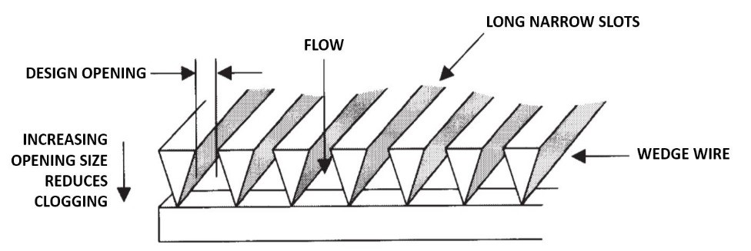
Figure 1
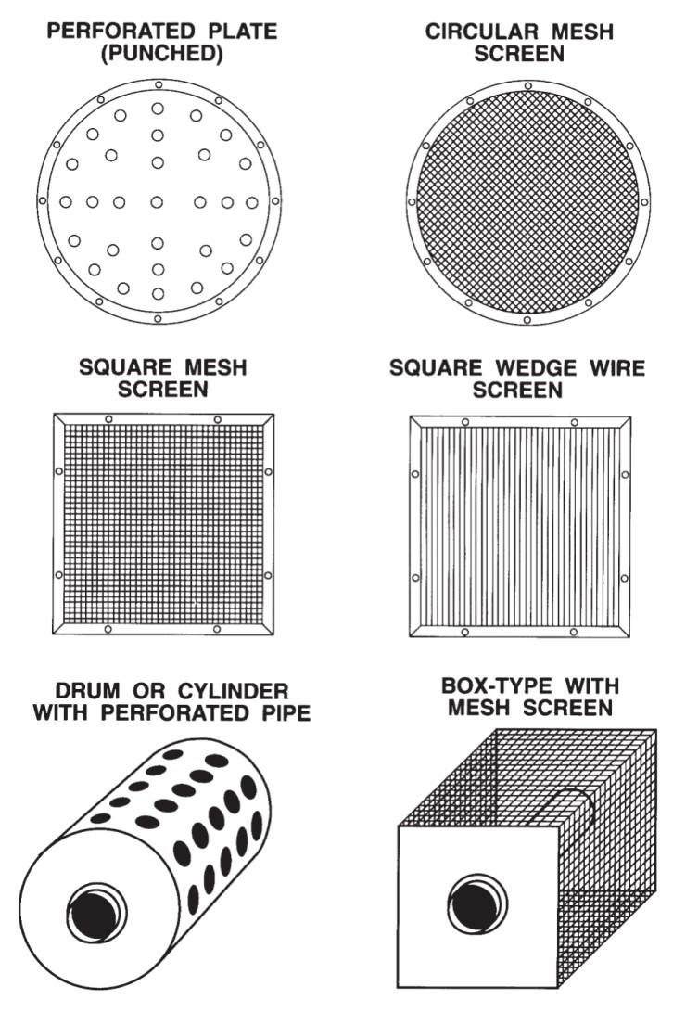
Figure 2

1.3 Screen shape
Use a manifold on designs where the flow would be uneven across the surface of the screen (e.g.: cylindrical or box type) (Figure 3).
- Ensure the manifold is equal distance from the outer screen
- Cap the end of the manifold with a solid material
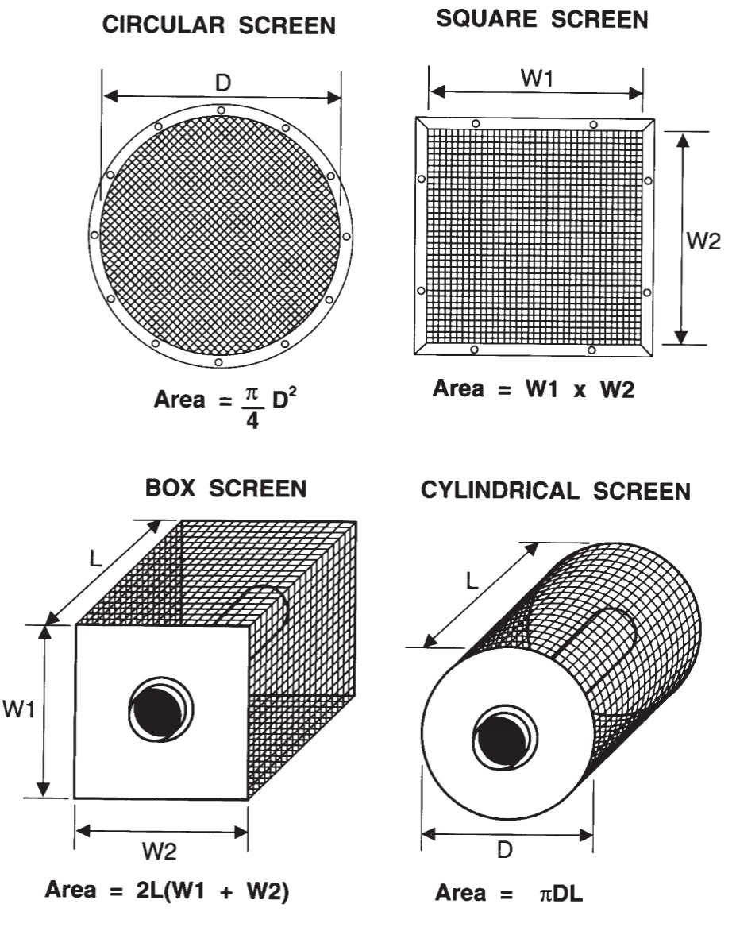
Figure 3

2 Fish screen installation
Consider the following best practices when installing a fish screen:
- Plan in water work, undertaking or activity to respect timing windows to protect fish including their eggs, juveniles, spawning adults and/or the organisms upon which they feed and migrate
- Place screens away from natural or man-made structures that may attract fish that are migrating, spawning, or in rearing habitat
- Place screens in waters with low concentrations of fish throughout the year
- Orient the screen so any natural water flow passes across the surface of the screen material
- Place screens a minimum of 30 cm above the bottom of the watercourse to prevent the entrainment of sediment and benthos that dwell in the substrate
- Ensure all openings for guides and seals are smaller than the opening width of the screen material (2.54 mm) so fish cannot pass through
- Ensure there is enough structural support to prevent sagging or collapsing of the screen panel
- Account for the areas blocked by supports while meeting the effective screen area recommended in this code of practice
- Protect large screens with trash racks fabricated of bar (150 mm spacing is typical) or grating in areas where there is debris loading (i.e. woody material, leaves or algae mats)
- Check the approach velocity directly in front of the screen to ensure it does not exceed the designed approach velocity at any location
- Avoid withdrawing water from the littoral zone when possible
- When possible, avoid withdrawing water, or reduce the rate of water withdrawal, during critical timing windows to diminish the likelihood of entraining eggs and larval fish

3 Screen maintenance and cleaning
Debris or damage to screens can cause uneven intake flow across the screen surface. Uneven flow may result in higher intake velocities on some sections of the screen, increasing the likelihood of impinged fish. You can verify the pump's approach velocity to assess the need for screen cleaning using a flow meter. Keeping fish screens clean maintains their effectiveness for supplying water and protecting fish.
- Properly maintain cleaning apparatuses, seals and screens
- Turn off intake pump prior to the removal of the screen for cleaning and/ or maintenance

4 Project notification
Please submit a Notification Form to your regional DFO office to help us improve this fish and fish habitat protection guidance over time.

Notification form
(PDF, 41 KB)

5 Contact us
If you have questions regarding this Code of Practice contact the Fish and Fish Habitat Protection Program located in your region. https://www.dfo-mpo.gc.ca/pnw-ppe/contact-eng.html

Nunavut
Fish and Fish Habitat Protection Program
Fisheries and Oceans Canada
867 Lakeshore Rd
Burlington ON L7S 1A1
Telephone: 1-855-852-8320
Email: FisheriesProtection@dfo-mpo.gc.ca

6 Glossary
Affected area Area within which potential impacts from works, undertakings or activities are likely to occur.
Approach velocity The water velocity measured directly in front of the intake screen.
Benthos Organisms that live on or in the bottom sediments of a body of water.
Design opening
The narrowest dimension of any opening on the screen, regardless of opening shape.
Effective screen area
The area of the open spaces available for the free flow of water, including screen material but excluding major support structures.
Entrainment
Occurs when a fish is drawn into a water intake and cannot escape.
Fork length
The straight line distance measured from the tip of the nose to the fork of the tail of a fish.
Impingement
Occurs when an entrapped fish is held in contact with the intake screen and is unable to free itself.
Intake flow rate
The amount of water withdrawn over time.
Littoral zone
The shallow water near shore. The depth of the littoral zone varies but is generally 2-5 meters deep in most freshwater systems.

