

**Hackett River Project**

**2011 Annual Report For**

**INAC Land Use License N2010C0015**

March 2012

1. The camp for the Hackett River Project (Figure 1) was in operation from February 22 to October 2 for a total of 223 days. During the 2011 season, a number of activities were carried out.

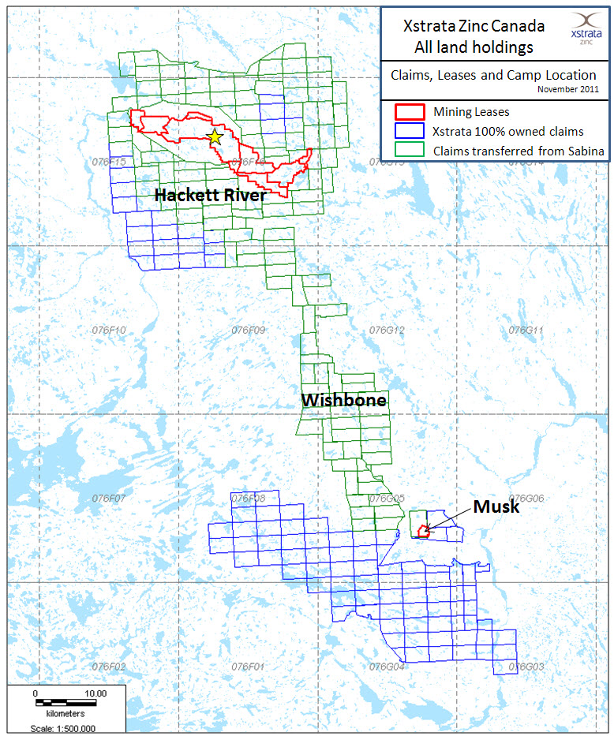

*Figure 1 – Xstrata landholdings in the Hackett River / Wishbone area.*

The 2011 diamond drilling program at Hackett was undertaken in order to increase confidence in the existing deposits as well as to add to the margins of the known deposit boundaries. At Hackett a total of 42 holes were collared for a total of 9,269 m drilled; all within 300 m of 2 of the core deposits (Main Zone, and East Cleaver).

Additional planned early-stage exploration drilling in the D’Arcy Lake area, targeting geophysical anomalies and testing the regional mineralization potential, was suspended after the announcement of the impending sale of the property to Xstrata.

Beginning on June 2, and completed by June 19, both diamond drills were moved to test gold targets, which will remain under the control of Sabina. The drills were supported through the Hackett camp, and drilling continued until September 22, to complete 44 drill holes, at which point, both drills were shut down, brought back to the Camp Lake winter laydown area, and winterized

Additional exploration activities during the 2011 season consisted of ground and down-hole geophysical surveys, prospecting and mapping and lake sediment sampling on the Wishbone claims. Claim staking added a total of 106 claims ( 91,917 ha) to the Wishbone properties during May and additional claims were staked, on behalf of Sabina, in August.



*Figure 2. 2011 drilling, Hackett area, by Sabina Gold & Silver.*

(b) Plans for 2012 include continuing to evaluate the resource potential at the known deposit sites (Main Zone, East Cleaver, Boot Lake, JO Zone) as well as follow up drilling at the D’Arcy Lake area. Geophysical surveys will be conducted to re-evaluate and refine the knowledge of the local geology, and continued mapping in the Wishbone area will be done to further the understanding of the local geology and mineralization controls.

(c) Much of the environmental work on site consisted of ongoing in-house data collection and sampling in order to address data gaps in previous work conducted at the Hackett project.

The weather station operated continuously over the year to collect temperature, wind (speed and direction), solar radiation and barometric pressure data.

Several issues arose in 2010 with the thermistor data loggers and permafrost monitoring stations; plans for 2011 included replacement of the data loggers to simplify the data collection process. However, in the end, only one data logger was operational (Camp Lake), while the other still remains under repair, with plans to reinstall in early 2012.

Acid rock drainage/metal leaching (ARD/ML) sampling included weathering bin drainage samples from ongoing field testing of the potential ore and waste material. Attempts at sample collection were made twice during the year; there was insufficient leachate material for sampling during the second attempt later in the summer

(d)

Several grizzly bears were seen around camp during the course of the 2011 season. The first bears were seen in late April, though neither sighting was within camp boundaries. Subsequent bear sightings occurred at the esker strip south of camp, in the Finger Lake area, and a bear was observed chasing a caribou on the Mara River, in late May.

Later in the season, a sow and her cub, often followed by a large male grizzly were seen around the south end of camp, where the incinerator is located. They were spotted on numerous occasions, in the evening, and were chased away by shouting and/or the helicopter on each occasion. In all cases, the bears were non-threatening, and showed no interest in entering camp further, now did they pose a threat to property or persons in camp.

Bears were seen until mid September, and then there were no reported sightings or signs of bears within 1Km of camp until closure on October 2.

(e)

The following table identifies the Nunavut Land Claim Agreement (NLCA) beneficiaries employed by Sabina and total days worked on the Hackett property. The table does not include those workers employed by contractors/suppliers.

**HACKETT / WISHBONE PROJECTS COMBINED**

|  |  |  |  |
| --- | --- | --- | --- |
| **Name** | **Position** | **Community** | **Days** |
| Albert Anavilok | Camp Hand, Mechanical | Kugluktuk |  |
| Bob Kohoktak | Camp Hand, Supervisor | Kugluktuk |  |
| Chris Ipakohak | Camp Man, Core Cutter | Kugluktuk |  |
| Frank Ipakohak | Camp Hand, Environmental Assistant, Community Relations Manager | Kugluktuk |  |
| Jerry Oniak | Field (Survey) Technician | Kugluktuk |  |
| John Jr. Kuneluk | Camp Hand, Mechanical | Kugluktuk |  |
| **Total Kugluktuk** | | | **741** |
| Ramona Kikpak | Camp Hand, Sample Prep | Gjoa Haven |  |
|  |  | **Total Gjoa Haven** |  |
| Andrew Pokiak | Camp Hand | Cambridge Bay |  |
| Carl Atatahak | Core Cutter | Cambridge Bay |  |
| Cody Evalik | Core Cutter | Cambridge Bay |  |
| George Taptuna | Core Cutter | Cambridge Bay |  |
| Lucie Tedjuk | Camp – kitchen/cleaning/sample prep | Cambridge Bay |  |
| Martin McCallum | Camp Hand, Carpenter | Cambridge Bay |  |
| Mary-Anne Palvialok | Camp – kitchen/cleaning/sample prep | Cambridge Bay |  |
| **Total Cambridge Bay** | | | **601** |
| Amanda Anavilok | Camp – kitchen/cleaning/sample prep | Yellowknife |  |
| Trish Hala | Camp – kitchen/cleaning/sample prep | Yellowknife |  |
| **Total Yellowknife** | | | **128** |
| ***Total Hackett Project*** | | | ***1476*** |

Table 1. NLCA beneficiary employees of Hackett camp, 2011.

(f) Sabina did not conduct any formal community engagement or consultation activities in 2011. Representatives from the company regularly attend various trade shows and conferences where members of the various regulatory agencies are present, and make an effort to discuss project details and plans.

(g) Inspections that occurred during the 2011 exploration program include:

* July 6 - 8, AANDC geologist Matthew Senkow was on site to go over drilling and exploration programs, and review other pertinent parts of the project.
* July 9, AANDC Water Resources inspection. Ian Rumboldt, Water Resources Officer, and a student completed an inspection of camp, permits and all paperwork. Overall the visits went well, with no concerns of note.
* July 20, KIA inspection. Stanley Anablak, Luigi Toretti and a student visited the Hackett project for the annual inspection. No serious concerns were noted during the visit to Hackett camp. Location of drill sites on land and general cleanup in the area of camp were identified and addressed prior to camp closure. A verbal approval for the Quonset hut was given to camp management by Stanley during the visit.

(h) No community members visited Hackett River Project in 2011.

1. Site photos.

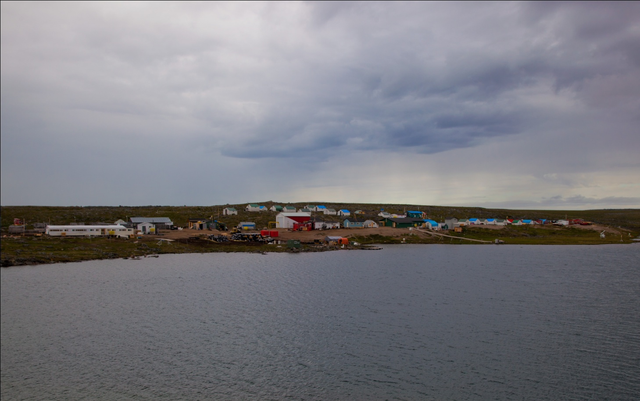

*Figure 3. Aerial image of Hackett camp. Photograph taken July, 2011.*

(j) Personnel, equipment and supplies were mobilized to the property by fixed wing aircraft including De Havilland DHC-5, Buffalo, Dornier 228, Dash-7, Skyvan and Twin Otter on the ice strip in spring and float equipped Twin Otter aircraft on the lake in the summer. The ice strip on Camp Lake was operational from mid-February to early June. From June to July, the gravel air strip located approximately 7 km south of camp was utilized on occasion.

Regularly scheduled supply flights started landing on Camp Lake in early July; these are typically two planes a week, on Tuesday and Friday. The final float plane of the season took off from Camp Lake on October 2, at which point the camp was closed for the season

(k) A Bell 407 was used throughout the course of the 2011 exploration program, and was supplemented with the use of a Bell 206L (Long Ranger). Records were not kept of every individual touchdown, however it would be reasonable to estimate an overall average of 3-4 landings per day including drill crew shift changes, drill support, as well as geological, geophysical, survey and environmental crews. This estimate would result in a total of 670-900 landings.

The main flight routes would be between the camp at Hackett River and the drilling areas indicated in Figures 2 and 3, as well as the mapping and sampling locations at Wishbone. Most landings would only be brief touchdowns to allow passengers to enter or exit the helicopter, without the machine actually shutting down.

(l) See Item (d) above.

(m)

Progressive reclamation activities in 2011 focussed on reclamation of the drill sites. Ongoing efforts were made to reclaim drill sites at the completion of each hole/setup. Several old, steel, fuel drums were located down near Noranda’s old Musk Camp, and were flown out to Yellowknife for disposal. No other progressive reclamation activities were undertaken in 2011.

(n) Sabina has, to the best of our knowledge, conducted this operation in full compliance with the terms and conditions annexed to the permits, and we are actively working with inspectors and regulators to address any issues or concerns which arise and to improve the way in which we operate. We strive to maintain a high standard of performance in the course of all of our operations.